## TimeStamp and Windows

### Timestamps and Timestamp Extractors



In the previous section, we learned about computing aggregates on a KTable and KStream. The methods that we learned are good to compute aggregates on an infinite stream of data. For example, you are calculating total sales by the store. You started today, and the total sale was 100K. The next day, the same total will increase, let's say it goes to 180K. This 180K is the sum of the total sale since we started computing it. Right? The next day, it is going to increase further, let's say 270K. Right?

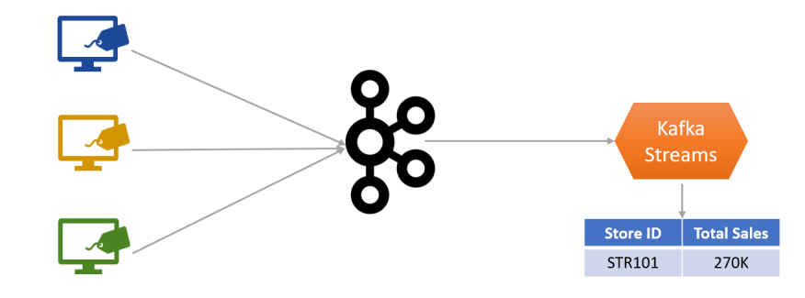

Does it make any sense to keep growing the same total all the time? No. Such things are more meaningful when we compute them in the time-based window. For example, daily sales, hourly sales, per minute, or even per second, right? The point is straightforward.

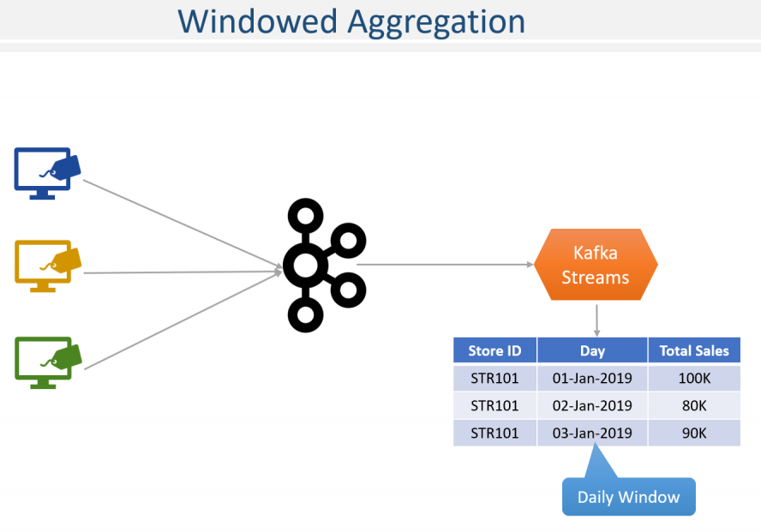

You often need to create smaller chunks or buckets of data and calculate aggregates on the bucket only. Such buckets are more often termed as windows, and the time is the most commonly used attribute for windowing. However, there are two additional questions about time. Which time are we talking about? And How do I know the time? Let me explain the first part - Which time are we talking about?

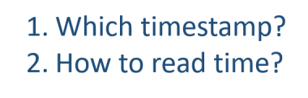

The invoice is generated at the store. Let's say, and it is created at 9.59.00 AM. Just one minute before 10.00 AM. Right? You are sending it to Kafka. But your network hanged or went down for 10 minutes. But ultimately, your invoice reaches to Kafka cluster at 10.10. Now you have a stream processing application that is computing the totals. However, your application is running a little slow.

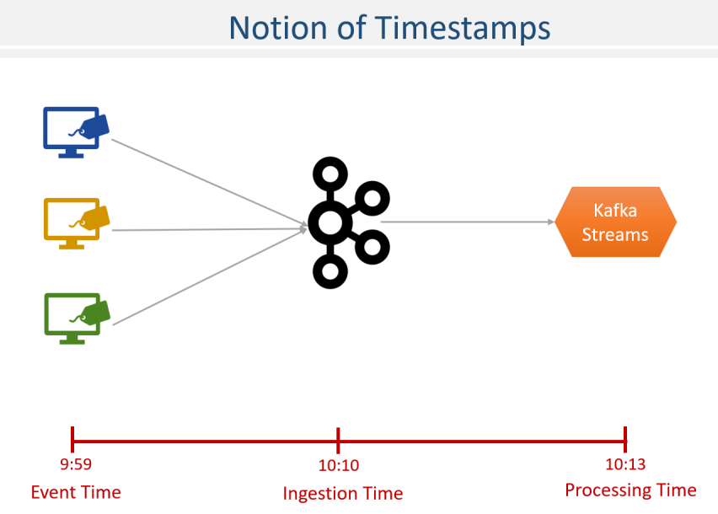

So It reads the invoice at 10.13 AM and calculates the sum. Now, look at the situation. For the same invoice, we have a notion of three timestamps, which one do you want to consider. I am talking about minutes here, and you might be thinking that these differences in three timestamps are unrealistic, or at least it is not going to happen on a day to day basis. Right? But think about seconds and milliseconds. These three timestamps are going to exists and will be different. That difference might be as small as few milliseconds, but they will be different. The point is, which timestamp do you want to consider? We have a proper name for these three timestamps. Here they are. The event time is the exact time when the event was generated at the source system. For example, an invoice is made at the POS terminal. In this case, the event time can be stamped by the POS system, and the time becomes an integral part of the invoice. In such cases, we represent the event time using a field in the event object itself. For example, our POS simulator generates invoices with a filed CreatedTime.

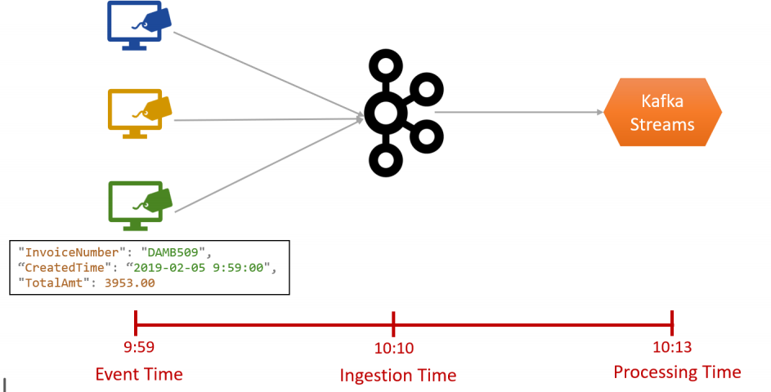

Having CreatedTime in your event is the best thing that you can have. Why? Because it represents the actual time when the event occurred. Right? However, in many cases, your event generating system may not already have a timestamp field. Also, some times, it may not be feasible to modify such applications to add a timestamp field. What can you do in those cases? In some of those cases, you may be using producer API to transmits your events to Kafka.

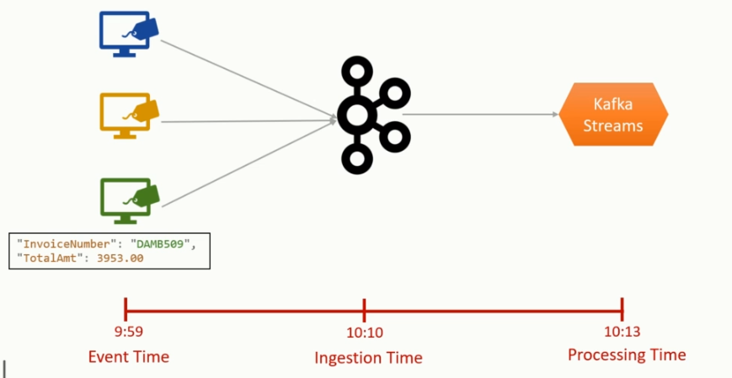

The producer API is smart enough to put a timestamp in the record metadata. So, your Kafka records are timestamped by the producer automatically. Thus, the producer timestamp is the best possible alternative that you can have when the message does not come with its own timestamp. These two alternatives are used to work with the notion of Event time. But the real world is so complicated. You may have a situation when you don't have a timestamp in the event, and you are not using Kafka Producer API. You might be using a third-party tool to bring data to Kafka, and the tool does not create a timestamp in the record metadata. Possible? Absolutely yes. So what option do you have now? The next option is the ingestion time. Ingestion time is the time when the event reaches to your Kafka Broker. Obviously, you can't explicitly set the ingestion time.

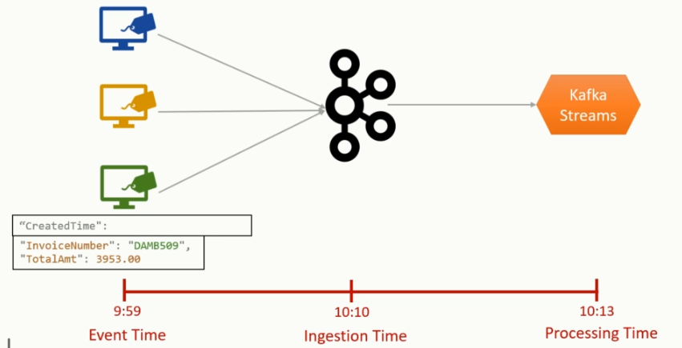

It must be assigned by the Kafka broker, and the broker does that for you. However, you need to set a configuration for this. Here it is. You can set this configuration at the topic level. But remember this. When the topic is configured to use LogAppendTime, the timestamp in your record metadata is overwritten by the broker using the broker system time. That means you can either create a timestamp metadata using the producer time or the broker time. But you can't have both because there is only one timestamp in the message metadata. Great! In most cases, you should be using the event time. However, when your use case demands to use the ingestion time, or you do not have a mechanism to implement the event time, you should be using ingestion time.

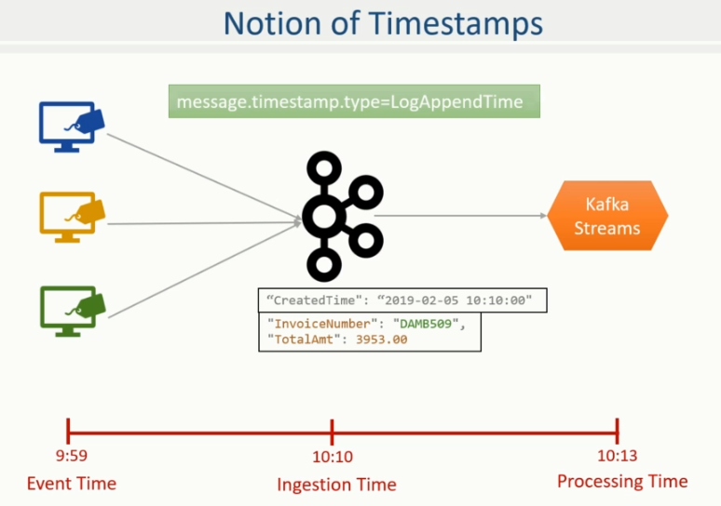

Finally, the third and last option is to use the processing time. The Processing time is the time when you receive the message in your Kafka streams topology.

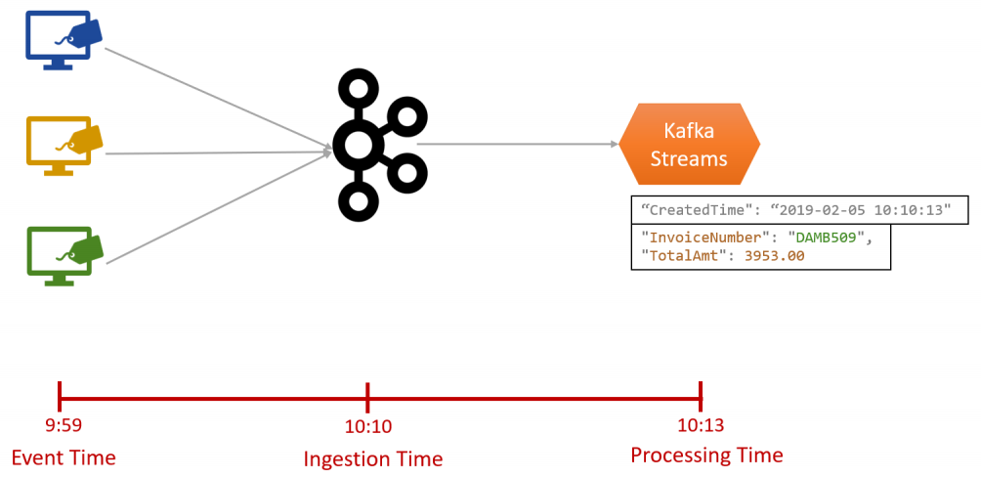

Your messages are sitting in the broker, you will be reading it using your Streams API, and when it comes to the topology source processor, it is timestamped with the current time of your computer, and that's what we call the processing time. Right? Great! We answered the first question - Which time are we talking about? Now the next question - How do I know the time? Let me elaborate. These timestamps are sitting inside the message or in the message metadata. Right? For example, the event time is hidden inside the created date field in your message body. Similarly, the producer time or the log-append time is hidden inside the record metadata. How do you tell your application about which timestamp do you want to use? Right? That's the question. Well, that's absolutely straightforward. All you do is this. Set the following configuration. What are we doing in this configuration?

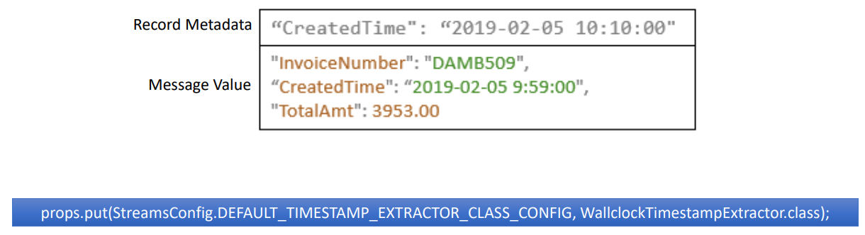

We are simply telling How to extract the timestamp. The WallclockTimestampExtractor is available to you as an out of the box timestamp extractor, which simply gives current system time. So, if you are configuring WallclockTimestampExtractor, that means you are going to use the processing time.

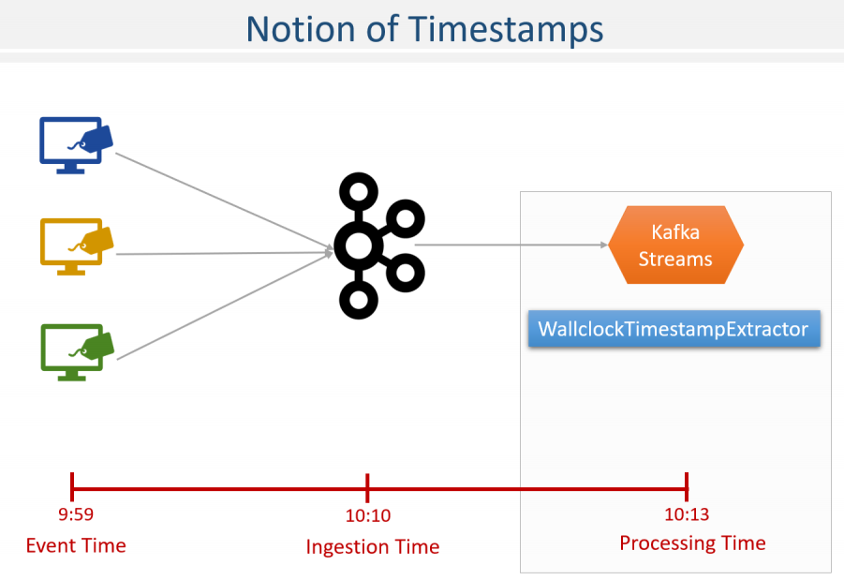

If you want to use the producer time or the log-append time, you must provide a different extractor which reads timestamp from the record metadata. Right? You have three out of box extractor for this purpose. All of these are to extract time from the metadata. That means you will be using producer time or the log-append time.

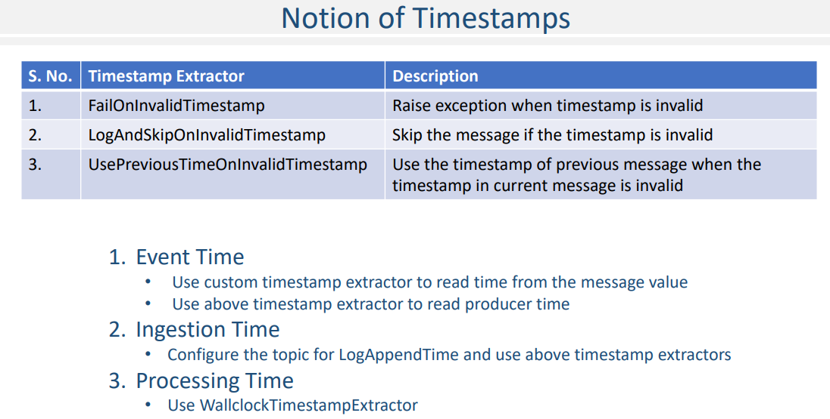

Finally, how to use message timestamp? I mean, how can I extract created time from my message and use it for time-based windows. Any guesses? Yes. You will be creating a custom timestamp extractor and configure it here. That's all. Let me quickly summarize it. Kafka allows you to work on three types of time semantics. Event Time Ingestion Time and Processing Time To use the event time, you must have a timestamp in your message itself and use a custom timestamp extractor. Alternatively, you can use producer timestamps to simulate an event time and use any of these three extractors. If you want to use Ingestion time semantics, then you should configure the topic for LogAppendTime and use one of these timestamp extractors. Finally, if you are interested in using processing time, then all you do is to configure the WallclockTimestampExtractor.

### Creating Tumbling Windows



I talked about the notion of windowing. Kafka Stream API offers two types of windows. Time window and Session window In this lecture, we will learn about the time-based windowing. So, let's start.

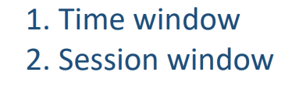

We want to take a problem solution approach, and here is the problem description. We want to compute the number of invoices generated in a five-minute window by each store. You can simulate the scenario in a controlled environment. Create a Kafka topic named as simple-invoice. Send the following Invoices to the Kafka topic. Each invoice comes as key/value pair. The value before the colon is a store-id which is the key. Rest of the value is a JSON Serialize invoice event. The event time of the invoice is recorded in the CreatedTime field.

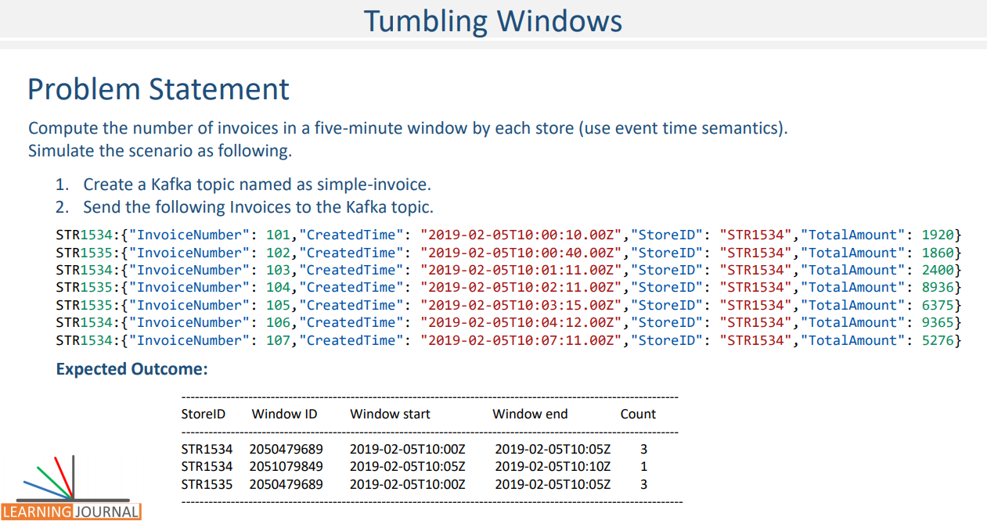

We want to develop a stream processing application that uses event-time semantics to compute the number of invoices in a five-minute window for each store. For the given invoices, you can expect the following outcome. Let's talk about the solution. We already learned that grouping your data is a mandatory step for computing aggregates. The problem statement clearly states that we want to group our data by StoreID.

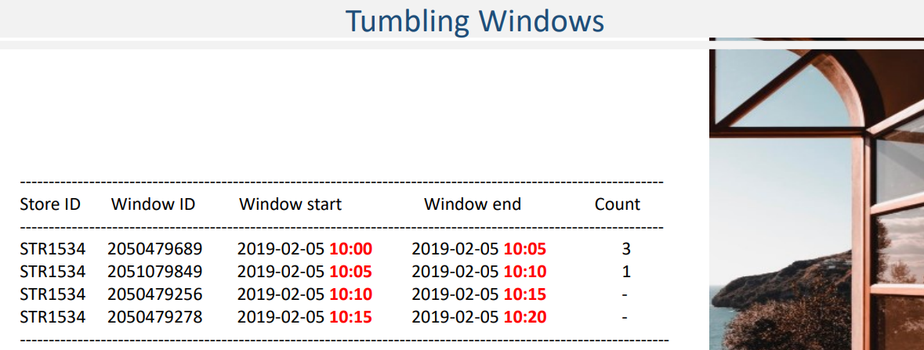

However, we also want to create a subgroup of a five-minute window. In other words, for each group or store-id, we want to create a series of a five-minute time window, as shown in this figure. The idea represented in the diagram is central to the windowed aggregation. Once you conceptualize the notion of the window as a subgroup, rest is straightforward. As the record flows, we want them to map to a key and time window combination.

Once the record is assigned to the window, computing count() or any other aggregate is straightforward. Let's write some code to implement it. As always, I got you a starter project. The starter project comes with the invoice schema definition and an autogenerated class.

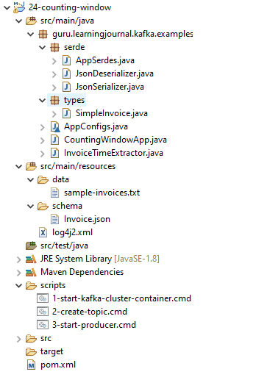

Same as earlier examples, I have also included required serdes, AppConfigs, and the main application class. You are already familiar with the boilerplate code here, right? I am setting some necessary configurations and also consuming messages from the Kafka topic. I talked about the stream time and the timestamp extractors in the earlier lecture. In this example, we want to work with the event time, right? That's what the requirement says. The event time is embedded in the invoice schema, and hence, we must create and specify a custom timestamp extractor. So, let's create a timestamp extractor. Let me name it as InvoiceTimeExtractor, which implements the TimestampExtractor interface. All we do here is to override the extract method. The extract method is invoked by the framework and given a ConsumerRecord. We also receive the timestamp of the previous message. All we do in this method is to extract the timestamp from the consumer record value and return it. That's is all, and that's what the timestamp extractor means. Right? Extract the time. Let's do it. We take out the invoice from the consumer record. Now, we will extract the created-time as epoch milliseconds. So, let's declare a long and get the invoice created time, parse the string and convert it to epoch milliseconds. Right? Now we are going to return the epoch milliseconds. However, let me check the timestamp for a valid non-negative value. Else, we return the timestamp of the previous message. That's all.

**InvoiceTimeExtractor.java**

import guru.learningjournal.kafka.examples.types.SimpleInvoice;

import org.apache.kafka.clients.consumer.ConsumerRecord;

import org.apache.kafka.streams.processor.TimestampExtractor;

import java.time.Instant;

public class InvoiceTimeExtractor implements TimestampExtractor {

@Override

public long extract(ConsumerRecord<Object, Object> consumerRecord, long prevTime) {

SimpleInvoice invoice = (SimpleInvoice) consumerRecord.value();

long eventTime = Instant.parse(invoice.getCreatedTime()).toEpochMilli();

return ((eventTime>0) ? eventTime : prevTime);

}

}

What`s next? We come back to our main() method. We have this consumed-with method. Right? We can set the timestamp extractor in this method. So, while we consume messages from the Kafka topic, we also tell how to consume it, which includes the serdes and the timestamp extractor. Great! So we are now all set for the event time semantics on this stream. The next step is to group this stream on the store-id. We are lucky enough because the event already comes with store-id as a key. Right? So, we can use the groupByKey method. Great! What is the next step? windowBy(). That's how we regroup this stream on a time window. And we want to create a time window for the duration of five minutes. Good. The stream is now grouped. The first level group is on the store-id, the second level group is on the 5-minute time-window. We are now ready to apply the aggregation formula. Count. That's what we want to do, right? Same as earlier, the count method with return a KTable of the key and value. The key is going to be a windowed string. Right? In our case, the store-id string is the key, and the stream is windowed. So, the key is a windowed string. What is the value? Long. Isn't it? The count is going to be a Long number.

import guru.learningjournal.kafka.examples.serde.AppSerdes;

import guru.learningjournal.kafka.examples.types.SimpleInvoice;

import org.apache.kafka.streams.KafkaStreams;

import org.apache.kafka.streams.StreamsBuilder;

import org.apache.kafka.streams.StreamsConfig;

import org.apache.kafka.streams.kstream.*;

import org.apache.logging.log4j.LogManager;

import org.apache.logging.log4j.Logger;

import java.time.Duration;

import java.time.Instant;

import java.time.ZoneOffset;

import java.util.Properties;

public class CountingWindowApp {

private static final Logger logger = LogManager.getLogger();

public static void main(String[] args) {

Properties props = new Properties();

props.put(StreamsConfig.APPLICATION_ID_CONFIG, AppConfigs.applicationID);

props.put(StreamsConfig.BOOTSTRAP_SERVERS_CONFIG, AppConfigs.bootstrapServers);

props.put(StreamsConfig.STATE_DIR_CONFIG, AppConfigs.stateStoreName);

props.put(StreamsConfig.COMMIT_INTERVAL_MS_CONFIG, 0);

StreamsBuilder streamsBuilder = new StreamsBuilder();

KStream<String, SimpleInvoice> KS0 = streamsBuilder.stream(AppConfigs.posTopicName,

Consumed.with(AppSerdes.String(), AppSerdes.SimpleInvoice())

.withTimestampExtractor(new InvoiceTimeExtractor())

);

KTable<Windowed<String>, Long> KT0 =

KS0.groupByKey(Grouped.with(AppSerdes.String(), AppSerdes.SimpleInvoice()))

.windowedBy(TimeWindows.of(Duration.ofMinutes(5)))

.count();

KT0.toStream().foreach(

(wKey, value) -> logger.info(

"Store ID: " + wKey.key() + " Window ID: " + wKey.window().hashCode() +

" Window start: " + Instant.ofEpochMilli( wKey.window().start() )

.atOffset(ZoneOffset.UTC) +

" Window end: " + Instant.ofEpochMilli( wKey.window().end() )

.atOffset(ZoneOffset.UTC) +

" Count: " + value

)

);

KafkaStreams streams = new KafkaStreams(streamsBuilder.build(), props);

streams.start();

Runtime.getRuntime().addShutdownHook(new Thread(() -> {

logger.info("Stopping Streams");

streams.close();

}));

}

}

Right? Now what? Let me print the content. I am going to use the for-each method. Each record in the for-each method is coming from the KTable, and we get the key and the value. The key is not a simple-key. It is windowed-key. You can get the simple key-value from the windowed key. You can also get a window id, window start time, and window end time. Finally, we print the count. That's all. I already have this boilerplate code here. You want to execute it. Let's do it. Unfortunately, this example doesn't work with a windows Kafka cluster. So, I got you a Linux Kafka Cluster container. However, you must have a Docker setup on your machine.

I have a separate video in the appendix section to explain how can you set up a docker and use it to run a Kafka cluster in a docker container. I recommend that you go and check that video and then come back here.

$ docker run -i -p 2181:2181 -p 9092:9092 -p 9093:9093 -p 9094:9094

--name kafka2.3-3in1

-h kafka learningjournal/kafka:kafka2.3-3in1-centos7

Once you have a docker setup, start this script. The script is a docker command to start a Kafka container. The container image is available in the Learning Journal docker hub repository. If you are executing it for the first time, this command will download the image from the public repository. So, you must have an internet connection to run this command for the first time. Let me start it. Great! My Kafka cluster is running. Let me create the topic. Start the producer. Start the application. Send all the invoices. Let me check the results. Good. You can compare the results with the expected outcome.

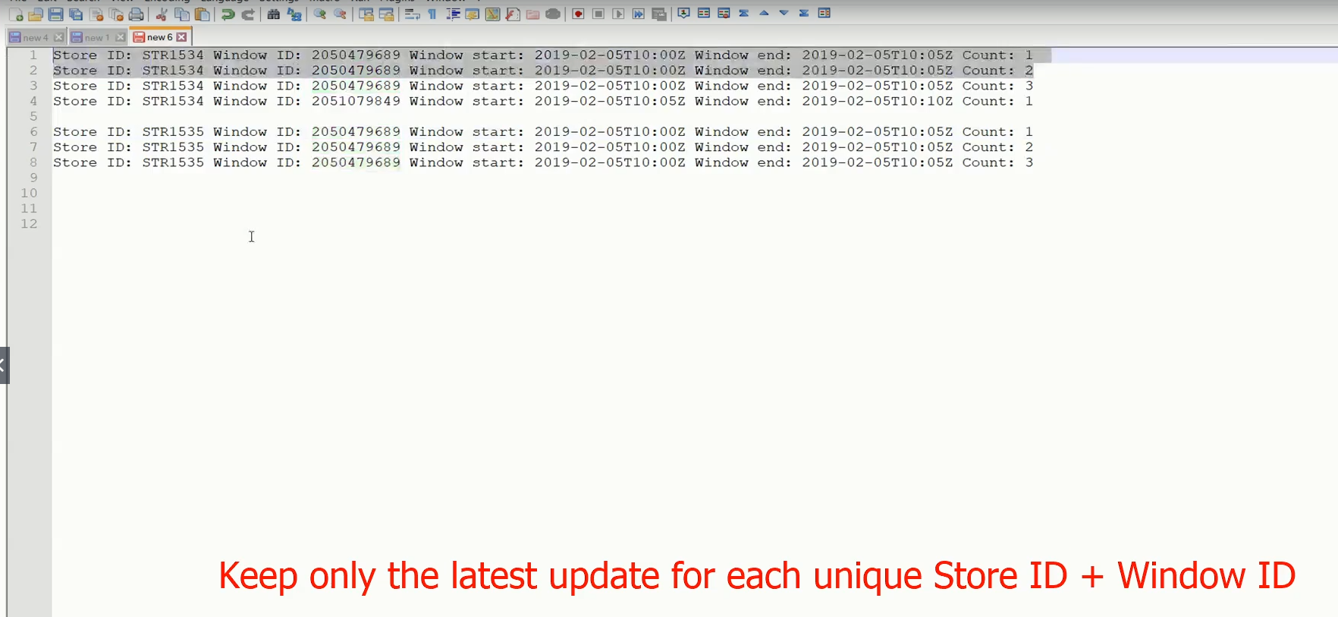

Great! In this example, we created a fixed size, non-overlapping, gap-less time window. Such windows are known as tumbling time window. Here is a figure that shows a visual representation of a tumbling window for the current example. Let me explain it.

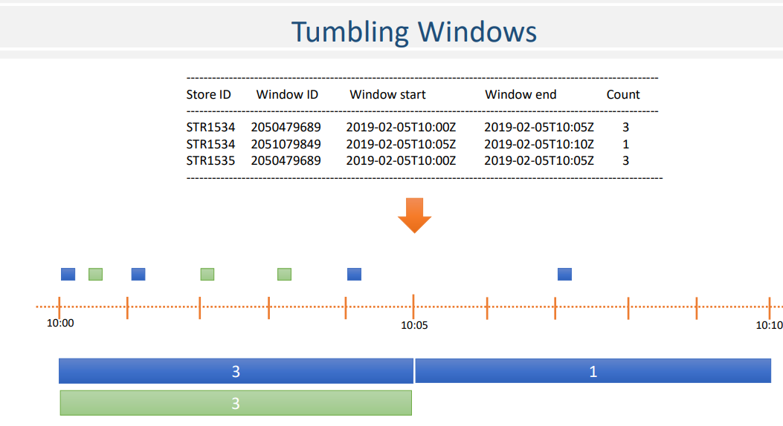

The dotted line at the top is to represent the time. Each small box on the timeline is to express an invoice by the created time. A different color of the invoice shows a different key: the store-id. Right? The larger boxes under the timeline are to represent the windows. So, we have three windows. These two consecutive windows are for the first store, and the third window is for the second store.

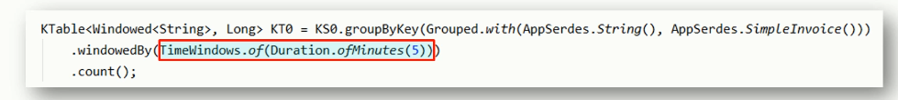

The count for each window is shown in the center of the window. Make sense? Ok, Just to summarize, tumbling windows are fixed-size, non-overlapping, gap-less windows. You can define a tumbling window using the size of the window as we did in TimeWindows.of() method. You might be wondering, what will be the start time of the window? I mean, we just give a window size and let Kafka decide the start time of the window. Right? Kafka API would look at the timestamp of the first message and use a rounding algorithm to arrive at a starting time for the window. They call it “normalizing the window start to the epoch.”

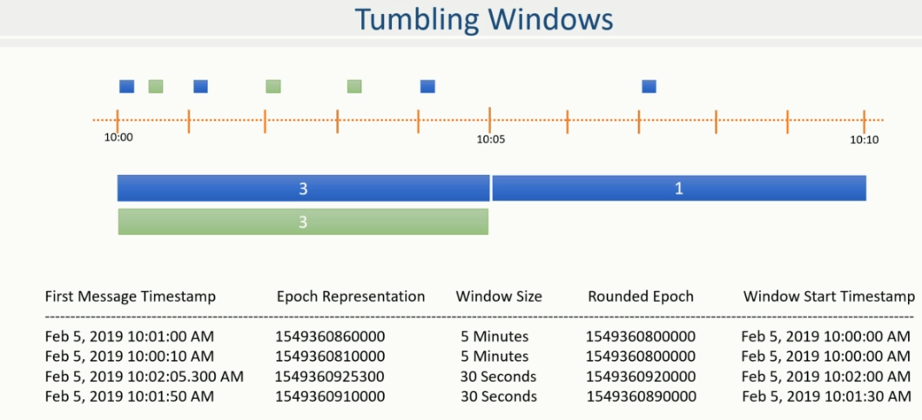

Rest of the code for this lesson

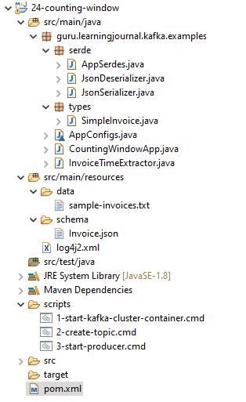

**AppSerdes.java**

import guru.learningjournal.kafka.examples.types.SimpleInvoice;

import org.apache.kafka.common.serialization.Serde;

import org.apache.kafka.common.serialization.Serdes;

import java.util.HashMap;

import java.util.Map;

public class AppSerdes extends Serdes {

static final class PosInvoiceSerde extends WrapperSerde<SimpleInvoice> {

PosInvoiceSerde() {

super(new JsonSerializer<>(), new JsonDeserializer<>());

}

}

public static Serde<SimpleInvoice> SimpleInvoice() {

PosInvoiceSerde serde = new PosInvoiceSerde();

Map<String, Object> serdeConfigs = new HashMap<>();

serdeConfigs.put(JsonDeserializer.VALUE_CLASS_NAME_CONFIG, SimpleInvoice.class);

serde.configure(serdeConfigs, false);

return serde;

}

}

**JsonDeserializer.java**

import com.fasterxml.jackson.databind.ObjectMapper;

import org.apache.kafka.common.errors.SerializationException;

import org.apache.kafka.common.serialization.Deserializer;

import java.util.Map;

public class JsonDeserializer<T> implements Deserializer<T> {

private ObjectMapper objectMapper = new ObjectMapper();

private Class<T> className;

public static final String KEY_CLASS_NAME_CONFIG = "key.class.name";

public static final String VALUE_CLASS_NAME_CONFIG = "value.class.name";

public JsonDeserializer() {

}

@SuppressWarnings("unchecked")

@Override

public void configure(Map<String, ?> props, boolean isKey) {

if (isKey)

className = (Class<T>) props.get(KEY_CLASS_NAME_CONFIG);

else

className = (Class<T>) props.get(VALUE_CLASS_NAME_CONFIG);

}

@Override

public T deserialize(String topic, byte[] data) {

if (data == null) {

return null;

}

try {

return objectMapper.readValue(data, className);

} catch (Exception e) {

throw new SerializationException(e);

}

}

@Override

public void close() {

//nothing to close

}

}

**JsonSerializer.java**

import com.fasterxml.jackson.databind.ObjectMapper;

import org.apache.kafka.common.errors.SerializationException;

import org.apache.kafka.common.serialization.Serializer;

import java.util.Map;

public class JsonSerializer<T> implements Serializer<T> {

private final ObjectMapper objectMapper = new ObjectMapper();

public JsonSerializer() { }

@Override

public void configure(Map<String, ?> config, boolean isKey) {

//Nothing to Configure

}

@Override

public byte[] serialize(String topic, T data) {

if (data == null) {

return null;

}

try {

return objectMapper.writeValueAsBytes(data);

} catch (Exception e) {

throw new SerializationException("Error serializing JSON message", e);

}

}

@Override

public void close() {

}

}

**sample-invoices.txt**

STR1534:{"InvoiceNumber": 101,"CreatedTime": "2019-02-05T10:00:10.00Z","StoreID": "STR1534","TotalAmount": 1920}

STR1535:{"InvoiceNumber": 102,"CreatedTime": "2019-02-05T10:00:40.00Z","StoreID": "STR1534","TotalAmount": 1860}

STR1534:{"InvoiceNumber": 103,"CreatedTime": "2019-02-05T10:01:11.00Z","StoreID": "STR1534","TotalAmount": 2400}

STR1535:{"InvoiceNumber": 104,"CreatedTime": "2019-02-05T10:02:11.00Z","StoreID": "STR1534","TotalAmount": 8936}

STR1535:{"InvoiceNumber": 105,"CreatedTime": "2019-02-05T10:03:15.00Z","StoreID": "STR1534","TotalAmount": 6375}

STR1534:{"InvoiceNumber": 106,"CreatedTime": "2019-02-05T10:04:12.00Z","StoreID": "STR1534","TotalAmount": 9365}

STR1534:{"InvoiceNumber": 107,"CreatedTime": "2019-02-05T10:07:11.00Z","StoreID": "STR1534","TotalAmount": 5276}

**Invoice.json**

{

"type": "object",

"javaType": "guru.learningjournal.kafka.examples.types.SimpleInvoice",

"properties": {

"InvoiceNumber": {

"type": "string"

},

"CreatedTime": {

"type": "string"

},

"StoreID": {

"type": "string"

},

"TotalAmount": {

"type": "number"

}

}

}

**1-start-kafka-cluster-container.cmd**

docker run -i -p 2181:2181 -p 9092:9092 -p 9093:9093 -p 9094:9094

--name kafka2.3-3in1

-h kafka learningjournal/kafka:kafka2.3-3in1-centos7

**2-create-topic.cmd**

kafka-topics.bat --create

--zookeeper localhost:2181

--replication-factor 3

--partitions 3

--topic simple-invoice

**3-start-producer.cmd**

kafka-console-producer.bat --broker-list localhost:9092

--topic simple-invoice

--property parse.key=true

--property key.separator=":"

**pom.xml**

<?xml version="1.0" encoding="UTF-8"?>

<project xmlns="http://maven.apache.org/POM/4.0.0"

xmlns:xsi="http://www.w3.org/2001/XMLSchema-instance"

xsi:schemaLocation="http://maven.apache.org/POM/4.0.0 http://maven.apache.org/xsd/maven-4.0.0.xsd">

<modelVersion>4.0.0</modelVersion>

<groupId>guru.learningjournal.kafka.examples</groupId>

<artifactId>counting-window</artifactId>

<version>2.3.0</version>

<properties>

<java.version>1.8</java.version>

<kafka.version>2.3.0</kafka.version>

<project.build.sourceEncoding>UTF-8</project.build.sourceEncoding>

</properties>

<build>

<plugins>

<!-- Maven Compiler Plugin-->

<plugin>

<groupId>org.apache.maven.plugins</groupId>

<artifactId>maven-compiler-plugin</artifactId>

<version>3.8.0</version>

<configuration>

<source>${java.version}</source>

<target>${java.version}</target>

</configuration>

</plugin>

<!-- Json Schema to POJO plugin-->

<plugin>

<groupId>org.jsonschema2pojo</groupId>

<artifactId>jsonschema2pojo-maven-plugin</artifactId>

<version>0.5.1</version>

<executions>

<execution>

<goals>

<goal>generate</goal>

</goals>

<configuration>

<sourceDirectory>

${project.basedir}/src/main/resources/schema/

</sourceDirectory>

<outputDirectory>

${project.basedir}/src/main/java/

</outputDirectory>

<includeAdditionalProperties>false</includeAdditionalProperties>

<includeHashcodeAndEquals>false</includeHashcodeAndEquals>

<generateBuilders>true</generateBuilders>

</configuration>

</execution>

</executions>

</plugin>

</plugins>

</build>

<dependencies>

<!--Apache commons-->

<dependency>

<groupId>commons-lang</groupId>

<artifactId>commons-lang</artifactId>

<version>2.6</version>

</dependency>

<!-- Apache Kafka Streams-->

<dependency>

<groupId>org.apache.kafka</groupId>

<artifactId>kafka-streams</artifactId>

<version>${kafka.version}</version>

</dependency>

<!-- Apache Log4J2 binding for SLF4J -->

<dependency>

<groupId>org.apache.logging.log4j</groupId>

<artifactId>log4j-slf4j-impl</artifactId>

<version>2.11.0</version>

</dependency>

</dependencies>

</project>

I have done some experiments and tabulated the results here to help you understand the epoch normalization. So, “Normalized to the epoch” means that the first window starts at a rounded epoch, which is lower than the timestamp of the first message. Once the first window start is normalized, all other windows are at a fixed interval of defined size.

### Stream Time and Grace Period

In this section, we learned about the timestamping of the events and also learned to create tumbling windows. However, we still have a couple of additional use cases that we need to cover and talk about the following features. Grace period And suppressing intermediate results.



In this section, I will help you to understand the grace period and put some additional light on the notion of stream time vs. wall clock time. Suppressing intermediate results is the topic for the next lecture. So, let's start. We created a tumbling window example to count the invoices in a five-minute window, Right? Let me open that project. Great! Let's start the Kafka services, create the topic, start the application. Now, I am going to start a console producer and send some invoices. Here is the first invoice with the event time as 10:01. Right? The next invoice is sent at 10:08 and ten seconds. Right? We are counting invoices in a five-minute window. So, I expect two windows here. Let me show you. Here it is. The first window starts at 10:00 and ends five minutes later at 10:05. We got one invoice in this window, and that's what the count is showing. Right? The next window starts at 10:05 and ends at 10:10. That's how tumbling window works. Right? Fixed-size, non-overlapping, gap-less windows of the given duration. We got one invoice, and hence, the count is one. Now, I have a question here. What if we receive a new invoice that was generated at 10:03. I don't expect that record in normal circumstances because we already received a record for 10:08. How can we get a new record for an earlier time?

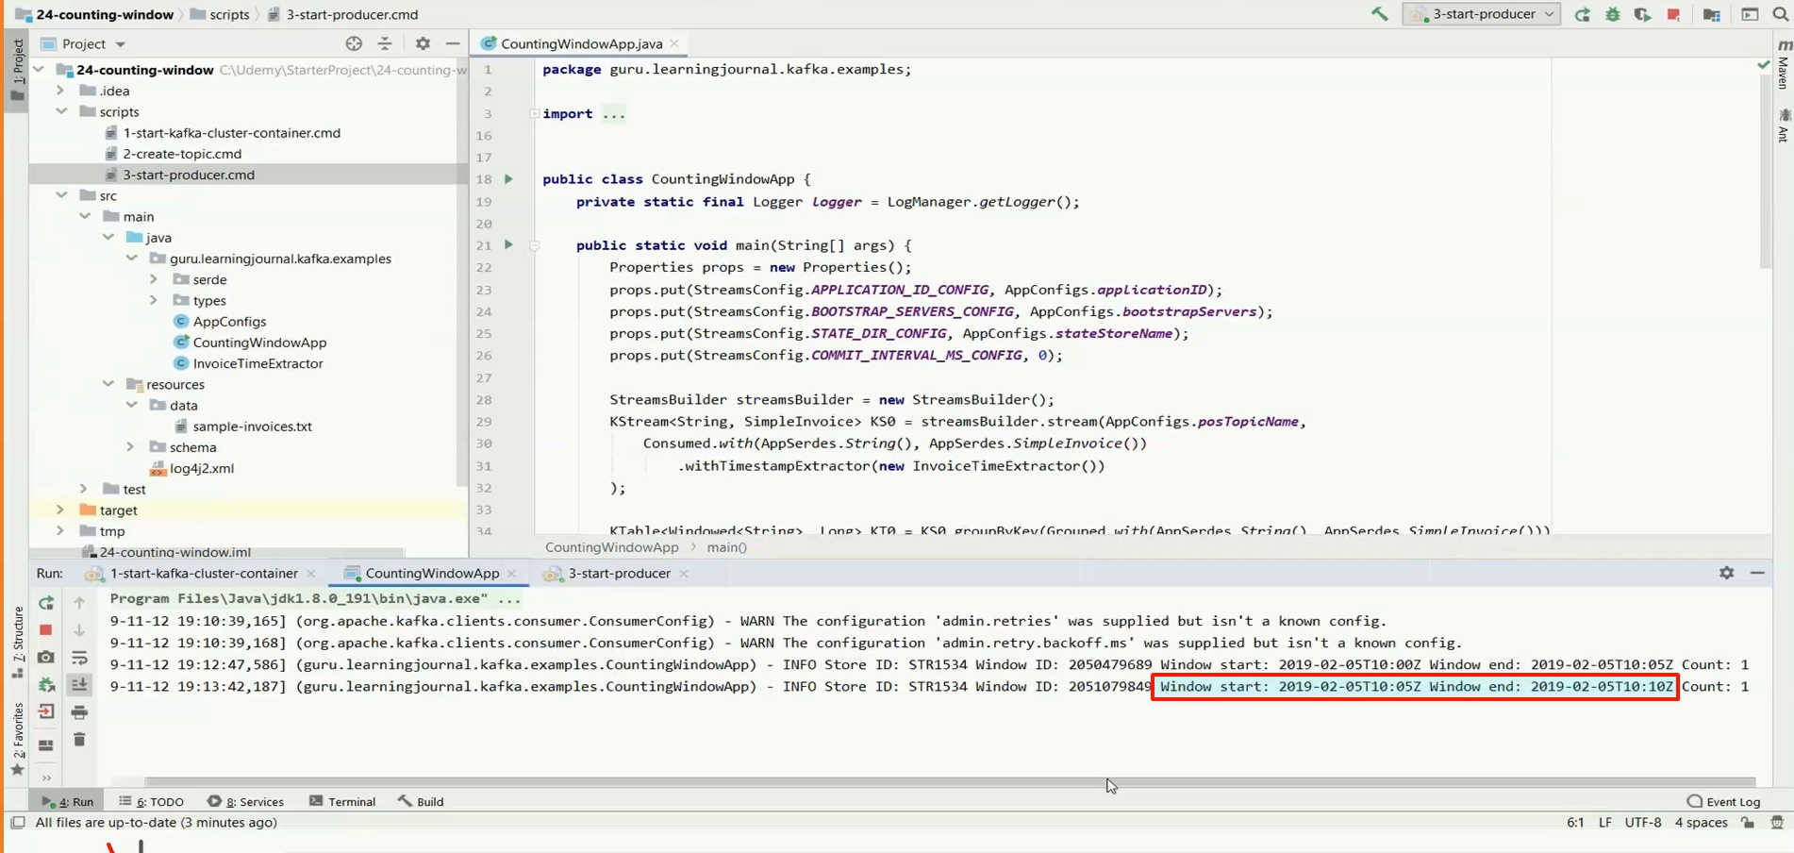

Well, it may happen if the record is arriving late to the Kafka cluster. The latecomers are part of real-life scenarios, and we must be able to deal with them. The question is this. How Kafka Streams API deals with the latecomers? Let me send the late coming invoice, and we will observe what happens. Good. So the same window id is updated with the new count, and we term this approach as the notion of continuous update. What it means is to compute the aggregates for the window and forward the results to downstream for reporting.

If a late record arrives, update the results and deliver it again to the downstream to refresh the reports. Right? And this approach of continuous refresh is perfectly fine in most of the cases. However, we have a question here. Do you want to allow latecomers for infinite time? What do you think? I guess the answer will be a No in most of the cases. In most cases, the late coming records beyond a particular time have no value. For example, in healthcare. You are estimating patients' condition on her vital signals, and a message arriving late by more than five minutes may not have any significance because your formula doesn't depend upon older values. Right?

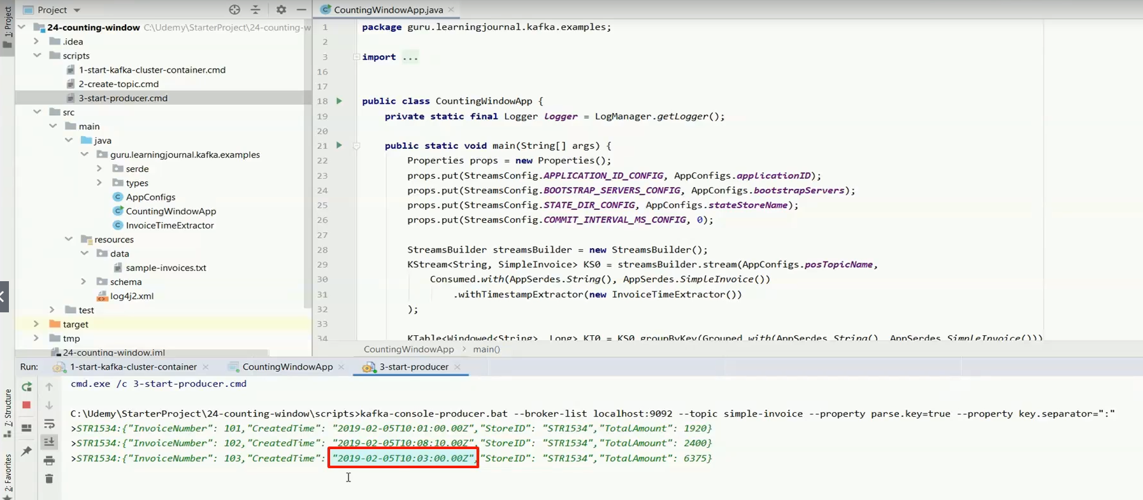

So the point is straightforward. How can we ignore latecomers if they are arriving too late? The answer is the grace period operator. Let me implement a grace period of two minutes in this example and restart it to help you understand how it works? Great! Let me send the first invoice. Good! Based on the first invoice, Kafka created a window. The window starts on February fifth, 10:00 AM 2019. I am executing this example in November 2019. But for this Kafka stream, the clock is stuck at Fifth February 2019 10:01 AM. Why? Because the Kafka Streams API implements the notion of stream time rather than the wallclock time, and the stream time advances with the record timestamp.

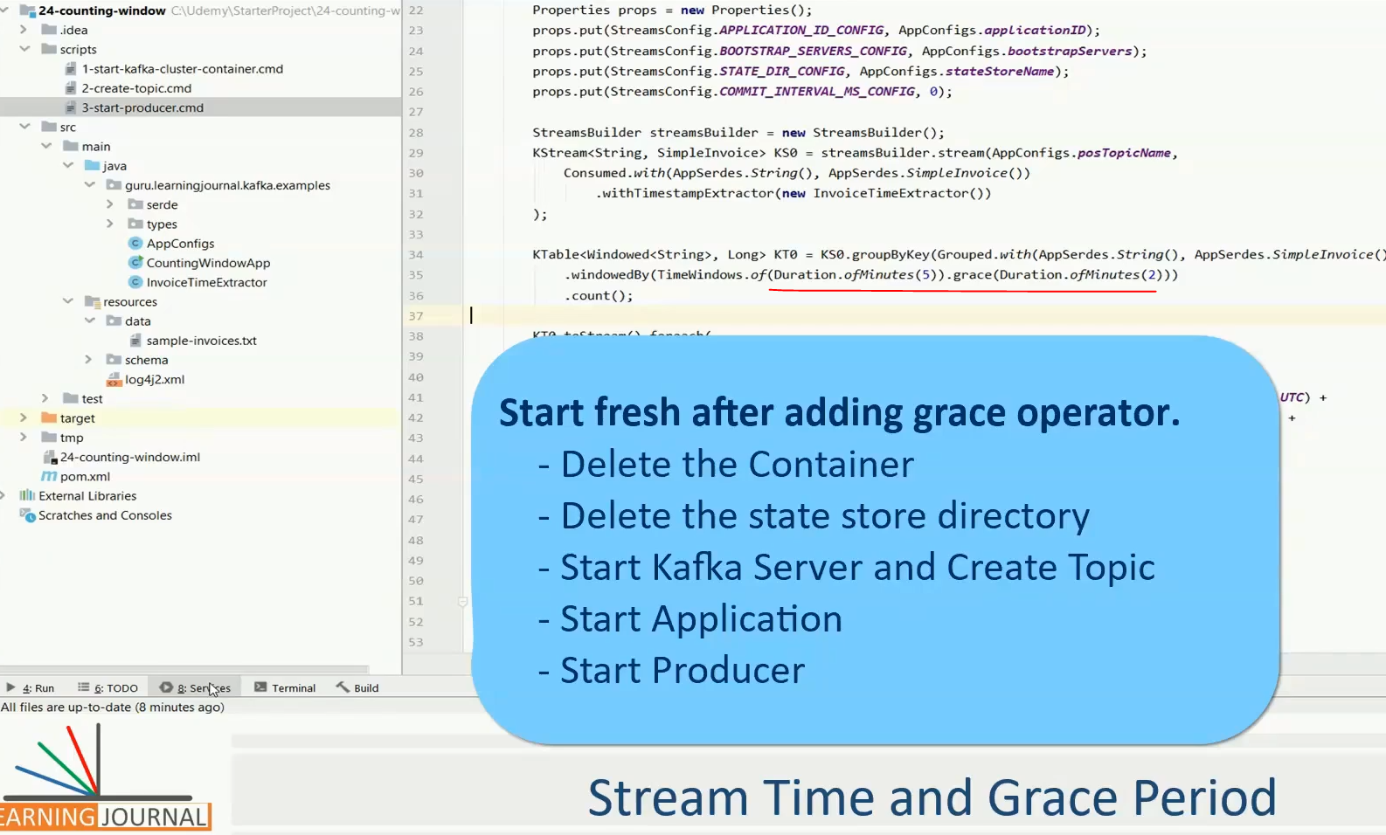

For example, if you received three records at 10:01, 10:08, and 10:03, then the current stream time is 10:08, which is the maximum of the timestamps seen in the stream. If you don't get more records, the stream time is stuck at 10:08.

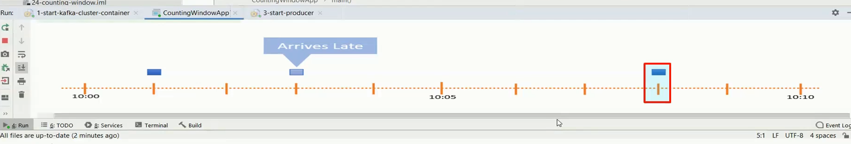

Make sense. Great! So, I send one invoice, and Kafka created a window starting from 10:00 AM to 10:05. However, the current stream time is stuck at 10:01, which is the maximum record timestamp received so far. Let's send the next record.

This new record will advance the stream time to 10:08 and ten seconds. Right? Kafka will also create a new window because the time stream time clock pushed beyond the first window boundary. Let's send a latecomer record.

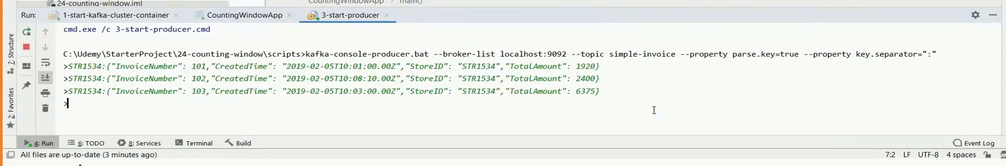

What do you expect? In standard cases, Kafka should update the count for the first window. However, we created the window with 2 minutes of the grace period. So, Kafka will update the count for the first window only if a late coming record for the first window arrives before 10:07. In our case, the clock is already passed 10:08, and now we got a late coming record.

So, this guy is too late and arrived beyond the grace period. Hence, Kafka will ignore the late coming invoice. In other words, we can say that the first window of 10:00 to 10:05 is now fully closed. Why? Because the stream time clock is passed the window end time as well as the grace period of two minutes. Now the aggregate count of the first window is fixed and final. It is never going to update. Hence, we consider it a fully closed window. Great! I hope you get the notion of stream time and the grace period.

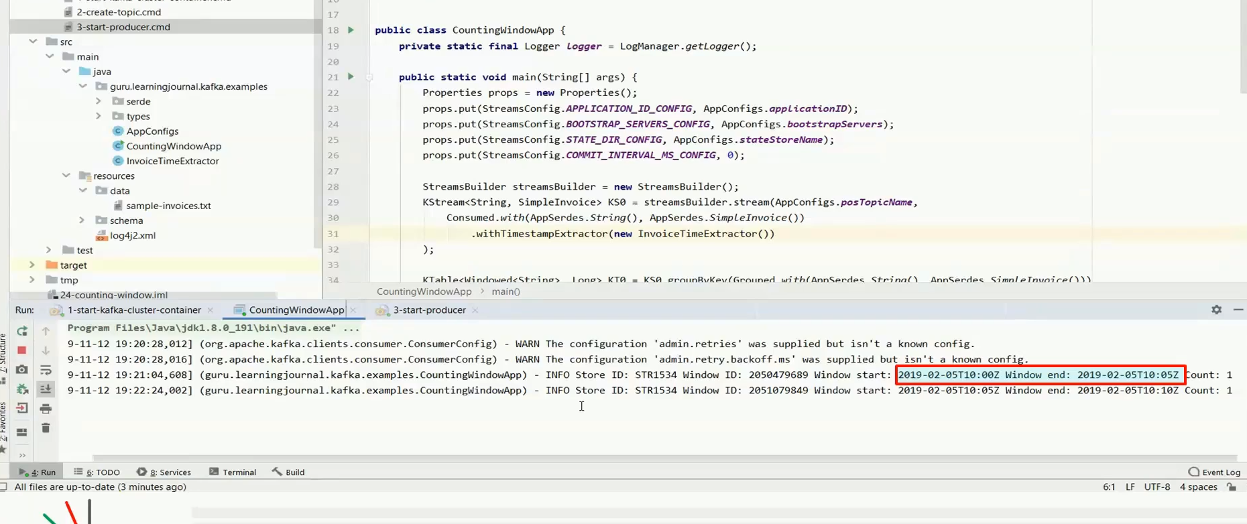

Let me summarize. The stream time clock is different than your wallclock time. The stream time advances when you receive a new record with a greater timestamp. Kafka windows are kept open to accept latecomers and implement the notion of continuous updates. However, you can set the grace period and close older windows as the stream time clock advances beyond the grace period. The default grace period is 24 hours. That's all about the stream time and the grace period.

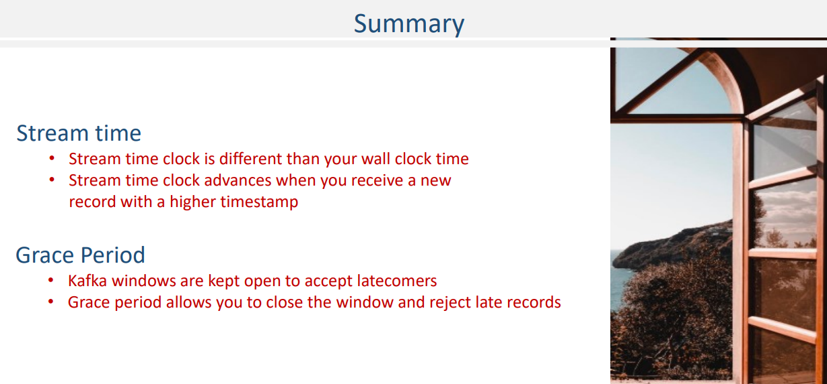

Complete code for above lesson

**AppConfigs.java**

class AppConfigs {

final static String applicationID = "CountingWindowApp";

final static String bootstrapServers = "localhost:9092,localhost:9093,localhost:9094";

final static String posTopicName = "simple-invoice";

final static String stateStoreName = "tmp/state-store";

}

**CountingWindowApp.java**

import guru.learningjournal.kafka.examples.serde.AppSerdes;

import guru.learningjournal.kafka.examples.types.SimpleInvoice;

import org.apache.kafka.streams.KafkaStreams;

import org.apache.kafka.streams.StreamsBuilder;

import org.apache.kafka.streams.StreamsConfig;

import org.apache.kafka.streams.kstream.*;

import org.apache.logging.log4j.LogManager;

import org.apache.logging.log4j.Logger;

import java.time.Duration;

import java.time.Instant;

import java.time.ZoneOffset;

import java.util.Properties;

public class CountingWindowApp {

private static final Logger logger = LogManager.getLogger();

public static void main(String[] args) {

Properties props = new Properties();

props.put(StreamsConfig.APPLICATION_ID_CONFIG, AppConfigs.applicationID);

props.put(StreamsConfig.BOOTSTRAP_SERVERS_CONFIG, AppConfigs.bootstrapServers);

props.put(StreamsConfig.STATE_DIR_CONFIG, AppConfigs.stateStoreName);

props.put(StreamsConfig.COMMIT_INTERVAL_MS_CONFIG, 0);

StreamsBuilder streamsBuilder = new StreamsBuilder();

KStream<String, SimpleInvoice> KS0 = streamsBuilder.stream(AppConfigs.posTopicName,

Consumed.with(AppSerdes.String(), AppSerdes.SimpleInvoice())

.withTimestampExtractor(new InvoiceTimeExtractor())

);

KTable<Windowed<String>, Long> KT0 =

KS0.groupByKey( Grouped.with( AppSerdes.String(),

AppSerdes.SimpleInvoice() ) )

.windowedBy(TimeWindows.of(Duration.ofMinutes(5))

.grace(Duration.ofMinutes(2)))

.count();

KT0.toStream().foreach(

(wKey, value) -> logger.info(

"Store ID: " + wKey.key() + " Window ID: " + wKey.window().hashCode()

+ " Window start: " + Instant.ofEpochMilli(wKey.window().start())

.atOffset(ZoneOffset.UTC) +

" Window end: " + Instant.ofEpochMilli(wKey.window().end())

.atOffset(ZoneOffset.UTC) +

" Count: " + value

)

);

KafkaStreams streams = new KafkaStreams(streamsBuilder.build(), props);

streams.start();

Runtime.getRuntime().addShutdownHook(new Thread(() -> {

logger.info("Stopping Streams");

streams.close();

}));

}

}

**InvoiceTimeExtractor.java**

import guru.learningjournal.kafka.examples.types.SimpleInvoice;

import org.apache.kafka.clients.consumer.ConsumerRecord;

import org.apache.kafka.streams.processor.TimestampExtractor;

import java.time.Instant;

public class InvoiceTimeExtractor implements TimestampExtractor {

@Override

public long extract(ConsumerRecord<Object, Object> consumerRecord, long prevTime) {

SimpleInvoice invoice = (SimpleInvoice) consumerRecord.value();

long eventTime = Instant.parse(invoice.getCreatedTime()).toEpochMilli();

return ((eventTime>0) ? eventTime : prevTime);

}

}

**AppSerdes.java**

import guru.learningjournal.kafka.examples.types.SimpleInvoice;

import org.apache.kafka.common.serialization.Serde;

import org.apache.kafka.common.serialization.Serdes;

import java.util.HashMap;

import java.util.Map;

public class AppSerdes extends Serdes {

static final class PosInvoiceSerde extends WrapperSerde<SimpleInvoice> {

PosInvoiceSerde() {

super(new JsonSerializer<>(), new JsonDeserializer<>());

}

}

public static Serde<SimpleInvoice> SimpleInvoice() {

PosInvoiceSerde serde = new PosInvoiceSerde();

Map<String, Object> serdeConfigs = new HashMap<>();

serdeConfigs.put(JsonDeserializer.VALUE_CLASS_NAME_CONFIG, SimpleInvoice.class);

serde.configure(serdeConfigs, false);

return serde;

}

}

**JsonDeserializer.java**

import com.fasterxml.jackson.databind.ObjectMapper;

import org.apache.kafka.common.errors.SerializationException;

import org.apache.kafka.common.serialization.Deserializer;

import java.util.Map;

public class JsonDeserializer<T> implements Deserializer<T> {

private ObjectMapper objectMapper = new ObjectMapper();

private Class<T> className;

public static final String KEY_CLASS_NAME_CONFIG = "key.class.name";

public static final String VALUE_CLASS_NAME_CONFIG = "value.class.name";

public JsonDeserializer() { }

@SuppressWarnings("unchecked")

@Override

public void configure(Map<String, ?> props, boolean isKey) {

if (isKey)

className = (Class<T>) props.get(KEY_CLASS_NAME_CONFIG);

else

className = (Class<T>) props.get(VALUE_CLASS_NAME_CONFIG);

}

@Override

public T deserialize(String topic, byte[] data) {

if (data == null) {

return null;

}

try {

return objectMapper.readValue(data, className);

} catch (Exception e) {

throw new SerializationException(e);

}

}

@Override

public void close() {

//nothing to close

}

}

**JsonSerializer.java**

import com.fasterxml.jackson.databind.ObjectMapper;

import org.apache.kafka.common.errors.SerializationException;

import org.apache.kafka.common.serialization.Serializer;

import java.util.Map;

public class JsonSerializer<T> implements Serializer<T> {

private final ObjectMapper objectMapper = new ObjectMapper();

public JsonSerializer() { }

@Override

public void configure(Map<String, ?> config, boolean isKey) {

//Nothing to Configure

}

@Override

public byte[] serialize(String topic, T data) {

if (data == null) {

return null;

}

try {

return objectMapper.writeValueAsBytes(data);

} catch (Exception e) {

throw new SerializationException("Error serializing JSON message", e);

}

}

@Override

public void close() { }

}

**sample-invoices.txt**

STR1534:{"InvoiceNumber": 101,"CreatedTime": "2019-02-05T10:01:00.00Z","StoreID": "STR1534","TotalAmount": 1920}

STR1534:{"InvoiceNumber": 102,"CreatedTime": "2019-02-05T10:08:10.00Z","StoreID": "STR1534","TotalAmount": 2400}

STR1534:{"InvoiceNumber": 103,"CreatedTime": "2019-02-05T10:03:00.00Z","StoreID": "STR1534","TotalAmount": 6375}

**Invoice.json**

{

"type": "object",

"javaType": "guru.learningjournal.kafka.examples.types.SimpleInvoice",

"properties": {

"InvoiceNumber": {

"type": "string"

},

"CreatedTime": {

"type": "string"

},

"StoreID": {

"type": "string"

},

"TotalAmount": {

"type": "number"

}

}

}

**pom.xml**

<?xml version="1.0" encoding="UTF-8"?>

<project xmlns="http://maven.apache.org/POM/4.0.0"

xmlns:xsi="http://www.w3.org/2001/XMLSchema-instance"

xsi:schemaLocation="http://maven.apache.org/POM/4.0.0 http://maven.apache.org/xsd/maven-4.0.0.xsd">

<modelVersion>4.0.0</modelVersion>

<groupId>guru.learningjournal.kafka.examples</groupId>

<artifactId>window-grace</artifactId>

<version>2.3.0</version>

<properties>

<java.version>1.8</java.version>

<kafka.version>2.3.0</kafka.version>

<project.build.sourceEncoding>UTF-8</project.build.sourceEncoding>

</properties>

<build>

<plugins>

<!-- Maven Compiler Plugin-->

<plugin>

<groupId>org.apache.maven.plugins</groupId>

<artifactId>maven-compiler-plugin</artifactId>

<version>3.8.0</version>

<configuration>

<source>${java.version}</source>

<target>${java.version}</target>

</configuration>

</plugin>

<!-- Json Schema to POJO plugin-->

<plugin>

<groupId>org.jsonschema2pojo</groupId>

<artifactId>jsonschema2pojo-maven-plugin</artifactId>

<version>0.5.1</version>

<executions>

<execution>

<goals>

<goal>generate</goal>

</goals>

<configuration>

<sourceDirectory>

${project.basedir}/src/main/resources/schema/

</sourceDirectory>

<outputDirectory>${project.basedir}/src/main/java/</outputDirectory>

<includeAdditionalProperties>false</includeAdditionalProperties>

<includeHashcodeAndEquals>false</includeHashcodeAndEquals>

<generateBuilders>true</generateBuilders>

</configuration>

</execution>

</executions>

</plugin>

</plugins>

</build>

<dependencies>

<!--Apache commons-->

<dependency>

<groupId>commons-lang</groupId>

<artifactId>commons-lang</artifactId>

<version>2.6</version>

</dependency>

<!-- Apache Kafka Streams-->

<dependency>

<groupId>org.apache.kafka</groupId>

<artifactId>kafka-streams</artifactId>

<version>${kafka.version}</version>

</dependency>

<!-- Apache Log4J2 binding for SLF4J -->

<dependency>

<groupId>org.apache.logging.log4j</groupId>

<artifactId>log4j-slf4j-impl</artifactId>

<version>2.11.0</version>

</dependency>

</dependencies>

</project>

### Supressing Intermediate Results

In the previous lecture, I talked about the grace period and also promised a separate lecture about suppressing intermediate results. In this lecture, I will talk about a use case which requires suppressing intermediate results and talk about the implementation details. So, Let's start.



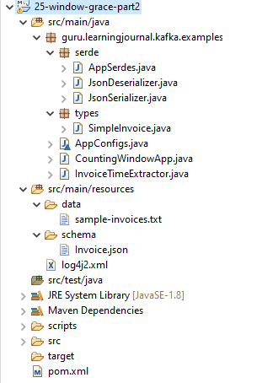

Let's assume you are creating an application that is supposed to monitor a bunch of other systems in real-time. So, you have some applications. They are sending heartbeats for the monitoring system to announce that they are alive and functioning correctly. Here is a sample heartbeat event. Right? You are streaming these events to the Kafka cluster and written a Kafka Streams application to implement the following requirements.

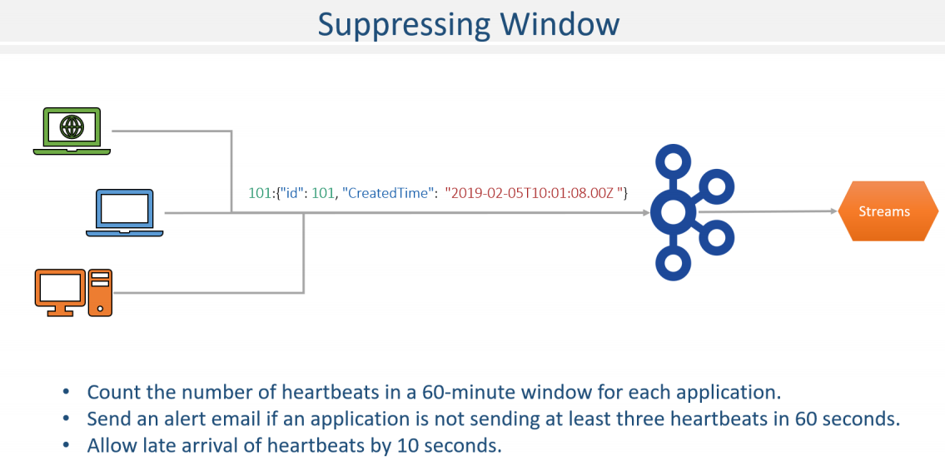

Count the number of heartbeats for each application id. If you received less than three heartbeats in 60 seconds, then you should assume that the application is down, and you should be sending an alert email to the concerned team. Simple! Isn't it? We also want to allow the late arrival of heartbeats by 10 seconds. Let's code it. Same as earlier, here is your starter project. The starter project comes with things that you already learned earlier in this course.

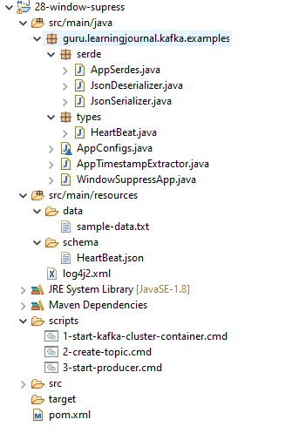

Now, let's look into the main() method. I am consuming the heartbeat topic and using this custom timestamp extractor. So, we will be using event time semantics in this example. Now, the KS0 is a stream of heartbeats. We are going to count it by application id. Right? Remember, the aggregation steps. We must group our stream using the application id, and then we can apply the count aggregation. Right? Let's do it. The first step is to group by key. Done. Now, before we compute count, we should also subgroup it by a one minute window. That's what the requirement is asking. Count the heartbeat in a one minute window. Right? Let's add a window by the method. What do we want? A time window of 60 seconds. However, we also want to allow late coming heartbeats by ten seconds. So, let's add a grace period of 10 seconds. Finally, we can count it. Looks good? So, we have a KTable of counts. What is next? We need to send an alert if the count is less than three. Right? Let's do it. I am going to print a text on the console to simulate the alert. So, if the count is greater than two, the application is alive, else, it failed, and we must send an alert. Looks fine.

**WindowSuppressApp.java**

import guru.learningjournal.kafka.examples.serde.AppSerdes;

import guru.learningjournal.kafka.examples.types.HeartBeat;

import org.apache.kafka.streams.KafkaStreams;

import org.apache.kafka.streams.StreamsBuilder;

import org.apache.kafka.streams.StreamsConfig;

import org.apache.kafka.streams.kstream.*;

import org.apache.logging.log4j.LogManager;

import org.apache.logging.log4j.Logger;

import java.time.Duration;

import java.time.Instant;

import java.time.ZoneOffset;

import java.util.Properties;

public class WindowSuppressApp {

private static final Logger logger = LogManager.getLogger();

public static void main(String[] args) {

Properties props = new Properties();

props.put(StreamsConfig.APPLICATION_ID_CONFIG, AppConfigs.applicationID);

props.put(StreamsConfig.BOOTSTRAP_SERVERS_CONFIG, AppConfigs.bootstrapServers);

props.put(StreamsConfig.STATE_DIR_CONFIG, AppConfigs.stateStoreName);

props.put(StreamsConfig.COMMIT_INTERVAL_MS_CONFIG, 0);

StreamsBuilder streamsBuilder = new StreamsBuilder();

KStream<String, HeartBeat> KS0 = streamsBuilder.stream(AppConfigs.topicName,

Consumed.with(AppSerdes.String(), AppSerdes.HeartBeat())

.withTimestampExtractor(new AppTimestampExtractor())

);

KTable<Windowed<String>, Long> KT01 =

KS0.groupByKey(Grouped.with(

AppSerdes.String(), AppSerdes.HeartBeat() ) )

.windowedBy( TimeWindows.of(Duration.ofSeconds(60) )

.grace( Duration.ofSeconds(10) ) )

.count()

.suppress(Suppressed.untilWindowCloses(

Suppressed.BufferConfig.unbounded() ) );

KT01.toStream().foreach(

(wKey, value) -> logger.info(

"App ID: " + wKey.key() + " Window ID: " + wKey.window().hashCode()

+ " Window start: " + Instant.ofEpochMilli(wKey.window().start())

.atOffset(ZoneOffset.UTC) +

" Window end: " + Instant.ofEpochMilli(wKey.window().end())

.atOffset(ZoneOffset.UTC) +

" Count: " + value + (value>2? " Application is Alive" :

" Application Failed - Sending Alert Email...")

)

);

logger.info("Starting Stream...");

KafkaStreams streams = new KafkaStreams(streamsBuilder.build(), props);

streams.start();

Runtime.getRuntime().addShutdownHook(new Thread(() -> {

logger.info("Stopping Streams...");

streams.close();

}));

}

}

**AppTimestampExtractor.java**

public class AppTimestampExtractor implements TimestampExtractor {

@Override

public long extract(ConsumerRecord<Object, Object> consumerRecord, long prevTime) {

HeartBeat record = (HeartBeat) consumerRecord.value();

long eventTime = Instant.parse(record.getCreatedTime()).toEpochMilli();

return ((eventTime > 0) ? eventTime : prevTime);

}

}

However, we have a bug in this code. Let me execute the example and show you the problem. So, here is the first heartbeat. It is timestamped with 10:01 and eight seconds. Let's see if we got some outcome. Oops! Well, we got output as Server Failed and supposed to send an email.

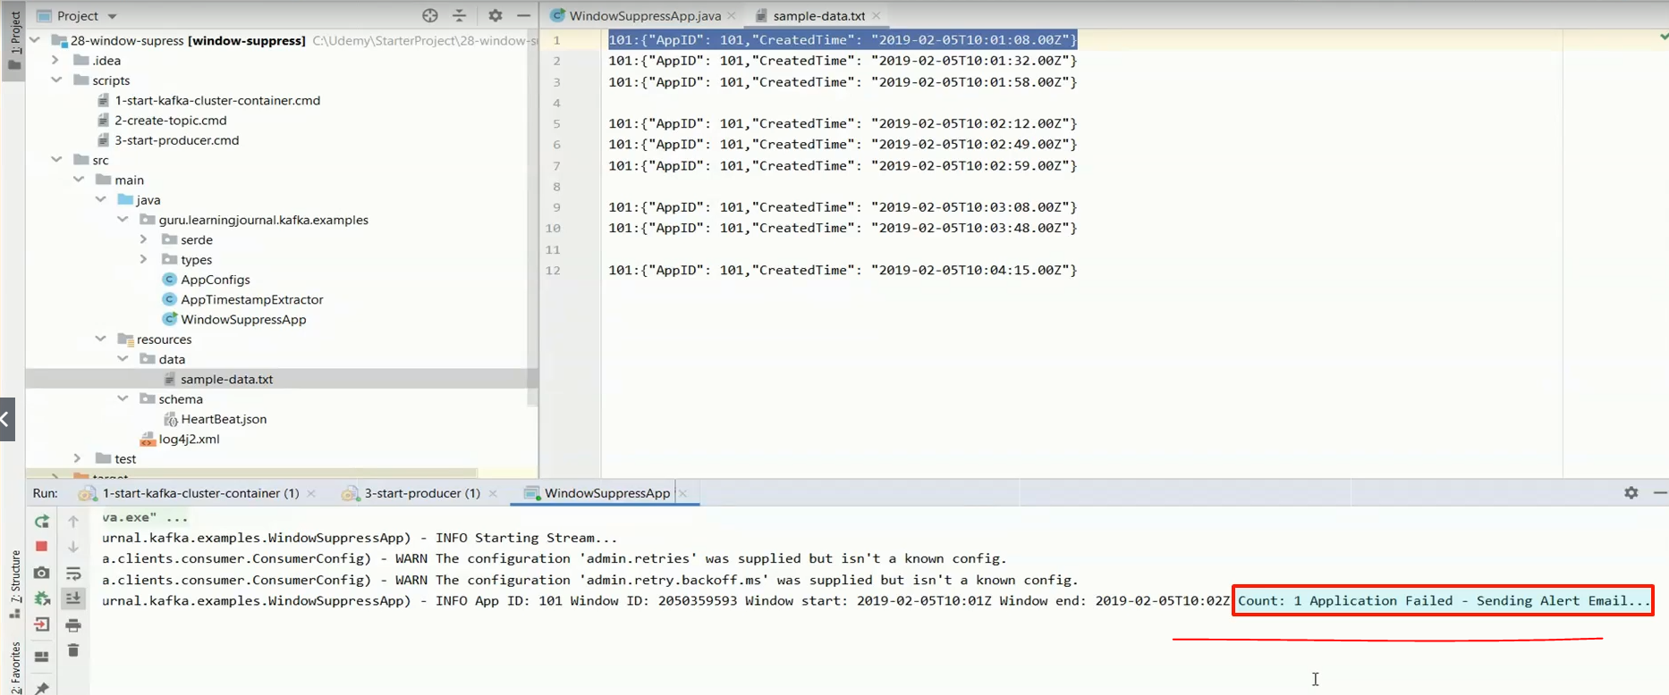

Why did this happen? This happens because the Kafka Streams is a real-time stream processing system, and it implements the notion of continuous updates. What is means is simple. Give an outcome as soon as some event is received. Let the downstream systems use this outcome to refresh a report or take some action. As we collect more events, the Kafka streams will recompute the results and revise the outcome.

So, the downstream systems can also refresh the reports. Right? However, this approach doesn't allow us to handle threshold monitoring use cases. In our example, we want to wait until the window is fully closed. Once the window is fully closed, it is then we should be check if we crossed the threshold of three heartbeats. If not, send an alert. Right? With the notion of continuous updates, the threshold will keep failing from the beginning, and we don't want that to happen. How to handle it? You can suppress the continuous updates and let the outcome flow down further only when the window is fully closed. Let me do it. After computing the count, we call the suppress method. And we configure it to suppress until the window fully closes. That means you should have a grace period to make sure the window closes. Right? We already have that, so nothing more for our example. Suppressing the window will need some memory to buffer the intermediate results and apply updates

So, let's give it an unbounded buffer. When the window closes, you will get only one record per key. Which is the most recent state of the window? So, in our case, we will get the final count for the window. If the final count is less than three, we will send an alert, and the false alerts caused by continuous intermediate results will go away. Make sense? I have included some sample events in the project file. Let me re-execute the example and send these records. I am sending two events for the first window. Let me check if got something. No output, and that's expected because the window is still open. Let me send the third record. You won't see anything yet. Why? Because the window is still open.

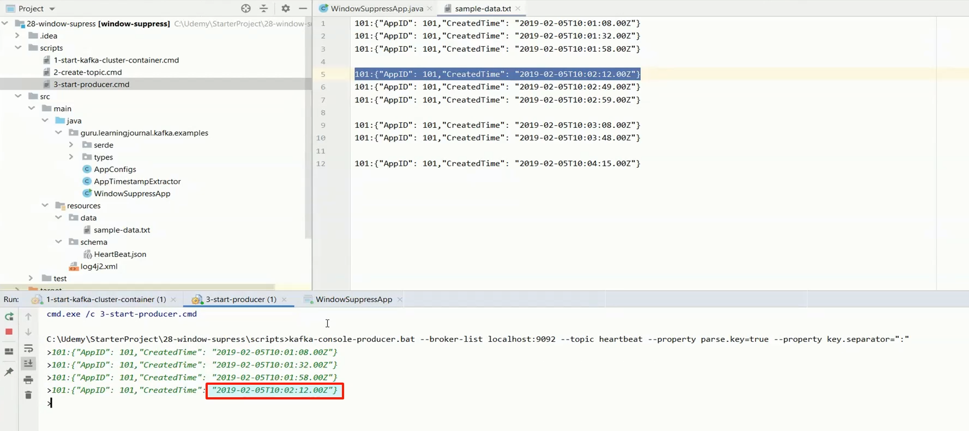

Let me send an event for the second window. This record should close the first window. Why?

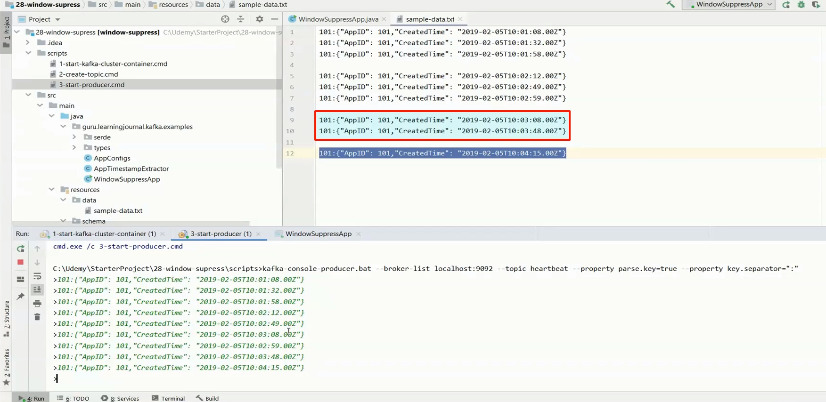

Because the timestamp is large enough to move the stream time clock outside the grace period of the first window. Great! Now you got the outcome. The server is Alive. Right? Because the count is three. Let me send the second record. Then we send a record for the next window. We skip this event to simulate a latecomer. We have no outcome for the second window. Right?

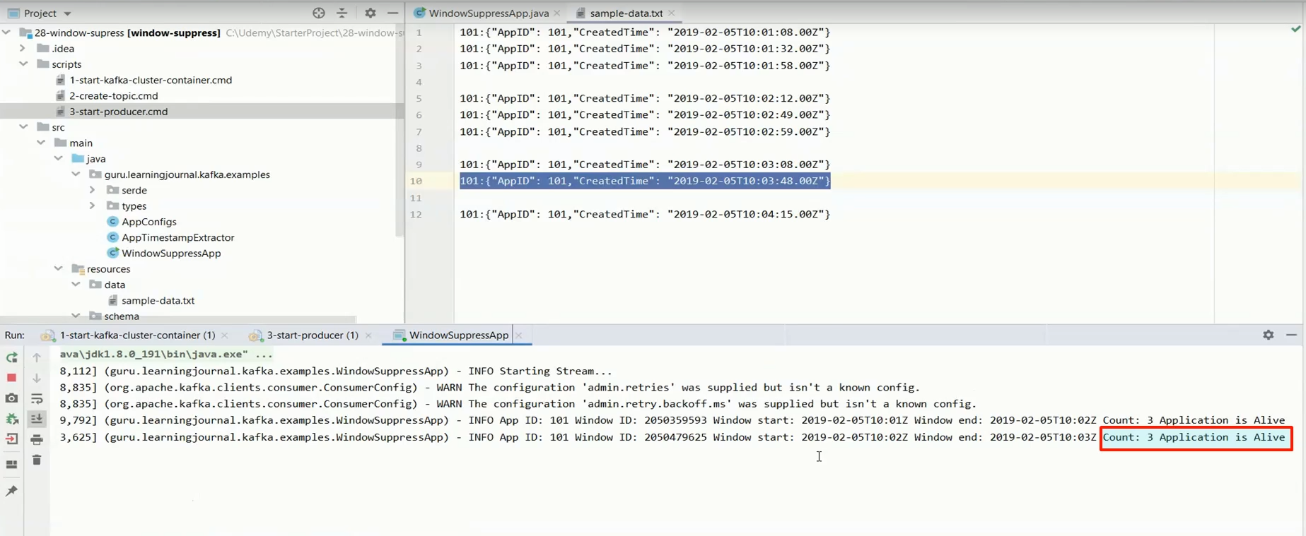

Now, let me send the latecomer. Finally, we send another record to make sure the second window is closed. We got the outcome for the second window. One record came late by three seconds. But it is accepted by the 10 second grace period. Let me close the second window as well. We are closing it with just two heartbeats. Here it is. Failed.

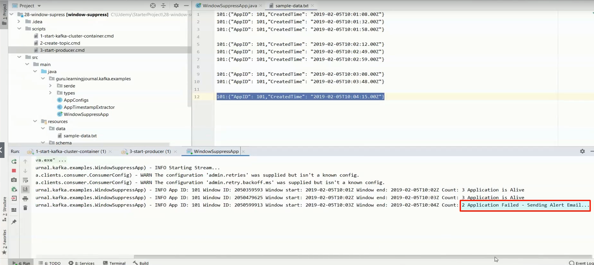

**In Code above**

KTable<Windowed<String>, Long> KT01 =

KS0.groupByKey(Grouped.with(

AppSerdes.String(), AppSerdes.HeartBeat() ) )

.windowedBy( TimeWindows.of(Duration.ofSeconds(60) )

.grace( Duration.ofSeconds(10) ) )

.count()

.suppress(Suppressed.untilWindowCloses(

Suppressed.BufferConfig.unbounded() ) );

**Rest of the code**

**AppConfigs.java**

class AppConfigs {

final static String applicationID = "WindowSuppressApp";

final static String bootstrapServers = "localhost:9092,localhost:9093,localhost:9094";

final static String topicName = "heartbeat";

final static String stateStoreName = "tmp/state-store";

}

**AppSerdes.java**

import guru.learningjournal.kafka.examples.types.HeartBeat;

import org.apache.kafka.common.serialization.Serde;

import org.apache.kafka.common.serialization.Serdes;

import java.util.HashMap;

import java.util.Map;

public class AppSerdes extends Serdes {

static final class HeartBeatSerde extends WrapperSerde<HeartBeat> {

HeartBeatSerde() {

super(new JsonSerializer<>(), new JsonDeserializer<>());

}

}

public static Serde<HeartBeat> HeartBeat() {

HeartBeatSerde serde = new HeartBeatSerde();

Map<String, Object> serdeConfigs = new HashMap<>();

serdeConfigs.put(JsonDeserializer.VALUE_CLASS_NAME_CONFIG, HeartBeat.class);

serde.configure(serdeConfigs, false);

return serde;

}

}

**JsonDeserializer.java**

import com.fasterxml.jackson.databind.ObjectMapper;

import org.apache.kafka.common.errors.SerializationException;

import org.apache.kafka.common.serialization.Deserializer;

import java.util.Map;

public class JsonDeserializer<T> implements Deserializer<T> {

private ObjectMapper objectMapper = new ObjectMapper();

private Class<T> className;

public static final String KEY_CLASS_NAME_CONFIG = "key.class.name";

public static final String VALUE_CLASS_NAME_CONFIG = "value.class.name";

public JsonDeserializer() { }

@SuppressWarnings("unchecked")

@Override

public void configure(Map<String, ?> props, boolean isKey) {

if (isKey)

className = (Class<T>) props.get(KEY_CLASS_NAME_CONFIG);

else

className = (Class<T>) props.get(VALUE_CLASS_NAME_CONFIG);

}

@Override

public T deserialize(String topic, byte[] data) {

if (data == null) {

return null;

}

try {

return objectMapper.readValue(data, className);

} catch (Exception e) {

throw new SerializationException(e);

}

}

@Override

public void close() {

//nothing to close

}

}

**JsonSerializer.java**

import com.fasterxml.jackson.databind.ObjectMapper;

import org.apache.kafka.common.errors.SerializationException;

import org.apache.kafka.common.serialization.Serializer;

import java.util.Map;

public class JsonSerializer<T> implements Serializer<T> {

private final ObjectMapper objectMapper = new ObjectMapper();

public JsonSerializer() { }

@Override

public void configure(Map<String, ?> config, boolean isKey) {

//Nothing to Configure

}

@Override

public byte[] serialize(String topic, T data) {

if (data == null) {

return null;

}

try {

return objectMapper.writeValueAsBytes(data);

} catch (Exception e) {

throw new SerializationException("Error serializing JSON message", e);

}

}

@Override

public void close() { }

}

**sample-data.txt**

101:{"AppID": 101,"CreatedTime": "2019-02-05T10:01:08.00Z"}

101:{"AppID": 101,"CreatedTime": "2019-02-05T10:01:32.00Z"}

101:{"AppID": 101,"CreatedTime": "2019-02-05T10:01:58.00Z"}

101:{"AppID": 101,"CreatedTime": "2019-02-05T10:02:12.00Z"}

101:{"AppID": 101,"CreatedTime": "2019-02-05T10:02:49.00Z"}

101:{"AppID": 101,"CreatedTime": "2019-02-05T10:02:59.00Z"}

101:{"AppID": 101,"CreatedTime": "2019-02-05T10:03:08.00Z"}

101:{"AppID": 101,"CreatedTime": "2019-02-05T10:03:48.00Z"}

101:{"AppID": 101,"CreatedTime": "2019-02-05T10:04:15.00Z"}

**HeartBeat.json**

{

"type": "object",

"javaType": "guru.learningjournal.kafka.examples.types.HeartBeat",

"properties": {

"AppID": {

"type": "string"

},

"CreatedTime": {

"type": "string"

}

}

}

**1-start-kafka-cluster-container.cmd**

docker run -i -p 2181:2181 -p 9092:9092 -p 9093:9093 -p 9094:9094

--name kafka2.3-3in1

-h kafka learningjournal/kafka:kafka2.3-3in1-centos7

**2-create-topic.cmd**

kafka-topics.bat --create

--zookeeper localhost:2181

--replication-factor 3

--partitions 2 --topic heartbeat

--config min.insync.replicas=2

**3-start-producer.cmd**

kafka-console-producer.bat --broker-list localhost:9092

--topic heartbeat

--property parse.key=true

--property key.separator=":"

**pom.xml**

<?xml version="1.0" encoding="UTF-8"?>

<project xmlns="http://maven.apache.org/POM/4.0.0"

xmlns:xsi="http://www.w3.org/2001/XMLSchema-instance"

xsi:schemaLocation="http://maven.apache.org/POM/4.0.0 http://maven.apache.org/xsd/maven-4.0.0.xsd">

<modelVersion>4.0.0</modelVersion>

<groupId>guru.learningjournal.kafka.examples</groupId>

<artifactId>window-suppress</artifactId>

<version>2.3.0</version>

<properties>

<java.version>1.8</java.version>

<kafka.version>2.3.0</kafka.version>

<project.build.sourceEncoding>UTF-8</project.build.sourceEncoding>

</properties>

<build>

<plugins>

<!-- Maven Compiler Plugin-->

<plugin>

<groupId>org.apache.maven.plugins</groupId>

<artifactId>maven-compiler-plugin</artifactId>

<version>3.8.0</version>

<configuration>

<source>${java.version}</source>

<target>${java.version}</target>

</configuration>

</plugin>

<!-- Json Schema to POJO plugin-->

<plugin>

<groupId>org.jsonschema2pojo</groupId>

<artifactId>jsonschema2pojo-maven-plugin</artifactId>

<version>0.5.1</version>

<executions>

<execution>

<goals>

<goal>generate</goal>

</goals>

<configuration>

<sourceDirectory>

${project.basedir}/src/main/resources/schema/

</sourceDirectory>

<outputDirectory>

${project.basedir}/src/main/java/

</outputDirectory>

<includeAdditionalProperties>false</includeAdditionalProperties>

<includeHashcodeAndEquals>false</includeHashcodeAndEquals>

<generateBuilders>true</generateBuilders>

</configuration>

</execution>

</executions>

</plugin>

</plugins>

</build>

<dependencies>

<!--Apache commons-->

<dependency>

<groupId>commons-lang</groupId>

<artifactId>commons-lang</artifactId>

<version>2.6</version>

</dependency>

<!-- Apache Kafka Streams-->

<dependency>

<groupId>org.apache.kafka</groupId>

<artifactId>kafka-streams</artifactId>

<version>${kafka.version}</version>

</dependency>

<!-- Apache Log4J2 binding for SLF4J -->

<dependency>

<groupId>org.apache.logging.log4j</groupId>

<artifactId>log4j-slf4j-impl</artifactId>

<version>2.11.0</version>

</dependency>

</dependencies>

</project>

### Hopping Windows

In the earlier lecture, we created a tumbling window example. In this lecture, we are going to create a hopping window. So, let's start. Hopping time windows are also fixed-size, but they are overlapping windows.



Unlike a tumbling window, a hopping window is defined by two properties. The window's size and the advance interval, kind of hop. The advance interval specifies how much a window moves forward relative to the previous one. For example, you can configure a hopping window of 5 minutes and an advance interval of 1 minute.

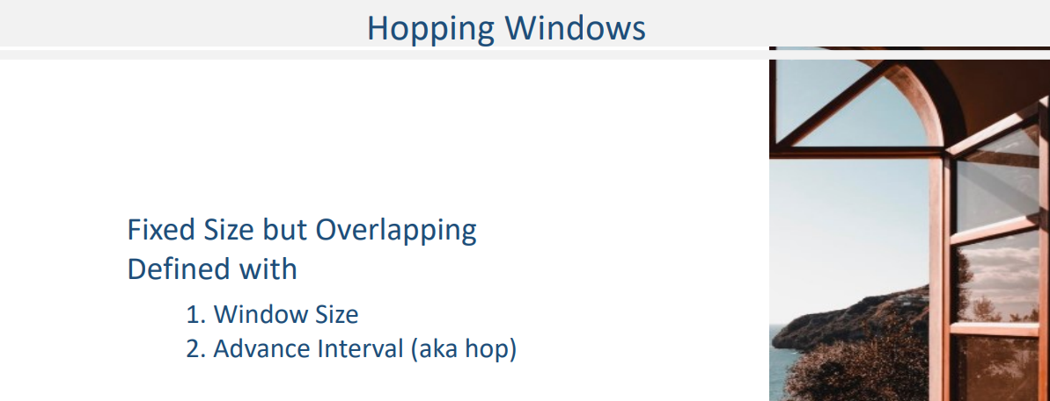

Here is a figure that shows a visual representation of a hopping window for a given store-id. Let me explain. I created this diagram considering the following four invoices.

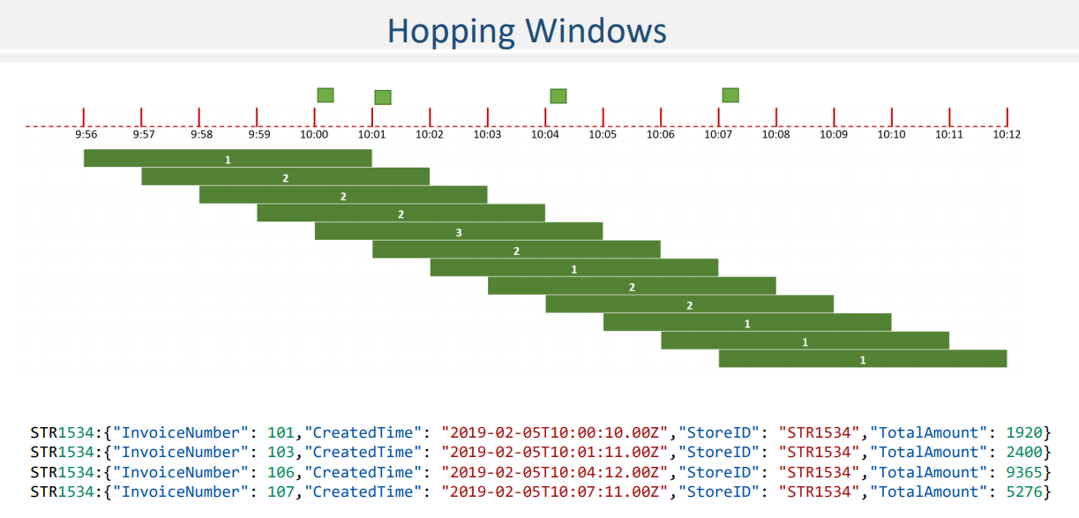

The first invoice is sent at 10 hours and 10 seconds. Same as tumbling windows, the Hopping time windows are also normalized to the epoch. So, assuming that the first window starts at 9.56 and ends five minutes later at 10:01. Right? This window has got only one message, so the count shows as one. The next window is also a five-minute window, but it slides by one minute.

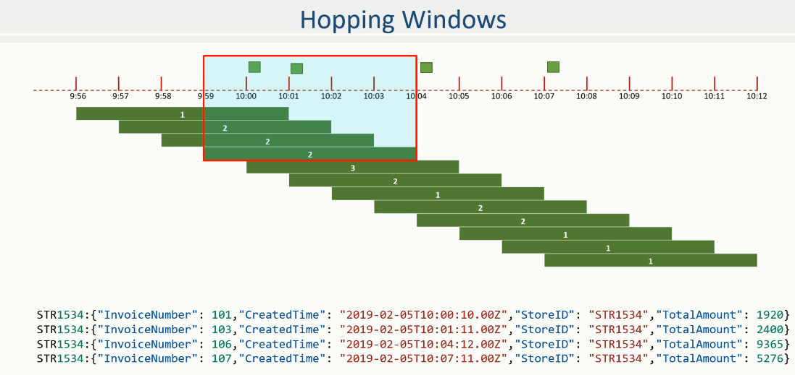

As it moves further, the second window covers two messages and hence counts as two. Similarly, the third and fourth windows are created by sliding one minute each.

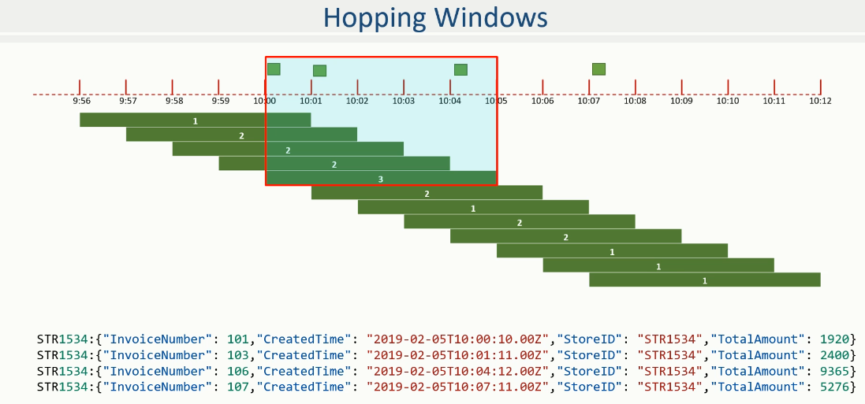

However, the count remains two because they still don't cover the third invoice. Right? The next slide will pick up another invoice, and hence, the count will be updated to three. As you slide further, the count for the current window will keep changing. If you notice the count for the rest of the windows, it is not always increasing, it is decreasing also depending upon the message timestamp. Right?

Hopping windows are used to compute moving aggregates for a fixed size window. For example, you might want to use hopping windows to calculate the number of invoices in the most recent five minutes that is reported every one minute. And that's what this example is doing. Isn't it? Hopping windows are sometimes called sliding windows in other stream processing tools. However, Kafka Streams follows the terminology as in academic literature. Sliding windows are different, and they are implemented as JoinWindows in Kafka We will learn JoinWindows in a separate section and name these windows as the hopping window. Great! If you want to modify the same example with a hopping window, you can do that by adding an advanceBy() to the window specification, as shown here. That's all. Just one change and the old tumbling window example changes to a hopping window example.

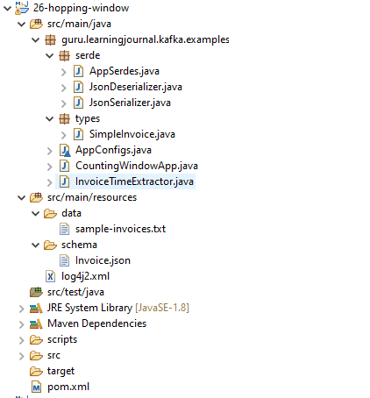

**CountingWindowApp.java**

import guru.learningjournal.kafka.examples.serde.AppSerdes;

import guru.learningjournal.kafka.examples.types.SimpleInvoice;

import org.apache.kafka.streams.KafkaStreams;

import org.apache.kafka.streams.StreamsBuilder;

import org.apache.kafka.streams.StreamsConfig;

import org.apache.kafka.streams.kstream.*;

import org.apache.logging.log4j.LogManager;

import org.apache.logging.log4j.Logger;

import java.time.Duration;

import java.time.Instant;

import java.time.ZoneOffset;

import java.util.Properties;

public class CountingWindowApp {

private static final Logger logger = LogManager.getLogger();

public static void main(String[] args) {

Properties props = new Properties();

props.put(StreamsConfig.APPLICATION_ID_CONFIG, AppConfigs.applicationID);

props.put(StreamsConfig.BOOTSTRAP_SERVERS_CONFIG, AppConfigs.bootstrapServers);

props.put(StreamsConfig.STATE_DIR_CONFIG, AppConfigs.stateStoreName);

//props.put(StreamsConfig.COMMIT_INTERVAL_MS_CONFIG, 0);

StreamsBuilder streamsBuilder = new StreamsBuilder();

KStream<String, SimpleInvoice> KS0 = streamsBuilder.stream(AppConfigs.posTopicName,

Consumed.with(AppSerdes.String(), AppSerdes.SimpleInvoice())

.withTimestampExtractor(new InvoiceTimeExtractor())

);

KTable<Windowed<String>, Long> KT0 =

KS0.groupByKey( Grouped.with( AppSerdes.String(), AppSerdes.SimpleInvoice() ) )

.windowedBy( TimeWindows.of( Duration.ofMinutes(5))

.advanceBy( Duration.ofMinutes(1) ) )

.count();

KT0.toStream().foreach(

(wKey, value) -> logger.info(

"Store ID: " + wKey.key() + " Window ID: " + wKey.window().hashCode() +

" Window start: " + Instant.ofEpochMilli(wKey.window().start())

.atOffset(ZoneOffset.UTC) +

" Window end: " + Instant.ofEpochMilli(wKey.window().end())

.atOffset(ZoneOffset.UTC) +

" Count: " + value

)

);

KafkaStreams streams = new KafkaStreams(streamsBuilder.build(), props);

streams.start();

Runtime.getRuntime().addShutdownHook(new Thread(() -> {

logger.info("Stopping Streams");

streams.close();

}));

}

}

**InvoiceTimeExtractor.java**

import guru.learningjournal.kafka.examples.types.SimpleInvoice;

import org.apache.kafka.clients.consumer.ConsumerRecord;

import org.apache.kafka.streams.processor.TimestampExtractor;

import java.time.Instant;

public class InvoiceTimeExtractor implements TimestampExtractor {

@Override

public long extract(ConsumerRecord<Object, Object> consumerRecord, long prevTime) {

SimpleInvoice invoice = (SimpleInvoice) consumerRecord.value();

long eventTime = Instant.parse(invoice.getCreatedTime()).toEpochMilli();

return ((eventTime>0) ? eventTime : prevTime);

}

}

**AppSerdes.java**

public class AppSerdes extends Serdes {

static final class PosInvoiceSerde extends WrapperSerde<SimpleInvoice> {

PosInvoiceSerde() {

super(new JsonSerializer<>(), new JsonDeserializer<>());

}

}

public static Serde<SimpleInvoice> SimpleInvoice() {

PosInvoiceSerde serde = new PosInvoiceSerde();

Map<String, Object> serdeConfigs = new HashMap<>();

serdeConfigs.put(JsonDeserializer.VALUE_CLASS_NAME_CONFIG, SimpleInvoice.class);

serde.configure(serdeConfigs, false);

return serde;

}

}

**JsonDeserializer.java**

import com.fasterxml.jackson.databind.ObjectMapper;

import org.apache.kafka.common.errors.SerializationException;

import org.apache.kafka.common.serialization.Deserializer;

import java.util.Map;

public class JsonDeserializer<T> implements Deserializer<T> {

private ObjectMapper objectMapper = new ObjectMapper();

private Class<T> className;

public static final String KEY_CLASS_NAME_CONFIG = "key.class.name";

public static final String VALUE_CLASS_NAME_CONFIG = "value.class.name";

public JsonDeserializer() { }

@SuppressWarnings("unchecked")

@Override

public void configure(Map<String, ?> props, boolean isKey) {

if (isKey)

className = (Class<T>) props.get(KEY_CLASS_NAME_CONFIG);

else

className = (Class<T>) props.get(VALUE_CLASS_NAME_CONFIG);

}

@Override

public T deserialize(String topic, byte[] data) {

if (data == null) {

return null;

}

try {

return objectMapper.readValue(data, className);

} catch (Exception e) {

throw new SerializationException(e);

}

}

@Override

public void close() {

//nothing to close

}

}

**JsonSerializer.java**

import com.fasterxml.jackson.databind.ObjectMapper;

import org.apache.kafka.common.errors.SerializationException;

import org.apache.kafka.common.serialization.Serializer;

import java.util.Map;

public class JsonSerializer<T> implements Serializer<T> {

private final ObjectMapper objectMapper = new ObjectMapper();

public JsonSerializer() { }

@Override

public void configure(Map<String, ?> config, boolean isKey) {

//Nothing to Configure

}

@Override

public byte[] serialize(String topic, T data) {

if (data == null) {

return null;

}

try {

return objectMapper.writeValueAsBytes(data);

} catch (Exception e) {

throw new SerializationException("Error serializing JSON message", e);

}

}

@Override

public void close() { }

}

**sample-invoices.txt**

STR1534:{"InvoiceNumber": 101,"CreatedTime": "2019-02-05T10:00:10.00Z","StoreID": "STR1534","TotalAmount": 1920}

STR1534:{"InvoiceNumber": 103,"CreatedTime": "2019-02-05T10:01:11.00Z","StoreID": "STR1534","TotalAmount": 2400}

STR1534:{"InvoiceNumber": 106,"CreatedTime": "2019-02-05T10:04:12.00Z","StoreID": "STR1534","TotalAmount": 9365}

STR1534:{"InvoiceNumber": 107,"CreatedTime": "2019-02-05T10:07:11.00Z","StoreID": "STR1534","TotalAmount": 5276}

**Invoice.json**

{

"type": "object",

"javaType": "guru.learningjournal.kafka.examples.types.SimpleInvoice",

"properties": {

"InvoiceNumber": {

"type": "string"

},

"CreatedTime": {

"type": "string"

},

"StoreID": {

"type": "string"

},

"TotalAmount": {

"type": "number"

}

}

}

**pom.xml**

<?xml version="1.0" encoding="UTF-8"?>

<project xmlns="http://maven.apache.org/POM/4.0.0"

xmlns:xsi="http://www.w3.org/2001/XMLSchema-instance"

xsi:schemaLocation="http://maven.apache.org/POM/4.0.0 http://maven.apache.org/xsd/maven-4.0.0.xsd">

<modelVersion>4.0.0</modelVersion>

<groupId>guru.learningjournal.kafka.examples</groupId>

<artifactId>window-grace</artifactId>

<version>2.3.0</version>

<properties>

<java.version>1.8</java.version>

<kafka.version>2.3.0</kafka.version>

<project.build.sourceEncoding>UTF-8</project.build.sourceEncoding>

</properties>

<build>

<plugins>

<!-- Maven Compiler Plugin-->

<plugin>

<groupId>org.apache.maven.plugins</groupId>

<artifactId>maven-compiler-plugin</artifactId>

<version>3.8.0</version>

<configuration>

<source>${java.version}</source>

<target>${java.version}</target>

</configuration>

</plugin>

<!-- Json Schema to POJO plugin-->

<plugin>

<groupId>org.jsonschema2pojo</groupId>

<artifactId>jsonschema2pojo-maven-plugin</artifactId>

<version>0.5.1</version>

<executions>

<execution>

<goals>

<goal>generate</goal>

</goals>

<configuration>

<sourceDirectory>

${project.basedir}/src/main/resources/schema/

</sourceDirectory>

<outputDirectory>${project.basedir}/src/main/java/</outputDirectory>

<includeAdditionalProperties>false</includeAdditionalProperties>

<includeHashcodeAndEquals>false</includeHashcodeAndEquals>

<generateBuilders>true</generateBuilders>

</configuration>

</execution>

</executions>

</plugin>

</plugins>

</build>

<dependencies>

<!--Apache commons-->

<dependency>

<groupId>commons-lang</groupId>

<artifactId>commons-lang</artifactId>

<version>2.6</version>

</dependency>

<!-- Apache Kafka Streams-->

<dependency>

<groupId>org.apache.kafka</groupId>

<artifactId>kafka-streams</artifactId>

<version>${kafka.version}</version>

</dependency>

<!-- Apache Log4J2 binding for SLF4J -->

<dependency>

<groupId>org.apache.logging.log4j</groupId>

<artifactId>log4j-slf4j-impl</artifactId>

<version>2.11.0</version>

</dependency>

</dependencies>

</project>

### Session Windows

We learned to create time-based windows. In this session, I will talk about the session windows. So, Let's start. What is a session?



A session is a period of activity followed by a defined gap of inactivity. For that reason, session windows are represented by a period of activity rather than being a fixed size time based window.





Let`s try to understand with an example. Let us assume that you modified your website to capture user click events. So, you catch the user clicks and send it to your server. Your click events are JSON messages, as shown here. Great! Now you planned to stream these events to your Kafka cluster.

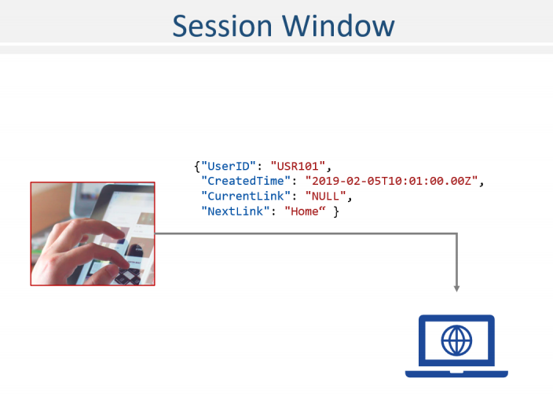

You wanted all the events for the same user to flow to a designated partition, and hence you implement UserID as a message key. A continuous flow of click events is often known as clickstream.

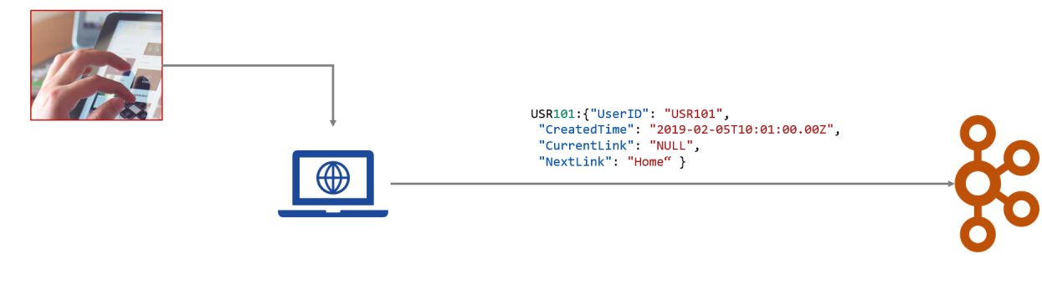

Here is a sample list of such a clickstream. All the events are for Feb 05, 2019, which I have normalized to minutes for simplicity. The first event is for USR101, and it is raised at 10:01. The second event is for USR102 that is raised at 10:02 and so on. Â Let me highlight this one event, which was created at 10:07. However, for some reason, it arrived a bit late to Kafka after we received an event for 10:10. Now, for the given sample clickstream, we want to count the number of clicks per user session, a kind of user visit.

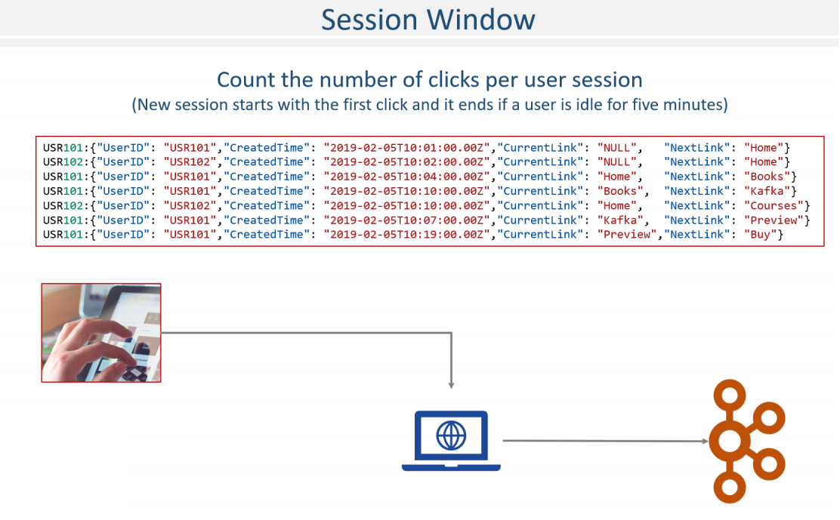

Great! Think about it. Do you see a problem? Let me highlight the problem in this statement count the number of clicks per user session How do we define a user session? We can make some assumptions such as a new session starts with the first click, and it ends if a user is idle I mean, he is not clicking any link for five minutes. Right? Looks fair? With this definition of an event and the session, let's try to compute the user clicks per visit. Same as earlier, I got you a starter project with some boilerplate code. Like any other Kafka Streams application, we start with creating a StreamBuilder and open a stream to the topic.

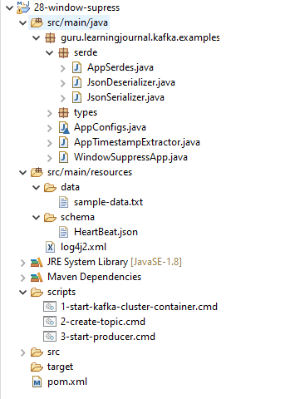

We wanted to use event time schematics, and hence we consume the records with a custom timestamp extractor. You already learned all this in the earlier example. Right? What is the next step? We must group our stream. Right? Kafka records are already coming with an appropriate key, so we group our data using the groupByKey() method. Great! Now we are ready to create a session window. Creating a session window is as straightforward as creating a tumbling window. So, the same as the tumbling window, we use the windowedBy() method. Then, instead of TimeWindows, we will be describing our window using SessionWindows and set the duration to 5 minutes. But remember, for a session window, the duration is to define the idle time or inactivity time. Right? Finally, we count() the messages in each window.

**WindowSuppressApp.java**

import guru.learningjournal.kafka.examples.serde.AppSerdes;

import guru.learningjournal.kafka.examples.types.HeartBeat;

import org.apache.kafka.streams.KafkaStreams;

import org.apache.kafka.streams.StreamsBuilder;

import org.apache.kafka.streams.StreamsConfig;

import org.apache.kafka.streams.kstream.*;

import org.apache.logging.log4j.LogManager;

import org.apache.logging.log4j.Logger;

import java.time.Duration;

import java.time.Instant;

import java.time.ZoneOffset;

import java.util.Properties;

public class WindowSuppressApp {

private static final Logger logger = LogManager.getLogger();

public static void main(String[] args) {

Properties props = new Properties();

props.put(StreamsConfig.APPLICATION_ID_CONFIG, AppConfigs.applicationID);

props.put(StreamsConfig.BOOTSTRAP_SERVERS_CONFIG, AppConfigs.bootstrapServers);

props.put(StreamsConfig.STATE_DIR_CONFIG, AppConfigs.stateStoreName);

props.put(StreamsConfig.COMMIT_INTERVAL_MS_CONFIG, 0);

StreamsBuilder streamsBuilder = new StreamsBuilder();

KStream<String, HeartBeat> KS0 = streamsBuilder.stream(AppConfigs.topicName,

Consumed.with(AppSerdes.String(), AppSerdes.HeartBeat())

.withTimestampExtractor(new AppTimestampExtractor())

);

KTable<Windowed<String>, Long> KT01 =

KS0.groupByKey( Grouped.with( AppSerdes.String(), AppSerdes.HeartBeat() ) )

.windowedBy(TimeWindows.of(Duration.ofSeconds(60))

.grace(Duration.ofSeconds(10)))

.count()

.suppress(Suppressed.untilWindowCloses(Suppressed.BufferConfig.unbounded()));

KT01.toStream().foreach(

(wKey, value) -> logger.info(

"App ID: " + wKey.key() + " Window ID: " + wKey.window().hashCode()

+ " Window start: " + Instant.ofEpochMilli(wKey.window().start())

.atOffset(ZoneOffset.UTC) +

" Window end: " + Instant.ofEpochMilli(wKey.window().end())

.atOffset(ZoneOffset.UTC) +

" Count: " + value +

(value>2? " Application is Alive" :

" Application Failed - Sending Alert Email...")

)

);

logger.info("Starting Stream...");

KafkaStreams streams = new KafkaStreams(streamsBuilder.build(), props);

streams.start();

Runtime.getRuntime().addShutdownHook(new Thread(() -> {

logger.info("Stopping Streams...");

streams.close();

}));

}

}

Do you want to execute it? Let's start the Kafka Cluster container. Create a topic. Start the producer. Start the application and send the first five messages. Okay! So, here is the outcome.

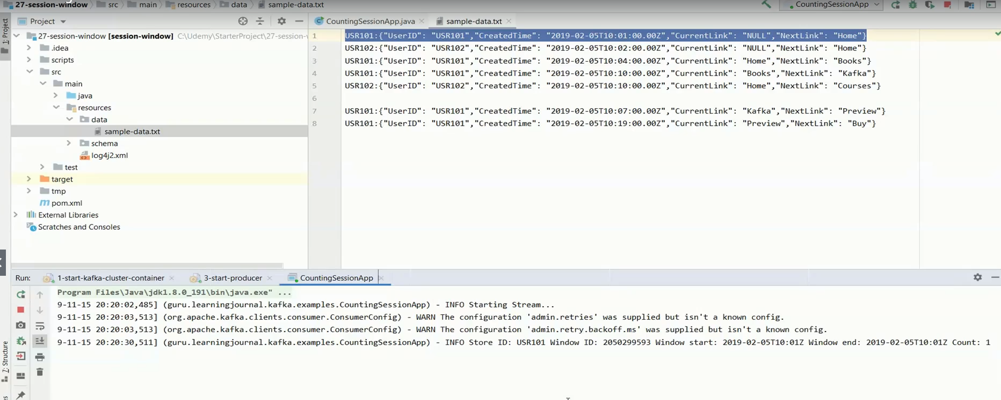

Let me explain what exactly happened. We already know that the session window is not a fixed time window. These windows could be as long as the session is active. So the window size could be one minute, two minutes, or maybe an hour long. And it could be as short as one millisecond because you got only one message in the session. Right? Also, since they are not fixed-size windows, they are not normalized to the epoch. Great! Now, let's see what happened in our example.

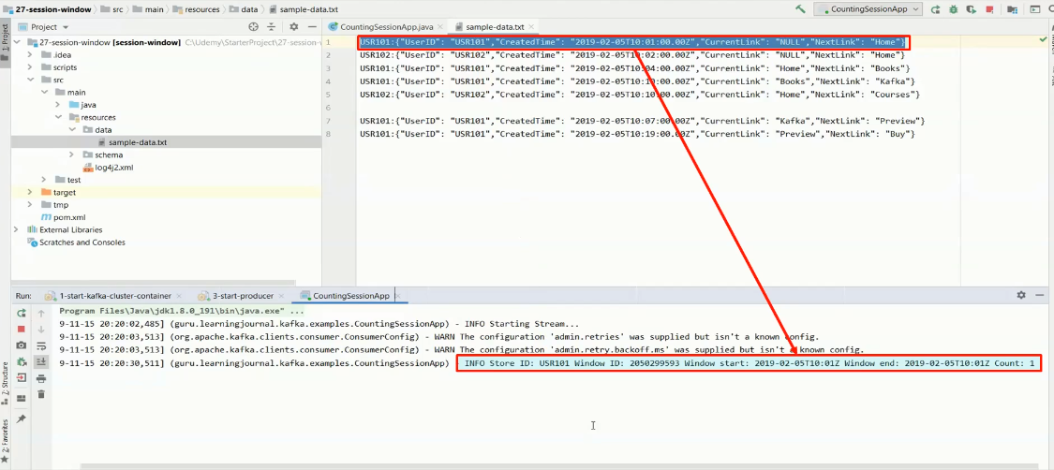

When Kafka receives a new message, it will start a new session window for the key. The window start time will be the same as the event time. Right? So, we have this the first window for USR101, which starts at 10:01. Why? Because the first message event time is 10:01. However, when we received the first message, we do not know how long this session is going to last. So, the Kafka assumes that the window ends at the same time. And hence, the window end time is also the same for the first message.

The next message for USR101 arrives at 10:04, which is within the five minutes idle time boundary from the window end time. Right? So, Kafka would extend the first window and include a new record into the same window. Extending a session window is to delete and recreate operation. Every time Kafka needs to extend or revise the session window, the old session record is removed, and a new session window is established. Deleting the old session is as simple as setting the value as NULL. That's how records in a KTable are deleted. Right? You already learned that. Kafka does all this automatically, and hence, you see this same window being set to null and a new window created for the user101. Now the new record represents the current session for user 101. Session window start time remains the same as 10:01.

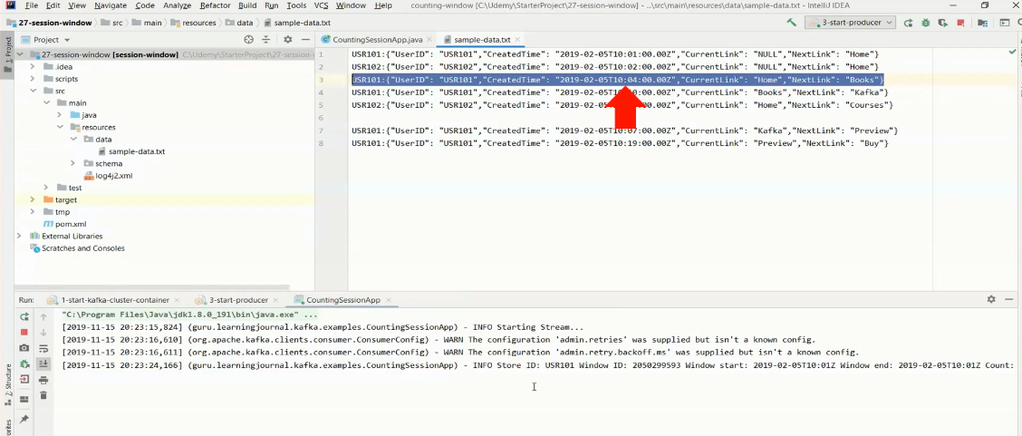

However, the session window end time would extend to the timestamp of the most recent record, i.e., 10:04. And the count is also updated as two. Right?

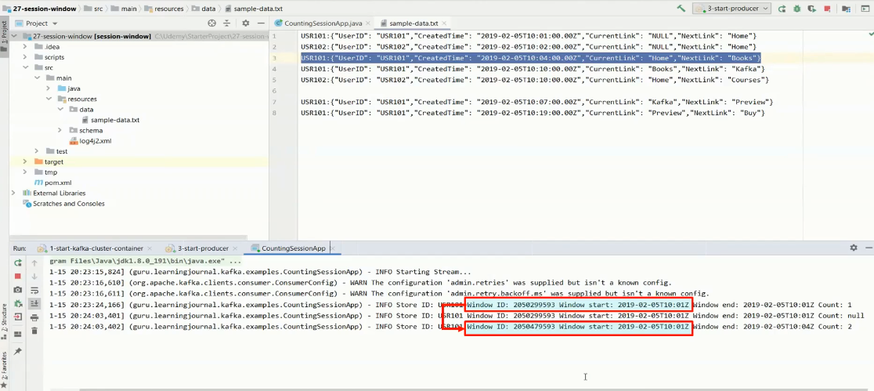

Now, if you look at the session for user101, the next record should also belong to the same window if it arrives within five minutes of the session end time i.e., 10:04. However, the next record came with a timestamp of 10:10, which is beyond five minutes of idle time since 10:04. Right?

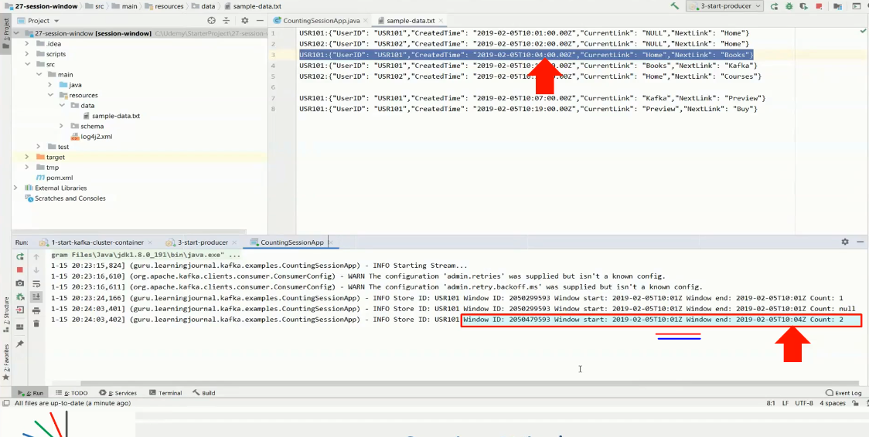

Hence, Kafka would create a new session starting at 10:10. We haven't received any other message for USR101, so the second session ends at 10:10.

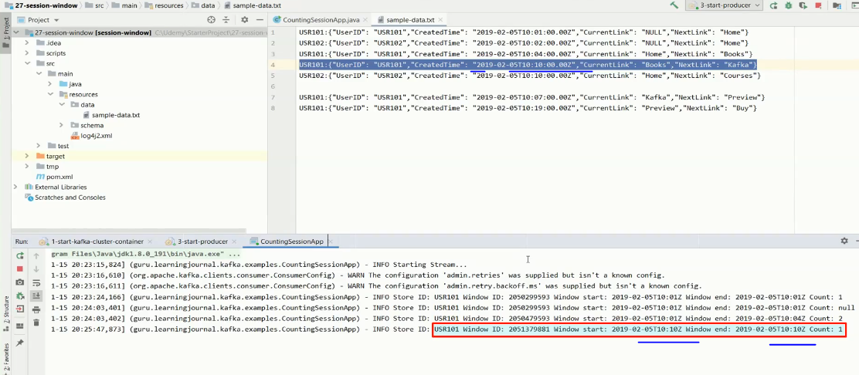

A similar approach is applied for USR102, and we get two windows because the difference between the two messages is more than five minutes. Now you can send the remaining two messages from the sample stream and expect a revised window structure for USE101.

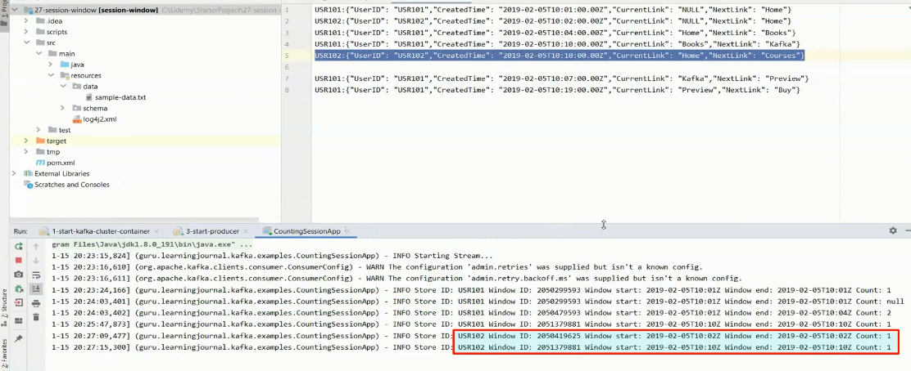

The next message is timestamped at 10:07. This message came late and arrived after the message that was timestamped at 10:10. Right?

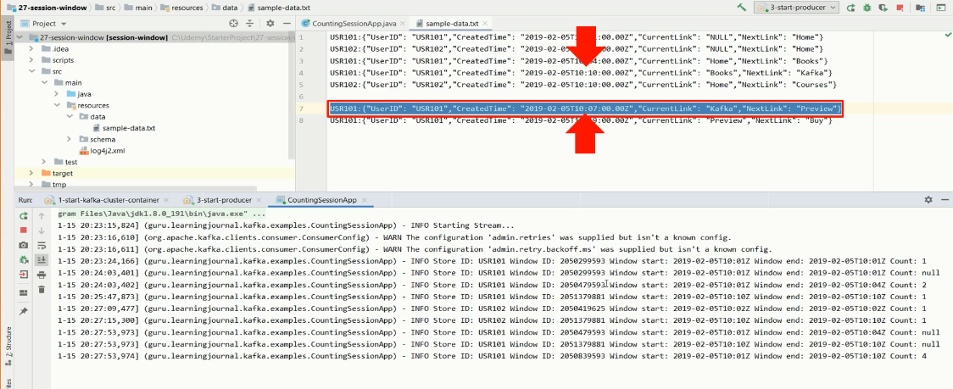

However, this message should have been part of the first window that ended at 10:04 because the timestamp 10:07 falls within the five minutes of idle time since 10:04. So, Kafka would again extend the appropriate window. Now the end time of the first session window should be 10:07.

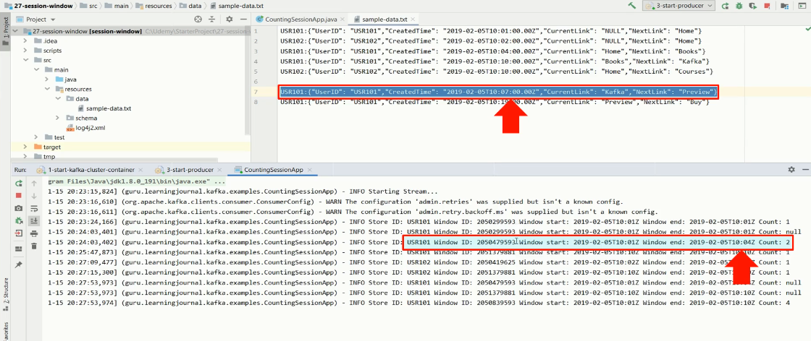

Why? Because that's what is the latest message timestamp is, Right? But look at the next window for user101.

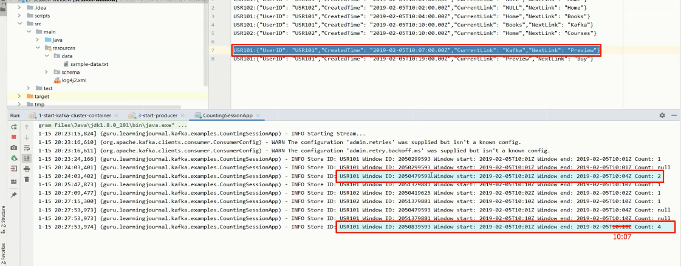

This one is at 10:10. What does it mean? That means a late-arriving record has also invalidated the next window of 10:10. The record arriving at 10:10 should also be part of the first window because the timestamp is within five minutes of the timestamp 10:07. But nothing to worry. Kafka will merge these two windows.

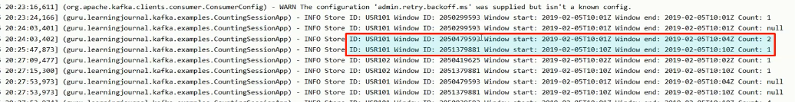

We already learned that merging or extending sessions is delete and recreate operation. That is why you see these two nullified records.

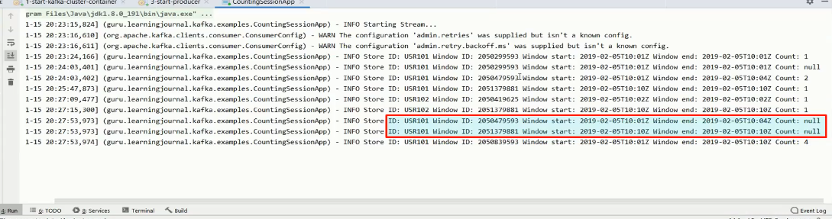

So, what do we have as the final result? Let's look at the user101 sessions. This first session is nullified later. So, we don't consider it. The next one is also nullified. The same thing happens to the next one. So, we are left with these two sessions for user101. So, user101 has got two visits. In his first visit, he clicked four links. In his second visit, he clicked only one link. Make sense?

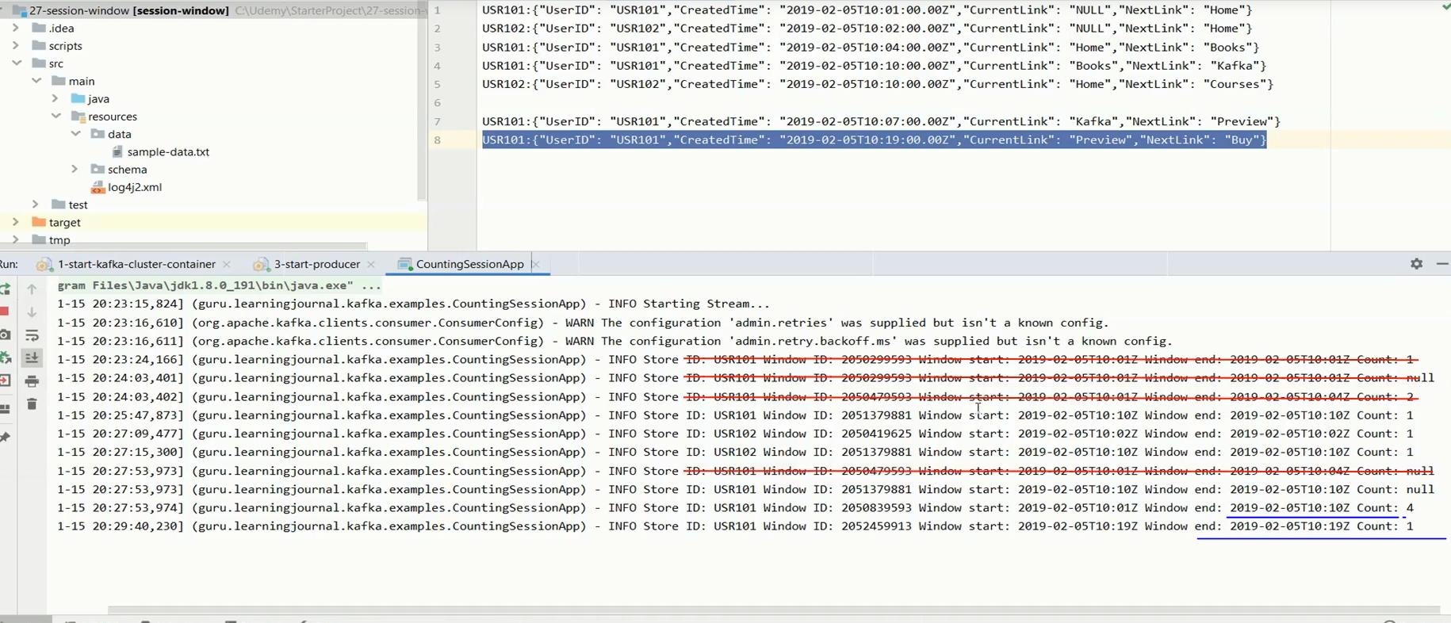

Great!

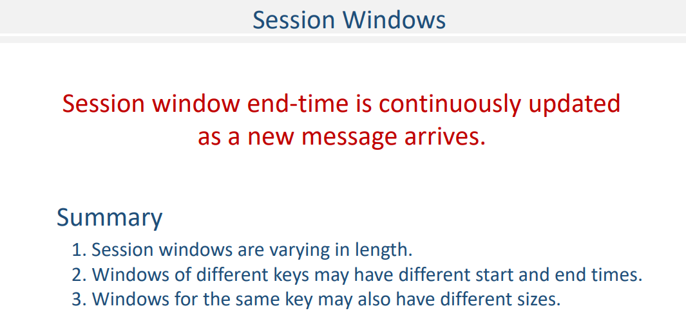

Just to summarize, session windows are different from the other window types in the following respect. Session windows are varying in length. Windows of different keys typically have different start and end times. Even the windows for the same key usually have different sizes. The prime area of application for session windows is user behavior analysis.

## Joining Streams and Tables

### Streaming Joins



We learned about windowing. In this section, we will focus on the Joins. So, Let's start. Joins are one of the most common and desirable features of any data system. You might be working with a batch system or a real-time system. In both cases, at some point, you would need to join two data sets.

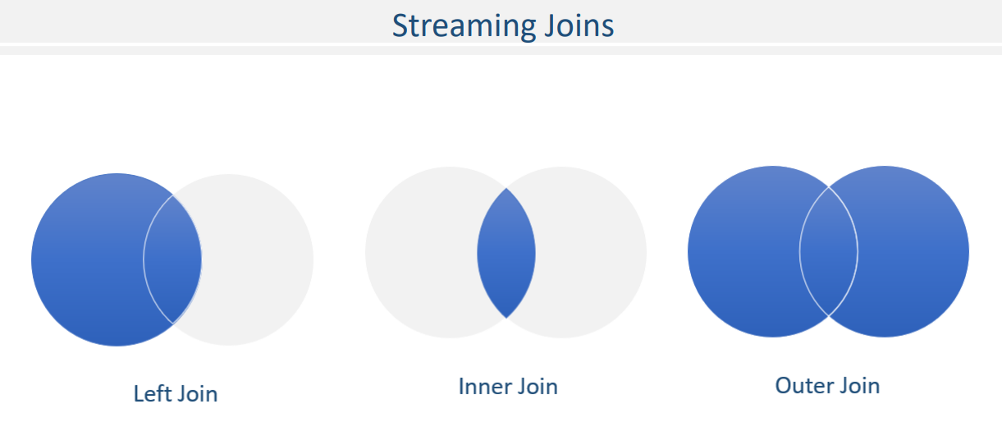

In the Kafka Streams framework, your datasets are abstracted into two categories. KStream KTable and GlobalKTable Hence, you would expect the capability to join a combination of these two types of datasets.

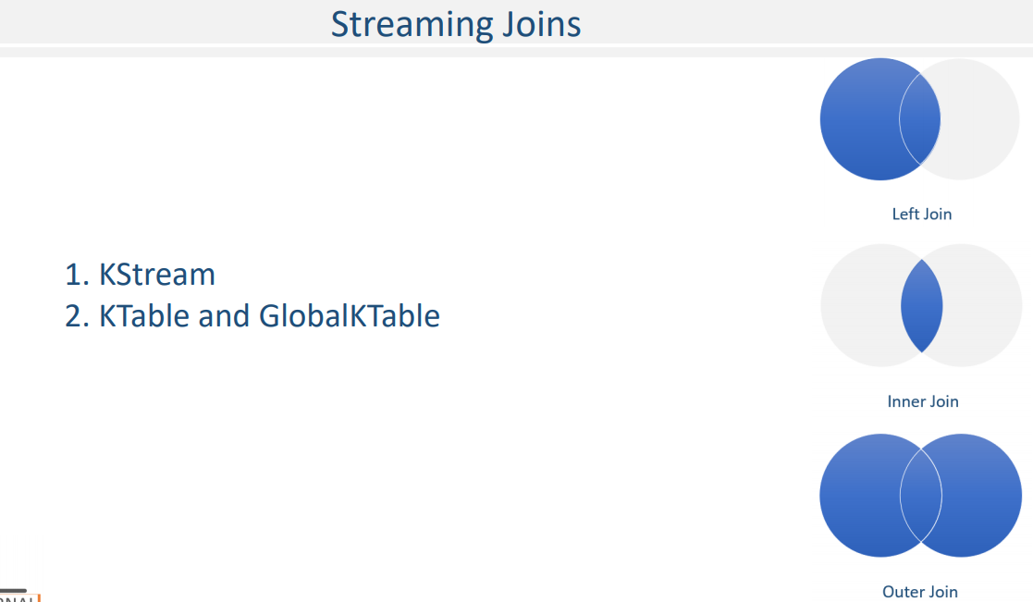

Kafka streams API supports following join operations.

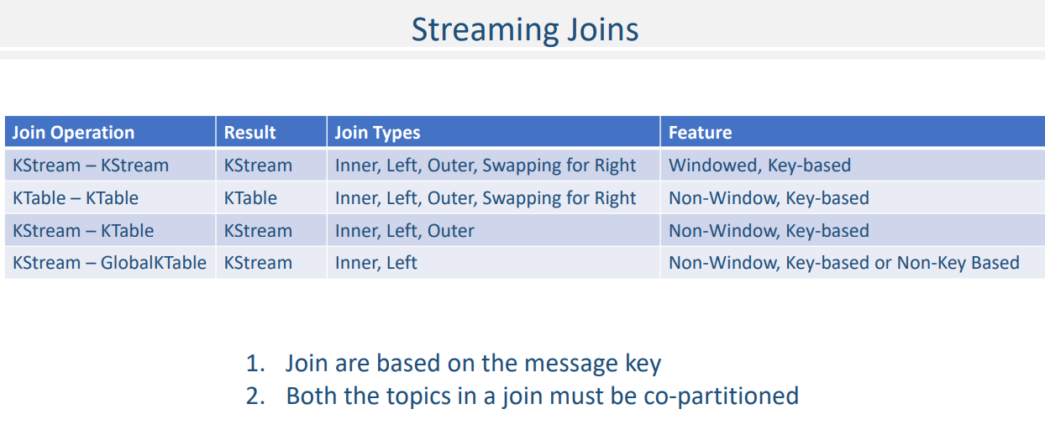

Before we learn the mechanics of these four types of joins, it is essential to list down some preconditions and limitations for joining two datasets in Kafka. Like any other system, joins in Kafka are performed over record keys. Hence, your KStream or KTable must have a valid key. If you don't have a key, If you don't have a key, or the key is null, you cannot perform a join. There is only one exception, and that is GlobalKtable. Non-Key based joins are allowed with KStream-GlobalKTable joins. All other joins are only key-based joins. The input topics of the join left side and right side must have the same number of partitions. And data on both the topics must be co-partitioned. That means all applications that write to the input topics must have the same partitioning strategy so that records with the same key are delivered to the same partition number. If the inputs of a join are not co-partitioned yet, you must ensure this manually by rewriting the data into a new topic that has the same number of partitions and uses the same partitioner. This is a mandatory requirement for parallel processing in Kafka.

There is only one exception to this rule, and that is GlobalKTable. Co-partitioning is not compulsory for KStream-GlobalKTable joins, and that's obvious because all partitions of the GlobalKTable are made available to each instance, i.e., each streams task has a full copy of the GlobalKTable, right? Hence, co-partitioning is not needed for joining GlobalKTable. As listed in the table, Inner joins and left outer joins are supported everywhere. But you must remember that the Kafka does not have a method for implementing right-outer join. However, you can easily perform right-outer join by swapping left and right-side datasets.

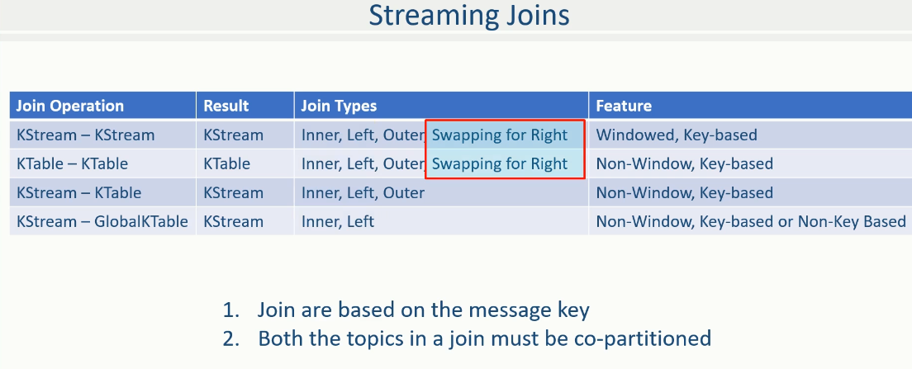

This swapping is only allowed with KStream–KStream, and KTable –KTable joins. In other cases, such as KStream-KTable and KStream-GlobalKTable, the stream, I mean the KStream must be on the left side of the join. So, the right-outer join is not possible in these two cases because you cannot swap the orders.

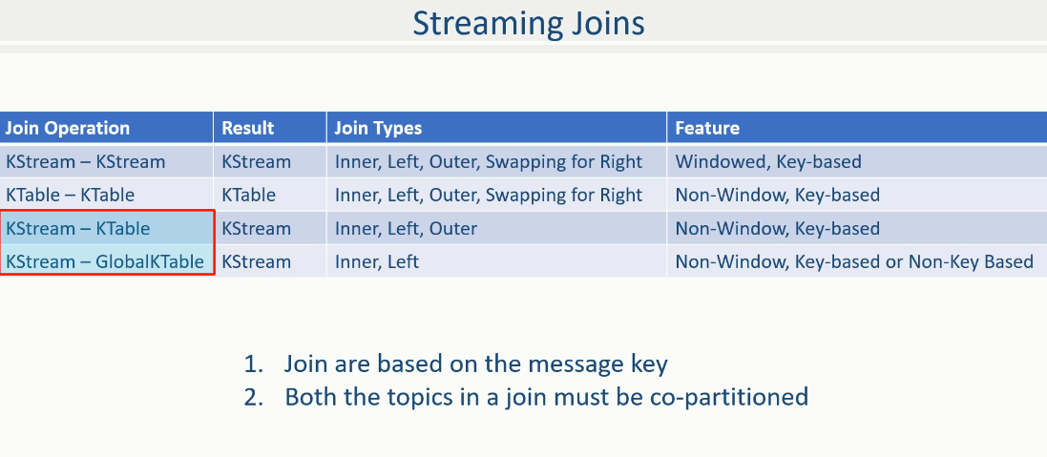

Finally, full-outer joins are available for the first three cases. However, it is not allowed with the GlobalKTable.

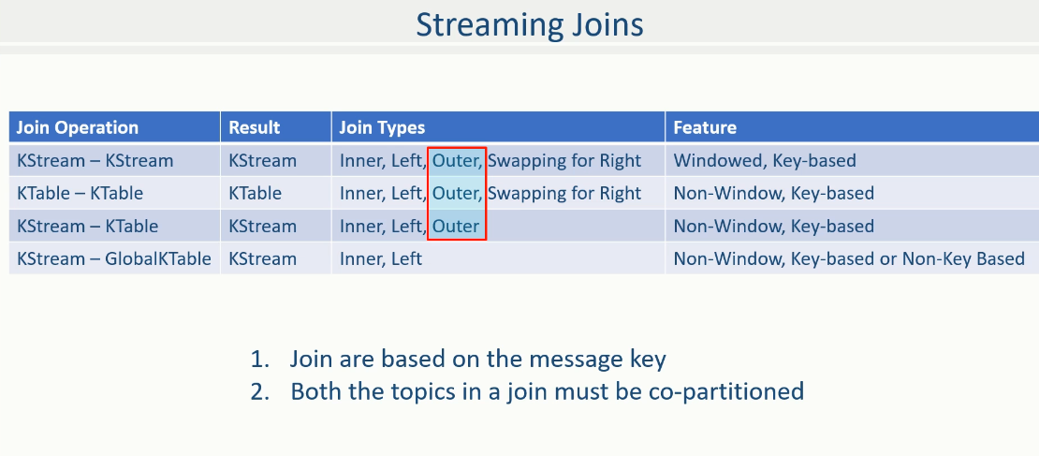

I have also listed the outcome of the join operations. For example, when you join a Kstream to another KStream, the result of the join is going to be a new KStream.

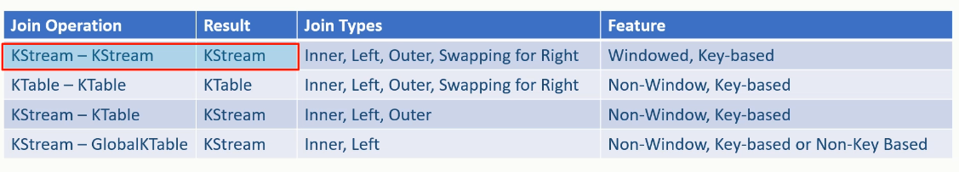

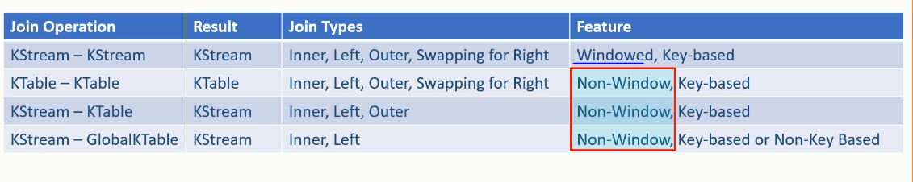

Similarly, other outcome types are listed here. Finally, the KStream to KStream join must be a windowed join, and all others are always non-windowed joins. We will learn all this with appropriate examples, so if you still have some doubts about the joins, hold on until we create examples in the following lectures. Great! That's all for the introduction to joins.

### Joining a KStream to another Kstream

In this lecture, we are going to learn the mechanics of implementing KStream to KStream joins. So, let's start. KStream is an infinite, unbounded stream of records. Right? So, if you try to join two endless streams, sooner or later, you will end up consuming all your resources and crash your system. Hence KStream-KStream joins are always windowed joins, and non-windowed joins are not permitted.

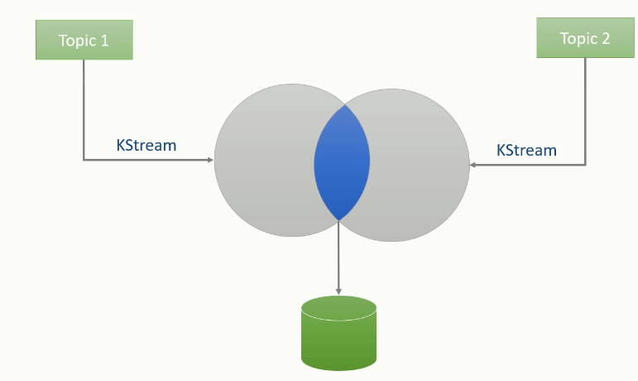 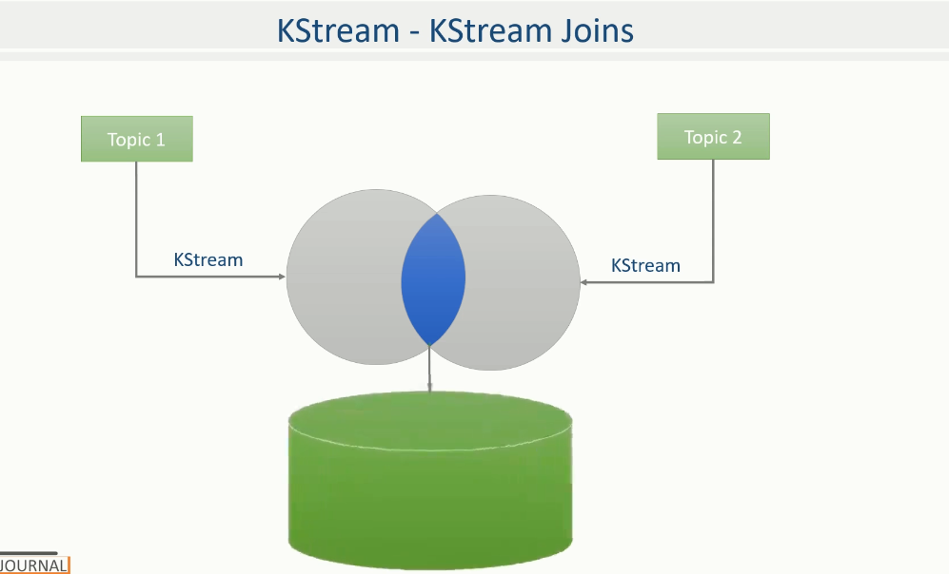

When joining two streams, you must specify a boundary condition using a JoinWindow. We want to take a problem solution approach, so let's define a simple problem to learn the mechanics of implementing streaming joins. You want to pay bills for your Internet provider let's name it as iNet that gives you an option to pay using your mobile wallet let's call it the mWallet You log-into the iNet application and select the mWallet option to initiate the bill payment.

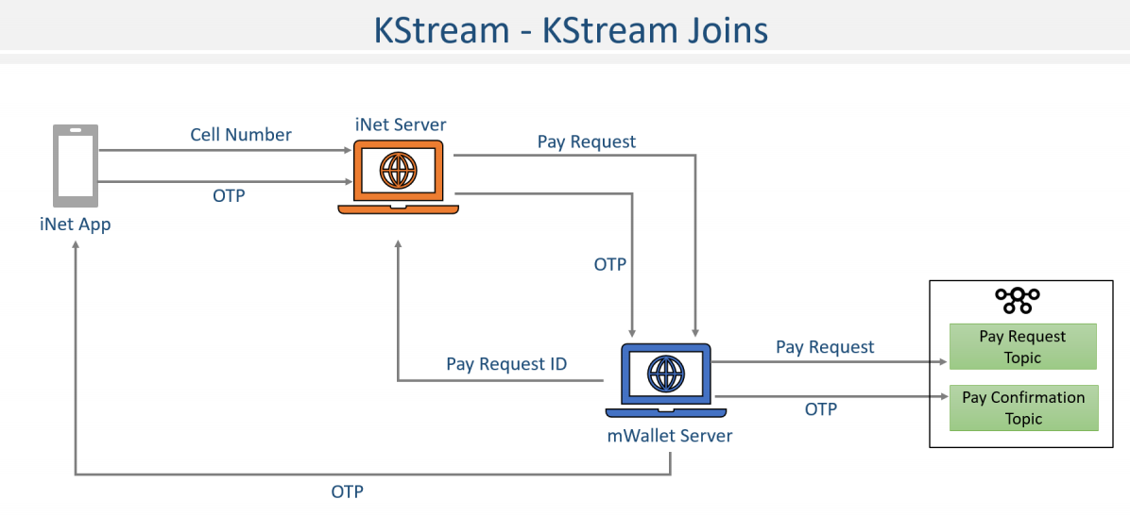

The iNet would ask for your linked mobile number. Once you supply your cell number, the iNet would call the mWallet payment API. The mWallet payment API implement Apache Kafka based system, and for each payment request, it performs the following actions.

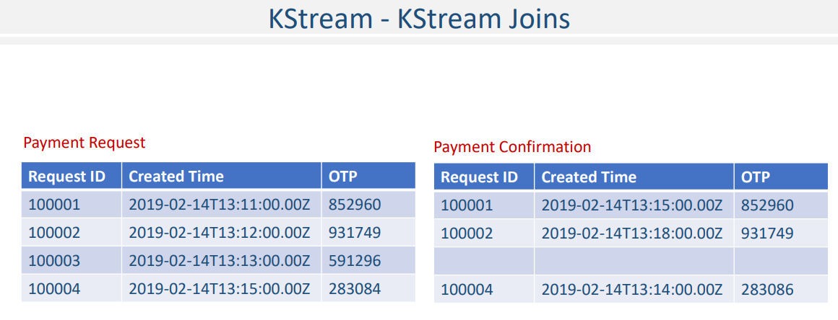

On receiving requests from iNet, The mWallet initiates a transaction and sends the transaction event to the Kafka cluster. Here is a sample payment transaction event.

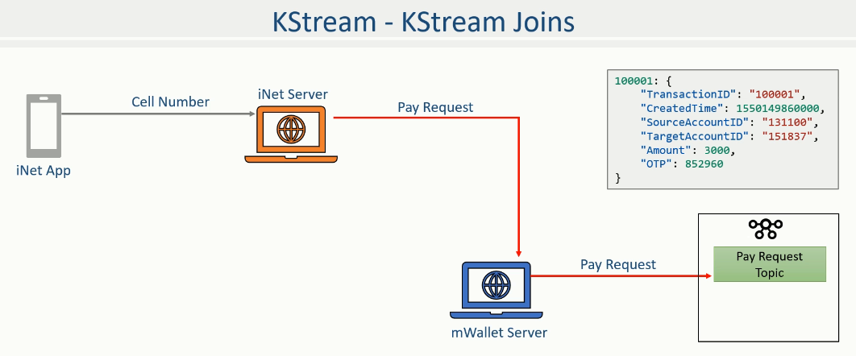

The mWallet will also send the transaction OTP to you. This OTP is valid for five minutes. Finally, the mWallet would respond back to iNet with a transaction ID.

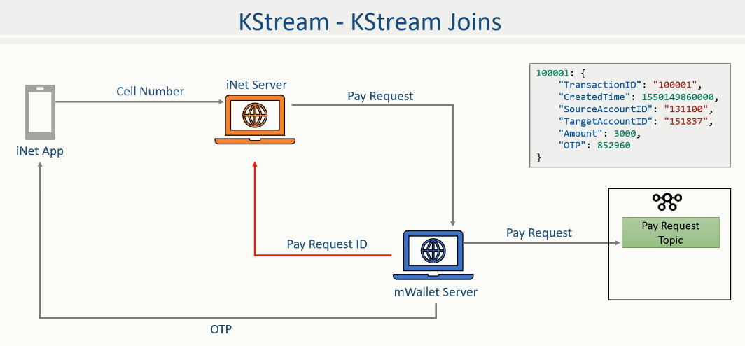

Now, the iNet would wait for you to enter the OTP. When you supply the OTP, the iNet again calls the mWallet with the TransactionID and OTP. This second call would generate a new event, as shown here. The second event comes to mWallet and is pushed to Kafka.

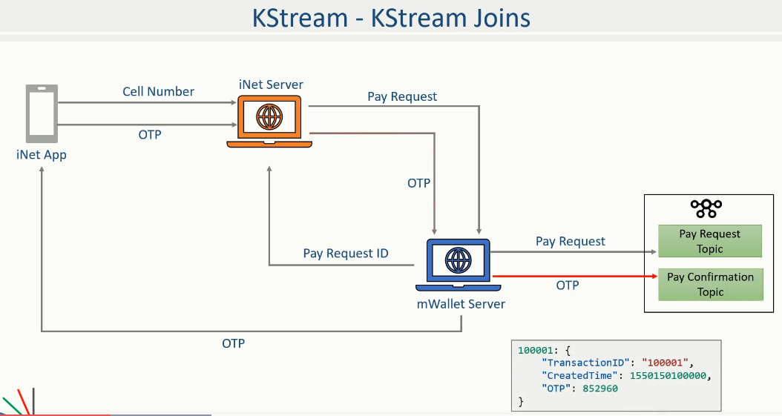

Now you need to write a streams-application that joins these two streams and validates the OTP. For the sake of simplicity, you can print the validation outcome on the console. Since the OTP is valid only for five minutes, this requirement makes an excellent use case for stream-stream join using a five-minute join window. Great! The problem is defined. Let's talk about the solution. Same as earlier, I got you a starter project with all the boilerplate code.

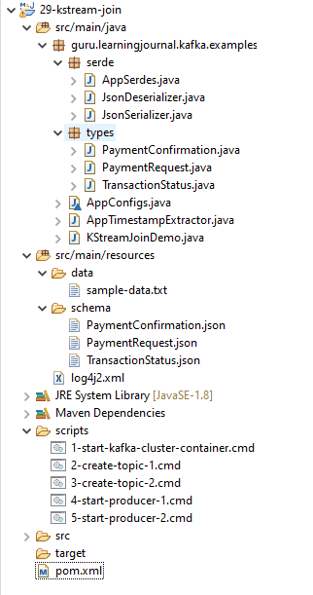

We need two schemas for this example. These schema definitions are obvious and are already mentioned in the problem description. The payment request and payment confirmation. Right? So these two schemas are for those two types of messages.

**PaymentConfirmation.json**

{

"type": "object",

"javaType": "guru.learningjournal.kafka.examples.types.PaymentConfirmation",

"properties": {

"TransactionID": {

"type": "string"

},

"CreatedTime": {

"type": "string"

},

"OTP": {

"type": "string"

}

}

}

**PaymentRequest.json**

{

"type": "object",

"javaType": "guru.learningjournal.kafka.examples.types.PaymentRequest",

"properties": {

"TransactionID": {

"type": "string"

},

"CreatedTime": {

"type": "string"

},

"SourceAccountID": {

"type": "string"

},

"TargetAccountID": {

"type": "string"

},

"Amount": {

"type": "number"

},

"OTP": {

"type": "string"

}

}

}

Both of these messages should go into two different topics, and hence, I have got two scripts to create both the topics. We also have two autogenerated class definitions for the two schemas.

**TransactionStatus.json**

{

"type": "object",

"javaType": "guru.learningjournal.kafka.examples.types.TransactionStatus",

"properties": {

"TransactionID": {

"type": "string"

},

"Status": {

"type": "string"

}

}

}

We also have other usual things, such as JSON Serializers, AppSerdes, AppConfigs, and a custom timestamp extractor. You have already learned all this. I have also added a class with the main() method and some boilerplate code. The code here is straightforward.

**KStreamJoinDemo.java**

import guru.learningjournal.kafka.examples.serde.AppSerdes;

import guru.learningjournal.kafka.examples.types.PaymentConfirmation;

import guru.learningjournal.kafka.examples.types.PaymentRequest;

import guru.learningjournal.kafka.examples.types.TransactionStatus;

import org.apache.kafka.streams.KafkaStreams;

import org.apache.kafka.streams.StreamsBuilder;

import org.apache.kafka.streams.StreamsConfig;

import org.apache.kafka.streams.kstream.*;

import org.apache.logging.log4j.LogManager;

import org.apache.logging.log4j.Logger;

import java.time.Duration;

import java.util.Properties;

public class KStreamJoinDemo {

private static final Logger logger = LogManager.getLogger();

public static void main(String[] args) {

Properties props = new Properties();

props.put(StreamsConfig.APPLICATION_ID_CONFIG, AppConfigs.applicationID);

props.put(StreamsConfig.BOOTSTRAP_SERVERS_CONFIG, AppConfigs.bootstrapServers);

props.put(StreamsConfig.STATE_DIR_CONFIG, AppConfigs.stateStoreName);

props.put(StreamsConfig.COMMIT_INTERVAL_MS_CONFIG, 0);

StreamsBuilder streamsBuilder = new StreamsBuilder();

**// Stream 1**

KStream<String, PaymentRequest> KS0 =

streamsBuilder.stream( AppConfigs.paymentRequestTopicName,

Consumed.with( AppSerdes.String(),

AppSerdes.PaymentRequest())

.**withTimestampExtractor**(AppTimestampExtractor.PaymentRequest())

);

**// Stream 2**

KStream<String, PaymentConfirmation> KS1 =

streamsBuilder.stream( AppConfigs.paymentConfirmationTopicName,

Consumed.with( AppSerdes.String(),

AppSerdes.PaymentConfirmation())

.withTimestampExtractor(AppTimestampExtractor.PaymentConfirmation())

);

**// Join**

KS0.join(KS1, (v1, v2) ->

new TransactionStatus()

.withTransactionID(v1.getTransactionID())

.withStatus( (v1.getOTP().equals(v2.getOTP()) ?

"Success" : "Failure") ),

JoinWindows.of(Duration.ofMinutes(5)),

Joined.with( AppSerdes.String(),

AppSerdes.PaymentRequest(),

AppSerdes.PaymentConfirmation() )

).print(Printed.toSysOut());

logger.info("Starting Stream...");

KafkaStreams streams = new KafkaStreams(streamsBuilder.build(), props);

streams.start();

Runtime.getRuntime().addShutdownHook(new Thread(() -> {

logger.info("Stopping Streams...");

streams.close();

}));

}

}

We created StreamBuilder and opened streams from two different Kafka topics. The first stream KS0 reads from a payment request topic where all initial payment requests are published. We also extract the event timestamp using a custom timestamp extractor. Similarly, the second stream KS1 reads from the payment confirmation topic where the conformation events are posted. With these two streams created, we are now ready to join them and compare the OTP to authenticate the transaction. Make sense? Good!

**AppTimestampExtractor.java**

import guru.learningjournal.kafka.examples.types.PaymentConfirmation;

import guru.learningjournal.kafka.examples.types.PaymentRequest;

import org.apache.kafka.clients.consumer.ConsumerRecord;

import org.apache.kafka.streams.processor.TimestampExtractor;

import java.time.Instant;

public class AppTimestampExtractor {

private static final class PaymentRequestTimeExtractor implements TimestampExtractor {

@Override

public long extract(ConsumerRecord<Object, Object> consumerRecord, long prevTime) {

PaymentRequest record = (PaymentRequest) consumerRecord.value();

long eventTime = Instant.parse(record.getCreatedTime()).toEpochMilli();

return ((eventTime > 0) ? eventTime : prevTime);

}

}

public static PaymentRequestTimeExtractor PaymentRequest() {

return new PaymentRequestTimeExtractor();

}

private static final class PaymentConfirmationTimeExtractor

implements TimestampExtractor {

@Override

public long extract(ConsumerRecord<Object, Object> consumerRecord, long prevTime) {

PaymentConfirmation record = (PaymentConfirmation) consumerRecord.value();

long eventTime = Instant.parse(record.getCreatedTime()).toEpochMilli();

return ((eventTime > 0) ? eventTime : prevTime);

}

}

public static PaymentConfirmationTimeExtractor PaymentConfirmation() {

return new PaymentConfirmationTimeExtractor();

}

}

I created both the topics with the same number of partitions. Both types of messages come with TransactionID as a key, and they use the same default partitioner.

StreamsBuilder streamsBuilder = new StreamsBuilder();

**// Stream 1**

KStream<String, PaymentRequest> KS0 =

streamsBuilder.stream( AppConfigs.paymentRequestTopicName,

Consumed.with( AppSerdes.String(),

AppSerdes.PaymentRequest())

.**withTimestampExtractor**(AppTimestampExtractor.PaymentRequest())

);

**// Stream 2**

KStream<String, PaymentConfirmation> KS1 =

streamsBuilder.stream( AppConfigs.paymentConfirmationTopicName,

Consumed.with( AppSerdes.String(),

AppSerdes.PaymentConfirmation())

.withTimestampExtractor(AppTimestampExtractor.PaymentConfirmation())

);

Hence, we already satisfy the co-partitioning requirement for the join, and there is no need to repartition the data. We are good to go and perform the join. Right? Let's do it. Start with the first stream KS0 and join() it with KS1. The join() method takes three mandatory arguments, and the fourth argument is optional. The first argument is obviously the other stream that we want to join. The second argument is a ValueJoiner lambda of the form (v1, v2) where v1 is a record from KS0 (the left side), and the v2 is a record from KS1 ( the right side of the join). The lambda method is triggered by the framework only if the matching record is found. The body of the lambda method is the place where you would create an output record. The join logic and outcome in our example are straightforward. We create a brand new TransactionStatus record as an outcome.

**// Join**

KS0.join(KS1, (v1, v2) ->

new TransactionStatus()

.withTransactionID(v1.getTransactionID())

.withStatus( (v1.getOTP().equals(v2.getOTP()) ?

"Success" : "Failure") ),

JoinWindows.of(Duration.ofMinutes(5)),

Joined.with( AppSerdes.String(),

AppSerdes.PaymentRequest(),

AppSerdes.PaymentConfirmation() )

).print(Printed.toSysOut());

Logic is as simple as we are matching the payment request OTP with the payment confirmation OTP and returning success or failure. The third argument is the JoinWindow that we use to define the duration constraint for the join operation. In the case of our example, if the payment request and payment confirmation records arrive within a five-minute window, the ValueJoiner is triggered, and you will get a transaction status record with success or failure. The success and failure depend upon the OTP matching, and the record is produced only if the ValueJoiner is triggered. What does that mean? This means, if we receive both the records within a five-minute window, we will get a transaction status record.

If any one side of the record is missing or they are not falling within the 5-minute window, ValueJoiner is not triggered, and you won't see a transaction status record. Make Sense? The last argument is to define the required Serdes. The first Serdes is for the common key among the two events. The second and the third Serdes are for the two events. Finally, let's print the transaction status record. Done! The rest of the code is standard.

**sample-data.txt**

100001:{"TransactionID": "100001", "CreatedTime": "2019-02-14T13:11:00.00Z", "SourceAccountID": "131100", "TargetAccountID": "151837", "Amount": 3000, "OTP": 852960}

100002:{"TransactionID": "100002", "CreatedTime": "2019-02-14T13:12:00.00Z", "SourceAccountID": "131200", "TargetAccountID": "151837", "Amount": 2000, "OTP": 931749}

100003:{"TransactionID": "100003", "CreatedTime": "2019-02-14T13:13:00.00Z", "SourceAccountID": "131300", "TargetAccountID": "151837", "Amount": 5000, "OTP": 591296}

100004:{"TransactionID": "100004", "CreatedTime": "2019-02-14T13:15:00.00Z", "SourceAccountID": "131400", "TargetAccountID": "151837", "Amount": 1000, "OTP": 283084}

100001:{"TransactionID": "100001", "CreatedTime": "2019-02-14T13:15:00.00Z", "OTP": 852960}

100002:{"TransactionID": "100002", "CreatedTime": "2019-02-14T13:18:00.00Z", "OTP": 931749}

100004:{"TransactionID": "100004", "CreatedTime": "2019-02-14T13:14:00.00Z", "OTP": 283086}

Do you want to execute and observe the results? Let's do it. Start the Kafka Cluster Container. Create Topics. Start both the producers. Start the application. Let me send some sample payment requests. All the messages are time stamped for Feb 14, 2019, with event time as 13:11, 13:12, 13:13, and 13:15. After sending these messages, the application does not show any outcome in the beginning because there are no matching confirmation records in the other topic yet. Right? Let's throw some confirmation messages. All the confirmation messages are also timestamped for Feb 14, 2019, with event timestamp as 13:15, 13:18, and 13:14. What do we get? We received four payment requests, but only two of them appeared in the outcome.

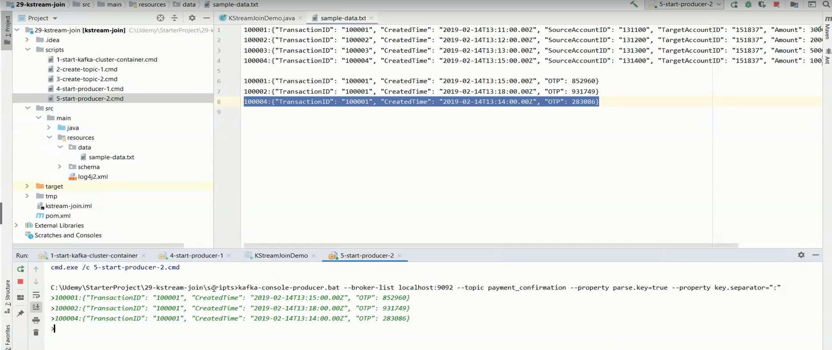

The request 100001 was sent at 13:11 and confirmed at 13:15 with a matching OTP. Hence, it comes as a success. The request 100002 was sent at 13:12 but confirmed outside the five-minute window at 13:18. Hence, the ValueJoiner for that pair didn't trigger, and status does not appear in the outcome.

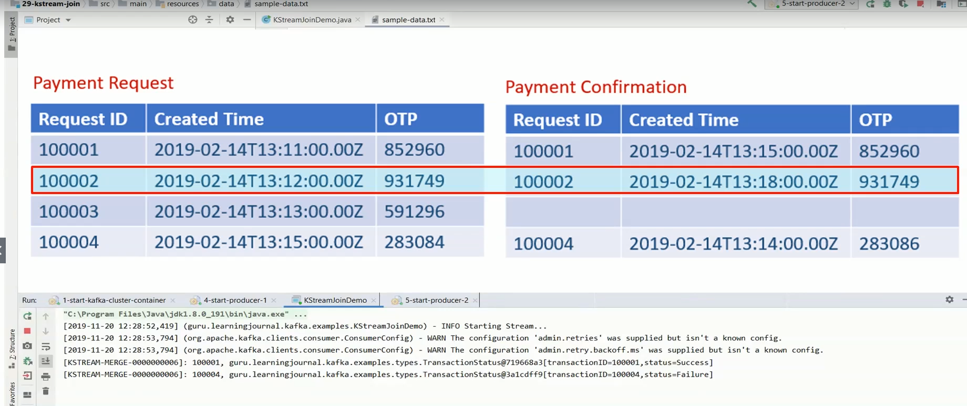

The request 100003 was not confirmed, so that one also doesn't appear in the outcome. Finally, request 100004 is an odd one. It was generated at 13:15. However, somehow, it was confirmed even earlier at 13:14. This record appears in the result because both the records fall in the five-minute window with a matching key. However, status is failed because their OTP didn't match.

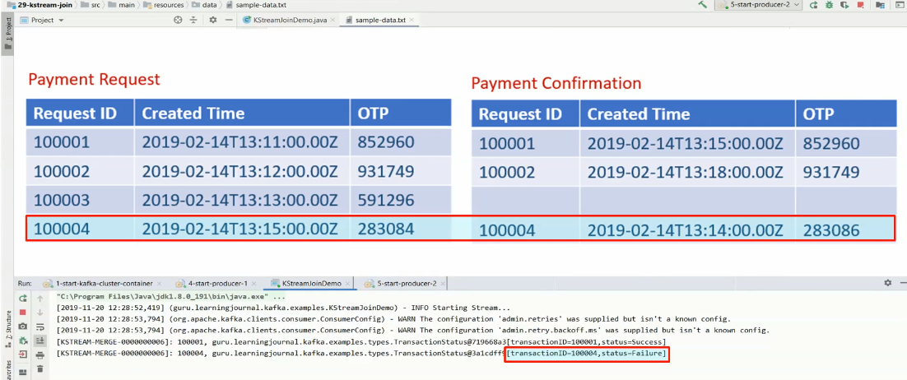

**Complete code for above**

**1-start-kafka-cluster-container.cmd**

docker run -i -p 2181:2181 -p 9092:9092 -p 9093:9093 -p 9094:9094

--name kafka2.3-3in1

-h kafka learningjournal/kafka:kafka2.3-3in1-centos7

**2-create-topic-1.cmd**

kafka-topics.bat --create --zookeeper localhost:2181

--replication-factor 3

--partitions 2

--topic payment_request

**3-create-topic-2.cmd**

kafka-topics.bat --create --zookeeper localhost:2181

--replication-factor 3

--partitions 2

--topic payment_confirmation

**4-start-producer-1.cmd**

kafka-console-producer.bat --broker-list localhost:9092

--topic payment_request

--property parse.key=true

--property key.separator=":"

**5-start-producer-2.cmd**

kafka-console-producer.bat --broker-list localhost:9092

--topic payment_confirmation

--property parse.key=true

--property key.separator=":"

**pom.xml**

<?xml version="1.0" encoding="UTF-8"?>

<project xmlns="http://maven.apache.org/POM/4.0.0"

xmlns:xsi="http://www.w3.org/2001/XMLSchema-instance"

xsi:schemaLocation="http://maven.apache.org/POM/4.0.0 http://maven.apache.org/xsd/maven-4.0.0.xsd">

<modelVersion>4.0.0</modelVersion>

<groupId>guru.learningjournal.kafka.examples</groupId>

<artifactId>kstream-join</artifactId>

<version>2.3.0</version>

<properties>

<java.version>1.8</java.version>

<kafka.version>2.3.0</kafka.version>

<project.build.sourceEncoding>UTF-8</project.build.sourceEncoding>

</properties>

<build>

<plugins>

<!-- Maven Compiler Plugin-->

<plugin>

<groupId>org.apache.maven.plugins</groupId>

<artifactId>maven-compiler-plugin</artifactId>

<version>3.8.0</version>

<configuration>

<source>${java.version}</source>

<target>${java.version}</target>

</configuration>

</plugin>

<!-- Json Schema to POJO plugin-->

<plugin>

<groupId>org.jsonschema2pojo</groupId>

<artifactId>jsonschema2pojo-maven-plugin</artifactId>

<version>0.5.1</version>

<executions>

<execution>

<goals>

<goal>generate</goal>

</goals>

<configuration>

<sourceDirectory>

${project.basedir}/src/main/resources/schema/

</sourceDirectory>

<outputDirectory>${project.basedir}/src/main/java/</outputDirectory>

<includeAdditionalProperties>false</includeAdditionalProperties>

<includeHashcodeAndEquals>false</includeHashcodeAndEquals>

<generateBuilders>true</generateBuilders>

</configuration>

</execution>

</executions>

</plugin>

</plugins>

</build>

<dependencies>

<!--Apache commons-->

<dependency>

<groupId>commons-lang</groupId>

<artifactId>commons-lang</artifactId>

<version>2.6</version>

</dependency>

<!-- Apache Kafka Streams-->

<dependency>

<groupId>org.apache.kafka</groupId>

<artifactId>kafka-streams</artifactId>

<version>${kafka.version}</version>

</dependency>

<!-- Apache Log4J2 binding for SLF4J -->

<dependency>

<groupId>org.apache.logging.log4j</groupId>

<artifactId>log4j-slf4j-impl</artifactId>

<version>2.11.0</version>

</dependency>

</dependencies>

</project>

**AppSerdes.java**

import guru.learningjournal.kafka.examples.types.PaymentConfirmation;

import guru.learningjournal.kafka.examples.types.PaymentRequest;

import org.apache.kafka.common.serialization.Serde;

import org.apache.kafka.common.serialization.Serdes;

import java.util.HashMap;

import java.util.Map;

public class AppSerdes extends Serdes {

static final class PaymentRequestSerde extends WrapperSerde<PaymentRequest> {

PaymentRequestSerde() {

super(new JsonSerializer<>(), new JsonDeserializer<>());

}

}

public static Serde<PaymentRequest> PaymentRequest() {

PaymentRequestSerde serde = new PaymentRequestSerde();

Map<String, Object> serdeConfigs = new HashMap<>();

serdeConfigs.put(JsonDeserializer.VALUE_CLASS_NAME_CONFIG, PaymentRequest.class);

serde.configure(serdeConfigs, false);

return serde;

}

static final class PaymentConfirmationSerde extends WrapperSerde<PaymentConfirmation> {

PaymentConfirmationSerde() {

super(new JsonSerializer<>(), new JsonDeserializer<>());

}

}

public static Serde<PaymentConfirmation> PaymentConfirmation() {

PaymentConfirmationSerde serde = new PaymentConfirmationSerde();

Map<String, Object> serdeConfigs = new HashMap<>();

serdeConfigs.put( JsonDeserializer.VALUE_CLASS_NAME_CONFIG,

PaymentConfirmation.class );

serde.configure(serdeConfigs, false);

return serde;

}

}

**JsonDeserializer.java**

import com.fasterxml.jackson.databind.ObjectMapper;

import org.apache.kafka.common.errors.SerializationException;

import org.apache.kafka.common.serialization.Deserializer;

import java.util.Map;

public class JsonDeserializer<T> implements Deserializer<T> {

private ObjectMapper objectMapper = new ObjectMapper();

private Class<T> className;

public static final String KEY_CLASS_NAME_CONFIG = "key.class.name";

public static final String VALUE_CLASS_NAME_CONFIG = "value.class.name";

public JsonDeserializer() { }

@SuppressWarnings("unchecked")

@Override

public void configure(Map<String, ?> props, boolean isKey) {

if (isKey)

className = (Class<T>) props.get(KEY_CLASS_NAME_CONFIG);

else

className = (Class<T>) props.get(VALUE_CLASS_NAME_CONFIG);

}

@Override

public T deserialize(String topic, byte[] data) {

if (data == null) {

return null;

}

try {

return objectMapper.readValue(data, className);

} catch (Exception e) {

throw new SerializationException(e);

}

}

@Override

public void close() {

//nothing to close

}

}

**JsonSerializer.java**

import com.fasterxml.jackson.databind.ObjectMapper;

import org.apache.kafka.common.errors.SerializationException;

import org.apache.kafka.common.serialization.Serializer;

import java.util.Map;

public class JsonSerializer<T> implements Serializer<T> {

private final ObjectMapper objectMapper = new ObjectMapper();

public JsonSerializer() { }

@Override

public void configure(Map<String, ?> config, boolean isKey) {

//Nothing to Configure

}

@Override

public byte[] serialize(String topic, T data) {

if (data == null) {

return null;

}

try {

return objectMapper.writeValueAsBytes(data);

} catch (Exception e) {

throw new SerializationException("Error serializing JSON message", e);

}

}

@Override

public void close() {

}

}

### KTable – KTable Joins

In this lecture, we are going to learn the mechanics of implementing KTable to a Ktable join. These joins are always non-windowed joins, and they offer the same result as in the case of standard database table joins. The join result is another KTable. KTable–KTable is the most straightforward join and the simplest to implement. So, let's create a simple scenario to understand the use case and implementation mechanics.

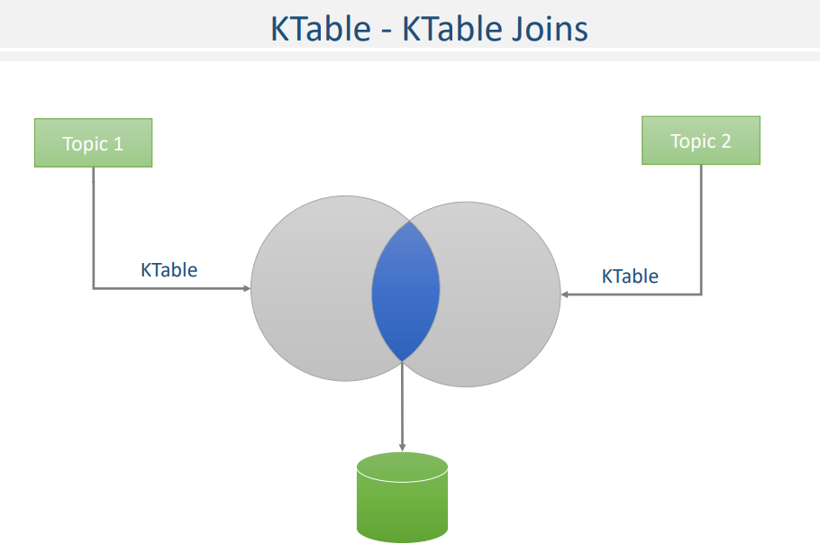

You are a global bank, and you have a vast user base. However, you have already streamed all your customer records to your Kafka Cluster.

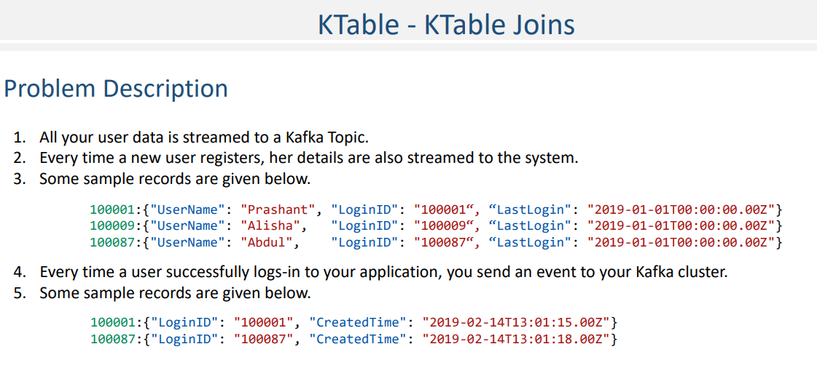

All the user data is now available for any real-time operation. Here is a list that shows some records that were streamed to your system earlier. Every time a new user registers, her details are also streamed to the system. Now, on the other side, whenever a user successfully logs-in to your application, you send an event to your Kafka cluster. Here is a list that shows some sample login events. Now we want to create a simple application that updates the last login timestamp whenever a user logs into the system. Let's talk about the solution. Same as earlier, I got you a startup project.

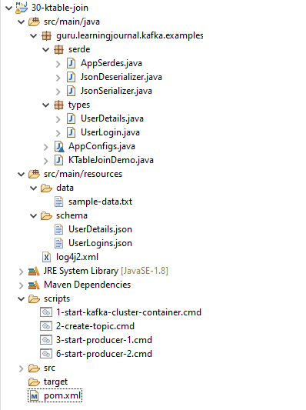

The project comes with two schema definitions. One for user details, and the other one is for user login events. We also have other usual things, such as JSON serializers, App Configs, and App Serdes. We are going to need two topics for this example. The first Topic is the user master, and that's where we are going to stream all the user records. The other Topic is for user-login events. I have all the necessary scripts already included in the project. You can start Kafka cluster containers, create topics, and also start producers to send sample messages. I have also included the main class with some initial code. We create a StreamBuilder and use it to subscribe to the user details topic and create a KTable.

**KTableJoinDemo.java**

import guru.learningjournal.kafka.examples.serde.AppSerdes;

import guru.learningjournal.kafka.examples.types.UserDetails;

import guru.learningjournal.kafka.examples.types.UserLogin;

import org.apache.kafka.streams.KafkaStreams;

import org.apache.kafka.streams.StreamsBuilder;

import org.apache.kafka.streams.StreamsConfig;

import org.apache.kafka.streams.kstream.*;

import org.apache.logging.log4j.LogManager;

import org.apache.logging.log4j.Logger;

import java.util.Properties;

public class KTableJoinDemo {

private static final Logger logger = LogManager.getLogger();

public static void main(String[] args) {

Properties props = new Properties();

props.put(StreamsConfig.APPLICATION_ID_CONFIG, AppConfigs.applicationID);

props.put(StreamsConfig.BOOTSTRAP_SERVERS_CONFIG, AppConfigs.bootstrapServers);

props.put(StreamsConfig.STATE_DIR_CONFIG, AppConfigs.stateStoreName);

props.put(StreamsConfig.COMMIT_INTERVAL_MS_CONFIG, 0);

StreamsBuilder streamsBuilder = new StreamsBuilder();

KTable<String, UserDetails> KT0 = streamsBuilder.table(AppConfigs.userMasterTopic,

Consumed.with(AppSerdes.String(), AppSerdes.UserDetails())

);

KTable<String, UserLogin> KT1 = streamsBuilder.table(AppConfigs.lastLoginTopic,

Consumed.with(AppSerdes.String(), AppSerdes.UserLogin())

);

KT0.join(KT1, (v1, v2) -> {

v1.setLastLogin(v2.getCreatedTime());

return v1;

}).toStream().print(Printed.toSysOut());

logger.info("Starting Stream...");

KafkaStreams streams = new KafkaStreams(streamsBuilder.build(), props);

streams.start();

Runtime.getRuntime().addShutdownHook(new Thread(() -> {

logger.info("Stopping Streams...");

streams.close();

}));

}

}

**AppConfigs.java**

class AppConfigs {

public final static String applicationID = "KTableJoinDemo";

public final static String bootstrapServers = "localhost:9092,localhost:9093";

public final static String userMasterTopic = "user-master";

public final static String lastLoginTopic = "user-login";

public final static String stateStoreName = "tmp/state-store";

}

The data in this Topic is keyed by the login id. On the other side, we subscribe to the user login topic and create another KTable. Data in the user login topic is also keyed by login id. Having the same key for both the topics will ensure that all the data from both the topics for a specific user will flow to the same stream task. Right? While working with Kafka, knowing your Topic and the partitioning strategy is critical. You must ensure that the data is co-partitioned for the join operation to happen. We cannot perform a join if the data for the same key flows to different instances.

Now, we are ready to join these two tables and update the last login timestamp in the user details. We start with the user login table and join() it with the user details table. Same as the previous lecture, the second argument of the join method is a ValueJoiner lambda that implements the join logic and returns the outcome of the join. The ValueJoiner lambda takes two arguments (v1, v2). The first argument v1 is a record from the user details table (the left side), and the v2 is a record from the login event ( the right side). You already learned that earlier, right? What do we want to do in the body? We are going to updating the last login timestamp in the user details and return the updated user details. Let's print the outcome. That's all. Do you want to execute it and observe the results? Well, that's a quite straightforward example, so I leave the execution on you.

Rest of the Code

**AppSerdes.java**

import guru.learningjournal.kafka.examples.types.UserDetails;

import guru.learningjournal.kafka.examples.types.UserLogin;

import org.apache.kafka.common.serialization.Serde;

import org.apache.kafka.common.serialization.Serdes;

import java.util.HashMap;

import java.util.Map;

public class AppSerdes extends Serdes {

static final class UserDetailsSerde extends WrapperSerde<UserDetails> {

UserDetailsSerde() {

super(new JsonSerializer<>(), new JsonDeserializer<>());

}

}

public static Serde<UserDetails> UserDetails() {

UserDetailsSerde serde = new UserDetailsSerde();

Map<String, Object> serdeConfigs = new HashMap<>();

serdeConfigs.put(JsonDeserializer.VALUE_CLASS_NAME_CONFIG, UserDetails.class);

serde.configure(serdeConfigs, false);

return serde;

}

static final class UserLoginSerde extends WrapperSerde<UserLogin> {

UserLoginSerde() {

super(new JsonSerializer<>(), new JsonDeserializer<>());

}

}

public static Serde<UserLogin> UserLogin() {

UserLoginSerde serde = new UserLoginSerde();

Map<String, Object> serdeConfigs = new HashMap<>();

serdeConfigs.put(JsonDeserializer.VALUE_CLASS_NAME_CONFIG, UserLogin.class);

serde.configure(serdeConfigs, false);

return serde;

}

}

**JsonDeserializer.java**

import com.fasterxml.jackson.databind.ObjectMapper;

import org.apache.kafka.common.errors.SerializationException;

import org.apache.kafka.common.serialization.Deserializer;

import java.util.Map;

public class JsonDeserializer<T> implements Deserializer<T> {

private ObjectMapper objectMapper = new ObjectMapper();

private Class<T> className;

public static final String KEY_CLASS_NAME_CONFIG = "key.class.name";

public static final String VALUE_CLASS_NAME_CONFIG = "value.class.name";

public JsonDeserializer() { }

@SuppressWarnings("unchecked")

@Override

public void configure(Map<String, ?> props, boolean isKey) {

if (isKey)

className = (Class<T>) props.get(KEY_CLASS_NAME_CONFIG);

else

className = (Class<T>) props.get(VALUE_CLASS_NAME_CONFIG);

}

@Override

public T deserialize(String topic, byte[] data) {

if (data == null) {

return null;

}

try {

return objectMapper.readValue(data, className);

} catch (Exception e) {

throw new SerializationException(e);

}

}

@Override

public void close() {

//nothing to close

}

}

**JsonSerializer.java**

import com.fasterxml.jackson.databind.ObjectMapper;

import org.apache.kafka.common.errors.SerializationException;

import org.apache.kafka.common.serialization.Serializer;

import java.util.Map;

public class JsonSerializer<T> implements Serializer<T> {

private final ObjectMapper objectMapper = new ObjectMapper();

public JsonSerializer() { }

@Override

public void configure(Map<String, ?> config, boolean isKey) {

//Nothing to Configure

}

@Override

public byte[] serialize(String topic, T data) {

if (data == null) {

return null;

}

try {

return objectMapper.writeValueAsBytes(data);

} catch (Exception e) {

throw new SerializationException("Error serializing JSON message", e);

}

}

@Override

public void close() {

}

}

**sample-data.txt**

100001:{"UserName": "Prashant", "LoginID": "100001", "LastLogin": "2019-01-01T00:00:00.00Z"}

100009:{"UserName": "Alisha", "LoginID": "100009", "LastLogin": "2019-01-01T00:00:00.00Z"}

100087:{"UserName": "Abdul", "LoginID": "100087", "LastLogin": "2019-01-01T00:00:00.00Z"}

100001:{"LoginID": "100001", "CreatedTime": "2019-02-14T13:01:15.00Z"}

100087:{"LoginID": "100087", "CreatedTime": "2019-02-14T13:01:18.00Z"}

**UserDetails.json**

{

"type": "object",

"javaType": "guru.learningjournal.kafka.examples.types.UserDetails",

"properties": {

"UserName": {

"type": "string"

},

"LoginID": {

"type": "string"

},

"LastLogin": {

"type": "string"

}

}

}

**UserLogins.json**

{

"type": "object",

"javaType": "guru.learningjournal.kafka.examples.types.UserLogin",

"properties": {

"LoginID": {

"type": "string"

},

"CreatedTime": {

"type": "string"

}

}

}

**1-start-kafka-cluster-container.cmd**

docker run -i -p 2181:2181 -p 9092:9092 -p 9093:9093 -p 9094:9094

--name kafka2.3-3in1

-h kafka learningjournal/kafka:kafka2.3-3in1-centos7

**2-create-topic.cmd**

kafka-topics.bat --create

--zookeeper localhost:2181

--replication-factor 3

--partitions 2

--topic user-master & kafka-topics.bat

--create --zookeeper localhost:2181

--replication-factor 3

--partitions 2

--topic user-login

**3-start-producer-1.cmd**

kafka-console-producer.bat --broker-list localhost:9092

--topic user-master

--property parse.key=true

--property key.separator=":"

**6-start-producer-2.cmd**

kafka-console-producer.bat --broker-list localhost:9092

--topic user-login

--property parse.key=true

--property key.separator=":"

**pom.xml**

<?xml version="1.0" encoding="UTF-8"?>

<project xmlns="http://maven.apache.org/POM/4.0.0"

xmlns:xsi="http://www.w3.org/2001/XMLSchema-instance"

xsi:schemaLocation="http://maven.apache.org/POM/4.0.0 http://maven.apache.org/xsd/maven-4.0.0.xsd">

<modelVersion>4.0.0</modelVersion>

<groupId>guru.learningjournal.kafka.examples</groupId>

<artifactId>ktable-join</artifactId>

<version>2.3.0</version>

<properties>

<java.version>1.8</java.version>

<kafka.version>2.3.0</kafka.version>

<project.build.sourceEncoding>UTF-8</project.build.sourceEncoding>

</properties>

<build>

<plugins>

<!-- Maven Compiler Plugin-->

<plugin>

<groupId>org.apache.maven.plugins</groupId>

<artifactId>maven-compiler-plugin</artifactId>

<version>3.8.0</version>

<configuration>

<source>${java.version}</source>

<target>${java.version}</target>

</configuration>

</plugin>

<!-- Json Schema to POJO plugin-->

<plugin>

<groupId>org.jsonschema2pojo</groupId>

<artifactId>jsonschema2pojo-maven-plugin</artifactId>

<version>0.5.1</version>

<executions>

<execution>

<goals>

<goal>generate</goal>

</goals>

<configuration>

<sourceDirectory>

${project.basedir}/src/main/resources/schema/

</sourceDirectory>

<outputDirectory>

${project.basedir}/src/main/java/

</outputDirectory>

<includeAdditionalProperties>false</includeAdditionalProperties>

<includeHashcodeAndEquals>false</includeHashcodeAndEquals>

<generateBuilders>true</generateBuilders>

</configuration>

</execution>

</executions>

</plugin>

</plugins>

</build>

<dependencies>

<!--Apache commons-->

<dependency>

<groupId>commons-lang</groupId>

<artifactId>commons-lang</artifactId>

<version>2.6</version>

</dependency>

<!-- Apache Kafka Streams-->

<dependency>

<groupId>org.apache.kafka</groupId>

<artifactId>kafka-streams</artifactId>

<version>${kafka.version}</version>

</dependency>

<!-- Apache Log4J2 binding for SLF4J -->

<dependency>

<groupId>org.apache.logging.log4j</groupId>

<artifactId>log4j-slf4j-impl</artifactId>

<version>2.11.0</version>

</dependency>

</dependencies>

</project>

### Joining a KStream to a KTable and GlobalKTable

We learned a couple of join types in Kafka Streams. The next kind of join operation is a Kstream to Ktable join. This join is also a non-windowed join.



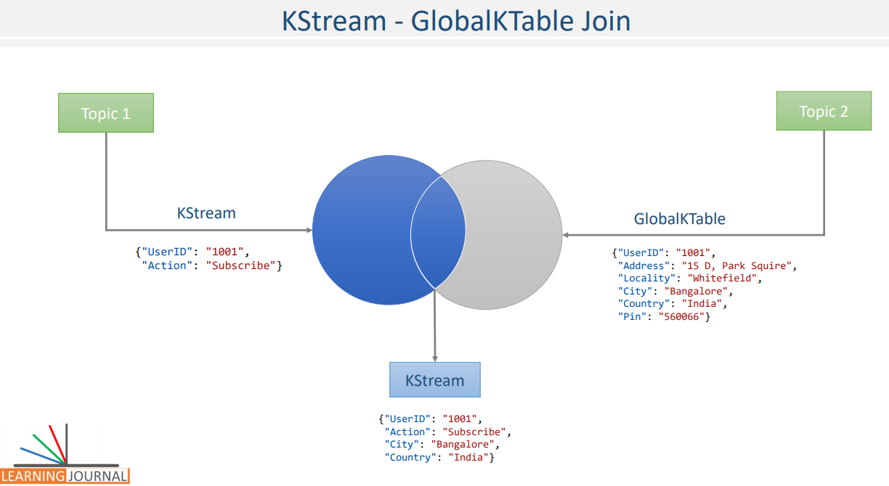

A typical use case of such join, is to implement look ups and stream enchrichment. For example, if you have a Kstream of user activity, and you are looking to enrich this stream with the latest user profile information. which is in a Ktable. You may want to implement a Kstream to a Ktable join. A similar use case is often implemented using Kstream to global Ktable join. However, when the look up data is too large we prefer to use Ktable to achieve partitioned joins. because global Ktable is not efficient with very large data. Since, the use case for Kstream to Ktable join and the Kstream to global Ktable joins are the same. We will implement an example for global Ktable. The mechanics of implementing Kstream to Ktable join is the same, as we are going to do it for a global Ktable. Great! We want to take a problem solution approach.

And here is the problem definition.

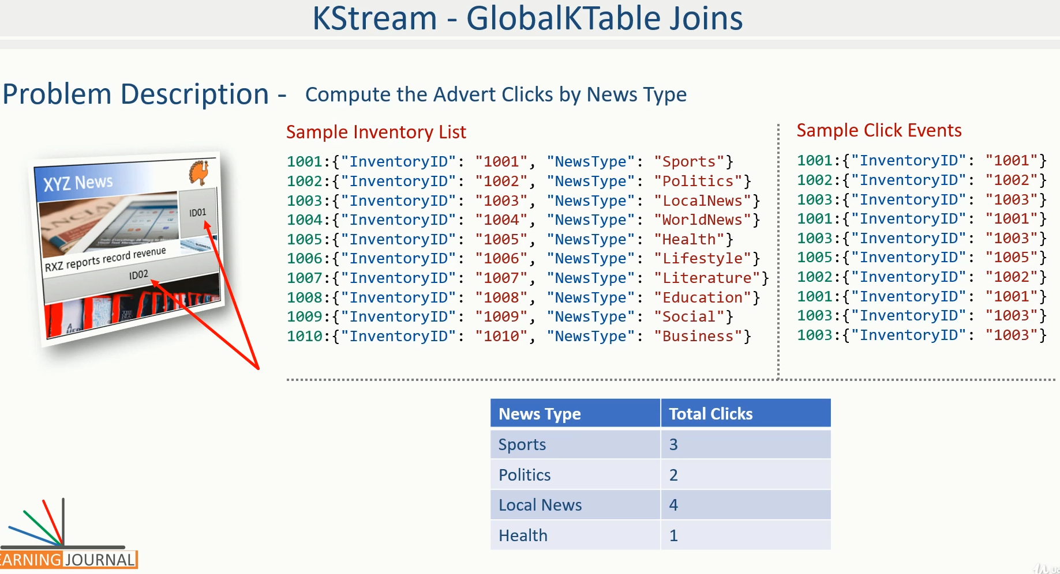

You are a popular news website. and you directly sell advertising campaigns to your customers. You have created pre-defined location, across your website, where you can place advertisements at run-time. These advert placement locations are often known as advert inventories. The advert inventories are tagged with a bunch of associated information. such as their age. I mean, how old is the news around the inventory. What is the type of the content? I mean, whether the story around them is a business news or a sport news. Placement location. I mean, left side, right side, top, bottom and in between the content, etc. It is a common requirement to measure the performance of such inventories in terms of impressions and clicks. These measurements are critical to adjust the campaign in real time.

We want to create a Kafka streams application to compute the ad clicks, by news type. In other words, we want to know the number of ad clicks for sports news, business news, political news and so on, for all available categories. The first step to achieve this goal is to bring all your advert inventories into your real time streaming infrastructure. For the sake of simplicity, let us model the inventory using JSON message as shown here. and publish them to your Kafka cluster. The second step is to bring all your ad clicks, as a real time streaming event into your Kafka cluster. Assume your website is sending all the clicks using a JSON event as shown here. Each event represents a click for the given inventory When you have these two topics and data starts flowing into them. We want to create a real time application. to count the ad clicks by the news type. Based on a sample data given here, you can expect the following outcome. Great! Let`s talk about the solution. Same as earlier, I again go to a starter project.

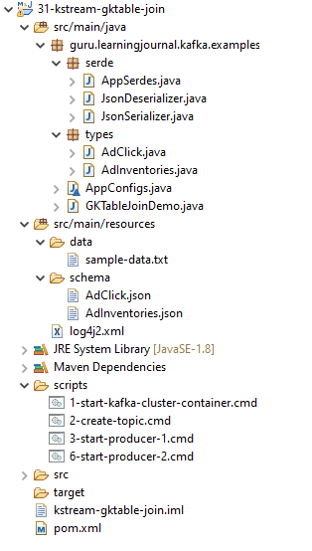

The project comes with two schema definitions. The first schema is to represent the inventories. The second one is to represent a click event. Same as earlier, We also have other usual things such as serializers AppSerdes AppConfig and finally an executable class.

**AdClick.json**

{

"type": "object",

"javaType": "guru.learningjournal.kafka.examples.types.AdClick",

"properties": {

"InventoryID": {

"type": "string"

}

}

}

**AdInventories.json**

{

"type": "object",

"javaType": "guru.learningjournal.kafka.examples.types.AdInventories",

"properties": {

"InventoryID": {

"type": "string"

},

"NewsType": {

"type": "string"

}

}

}

We are setting some configurations.

class AppConfigs {

public final static String applicationID = "GKTableJoinDemo";

public final static String bootstrapServers = "localhost:9092,localhost:9093";

public final static String inventoryTopic = "active-inventories";

public final static String clicksTopic = "ad-clicks";

public final static String stateStoreName = "tmp/state-store";

public final static String top3AggregateKey = "top3NewsTypes";

}

Creating StreamBuilder, and using it to read all advert inventories into a global Ktable. So, all the inventorie would be available to all the streams tasks. Why? Because we are reading it into a global Ktable. In the next step, we are reading all the advert clicks into a standard Kstream. Great! If you are going to execute multiple instances of the same application. You will have a full list of inventories at all the instances. And a partial list of click events. However, you can join them easily at each stream task. Why? Because all the records for the other side of the join are available with each stream task. Right? Let`s join them. We start with the click stream and join it with the global table of inventories. The purpose of the join is to enrich the click event, with the news type information. The click stream has got the inventory id. But we want to pull the news type string based on the identifier, right? Great!

**GKTableJoinDemo.java**

import guru.learningjournal.kafka.examples.serde.AppSerdes;

import guru.learningjournal.kafka.examples.types.AdClick;

import guru.learningjournal.kafka.examples.types.AdInventories;

import org.apache.kafka.streams.KafkaStreams;

import org.apache.kafka.streams.StreamsBuilder;

import org.apache.kafka.streams.StreamsConfig;

import org.apache.kafka.streams.kstream.*;

import org.apache.logging.log4j.LogManager;

import org.apache.logging.log4j.Logger;

import java.util.Properties;

public class GKTableJoinDemo {

private static final Logger logger = LogManager.getLogger();

public static void main(String[] args) {

Properties props = new Properties();

props.put(StreamsConfig.APPLICATION_ID_CONFIG, AppConfigs.applicationID);

props.put(StreamsConfig.BOOTSTRAP_SERVERS_CONFIG, AppConfigs.bootstrapServers);

props.put(StreamsConfig.STATE_DIR_CONFIG, AppConfigs.stateStoreName);

props.put(StreamsConfig.COMMIT_INTERVAL_MS_CONFIG, 0);

StreamsBuilder streamsBuilder = new StreamsBuilder();

GlobalKTable<String, AdInventories> GKT0 =

streamsBuilder.globalTable( AppConfigs.inventoryTopic,

Consumed.with( AppSerdes.String(),

AppSerdes.AdInventories())

);

KStream<String, AdClick> KS1 = streamsBuilder.stream(AppConfigs.clicksTopic,

Consumed.with(AppSerdes.String(), AppSerdes.AdClick())

);

KS1.join(GKT0, (k, v)-> k, (v1, v2)-> v2)

.groupBy( (k,v)-> v.getNewsType(),

Grouped.with( AppSerdes.String(), AppSerdes.AdInventories() ) )

.count()

.toStream().print(Printed.toSysOut());

logger.info("Starting Stream...");

KafkaStreams streams = new KafkaStreams(streamsBuilder.build(), props);

streams.start();

Runtime.getRuntime().addShutdownHook(new Thread(() -> {

logger.info("Stopping Streams...");

streams.close();

}));

}

}

What is the next argument to the join method? In all other cases, it would be the value joiner lambda. However, global Ktable has got one additional capability. A join with global Ktable takes a key value mapper lambda and returns a new join key, which could be a different key than the current Kstream key. This feature is to join global Ktable with a foreign key. However, we do not need this feature for our requirement. So, let me return the same key. Finally, the next argument is a value joiner lambda. The first argument for the value joiner lambda is the, ad click event. And the second requirement is the inventory record. The value joiner is triggered if and only if, both the record keys are matching. So, we know that the inventory is clicked and all we do hear is to return the inventory record. The outcome of the join is a new Kstream.

**sample-data.txt**

1001:{"InventoryID": "1001", "NewsType": "Sports"}

1002:{"InventoryID": "1002", "NewsType": "Politics"}

1003:{"InventoryID": "1003", "NewsType": "LocalNews"}

1004:{"InventoryID": "1004", "NewsType": "WorldNews"}

1005:{"InventoryID": "1005", "NewsType": "Health"}

1006:{"InventoryID": "1006", "NewsType": "Lifestyle"}

1007:{"InventoryID": "1007", "NewsType": "Literature"}

1008:{"InventoryID": "1008", "NewsType": "Education"}

1009:{"InventoryID": "1009", "NewsType": "Social"}

1010:{"InventoryID": "1010", "NewsType": "Business"}

1001:{"InventoryID": "1001"}

1002:{"InventoryID": "1002"}

1003:{"InventoryID": "1003"}

1001:{"InventoryID": "1001"}

1003:{"InventoryID": "1003"}

1005:{"InventoryID": "1005"}

1002:{"InventoryID": "1002"}

1001:{"InventoryID": "1001"}

1003:{"InventoryID": "1003"}

1003:{"InventoryID": "1003"}

The key is an inventory id string, and the value is an inventory record. However, this new joined Kstream represents the clicked inventories. Great! So we have a stream of inventories that are clicked. Group them on the news type and count, right? That`s what we want. Let`s do it. We start with the clicked inventory Kstream. apply the groupBy method, the groupBy method takes a key/value mapper lambda and returns a grouping key. In our case, we wanted to group it on the news type, right? Don`t forget to supply the Serdes. Finally, we count the grouped stream. That`s all. No? Ok. Let me print the final stream so we can see the output. You want to execute it? Well, I leave it on you. Because we are going to extend the same example in the next lecture. In the following lecture, we will implement the sorting and filtering of the top 3 inventories.

Rest of the code for this project

**1-start-kafka-cluster-container.cmd**

docker run -i -p 2181:2181 -p 9092:9092 -p 9093:9093 -p 9094:9094

--name kafka2.3-3in1

-h kafka learningjournal/kafka:kafka2.3-3in1-centos7

**2-create-topic.cmd**

kafka-topics.bat --create

--zookeeper localhost:2181

--replication-factor 3

--partitions 2

--topic active-inventories

&

kafka-topics.bat --create

--zookeeper localhost:2181

--replication-factor 3

--partitions 2

--topic ad-clicks

**3-start-producer-1.cmd**

kafka-console-producer.bat --broker-list localhost:9092

--topic active-inventories

--property parse.key=true

--property key.separator=":"

**6-start-producer-2.cmd**

kafka-console-producer.bat --broker-list localhost:9092

--topic ad-clicks

--property parse.key=true

--property key.separator=":"

pom.xml, AppSerdes.java, JsonDeserializer.java and JsonSerializer.java are same as in above projects

### Joins and Aggregates



In the previous lecture, we created an example to implement a join and the simplest form of aggregation. The count aggregation. Right? However, the aggregation and Joins are at the heart of the Kafka Streams applications. Almost every real-time stream application would end up using a combination of these two techniques. So, I wanted to create a couple of examples that combine these two features together.

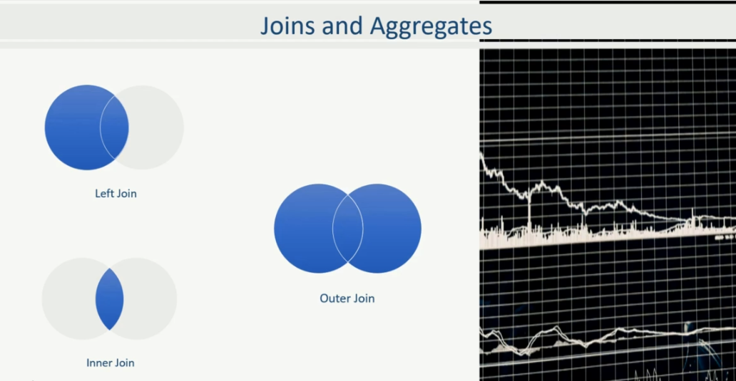

These examples will give you a real sense of how fundamental are these operations in a streaming application. Let's define the first example problem. In the previous example, we computed clicks by news type. However, the complete list of news types is exhaustive. We want to extend the application further to see the top 3 news types that are receiving the maximum number of clicks.

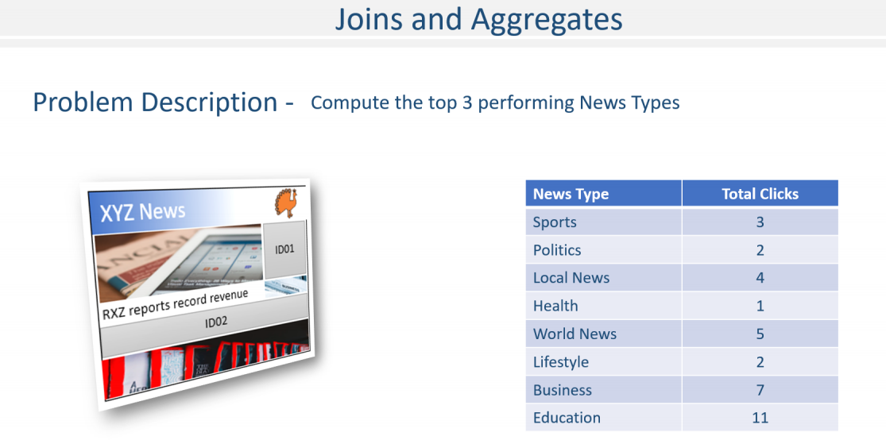

I have added the previous example as a starter project in your course material. Let me open it. So, in this example, we already achieved creating a KTable for clicks By News Type. All we need to do is to determine the top three from this KTable. However, that's not an easy goal. We must do the following to get the top three. Sort the KTable by the number of clicks. and then, Take the top three from the sorted KTable.

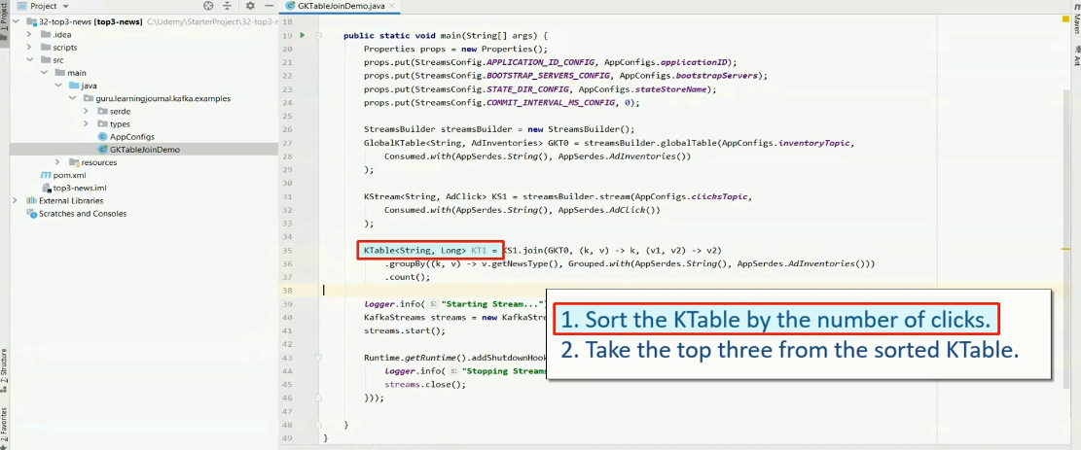

I wish we had an API for sorting a KTable. However, Kafka does not provide an API to achieve this. And I guess they have a valid reason for not providing that feature. Let me highlight a couple of those reasons. KTable is local for the stream task. So, your data is distributed across the stream tasks. To sort it, you must bring it to a single instance. Right? Sorting on the record key does not make any sense in many use cases. For example, in our case, we do not want to sort the record on the news type. Instead, we want to sort on the number of clicks and find the top three. Right?

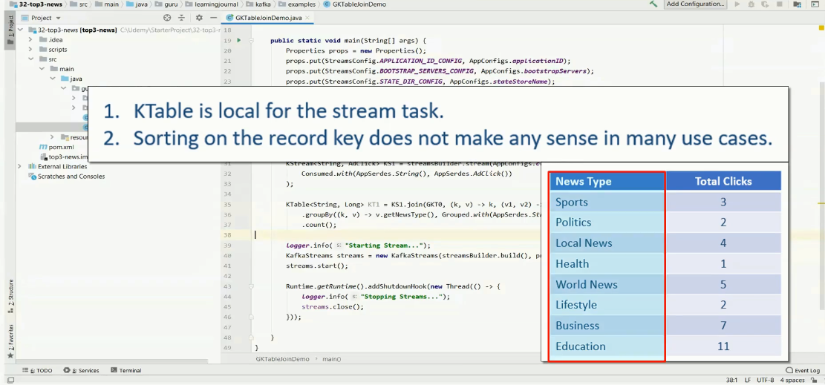

So, most of the use cases would need sorting on some other field and not on the record key. But Kafka streams APIs are evolving, and we can expect an API for achieving this in the upcoming versions. However, for now, we can produce a custom solution. Let's start with understanding what we have. So, we have a KTable of the following form. And this data is not available in one place. It is distributed across different streams tasks. Why? Because the KTable is local to the task, and the data is distributed across tasks. Each stream tasks would be maintaining its local share of the data. Isn't it?

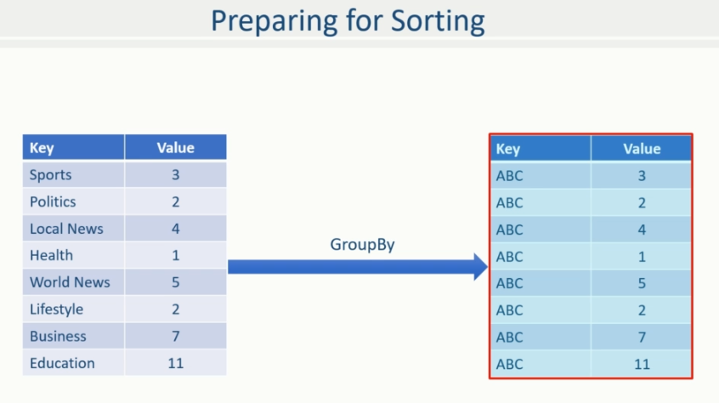

We already learned that earlier. However, we wanna sort it by value. So, the first thing that we wanna do is to bring it to one place. Otherwise, it is impossible to sort it. How can you do that? There are a couple of ways to do it. But the most convenient way is to group-by a fixed key. So, let's assume I am implementing a group by on this KTable and changing the key to "ABC," or maybe "XYZ." The result will be another Table. Right? The result will be a KGroupedTable, which would be something like this. All these records will come to a single partition because they all have the same key. However, we lost the news type information and are left with the click count only. Right? We can fix this problem easily. In the group By call, while we change the key to "ABC", we also change the value to preserve the news type and the count. The expected KGroupedTable should be something like this. Possible? Absolutely yes.

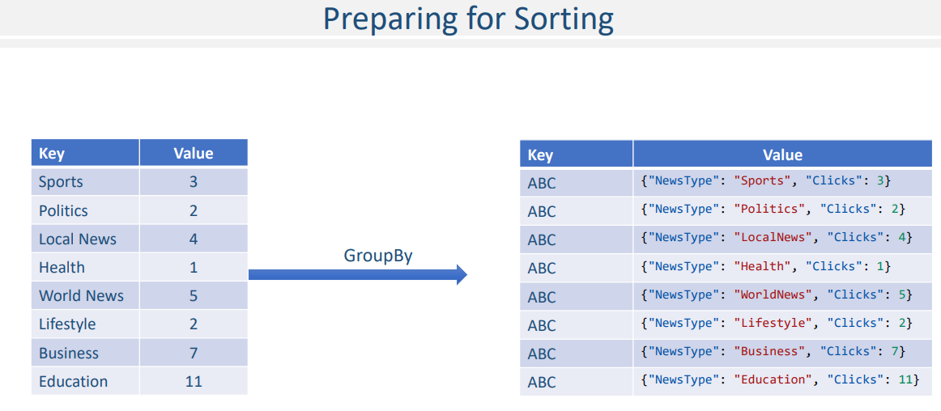

Let me code it. We need to create a new schema to hold the news type and the clicks. Right? Let's name it as ClicksByNewsType. All we need is two properties. News type and Clicks.

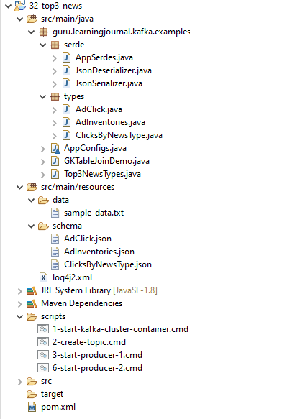

**AdClick.json**

{

"type": "object",

"javaType": "guru.learningjournal.kafka.examples.types.AdClick",

"properties": {

"InventoryID": {

"type": "string"

}

}

}

**AdInventories.json**

{

"type": "object",

"javaType": "guru.learningjournal.kafka.examples.types.AdInventories",

"properties": {

"InventoryID": {

"type": "string"

},

"NewsType": {

"type": "string"

}

}

}

**ClicksByNewsType.json**

{

"type": "object",

"javaType": "guru.learningjournal.kafka.examples.types.ClicksByNewsType",

"properties": {

"NewsType": {

"type": "string"

},

"Clicks": {

"javaType": "java.lang.Long"

}

}

}

**1-start-kafka-cluster-container.cmd**

docker run -i -p 2181:2181 -p 9092:9092 -p 9093:9093 -p 9094:9094

--name kafka2.3-3in1

-h kafka learningjournal/kafka:kafka2.3-3in1-centos7

**2-create-topic.cmd**

kafka-topics.bat --create

--zookeeper localhost:2181

--replication-factor 3

--partitions 2

--topic active-inventories

&

kafka-topics.bat --create

--zookeeper localhost:2181

--replication-factor 3

--partitions 2

--topic ad-clicks

**3-start-producer-1.cmd**

kafka-console-producer.bat

--broker-list localhost:9092

--topic active-inventories

--property parse.key=true

--property key.separator=":"

**6-start-producer-2.cmd**

kafka-console-producer.bat

--broker-list localhost:9092

--topic ad-clicks

--property parse.key=true

--property key.separator=":"

**sample-data.txt**

1001:{"InventoryID": "1001", "NewsType": "Sports"}

1002:{"InventoryID": "1002", "NewsType": "Politics"}

1003:{"InventoryID": "1003", "NewsType": "LocalNews"}

1004:{"InventoryID": "1004", "NewsType": "WorldNews"}

1005:{"InventoryID": "1005", "NewsType": "Health"}

1006:{"InventoryID": "1006", "NewsType": "Lifestyle"}

1007:{"InventoryID": "1007", "NewsType": "Literature"}

1008:{"InventoryID": "1008", "NewsType": "Education"}

1009:{"InventoryID": "1009", "NewsType": "Social"}

1010:{"InventoryID": "1010", "NewsType": "Business"}

1001:{"InventoryID": "1001"}

1002:{"InventoryID": "1002"}

1003:{"InventoryID": "1003"}

1004:{"InventoryID": "1004"}

1004:{"InventoryID": "1004"}

1002:{"InventoryID": "1002"}

Let me compile the project, so we get an auto-generated class definition. Let's implement the group-by. We start with the final KTable. The group by on KTable takes a Key/Value mapper lambda. Inside the lambda body, we create new value. Set the news type and the clicks. Finally, we return a key-value pair. The key is a fixed string. And the value is a new data stricture that we created. Great! So we achieved this KGroupedTable. Now we can easily sort it and take three records from the top. However, this KGroupedTable is not a static database table. It's a real-time grouped Table where new records and updates will keep flowing in, and we need to keep things sorted as they arrive. Right? How can we do that? Let's assume that we create a custom data structure for this purpose. Let's call it SortedNewsTypes.

**AppConfigs.java**

class AppConfigs {

public final static String applicationID = "GKTableJoinDemo";

public final static String bootstrapServers = "localhost:9092,localhost:9093";

public final static String inventoryTopic = "active-inventories";

public final static String clicksTopic = "ad-clicks";

public final static String stateStoreName = "tmp/state-store";

public final static String top3AggregateKey = "top3NewsTypes";

}

Now, assume that we got our first count. We simply add this to the SortedNewsTypes. Now you got your second click. We again add it to the SortedNewsTypes. The SortedNewsTypes data structure is smart enough to keep things sorted. So, with these two records, I am expecting the data structure state to become something like this. The politics is at the top, and the Sports is in the second position. Why? Because the clicks are the same for both the records. So, we have sorted them by the string name. Make sense? You got your third event and you simply add it to your smart data structure. The state changes to something like this. Similarly, you got your fourth event and you added that one too.

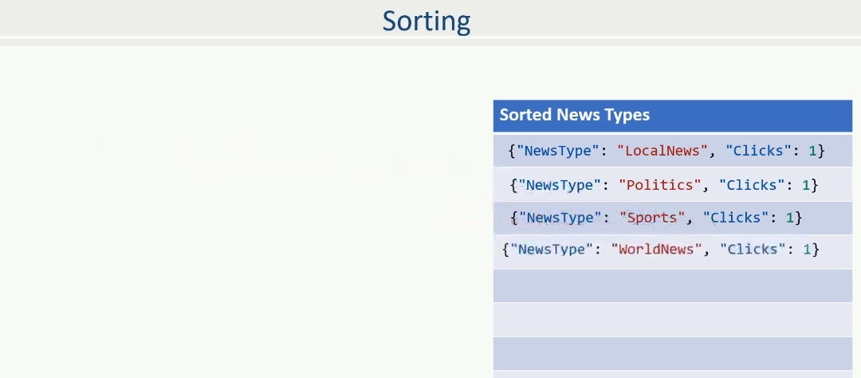

Now you have four items in the list. However, we wanted only top 3. So, let's make the SortedNewsTypes more smarter. I call it Top3SortedNewsTypes. This new structure will remove one record from the lower end and maintain only three records from the top. Right? So the state is going to look like this.

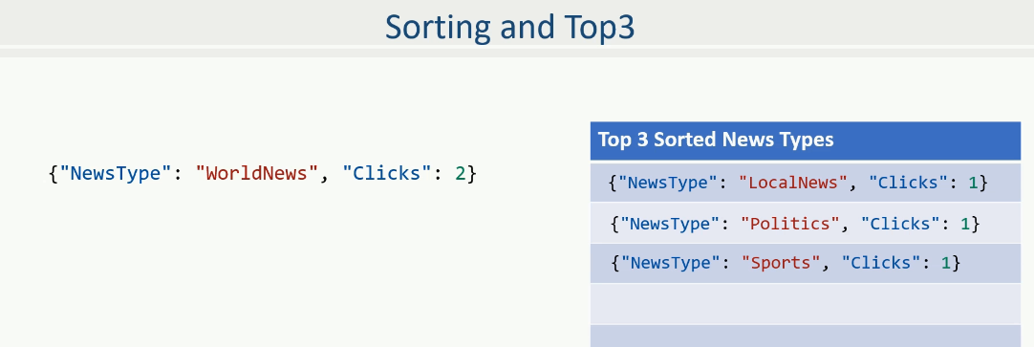

Now I am expecting the next record. Let's assume the next record is for WorldNews again. We got a new click on the WorldNews and hence the count is updated to 2. And we got an updated record for the WorldNews. Nothing to worry. We add it to the Top3SortedNewsTypes. The data-structure will sort it, and finally, remove the lowest member to keep only three. The final state looks like this. Make sense?

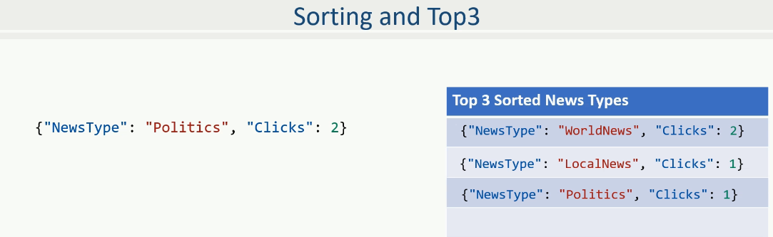

Now, lets assume you got another record. And this time, it is an update for the Politics. We add it to the Top3SortedNewsTypes. But wait a minute. We have a small situation here. The record for the Politics is already there in the list and it must be removed before we add a new updated record for the politics. Right? So, the Top3SortedNewsTypes should also have a method to remove an entry. Right? The point is straight. We need a class that supports adding and removing records. And it should automatically maintain a list of top3 records in sorted order. Assuming that the Top3SortedNewsTypes has got the required features, we will simply remove the existing entry and add a new updated entry for politics. The Top3SortedNewsTypes will sort it automatically, and the new state should look like this.

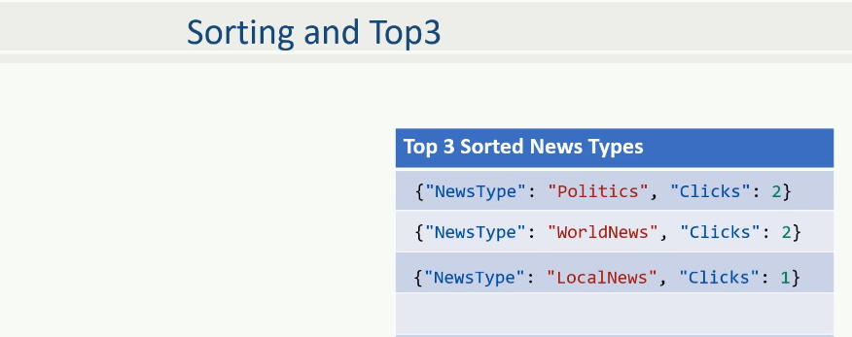

Make sense? Great!

Now you know what to do? Isn't it? Create a Top3SortedNewsTypes class with all the features that we discussed. Let me do it. We need a private member to hold the sorted list of records.

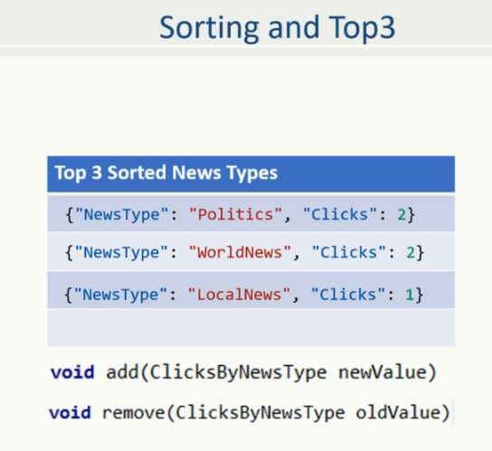

I hope you understand Java TreeSet. It is a sorted collection, and that's what we need. Right? However, we need a custom Comparator. Let's create it. So, we compare them by clicks, and if the click count is the same, we compare them by the NewsType string. That's all. The TreeSet will now automatically maintain an ordered set of the ClicksByNewsType object. Right? The next thing is to include an add() method. Take a new value, and add it to the TreeSet. Check for the size, whether it became more than three. If yes, remove the last item from the set. You also need a remove method. Let me create one. This one is as simple as remove the given item from the set. Right? What else? All your data structures must be serializable. Why? Because, the Kafka APIs are going to materialize them in the state store and also transmit them over the network. So, we have to make this class serializable. We are using JSON serialization, and making a class JSON Serializable is super simple. All we need is to do two things. Create getter and setter methods for each attribute. And annotate them using appropriate JSON annotations. Let me do it. We are going to need an ObjectMapper.

import com.fasterxml.jackson.core.JsonProcessingException;

import guru.learningjournal.kafka.examples.serde.AppSerdes;

import guru.learningjournal.kafka.examples.types.AdClick;

import guru.learningjournal.kafka.examples.types.AdInventories;

import guru.learningjournal.kafka.examples.types.ClicksByNewsType;

import org.apache.kafka.common.utils.Bytes;

import org.apache.kafka.streams.KafkaStreams;

import org.apache.kafka.streams.KeyValue;

import org.apache.kafka.streams.StreamsBuilder;

import org.apache.kafka.streams.StreamsConfig;

import org.apache.kafka.streams.kstream.*;

import org.apache.kafka.streams.state.KeyValueStore;

import org.apache.logging.log4j.LogManager;

import org.apache.logging.log4j.Logger;

import java.util.Properties;

public class GKTableJoinDemo {

private static final Logger logger = LogManager.getLogger();

public static void main(String[] args) {

Properties props = new Properties();

props.put(StreamsConfig.APPLICATION_ID_CONFIG, AppConfigs.applicationID);

props.put(StreamsConfig.BOOTSTRAP_SERVERS_CONFIG, AppConfigs.bootstrapServers);

props.put(StreamsConfig.STATE_DIR_CONFIG, AppConfigs.stateStoreName);

props.put(StreamsConfig.COMMIT_INTERVAL_MS_CONFIG, 0);

StreamsBuilder streamsBuilder = new StreamsBuilder();

GlobalKTable<String, AdInventories> GKT0 =

streamsBuilder.globalTable( AppConfigs.inventoryTopic,

Consumed.with(AppSerdes.String(), AppSerdes.AdInventories())

);

KStream<String, AdClick> KS1 =

streamsBuilder.stream( AppConfigs.clicksTopic,

Consumed.with( AppSerdes.String(),

AppSerdes.AdClick())

);

KTable<String, Long> KT1 =

KS1.join( GKT0, (k, v) -> k, (v1, v2) -> v2)

.groupBy((k, v) -> v.getNewsType(), Grouped.with( AppSerdes.String(),

AppSerdes.AdInventories()))

.count();

KT1.groupBy((k, v) -> {

ClicksByNewsType value = new ClicksByNewsType();

value.setNewsType(k);

value.setClicks(v);

return KeyValue.pair(AppConfigs.top3AggregateKey, value);

}, Grouped.with(AppSerdes.String(), AppSerdes.ClicksByNewsType())

).aggregate(() -> new Top3NewsTypes(),

(k, newV, aggV) -> { aggV.add(newV); return aggV; },

(k, oldV, aggV) -> { aggV.remove(oldV); return aggV; },

Materialized.<String, Top3NewsTypes, KeyValueStore<Bytes, byte[]>>

as("top3-clicks").withKeySerde(AppSerdes.String())

.withValueSerde(AppSerdes.Top3NewsTypes()))

.toStream().foreach((k, v) -> {

try {

logger.info("k=" + k + " v= " + v.getTop3Sorted());

} catch (JsonProcessingException e) {

e.printStackTrace();

}

});

logger.info("Starting Stream...");

KafkaStreams streams = new KafkaStreams(streamsBuilder.build(), props);

streams.start();

Runtime.getRuntime().addShutdownHook(new Thread(() -> {

logger.info("Stopping Streams...");

streams.close();

}));

}

}

**Top3NewsTypes.java**

import com.fasterxml.jackson.annotation.JsonInclude;

import com.fasterxml.jackson.annotation.JsonProperty;

import com.fasterxml.jackson.annotation.JsonPropertyOrder;

import com.fasterxml.jackson.core.JsonProcessingException;

import com.fasterxml.jackson.databind.ObjectMapper;

import guru.learningjournal.kafka.examples.types.ClicksByNewsType;

import java.io.IOException;

import java.util.TreeSet;

@JsonInclude(JsonInclude.Include.NON_NULL)

@JsonPropertyOrder({

"top3Sorted"

})

public class Top3NewsTypes {

private ObjectMapper mapper = new ObjectMapper();

private final TreeSet<ClicksByNewsType> top3Sorted = new TreeSet<>((o1, o2) -> {

final int result = o2.getClicks().compareTo(o1.getClicks());

if (result != 0)

return result;

else

return o1.getNewsType().compareTo(o2.getNewsType());

});

public void add(ClicksByNewsType newValue) {

top3Sorted.add(newValue);

if (top3Sorted.size() > 3) {

top3Sorted.remove(top3Sorted.last());

}

}

public void remove(ClicksByNewsType oldValue){

top3Sorted.remove(oldValue);

}

@JsonProperty("top3Sorted")

public String getTop3Sorted() throws JsonProcessingException {

return mapper.writeValueAsString(top3Sorted);

}

@JsonProperty("top3Sorted")

public void setTop3Sorted(String top3String) throws IOException {

ClicksByNewsType[] top3 = mapper.readValue(top3String, ClicksByNewsType[].class);

for (ClicksByNewsType i:top3){

add(i);

}

}

}

So, let me define it here. Great! We have just one attribute in this class. The TreeSet. Right? So, let me create a getter. We will be using the ObjectMapper's writeValueAsString method to convert the TreeSet into a JSON string and return it. Similarly, we will be using the ObjectMapper's readValue method to read a JSON string into an array, and then, we will loop through the array to use our add method and populate our TreeSet. That's it.

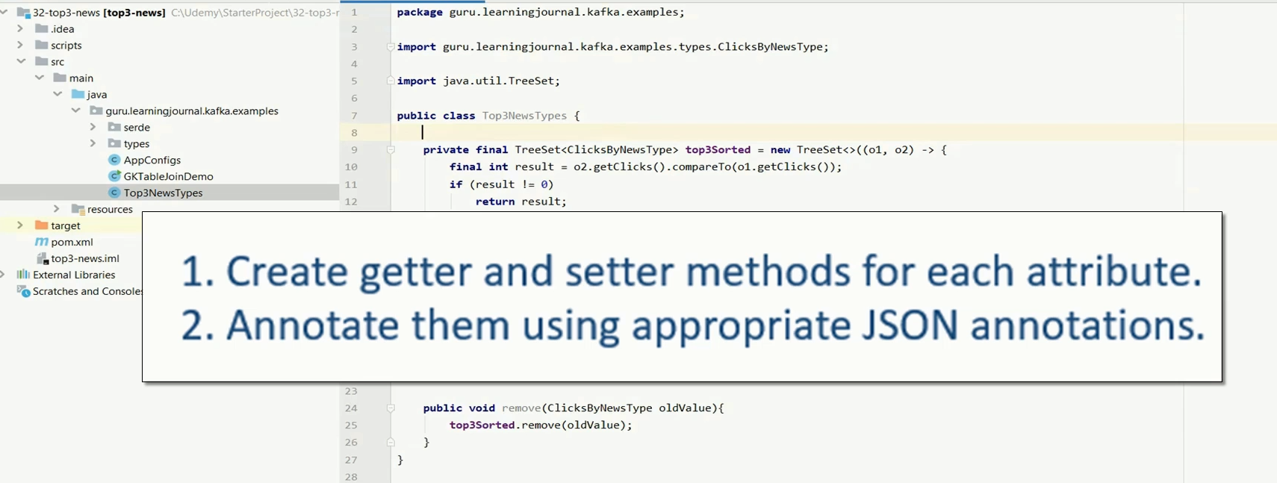

Now, let's add the annotations. Annotate the class to include only non-nulls and ignore the null values on serializing. Then, we annotate the class with the list of properties. However, we have just one. Finally, we annotate the getter and setter methods. That is all. Our class is ready. Let's see how can we use it to compute top3 news types. If you remember the step by step process for computing top3 in real-time, all we wanted to do is to add and remove the ClicksByNewsType into our smart data structure. Right? And that's what the aggregate method is designed for? So, we start with the KGroupedTable and apply an aggregate method.

As we learned in the earlier section, the aggregate method takes three mandatory arguments. Initializer Adder Subtractor The initializer is as simple as to create an empty data structure. The adder method takes three arguments, key, new event, and the previous aggregated values. All we need to do is to add the new value to the previously aggregated value and return the new aggregated value. That is all. Sorting and maintaining only three records is taken care of by the data structure. The next one is the subtractor. This one is also the same, but it removes the given element from the data structure. What else? Don't forget to provide the materialization details. That's all. Here is the code to print the top 3 news items. Do you want to execute it? Let's do it. Start the Kafka Cluster. Create topics. Start a producer and send the master inventory list. Start the other producer and also start the application. Now you can start simulating the clicks. Let me send the first click. What is the result? As expected. Right? Let me push two more clicks. Great! So, we have a sorted list. All of them have the same number of clicks, and hence, they are sorted alphabetically.

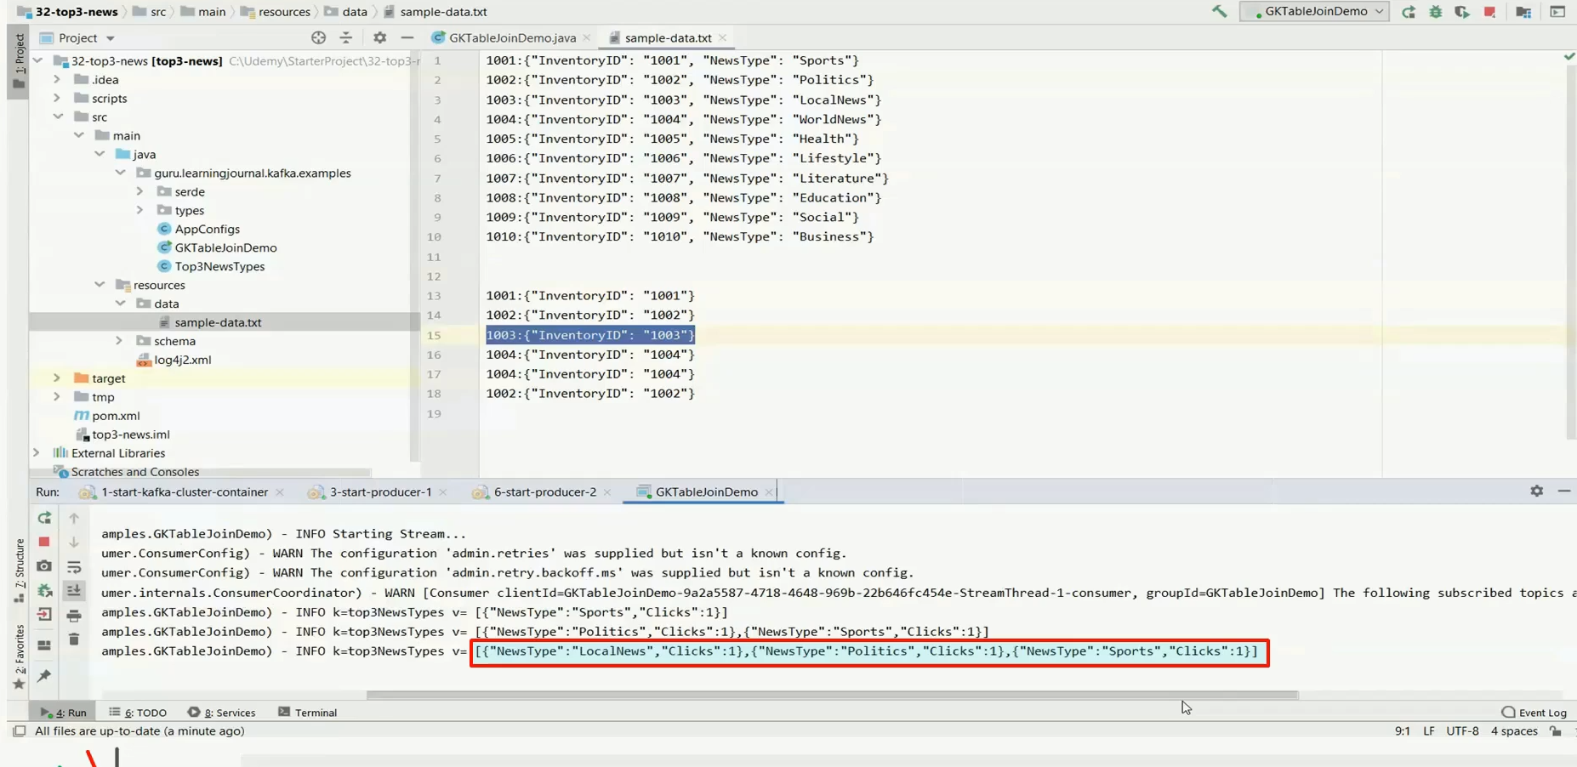

Let's push the fourth one. No Change, and that's what we expected. Why? Because the fourth one is the world-news, which is alphabetically in the fourth position. And we are tracking only the top three. Let me push the world news once again. Now, you can see, the world-news is landing at the first position with two clicks, and the Sports news is thrown out of the top-three list. Let me push the Politics this time.

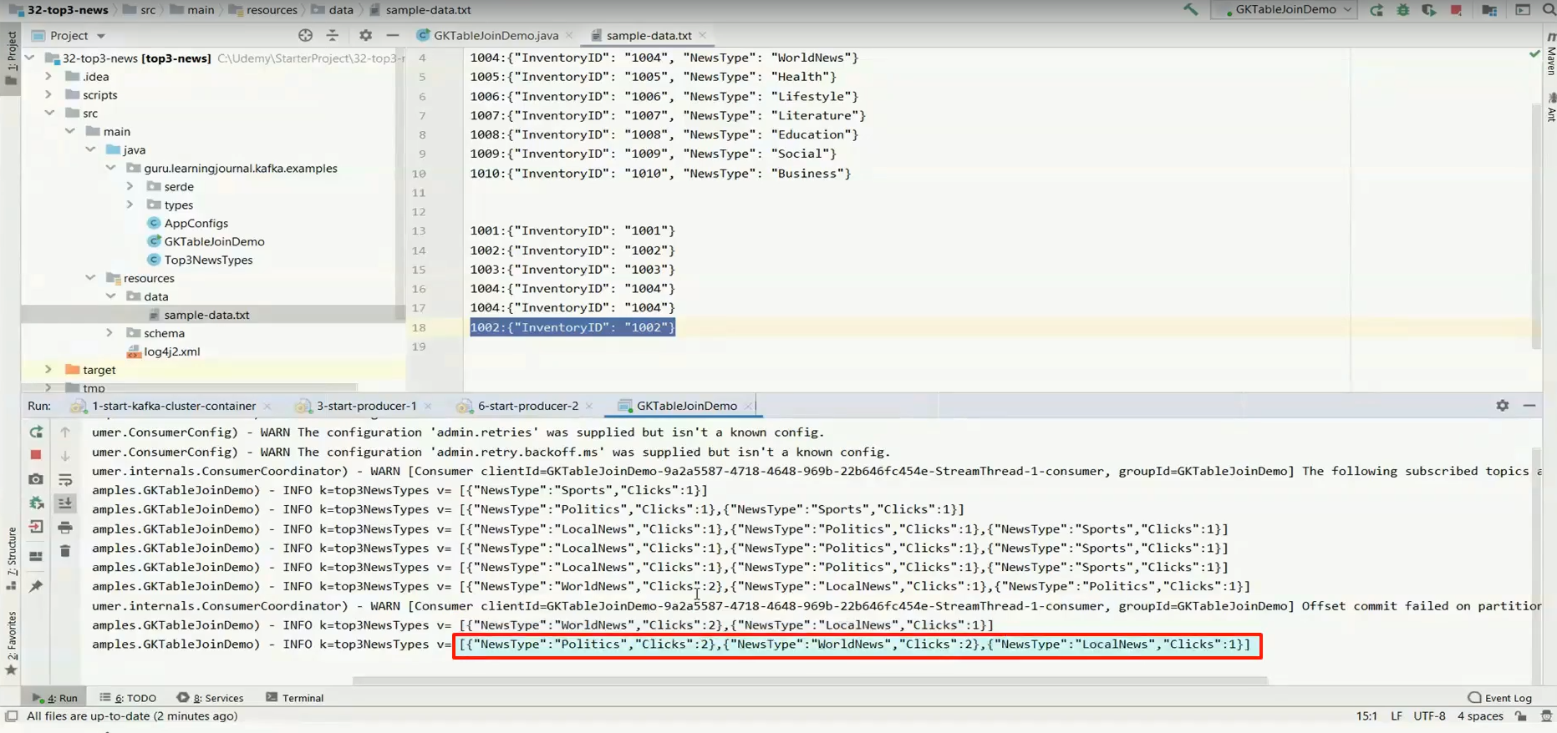

Great! So the first action was taken to remove the politics from the list, and then it is added back with a value of two clicks.

Rest of the code

**pom.xml**

<?xml version="1.0" encoding="UTF-8"?>

<project xmlns="http://maven.apache.org/POM/4.0.0"

xmlns:xsi="http://www.w3.org/2001/XMLSchema-instance"

xsi:schemaLocation="http://maven.apache.org/POM/4.0.0 http://maven.apache.org/xsd/maven-4.0.0.xsd">

<modelVersion>4.0.0</modelVersion>

<groupId>guru.learningjournal.kafka.examples</groupId>

<artifactId>top3-news</artifactId>

<version>2.3.0</version>

<properties>

<java.version>1.8</java.version>

<kafka.version>2.3.0</kafka.version>

<project.build.sourceEncoding>UTF-8</project.build.sourceEncoding>

</properties>

<build>

<plugins>

<!-- Maven Compiler Plugin-->

<plugin>

<groupId>org.apache.maven.plugins</groupId>

<artifactId>maven-compiler-plugin</artifactId>

<version>3.8.0</version>

<configuration>

<source>${java.version}</source>

<target>${java.version}</target>

</configuration>

</plugin>

<!-- Json Schema to POJO plugin-->

<plugin>

<groupId>org.jsonschema2pojo</groupId>

<artifactId>jsonschema2pojo-maven-plugin</artifactId>

<version>0.5.1</version>

<executions>

<execution>

<goals>

<goal>generate</goal>

</goals>

<configuration>

<sourceDirectory>

${project.basedir}/src/main/resources/schema/

</sourceDirectory>

<outputDirectory>

${project.basedir}/src/main/java/

</outputDirectory>

<includeAdditionalProperties>false</includeAdditionalProperties>

<includeHashcodeAndEquals>false</includeHashcodeAndEquals>

<generateBuilders>true</generateBuilders>

</configuration>

</execution>

</executions>

</plugin>

</plugins>

</build>

<dependencies>

<!--Apache commons-->

<dependency>

<groupId>commons-lang</groupId>

<artifactId>commons-lang</artifactId>

<version>2.6</version>

</dependency>

<!-- Apache Kafka Streams-->

<dependency>

<groupId>org.apache.kafka</groupId>

<artifactId>kafka-streams</artifactId>

<version>${kafka.version}</version>

</dependency>

<!-- Apache Log4J2 binding for SLF4J -->

<dependency>

<groupId>org.apache.logging.log4j</groupId>

<artifactId>log4j-slf4j-impl</artifactId>

<version>2.11.0</version>

</dependency>

</dependencies>

</project>

### Mixing Joins with Aggregates - Advert CTR

In the previous lecture, we created an example to implement a join and aggregation altogether. In this lecture, we are going to create another one to help you understand how all these things fit together in a real-life streaming application. However, this example is going to be simpler than the earlier one. So, let's start.

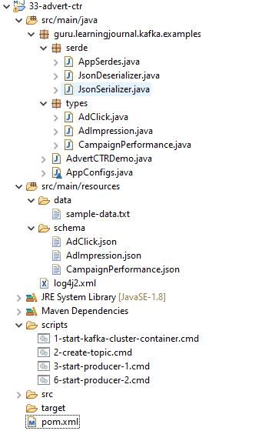

We already talked about a popular news website where you directly sell advertising campaigns to your customers. On any given day, you start some new campaigns and retire some old ones



In this example, we want to create a stream application to monitor campaign performance. To measure the performance, we want to compute two things. The total number of ad impressions that are shown up on the website. And then, the number of ad clicks. I mean, we want to compute the number of adverts displayed and how many of those are actually clicked. Once you have these two numbers, you can quickly calculate the click-through rate, which is an essential metric for measuring online advertisement effectiveness. Let us assume that you have one Kafka topic. When a user visits a webpage on your site, an advert impression is generated. You are sending this impression to your Kafka topic. Here are some sample impression events. Now you are supposed to create an application that counts the number of impressions by the Campaigner. Can you do it? I am sure you can. You can easily count the number of impressions by subscribing to the topic, grouping it by the campaigner, and then applying the count aggregate. Right? The outcome of this exercise should be something, as shown here. Make sense? Now let's come to the second part of the requirement. Whenever an impression is clicked, a copy of the same event also flows to the second Kafka topic to represent a click. Let's assume the following ad click events are generated and sent to the second topic. We want to extend the same application and also count the number of clicks by the campaigner. You should be able to do that also. All you do is subscribe to the topic, group it by the campaigner, and count. Right? The outcome of this activity should look like this. Great! Now let's come to the final requirement. We want to compute the Click Through Rate by each campaigner. The outcome should look like this. Make sense? Great! I am not going to do this here. I leave it as an exercise for you to develop yourself.

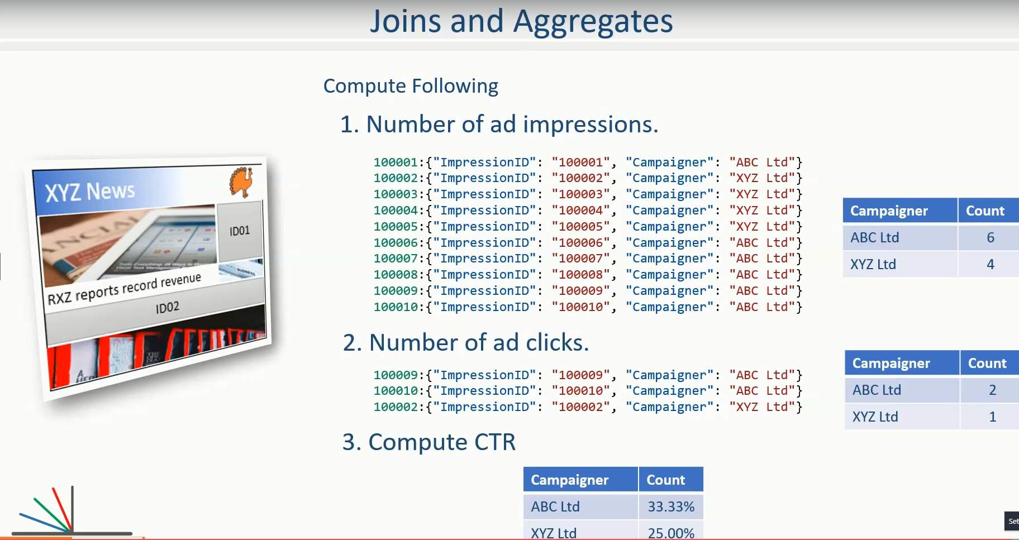

However, if you feel stuck, I have included code in your learning material. You can refer it to your comfort. But I recommend that you must give it an honest try and do it yourself without any help.

**Course # 71 – 77**

**Kafka Connect**

**Confluent Platform**

**Spring Reactive Kafka**

<https://projectreactor.io/docs/kafka/release/reference/#_overview>

**Overview**

This section describes the reactive API for producing and consuming messages using Apache Kafka. There are two main interfaces in Reactor Kafka:

reactor.kafka.sender.KafkaSender for publishing messages to Kafka

reactor.kafka.receiver.KafkaReceiver for consuming messages from Kafka

Full API for Reactor Kafka is available in the javadocs.

The project uses Reactor Core to expose a "Reactive Streams" API.

**Reactive Kafka Sender**

Outbound messages are sent to Kafka using reactor.kafka.sender.KafkaSender. Senders are thread-safe and can be shared across multiple threads to improve throughput. A KafkaSender is associated with one KafkaProducer that is used to transport messages to Kafka.

A KafkaSender is created with an instance of sender configuration options reactor.kafka.sender.SenderOptions. Changes made to SenderOptions after the creation of KafkaSender will not be used by the KafkaSender. The properties of SenderOptions such as a list of bootstrap Kafka brokers and serializers are passed down to the underlying KafkaProducer. The properties may be configured on the SenderOptions instance at creation time or by using the setter SenderOptions#producerProperty. Other configuration options for the reactive KafkaSender like the maximum number of in-flight messages can also be configured before the KafkaSender instance is created.

The generic types of SenderOptions<K, V> and KafkaSender<K, V> are the key and value types of producer records published using the KafkaSender and corresponding serializers must be set on the SenderOptions instance before the KafkaSender is created.

Map<String, Object> producerProps = new HashMap<>();

producerProps.put(ProducerConfig.BOOTSTRAP_SERVERS_CONFIG, bootstrapServers);

producerProps.put(ProducerConfig.KEY_SERIALIZER_CLASS_CONFIG, IntegerSerializer.class);

producerProps.put(ProducerConfig.VALUE_SERIALIZER_CLASS_CONFIG, StringSerializer.class);

SenderOptions<Integer, String> senderOptions =

SenderOptions.<Integer, String>create(producerProps)

.maxInFlight(1024);

1. Specify properties for underlying KafkaProducer
2. Configure options for reactive KafkaSender

Once the required options have been configured on the options instance, a new KafkaSender instance can be created with the options already configured in senderOptions.

KafkaSender<Integer, String> sender = KafkaSender.create(senderOptions);

The KafkaSender is now ready to send messages to Kafka. The underlying KafkaProducer instance is created lazily when the first message is ready to be sent. At this point, a KafkaSender instance has been created, but no connections to Kafka have been made yet.

Let’s now create a sequence of messages to send to Kafka. Each outbound message to be sent to Kafka is represented as a SenderRecord. A SenderRecord is a Kafka ProducerRecord with additional correlation metadata for matching send results to records. ProducerRecord consists of a key/value pair to send to Kafka and the name of the Kafka topic to send the message to. Producer records may also optionally specify a partition to send the message to or use the configured partitioner to choose a partition. Timestamp may also be optionally specified in the record and if not specified, the current timestamp will be assigned by the Producer. The additional correlation metadata included in SenderRecord is not sent to Kafka, but is included in the SendResult generated for the record when the send operation completes or fails. Since results of sends to different partitions may be interleaved, the correlation metadata enables results to be matched to their corresponding record.

A Flux<SenderRecord> of records is created for sending to Kafka. For beginners, Lite Rx API Hands-on provides a hands-on tutorial on using the Reactor classes Flux and Mono.

Flux<SenderRecord<Integer, String, Integer>> outboundFlux =

Flux.range(1, 10)

.map(i -> SenderRecord.create(topic, partition, timestamp, i, "Message_" + i, i));

The code segment above creates a sequence of messages to send to Kafka, using the message index as correlation metadata in each SenderRecord. The outbound Flux can now be sent to Kafka using the KafkaSender created earlier.

The code segment below sends the records to Kafka and prints out the response metadata received from Kafka and the correlation metadata for each record. The final subscribe() in the code block requests upstream to send the records to Kafka and the response metadata received from Kafka flow downstream. As each result is received, the record metadata from Kafka along with the correlation metadata identifying the record is printed out to console by the onNext handler. The response from Kafka includes the partition to which the record was sent as well as the offset at the which the record was appended, if available. When records are sent to multiple partitions, responses arrive in order for each partition, but responses from different partitions may be interleaved.

sender.send(outboundFlux)

.doOnError(e-> log.error("Send failed", e))

.doOnNext(r -> System.out.printf("Message #%d send response: %s\n", r.correlationMetadata(), r.recordMetadata()))

.subscribe();

Reactive send operation for the outbound Flux

If Kafka send fails, log an error

Print metadata returned by Kafka and the message index in correlationMetadata()

Subscribe to trigger the actual flow of records from outboundFlux to Kafka.

See github.com/reactor/reactor-kafka/blob/master/reactor-kafka-samples/src/main/java/reactor/kafka/samples/SampleProducer.java for the full code listing of a sample producer.

**Error handling**

public SenderOptions<K, V> stopOnError(boolean stopOnError);

SenderOptions#stopOnError() specifies whether each send sequence should fail immediately if one record could not delivered to Kafka after the configured number of retries or wait until all records have been processed. This can be used along with ProducerConfig#ACKS_CONFIG and ProducerConfig#RETRIES_CONFIG to configure the required quality of service.

<T> Flux<SenderResult<T>> send(Publisher<SenderRecord<K, V, T>> outboundRecords);

If stopOnError is false, a success or error response is returned for each outgoing record. For error responses, the exception from Kafka indicating the reason for send failure is set on SenderResult and can be retrieved using SenderResult#exception(). The Flux fails with an error after attempting to send all records published on outboundRecords. If outboundRecords is a non-terminating Flux, send continues to send records published on this Flux until the result Flux is explicitly cancelled by the user.

If stopOnError is true, a response is returned for the first failed send and the result Flux is terminated immediately with an error. Since multiple outbound messages may be in-flight at any time, it is possible that some messages are delivered successfully to Kafka after the first failure is detected. SenderOptions#maxInFlight() option may be configured to limit the number of messages in-flight at any time.

**Send without result metadata**

If individual results are not required for each send request, ProducerRecord can be sent to Kafka without providing correlation metadata using the KafkaOutbound interface. KafkaOutbound is a fluent interface that enables sends to be chained together.

KafkaOutbound<K, V> send(Publisher<? extends ProducerRecord<K, V>> outboundRecords);

The send sequence is initiated by subscribing to the Mono obtained from KafkaOutbound#then(). The returned Mono completes successfully if all the outbound records are delivered successfully. The Mono terminates on the first send failure. If outboundRecords is a non-terminating Flux, records continue to be sent to Kafka unless a send fails or the returned Mono is cancelled.

sender.createOutbound()

.send(Flux.range(1, 10)

.map(i -> new ProducerRecord<Integer, String>(topic, i, "Message_" + i)))

.then()

.doOnError(e -> e.printStackTrace())

.doOnSuccess(s -> System.out.println("Sends succeeded"))

.subscribe();

1. Create ProducerRecord Flux. Records are not wrapped in SenderRecord
2. Get the Mono to subscribe to for starting the message flow
3. Error indicates failure to send one or more records
4. Success indicates all records were published, individual partitions or offsets not returned
5. Subscribe to request the actual sends

Multiple sends can be chained together using a sequence of sends on KafkaOutbound. When the Mono returned from KafkaOutbound#then() is subscribed to, the sends are invoked in sequence in the declaration order. The sequence is cancelled if any of the sends fail after the configured number of retries.

sender.createOutbound()

.send(flux1)

.send(flux2)

.send(flux3)

.then()

.doOnError(e -> e.printStackTrace())

.doOnSuccess(s -> System.out.println("Sends succeeded"))

.subscribe();

1. Sends flux1, flux2 and flux3 in order
2. Get the Mono to subscribe to for starting the message flow sequence
3. Error indicates failure to send one or more records from any of the sends in the chain
4. Success indicates successful send of all records from the whole chain
5. Subscribe to initiate the sequence of sends in the chain

Note that in all cases the retries configured for the KafkaProducer are attempted and failures returned by the reactive KafkaSender indicate a failure to send after the configured number of retry attempts. Retries can result in messages being delivered out of order. The producer property ProducerConfig#MAX_IN_FLIGHT_REQUESTS_PER_CONNECTION may be set to one to avoid re-ordering.

**Threading model**

KafkaProducer uses a separate network thread for sending requests and processing responses. To ensure that the producer network thread is never blocked by applications while processing results, KafkaSender delivers responses to applications on a separate scheduler. By default, this is a single threaded pooled scheduler that is freed when no longer required. The scheduler can be overridden if required, for instance, to use a parallel scheduler when the Kafka sends are part of a larger pipeline. This is done on the SenderOptions instance before the KafkaSender instance is created using:

public SenderOptions<K, V> scheduler(Scheduler scheduler);

**Non-blocking back-pressure**

The number of in-flight sends can be controlled using the maxInFlight option. Requests for more elements from upstream are limited by the configured maxInFlight to ensure that the total number of requests at any time for which responses are pending are limited. Along with buffer.memory and max.block.ms options on KafkaProducer, maxInFlight enables control of memory and thread usage when KafkaSender is used in a reactive pipeline. This option can be configured on SenderOptions before the KafkaSender is created. Default value is 256. For small messages, a higher value will improve throughput.

public SenderOptions<K, V> maxInFlight(int maxInFlight);

**Closing the KafkaSender**

When the KafkaSender is no longer required, the KafkaSender instance can be closed. The underlying KafkaProducer is closed, closing all client connections and freeing all memory used by the producer.

sender.close();

**Access to the underlying KafkaProducer**

Reactive applications may sometimes require access to the underlying producer instance to perform actions that are not exposed by the KafkaSender interface. For example, an application might need to know the number of partitions in a topic in order to choose the partition to send a record to. Operations that are not provided directly by KafkaSender like send can be run on the underlying KafkaProducer using KafkaSender#doOnProducer.

sender.doOnProducer(producer -> producer.partitionsFor(topic))

.doOnSuccess(partitions -> System.out.println("Partitions " + partitions))

.subscribe();

User provided methods are executed asynchronously. A Mono is returned by doOnProducer which completes with the value returned by the user-provided function.

**Reactive Kafka Receiver**

Messages stored in Kafka topics are consumed using the reactive receiver reactor.kafka.receiver.KafkaReceiver. Each instance of KafkaReceiver is associated with a single instance of KafkaConsumer. KafkaReceiver is not thread-safe since the underlying KafkaConsumer cannot be accessed concurrently by multiple threads.

A receiver is created with an instance of receiver configuration options reactor.kafka.receiver.ReceiverOptions. Changes made to ReceiverOptions after the creation of the receiver instance will not be used by the KafkaReceiver. The properties of ReceiverOptions such as a list of bootstrap Kafka brokers and de-serializers are passed down to the underlying KafkaConsumer. These properties may be configured on the ReceiverOptions instance at creation time or by using the setter ReceiverOptions#consumerProperty. Other configuration options for the reactive KafkaReceiver including subscription topics must be added to options before the KafkaReceiver instance is created.

The generic types of ReceiverOptions<K, V> and KafkaReceiver<K, V> are the key and value types of consumer records consumed using the receiver and corresponding de-serializers must be set on the ReceiverOptions instance before the KafkaReceiver is created.

Map<String, Object> consumerProps = new HashMap<>();

consumerProps.put(ConsumerConfig.BOOTSTRAP_SERVERS_CONFIG, bootstrapServers);

consumerProps.put(ConsumerConfig.GROUP_ID_CONFIG, "sample-group");

consumerProps.put(ConsumerConfig.KEY_DESERIALIZER_CLASS_CONFIG, IntegerDeserializer.class);

consumerProps.put(ConsumerConfig.VALUE_DESERIALIZER_CLASS_CONFIG, StringDeserializer.class);

ReceiverOptions<Integer, String> receiverOptions =

ReceiverOptions.<Integer, String>create(consumerProps)

.subscription(Collections.singleton(topic));

1. Specify properties to be provided to KafkaConsumer
2. Topics to subscribe to

Once the required configuration options have been configured on the options instance, a new KafkaReceiver instance can be created with these options to consume inbound messages. The code block below creates a receiver instance and creates an inbound Flux for the receiver. The underlying KafkaConsumer instance is created lazily later when the inbound Flux is subscribed to.

Flux<ReceiverRecord<Integer, String>> inboundFlux =

KafkaReceiver.create(receiverOptions)

.receive();

The inbound Kafka Flux is ready to be consumed. Each inbound message delivered by the Flux is represented as a ReceiverRecord. Each receiver record is a ConsumerRecord returned by KafkaConsumer along with a committable ReceiverOffset instance. The offset must be acknowledged after the message is processed since unacknowledged offsets will not be committed. If commit interval or commit batch size are configured, acknowledged offsets will be committed periodically. Offsets may also be committed manually using ReceiverOffset#commit() if finer grained control of commit operations is required.

inboundFlux.subscribe(r -> {

System.out.printf("Received message: %s\n", r);

r.receiverOffset().acknowledge();

});

1. Prints each consumer record from Kafka
2. Acknowledges that the record has been processed so that the offset may be committed

**Subscribing to wildcard patterns**

The example above subscribed to a single Kafka topic. The same API can be used to subscribe to more than one topic by specifying multiple topics in the collection provided to ReceiverOptions#subscription(). Subscription can also be made to a wildcard pattern by specifying a pattern to subscribe to. Group management in KafkaConsumer dynamically updates topic assignment when topics matching the pattern are created or deleted and assigns partitions of matching topics to available consumer instances.

receiverOptions = receiverOptions.subscription(Pattern.compile("demo.*"));

Consume records from all topics starting with "demo"

Changes to ReceiverOptions must be made before the receiver instance is created. Altering the subscription deletes any existing subscriptions on the options instance.

**Manual assignment of topic partitions**

Partitions may be manually assigned to the receiver without using Kafka consumer group management.

receiverOptions = receiverOptions.assignment(

Collections.singleton(new TopicPartition(topic, 0)));

Consume from partition 0 of specified topic

Existing subscriptions and assignments on the options instance are deleted when a new assignment is specified. Every receiver created from this options instance with manual assignment consumes messages from all the specified partitions.

**Controlling commit frequency**

Commit frequency can be controlled using a combination of commit interval and commit batch size. Commits are performed when either the interval or batch size is reached. One or both of these options may be set on ReceiverOptions before the receiver instance is created. If commit interval is configured, at least one commit is scheduled within that interval if any records were consumed. If commit batch size is configured, a commit is scheduled when the configured number of records are consumed and acknowledged.

Manual acknowledgement of consumed records after processing along with automatic commits based on the configured commit frequency provides at-least-once delivery semantics. Messages are re-delivered if the consuming application crashes after message was dispatched but before it was processed and acknowledged. Only offsets explicitly acknowledged using ReceiverOffset#acknowledge() are committed. Note that acknowledging an offset acknowledges all previous offsets on the same partition. All acknowledged offsets are committed when partitions are revoked during rebalance and when the receive Flux is terminated.

Applications which require fine-grained control over the timing of commit operations can disable periodic commits and explicitly invoke ReceiverOffset#commit() when required to trigger a commit. This commit is asynchronous by default, but the application many invoke Mono#block() on the returned Mono to implement synchronous commits. Applications may batch commits by acknowledging messages as they are consumed and invoking commit() periodically to commit acknowledged offsets.

receiver.receive()

.doOnNext(r -> {

process(r);

r.receiverOffset().commit().block();

});

Note that committing an offset acknowledges and commits all previous offsets on that partition. All acknowledged offsets are committed when partitions are revoked during rebalance and when the receive Flux is terminated.

**Auto-acknowledgement of batches of records**

KafkaReceiver#receiveAutoAck returns a Flux of batches of records returned by each KafkaConsumer#poll(). The records in each batch are automatically acknowledged when the Flux corresponding to the batch terminates.

KafkaReceiver.create(receiverOptions)

.receiveAutoAck()

.concatMap(r -> r)

.subscribe(r -> System.out.println("Received: " + r));

1. Concatenate in order
2. Print out each consumer record received, no explicit ack required

The maximum number of records in each batch can be controlled using the KafkaConsumer property MAX_POLL_RECORDS. This is used together with the fetch size and wait times configured on the KafkaConsumer to control the amount of data fetched from Kafka brokers in each poll. Each batch is returned as a Flux that is acknowledged after the Flux terminates. Acknowledged records are committed periodically based on the configured commit interval and batch size. This mode is simple to use since applications do not need to perform any acknowledge or commit actions. It is efficient as well and can be used for at-least-once delivery of messages.

**Disabling automatic commits**

Applications which don’t require offset commits to Kafka may disable automatic commits by not acknowledging any records consumed using KafkaReceiver#receive().

receiverOptions = ReceiverOptions.<Integer, String>create()

.commitInterval(Duration.ZERO)

.commitBatchSize(0);

KafkaReceiver.create(receiverOptions)

.receive()

.subscribe(r -> process(r));

1. Disable periodic commits
2. Disable commits based on batch size
3. Process records, but don’t acknowledge

**At-most-once delivery**

Applications may disable automatic commits to avoid re-delivery of records. ConsumerConfig#AUTO_OFFSET_RESET_CONFIG can be configured to "latest" to consume only new records. But this could mean that an unpredictable number of records are not consumed if an application fails and restarts.

KafkaReceiver#receiveAtmostOnce can be used to consume records with at-most-once semantics with a configurable number of records-per-partition that may be lost if the application fails or crashes. Offsets are committed synchronously before the corresponding record is dispatched. Records are guaranteed not to be re-delivered even if the consuming application fails, but some records may not be processed if an application fails after the commit before the records could be processed.

This mode is expensive since each record is committed individually and records are not delivered until the commit operation succeeds. ReceiverOptions#atmostOnceCommitCommitAheadSize may be configured to reduce the cost of commits and avoid blocking before dispatch if the offset of the record has already been committed. By default, commit-ahead is disabled and at-most one record is lost per-partition if an application crashes. If commit-ahead is configured, the maximum number of records that may be lost per-partition is ReceiverOptions#atmostOnceCommitCommitAheadSize + 1.

KafkaReceiver.create(receiverOptions)

.receiveAtmostOnce()

.subscribe(r -> System.out.println("Received: " + r));

Process each consumer record, this record is not re-delivered if the processing fails

**Partition assignment and revocation listeners**

Applications can enable assignment and revocation listeners to perform any actions when partitions are assigned or revoked from a consumer.

When group management is used, assignment listeners are invoked whenever partitions are assigned to the consumer after a rebalance operation. When manual assignment is used, assignment listeners are invoked when the consumer is started. Assignment listeners can be used to seek to particular offsets in the assigned partitions so that messages are consumed from the specified offset.

When group management is used, revocation listeners are invoked whenever partitions are revoked from a consumer after a rebalance operation. When manual assignment is used, revocation listeners are invoked before the consumer is closed. Revocation listeners can be used to commit processed offsets when manual commits are used. Acknowledged offsets are automatically committed on revocation if automatic commits are enabled.

**Controlling start offsets for consuming records**

By default, receivers start consuming records from the last committed offset of each assigned partition. If a committed offset is not available, the offset reset strategy ConsumerConfig#AUTO_OFFSET_RESET_CONFIG configured for the KafkaConsumer is used to set the start offset to the earliest or latest offset on the partition. Applications can override offsets by seeking to new offsets in an assignment listener. Methods are provided on ReceiverPartition to seek to the earliest, latest or a specific offset in the partition.

void seekToBeginning();

void seekToEnd();

void seek(long offset);

For example, the following code block starts consuming messages from the latest offset.

receiverOptions = receiverOptions

.addAssignListener(partitions -> partitions.forEach(p -> p.seekToEnd()))

.subscription(Collections.singleton(topic));

KafkaReceiver.create(receiverOptions).receive().subscribe();

Seek to the last offset in each assigned partition

**Consumer lifecycle**

Each KafkaReceiver instance is associated with a KafkaConsumer that is created when the inbound Flux returned by one of the receive methods in KafkaReceiver is subscribed to. The consumer is kept alive until the Flux completes. When the Flux completes, all acknowledged offsets are committed and the underlying consumer is closed.

Only one receive operation may be active in a KafkaReceiver at any one time. Any of the receive methods can be invoked after the receive Flux corresponding to the last receive is terminated.

**Sample Scenarios**

This section shows sample code segments for typical scenarios where Reactor Kafka API may be used. Full code listing for these scenarios are included in the samples sub-project.

**Sending records to Kafka**

See KafkaSender API for details on the KafkaSender API for sending outbound records to Kafka. The following code segment creates a simple pipeline that sends records to Kafka and processes the responses. The outbound flow is triggered when the returned Flux is subscribed to.

KafkaSender.create(SenderOptions.<Integer, String>create(producerProps).maxInFlight(512))

.send(outbound.map(r -> senderRecord(r)))

.doOnNext(result -> processResponse(result))

.doOnError(e -> processError(e));

1. Create a sender with maximum 512 messages in-flight
2. Send a sequence of sender records
3. Process send result when onNext is triggered

**Replaying records from Kafka topics**

See KafkaReceiver API for details on the KafkaReceiver API for consuming records from Kafka topics. The following code segment creates a Flux that replays all records on a topic and commits offsets after processing the messages. Manual acknowledgement provides at-least-once delivery semantics.

ReceiverOptions<Integer, String> options =

ReceiverOptions.<Integer, String>create(consumerProps)

.consumerProperty(ConsumerConfig.AUTO_OFFSET_RESET_CONFIG, "earliest")

.commitBatchSize(10)

.subscription(Collections.singleton("demo-topic"));

KafkaReceiver.create(options)

.receive()

.doOnNext(r -> {

processRecord(r);

r.receiverOffset().acknowledge();

});

1. Start consuming from first available offset on each partition if committed offsets are not available
2. Commit every 10 acknowledged messages
3. Topics to consume from
4. Process consumer record from Kafka
5. Acknowledge that record has been consumed

**Reactive pipeline with Kafka sink**

The code segment below consumes messages from an external source, performs some transformation and stores the output records in Kafka. Large number of retry attempts are configured on the Kafka producer so that transient failures don’t impact the pipeline. Source commits are performed only after records are successfully written to Kafka.

senderOptions = senderOptions

.producerProperty(ProducerConfig.ACKS_CONFIG, "all")

.producerProperty(ProducerConfig.RETRIES_CONFIG, Integer.MAX_VALUE)

.maxInFlight(128);

KafkaSender.create(senderOptions)

.send(source.flux().map(r -> transform(r)))

.doOnError(e-> log.error("Send failed, terminating.", e))

.doOnNext(r -> source.commit(r.correlationMetadata()));

1. Send is acknowledged by Kafka for acks=all after message is delivered to all in-sync replicas
2. Large number of retries in the producer to cope with transient failures in brokers
3. Low in-flight count to avoid filling up producer buffer and blocking the pipeline, default stopOnError=true
4. Receive from external source, transform and send to Kafka
5. If a send fails, it indicates catastrophic error, fail the whole pipeline
6. Use correlation metadata in the sender record to commit source record

**Reactive pipeline with Kafka source**

The code segment below consumes records from Kafka topics, transforms the record and sends the output to an external sink. Kafka consumer offsets are committed after records are successfully output to sink.

receiverOptions = receiverOptions

.commitInterval(Duration.ZERO)

.commitBatchSize(0)

.subscription(Pattern.compile(topics));

KafkaReceiver.create(receiverOptions)

.receive()

.publishOn(Schedulers.newSingle("sample", true))

.concatMap(m -> sink.store(transform(m))

.doOnSuccess(r -> m.receiverOffset().commit().block()));

1. Disable periodic commits
2. Disable commits by batch size
3. Wildcard subscription
4. Tranform Kafka record and store in external sink
5. Synchronous commit after record is successfully delivered to sink

**Reactive pipeline with Kafka source and sink**

The code segment below consumes messages from Kafka topic, performs some transformation on the incoming messages and stores the result in some Kafka topics. Manual acknowledgement mode provides at-least-once semantics with messages acknowledged after the output records are delivered to Kafka. Acknowledged offsets are committed periodically based on the configured commit interval.

receiverOptions = receiverOptions

.commitInterval(Duration.ofSeconds(10))

.subscription(Pattern.compile(topics));

sender.send(KafkaReceiver.create(receiverOptions)

.receive()

.map(m -> SenderRecord.create( transform(m.value()),

m.receiverOffset())) )

.doOnNext(m -> m.correlationMetadata().acknowledge());

1. Configure interval for automatic commits
2. Transform incoming record and create outbound record with transformed data in the payload and inbound offset as correlation metadata

Acknowledge the inbound offset using the offset instance in correlation metadata after outbound record is delivered to Kafka

**At-most-once delivery**

The code segment below demonstrates a flow with at-most once delivery. Producer does not wait for acks and does not perform any retries. Messages that cannot be delivered to Kafka on the first attempt are dropped. KafkaReceiver commits offsets before delivery to the application to ensure that if the consumer restarts, messages are not redelivered. With replication factor 1 for topic partitions, this code can be used for at-most-once delivery.

senderOptions = senderOptions

.producerProperty(ProducerConfig.ACKS_CONFIG, "0")

.producerProperty(ProducerConfig.RETRIES_CONFIG, "0")

.stopOnError(false);

receiverOptions = receiverOptions

.subscription(Collections.singleton(sourceTopic));

KafkaSender.create(senderOptions)

.send(KafkaReceiver.create(receiverOptions)

.receiveAtmostOnce()

.map(cr -> SenderRecord.create( transform(cr.value()),

cr.offset())));

1. Send with acks=0 completes when message is buffered locally, before it is delivered to Kafka broker
2. No retries in producer
3. Ignore any error and continue to send remaining records
4. At-most-once receive

**Fan-out with Multiple Streams**

The code segment below demonstrates fan-out with the same records processed in multiple independent streams. Each stream is processed on a different thread and which transforms the input record and stores the output in a Kafka topic.

Reactor’s EmitterProcessor is used to broadcast the input records from Kafka to multiple subscribers.

EmitterProcessor<Person> processor = EmitterProcessor.create();

BlockingSink<Person> incoming = processor.connectSink();

inputRecords = KafkaReceiver.create(receiverOptions)

.receive()

.doOnNext(m -> incoming.emit(m.value()));

outputRecords1 = processor.publishOn(scheduler1).map(p -> process1(p));

outputRecords2 = processor.publishOn(scheduler2).map(p -> process2(p));

Flux.merge(sender.send(outputRecords1), sender.send(outputRecords2))

.doOnSubscribe(s -> inputRecords.subscribe())

.subscribe();

1. Create publish/subscribe EmitterProcessor for fan-out of Kafka inbound records
2. Create BlockingSink to which records are emitted
3. Receive from Kafka and emit to BlockingSink
4. Consume records on a scheduler, process and generate output records to send to Kafka
5. Add another processor for the same input data on a different scheduler
6. Merge the streams and subscribe to start the flow

**Concurrent Processing with Partition-Based Ordering**

The code segment below demonstrates a flow where messages are consumed from a Kafka topic, processed by multiple threads and the results stored in another Kafka topic. Messages are grouped by partition to guarantee ordering in message processing and commit operations. Messages from each partition are processed on a single thread.

Scheduler scheduler = Schedulers.newElastic("sample", 60, true);

KafkaReceiver.create(receiverOptions)

.receive()

.groupBy(m -> m.receiverOffset().topicPartition())

.flatMap(partitionFlux ->

partitionFlux.publishOn(scheduler)

.map(r -> processRecord(partitionFlux.key(), r))

.sample(Duration.ofMillis(5000))

.concatMap(offset -> offset.commit()));

1. Group by partition to guarantee ordering
2. Commit periodically
3. Commit in sequence using concatMap

**Transactional send**

The code segment below consumes messages from an external source, performs some transformation and stores multiple transformed records in different Kafka topics within a transaction.

senderOptions = senderOptions

.producerProperty(ProducerConfig.TRANSACTIONAL_ID_CONFIG, "SampleTxn");

KafkaSender.create(senderOptions)

.sendTransactionally(source.map(r -> Flux.fromIterable(transform(r))))

.concatMap(r -> r)

.doOnError(e-> log.error("Send failed, terminating.", e))

.doOnNext(r -> log.debug("Send completed {}", r.correlationMetadata());

1. Configure transactional id for producer
2. Send multiple records generated from each source record within a transaction

**Exactly-once delivery**

The code segment below demonstrates a flow with exactly once delivery. Source records received from a Kafka topic are transformed and sent to Kafka. Each batch of records is delivered to the application in a new transaction. Offsets of the source records of each batch are automatically committed within its transaction. Each transaction is committed by the application after the transformed records of the batch are successfully delivered to the destination topic. Next batch of records is delivered to the application in a new transaction after the current transaction is committed.

senderOptions = senderOptions

.producerProperty(ProducerConfig.TRANSACTIONAL_ID_CONFIG, "SampleTxn");

receiverOptions = receiverOptions

.consumerProperty(ConsumerConfig.ISOLATION_LEVEL_CONFIG, "read_committed")

.subscription(Collections.singleton(sourceTopic));

sender = KafkaSender.create(senderOptions);

transactionManager = sender.transactionManager();

receiver.receiveExactlyOnce(transactionManager)

.concatMap(f -> sender.send(f.map(r -> transform(r)))

.concatWith(transactionManager.commit()))

.onErrorResume(e -> transactionManager.abort().then(Mono.error(e)))

1. Configure transactional id for producer
2. Consume only committed messages
3. Receive exactly once within transactions, offsets are auto-committed when transaction is committed
4. Send transformed records within the same transaction as source record offsets
5. Commit transaction after sends complete successfully
6. Abort transaction if send fails and propagate error

# Spring Kafka

## Using Spring for Apache Kafka

Extracts from: <https://docs.spring.io/spring-kafka/docs/current/reference/html/#introduction>

### Changes between 2.4 and 2.5

**Consumer/Producer Factory Changes**

The default consumer and producer factories can now invoke a callback whenever a consumer or producer is created or closed. Implementations for native Micrometer metrics are provided. See [Factory Listeners](https://docs.spring.io/spring-kafka/docs/current/reference/html/#factory-listeners) for more information.

StreamsBuilderFactoryBean **Changes**

The factory bean can now invoke a callback whenever a KafkaStreams created or destroyed. An Implementation for native Micrometer metrics is provided. See [KafkaStreams Micrometer Support](https://docs.spring.io/spring-kafka/docs/current/reference/html/#streams-micrometer) for more information.

**Kafka Client Version**

This version requires the 2.5.0 kafka-clients.

**Class/Package Changes**

SeekUtils has been moved from the o.s.k.support package to o.s.k.listener.

**Delivery Attempts Header**

There is now an option to to add a header which tracks delivery attempts when using certain error handlers and after rollback processors. See [Delivery Attempts Header](https://docs.spring.io/spring-kafka/docs/current/reference/html/#delivery-header) for more information.

**@KafkaListener Changes**

Default reply headers will now be populated automatically if needed when a @KafkaListener return type is Message<?>. See [Reply Type Message<?>](https://docs.spring.io/spring-kafka/docs/current/reference/html/#reply-message) for more information.

The KafkaHeaders.RECEIVED_MESSAGE_KEY is no longer populated with a null value when the incoming record has a null key; the header is omitted altogether.

@KafkaListener methods can now specify a ConsumerRecordMetadata parameter instead of using discrete headers for metadata such as topic, partition, etc. See [Consumer Record Metadata](https://docs.spring.io/spring-kafka/docs/current/reference/html/#consumer-record-metadata) for more information.

**Listener Container Changes**

The assignmentCommitOption container property is now LATEST_ONLY_NO_TX by default. See [Listener Container Properties](https://docs.spring.io/spring-kafka/docs/current/reference/html/#container-props) for more information.

The subBatchPerPartition container property is now true by default when using transactions. See [Transactions](https://docs.spring.io/spring-kafka/docs/current/reference/html/#transactions) for more information.

A new RecoveringBatchErrorHandler is now provided. See [Recovering Batch Error Handler](https://docs.spring.io/spring-kafka/docs/current/reference/html/#recovering-batch-eh) for more information.

Static group membership is now supported. See [Message Listener Containers](https://docs.spring.io/spring-kafka/docs/current/reference/html/#message-listener-container) for more information.

When incremental/cooperative rebalancing is configured, if offsets fail to commit with a non-fatal RebalanceInProgressException, the container will attempt to re-commit the offsets for the partitions that remain assigned to this instance after the rebalance is completed.

The default error handler is now the SeekToCurrentErrorHandler for record listeners and RecoveringBatchErrorHandler for batch listeners. See [Container Error Handlers](https://docs.spring.io/spring-kafka/docs/current/reference/html/#error-handlers) for more information.

You can now control the level at which exceptions intentionally thrown by standard error handlers are logged. See [Container Error Handlers](https://docs.spring.io/spring-kafka/docs/current/reference/html/#error-handlers) for more information.

The getAssignmentsByClientId() method has been added, making it easier to determine which consumers in a concurrent container are assigned which partition(s). See [Listener Container Properties](https://docs.spring.io/spring-kafka/docs/current/reference/html/#container-props) for more information.

You can now suppress logging entire ConsumerRecord s in error, debug logs etc. See onlyLogRecordMetadata in [Listener Container Properties](https://docs.spring.io/spring-kafka/docs/current/reference/html/#container-props).

**KafkaTemplate Changes**

The KafkaTemplate can now maintain micrometer timers. See [Monitoring](https://docs.spring.io/spring-kafka/docs/current/reference/html/#micrometer) for more information.

The KafkaTemplate can now be configured with ProducerConfig properties to override those in the producer factory. See [Using KafkaTemplate](https://docs.spring.io/spring-kafka/docs/current/reference/html/#kafka-template) for more information.

A RoutingKafkaTemplate has now been provided. See [Using RoutingKafkaTemplate](https://docs.spring.io/spring-kafka/docs/current/reference/html/#routing-template) for more information.

You can now use KafkaSendCallback instead of ListenerFutureCallback to get a narrower exception, making it easier to extract the failed ProducerRecord. See [Using KafkaTemplate](https://docs.spring.io/spring-kafka/docs/current/reference/html/#kafka-template) for more information.

**Kafka String Serializer/Deserializer**

New ToStringSerializer/StringDeserializer s as well as an associated SerDe are now provided. See [String serialization](https://docs.spring.io/spring-kafka/docs/current/reference/html/#string-serde) for more information.

**JsonDeserializer**

The JsonDeserializer now has more flexibility to determine the deserialization type. See [Using Methods to Determine Types](https://docs.spring.io/spring-kafka/docs/current/reference/html/#serdes-type-methods) for more information.

**Delegating Serializer/Deserializer**

The DelegatingSerializer can now handle "standard" types, when the outbound record has no header. See [Delegating Serializer and Deserializer](https://docs.spring.io/spring-kafka/docs/current/reference/html/#delegating-serialization) for more information.

**esting Changes**

The KafkaTestUtils.consumerProps() helper record now sets ConsumerConfig.AUTO_OFFSET_RESET_CONFIG to earliest by default. See [JUnit](https://docs.spring.io/spring-kafka/docs/current/reference/html/#junit) for more information.

### Connecting to Kafka

* KafkaAdmin - see [Configuring Topics](https://docs.spring.io/spring-kafka/docs/current/reference/html/#configuring-topics)
* ProducerFactory - see [Sending Messages](https://docs.spring.io/spring-kafka/docs/current/reference/html/#sending-messages)
* ConsumerFactory - see [Receiving Messages](https://docs.spring.io/spring-kafka/docs/current/reference/html/#receiving-messages)

Starting with version 2.5, each of these extends KafkaResourceFactory. This allows changing the bootstrap servers at runtime by adding a Supplier<String> to their configuration: setBootstrapServersSupplier(() → …​). This will be called for all new connections to get the list of servers. Consumers and Producers are generally long-lived. To close existing Producers, call reset() on the DefaultKafkaProducerFactory. To close existing Consumers, call stop() (and then start()) on the KafkaListenerEndpointRegistry and/or stop() and start() on any other listener container beans.

For convenience, the framework also provides an ABSwitchCluster which supports two sets of bootstrap servers; one of which is active at any time. Configure the ABSwitchCluster and add it to the producer and consumer factories, and the KafkaAdmin, by calling setBootstrapServersSupplier(). When you want to switch, call primary() or secondary() and call reset() on the producer factory to establish new connection(s); for consumers, stop() and start() all listener containers. When using @KafkaListener s, stop() and start() the KafkaListenerEndpointRegistry bean.

**Factory Listeners**

Starting with version 2.5, the DefaultKafkaProducerFactory and DefaultKafkaConsumerFactory can be configured with a Listener to receive notifications whenever a producer or consumer is created or closed.

**Producer Factory Listener**

interface Listener<K, V> {

default void producerAdded(String id, Producer<K, V> producer) {

}

default void producerRemoved(String id, Producer<K, V> producer) {

}

}

**Consumer Factory Listener**

interface Listener<K, V> {

default void consumerAdded(String id, Consumer<K, V> consumer) {

}

default void consumerRemoved(String id, Consumer<K, V> consumer) {

}

}

In each case, the id is created by appending the client-id property (obtained from the metrics() after creation) to the factory beanName property, separated by ..

These listeners can be used, for example, to create and bind a Micrometer KafkaClientMetrics instance when a new client is created (and close it when the client is closed).

The framework provides listeners that do exactly that; see [Micrometer Native Metrics](https://docs.spring.io/spring-kafka/docs/current/reference/html/#micrometer-native).

### Configuring Topics

If you define a KafkaAdmin bean in your application context, it can automatically add topics to the broker. To do so, you can add a NewTopic @Bean for each topic to the application context. Version 2.3 introduced a new class TopicBuilder to make creation of such beans more convenient. The following example shows how to do so:

@Bean

public KafkaAdmin admin() {

Map<String, Object> configs = new HashMap<>();

configs.put( AdminClientConfig.BOOTSTRAP_SERVERS_CONFIG, ... );

return new KafkaAdmin(configs);

}

@Bean

public NewTopic topic1() {

return TopicBuilder.name( "thing1" )

.partitions(10)

.replicas(3)

.compact()

.build();

}

@Bean

public NewTopic topic2() {

return TopicBuilder.name( "thing2" )

.partitions(10)

.replicas(3)

.config(TopicConfig.COMPRESSION_TYPE_CONFIG, "zstd")

.build();

}

@Bean

public NewTopic topic3() {

return TopicBuilder.name("thing3")

.assignReplicas(0, Arrays.asList(0, 1))

.assignReplicas(1, Arrays.asList(1, 2))

.assignReplicas(2, Arrays.asList(2, 0))

.config(TopicConfig.COMPRESSION_TYPE_CONFIG, "zstd")

.build();

}

Starting with version 2.6, you can omit .partitions() and/or replicas() and the broker defaults will be applied to those properties. The broker version must be at least 2.4.0 to support this feature - see [KIP-464](https://cwiki.apache.org/confluence/display/KAFKA/KIP-464%3A+Defaults+for+AdminClient%23createTopic).

@Bean

public NewTopic topic4() {

return TopicBuilder.name("defaultBoth")

.build();

}

@Bean

public NewTopic topic5() {

return TopicBuilder.name("defaultPart")

.replicas(1)

.build();

}

@Bean

public NewTopic topic6() {

return TopicBuilder.name("defaultRepl")

.partitions(3)

.build();

}

When using Spring Boot, a KafkaAdmin bean is automatically registered so you only need the NewTopic @Bean s.

By default, if the broker is not available, a message is logged, but the context continues to load. You can programmatically invoke the admin’ s initialize() method to try again later. If you wish this condition to be considered fatal, set the admin’ s fatalIfBrokerNotAvailable property to true. The context then fails to initialize.

If the broker supports it (1.0.0 or higher), the admin increases the number of partitions if it is found that an existing topic has fewer partitions than the NewTopic.numPartitions.

For more advanced features, you can use the AdminClient directly. The following example shows how to do so:

@Autowired

private KafkaAdmin admin;

...

AdminClient client = AdminClient.create( admin.getConfigurationProperties() );

...

client.close();

### Sending Messages

This section covers how to send messages.

#### Using KafkaTemplate

This section covers how to use KafkaTemplate to send messages.

**Overview**

The KafkaTemplate wraps a producer and provides convenience methods to send data to Kafka topics. The following listing shows the relevant methods from KafkaTemplate:

ListenableFuture<SendResult<K, V>> sendDefault(V data);

ListenableFuture<SendResult<K, V>> sendDefault(K key, V data);

ListenableFuture<SendResult<K, V>> sendDefault(Integer partition, K key, V data);

ListenableFuture<SendResult<K, V>> sendDefault(Integer partition, Long timestamp, K key, V data);

ListenableFuture<SendResult<K, V>> send(String topic, V data);

ListenableFuture<SendResult<K, V>> send(String topic, K key, V data);

ListenableFuture<SendResult<K, V>> send(String topic, Integer partition, K key, V data);

ListenableFuture<SendResult<K, V>> send(String topic, Integer partition, Long timestamp, K key, V data);

ListenableFuture<SendResult<K, V>> send(ProducerRecord<K, V> record);

ListenableFuture<SendResult<K, V>> send(Message<?> message);

Map<MetricName, ? extends Metric> metrics();

List<PartitionInfo> partitionsFor(String topic);

<T> T execute(ProducerCallback<K, V, T> callback);

*// Flush the producer.*

**void** **flush**();

**interface** **ProducerCallback**<**K**, **V**, **T**> {

T **doInKafka**(Producer<K, V> producer);

}

The sendDefault API requires that a default topic has been provided to the template.

The API takes in a timestamp as a parameter and stores this timestamp in the record. How the user-provided timestamp is stored depends on the timestamp type configured on the Kafka topic. If the topic is configured to use CREATE_TIME, the user specified timestamp is recorded (or generated if not specified). If the topic is configured to use LOG_APPEND_TIME, the user-specified timestamp is ignored and the broker adds in the local broker time.

The metrics and partitionsFor methods delegate to the same methods on the underlying [Producer](https://kafka.apache.org/20/javadoc/org/apache/kafka/clients/producer/Producer.html). The execute method provides direct access to the underlying [Producer](https://kafka.apache.org/20/javadoc/org/apache/kafka/clients/producer/Producer.html).

To use the template, you can configure a producer factory and provide it in the template’ s constructor. The following example shows how to do so:

@Bean

public ProducerFactory<Integer, String> producerFactory() {

return new DefaultKafkaProducerFactory<>(producerConfigs());

}

@Bean

public Map<String, Object> producerConfigs() {

Map<String, Object> props = new HashMap<>();

props.put(ProducerConfig.BOOTSTRAP_SERVERS_CONFIG, "localhost:9092");

props.put(ProducerConfig.KEY_SERIALIZER_CLASS_CONFIG, StringSerializer.class);

props.put(ProducerConfig.VALUE_SERIALIZER_CLASS_CONFIG, StringSerializer.class);

// See https://kafka.apache.org/documentation/#producerconfigs for more properties

return props;

}

@Bean

public KafkaTemplate<Integer, String> kafkaTemplate() {

return new KafkaTemplate<Integer, String>(producerFactory());

}

Starting with version 2.5, you can now override the factory’ s ProducerConfig properties to create templates with different producer configurations from the same factory.

@Bean

public KafkaTemplate<String, String> stringTemplate(ProducerFactory<String, String> pf) {

return new KafkaTemplate<>(pf);

}

@Bean

public KafkaTemplate<String, byte[]> bytesTemplate(ProducerFactory<String, byte[]> pf) {

return new KafkaTemplate<>(pf,

Collections.singletonMap(ProducerConfig.VALUE_SERIALIZER_CLASS_CONFIG,

ByteArraySerializer.class));

}

Note that a bean of type ProducerFactory<?, ?> (such as the one auto-configured by Spring Boot) can be referenced with different narrowed generic types.

You can also configure the template by using standard <bean/> definitions.

Then, to use the template, you can invoke one of its methods.

When you use the methods with a Message<?> parameter, the topic, partition, and key information is provided in a message header that includes the following items:

* KafkaHeaders.TOPIC
* KafkaHeaders.PARTITION_ID
* KafkaHeaders.MESSAGE_KEY
* KafkaHeaders.TIMESTAMP

The message payload is the data.

Optionally, you can configure the KafkaTemplate with a ProducerListener to get an asynchronous callback with the results of the send (success or failure) instead of waiting for the Future to complete. The following listing shows the definition of the ProducerListener interface:

public interface ProducerListener<K, V> {

void onSuccess(ProducerRecord<K, V> producerRecord, RecordMetadata recordMetadata);

void onError(ProducerRecord<K, V> producerRecord, RecordMetadata recordMetadata,

Exception exception);

}

By default, the template is configured with a LoggingProducerListener, which logs errors and does nothing when the send is successful.

For convenience, default method implementations are provided in case you want to implement only one of the methods.

Notice that the send methods return a ListenableFuture<SendResult>. You can register a callback with the listener to receive the result of the send asynchronously. The following example shows how to do so:

ListenableFuture<SendResult<Integer, String>> future = template.send("myTopic", "something");

future.addCallback(new ListenableFutureCallback<SendResult<Integer, String>>() {

@Override

public void onSuccess(SendResult<Integer, String> result) {

...

}

@Override

public void onFailure(Throwable ex) {

...

}

});

SendResult has two properties, a ProducerRecord and RecordMetadata. See the Kafka API documentation for information about those objects.

The Throwable in onFailure can be cast to a KafkaProducerException; its failedProducerRecord property contains the failed record.

Starting with version 2.5, you can use a KafkaSendCallback instead of a ListenableFutureCallback, making it easier to extract the failed ProducerRecord, avoiding the need to cast the Throwable:

ListenableFuture<SendResult<Integer, String>> future = template.send("topic", 1, "thing");

future.addCallback(new KafkaSendCallback<Integer, String>() {

@Override

public void onSuccess(SendResult<Integer, String> result) {

...

}

@Override

public void onFailure(KafkaProducerException ex) {

ProducerRecord<Integer, String> failed = ex.getFailedProducerRecord();

...

}

});

ou can also use a pair of lambdas:

ListenableFuture<SendResult<Integer, String>> future = template.send("topic", 1, "thing");

future.addCallback(result -> {

...

}, (KafkaFailureCallback<Integer, String>) ex -> {

ProducerRecord<Integer, String> failed = ex.getFailedProducerRecord();

...

});

If you wish to block the sending thread to await the result, you can invoke the future’ s get() method; using the method with a timeout is recommended. You may wish to invoke flush() before waiting or, for convenience, the template has a constructor with an autoFlush parameter that causes the template to flush() on each send. Flushing is only needed if you have set the linger.ms producer property and want to immediately send a partial batch.

This section shows examples of sending messages to Kafka:

**Non Blocking (Async)**

public void sendToKafka(final MyOutputData data) {

final ProducerRecord<String, String> record = createRecord(data);

ListenableFuture<SendResult<Integer, String>> future = template.send(record);

future.addCallback(new KafkaSendCallback<SendResult<Integer, String>>() {

@Override

public void onSuccess(SendResult<Integer, String> result) {

handleSuccess(data);

}

@Override

public void onFailure(KafkaProducerException ex) {

handleFailure(data, record, ex);

}

});

}

**Blocking (Sync)**

public void sendToKafka(final MyOutputData data) {

final ProducerRecord<String, String> record = createRecord(data);

try {

template.send(record).get(10, TimeUnit.SECONDS);

handleSuccess(data);

}

catch (ExecutionException e) {

handleFailure(data, record, e.getCause());

}

catch (TimeoutException | InterruptedException e) {

handleFailure(data, record, e);

}

}

Note that the cause of the ExecutionException is KafkaProducerException with the failedProducerRecord property.

#### Using RoutingKafkaTemplate

Starting with version 2.5, you can use a RoutingKafkaTemplate to select the producer at runtime, based on the destination topic name.

The routing template does not support transactions, execute, flush, or metrics operations because the topic is not known for those operations.

The template requires a map of java.util.regex.Pattern to ProducerFactory<Object, Object> instances. This map should be ordered (e.g. a LinkedHashMap) because it is traversed in order; you should add more specific patterns at the beginning.

The following simple Spring Boot application provides an example of how to use the same template to send to different topics, each using a different value serializer.

@SpringBootApplication

public class Application {

public static void main(String[] args) {

SpringApplication.run(Application.class, args);

}

@Bean

public RoutingKafkaTemplate routingTemplate(GenericApplicationContext context,

ProducerFactory<Object, Object> pf) {

// Clone the PF with a different Serializer, register with Spring for shutdown

Map<String, Object> configs = new HashMap<>(pf.getConfigurationProperties());

configs.put(ProducerConfig.VALUE_SERIALIZER_CLASS_CONFIG, ByteArraySerializer.class);

DefaultKafkaProducerFactory<Object, Object> bytesPF

= new DefaultKafkaProducerFactory<>(configs);

context.registerBean(DefaultKafkaProducerFactory.class, "bytesPF", bytesPF);

Map<Pattern, ProducerFactory<Object, Object>> map = new LinkedHashMap<>();

map.put(Pattern.compile("two"), bytesPF);

map.put(Pattern.compile(".+"), pf); // Default PF with StringSerializer

return new RoutingKafkaTemplate(map);

}

@Bean

public ApplicationRunner runner(RoutingKafkaTemplate routingTemplate) {

return args -> {

routingTemplate.send("one", "thing1");

routingTemplate.send("two", "thing2".getBytes());

};

}

}

The corresponding @KafkaListener s for this example are shown in [Annotation Properties](https://docs.spring.io/spring-kafka/docs/current/reference/html/#annotation-properties).

For another technique to achieve similar results, but with the additional capability of sending different types to the same topic, see [Delegating Serializer and Deserializer](https://docs.spring.io/spring-kafka/docs/current/reference/html/#delegating-serialization).

#### Using DefaultKafkaProducerFactory

As seen in [Using KafkaTemplate](https://docs.spring.io/spring-kafka/docs/current/reference/html/#kafka-template), a ProducerFactory is used to create the producer.

When not using [Transactions](https://docs.spring.io/spring-kafka/docs/current/reference/html/#transactions), by default, the DefaultKafkaProducerFactory creates a singleton producer used by all clients, as recommended in the KafkaProducer javadocs. However, if you call flush() on the template, this can cause delays for other threads using the same producer. Starting with version 2.3, the DefaultKafkaProducerFactory has a new property producerPerThread. When set to true, the factory will create (and cache) a separate producer for each thread, to avoid this issue.

When producerPerThread is true, user code must call closeThreadBoundProducer() on the factory when the producer is no longer needed. This will physically close the producer and remove it from the ThreadLocal. Calling reset() or destroy() will not clean up these producers.

Also see [KafkaTemplate Transactional and non-Transactional Publishing](https://docs.spring.io/spring-kafka/docs/current/reference/html/#tx-template-mixed).

When creating a DefaultKafkaProducerFactory, key and/or value Serializer classes can be picked up from configuration by calling the constructor that only takes in a Map of properties (see example in [Using KafkaTemplate](https://docs.spring.io/spring-kafka/docs/current/reference/html/#kafka-template)), or Serializer instances may be passed to the DefaultKafkaProducerFactory constructor (in which case all Producer s share the same instances). Alternatively you can provide Supplier<Serializer> s (starting with version 2.3) that will be used to obtain separate Serializer instances for each Producer:

@Bean

public ProducerFactory<Integer, CustomValue> producerFactory() {

return new DefaultKafkaProducerFactory<>( producerConfigs(), null,

() -> new CustomValueSerializer());

}

@Bean

public KafkaTemplate<Integer, CustomValue> kafkaTemplate() {

return new KafkaTemplate<Integer, CustomValue>( producerFactory() );

}

Starting with version 2.5.10, you can now update the producer properties after the factory is created. This might be useful, for example, if you have to update SSL key/trust store locations after a credentials change. The changes will not affect existing producer instances; call reset() to close any existing producers so that new producers will be created using the new properties. NOTE: You cannot change a transactional producer factory to non-transactional, and vice-versa.

Two new methods are now provided:

void updateConfigs(Map<String, Object> updates);

void removeConfig(String configKey);

#### Using ReplyingKafkaTemplate

Version 2.1.3 introduced a subclass of KafkaTemplate to provide request/reply semantics. The class is named ReplyingKafkaTemplate and has two additional methods; the following shows the method signatures:

RequestReplyFuture<K, V, R> sendAndReceive(ProducerRecord<K, V> record);

RequestReplyFuture<K, V, R> sendAndReceive(ProducerRecord<K, V> record, Duration replyTimeout);

The result is a ListenableFuture that is asynchronously populated with the result (or an exception, for a timeout). The result also has a sendFuture property, which is the result of calling KafkaTemplate.send(). You can use this future to determine the result of the send operation.

If the first method is used, or the replyTimeout argument is null, the template’ s defaultReplyTimeout property is used (5 seconds by default).

The following Spring Boot application shows an example of how to use the feature:

@SpringBootApplication

public class KRequestingApplication {

public static void main(String[] args) {

SpringApplication.run(KRequestingApplication.class, args).close();

}

@Bean

public ApplicationRunner runner(ReplyingKafkaTemplate<String, String, String> template) {

return args -> {

ProducerRecord<String, String> record = new ProducerRecord<>("kRequests", "foo");

RequestReplyFuture<String, String, String> replyFuture = template.sendAndReceive(record);

SendResult<String, String> sendResult =

replyFuture.getSendFuture().get(10, TimeUnit.SECONDS);

System.out.println("Sent ok: " + sendResult.getRecordMetadata());

ConsumerRecord<String, String> consumerRecord = replyFuture.get(10, TimeUnit.SECONDS);

System.out.println("Return value: " + consumerRecord.value());

};

}

@Bean

public ReplyingKafkaTemplate<String, String, String> replyingTemplate(

ProducerFactory<String, String> pf,

ConcurrentMessageListenerContainer<String, String> repliesContainer) {

return new ReplyingKafkaTemplate<>(pf, repliesContainer);

}

@Bean

public ConcurrentMessageListenerContainer<String, String> repliesContainer(

ConcurrentKafkaListenerContainerFactory<String, String> containerFactory) {

ConcurrentMessageListenerContainer<String, String> repliesContainer =

containerFactory.createContainer("replies");

repliesContainer.getContainerProperties().setGroupId("repliesGroup");

repliesContainer.setAutoStartup(false);

return repliesContainer;

}

@Bean

public NewTopic kRequests() {

return TopicBuilder.name("kRequests")

.partitions(10)

.replicas(2)

.build();

}

@Bean

public NewTopic kReplies() {

return TopicBuilder.name("kReplies")

.partitions(10)

.replicas(2)

.build();

}

}

Note that we can use Boot’ s auto-configured container factory to create the reply container.

If a non-trivial deserializer is being used for replies, consider using an [ErrorHandlingDeserializer](https://docs.spring.io/spring-kafka/docs/current/reference/html/#error-handling-deserializer) that delegates to your configured deserializer. When so configured, the RequestReplyFuture will be completed exceptionally and you can catch the ExecutionException, with the DeserializationException in its cause property.

The template sets a header (named KafkaHeaders.CORRELATION_ID by default), which must be echoed back by the server side.

In this case, the following @KafkaListener application responds:

@SpringBootApplication

public class KReplyingApplication {

public static void main(String[] args) {

SpringApplication.run(KReplyingApplication.class, args);

}

@KafkaListener(id="server", topics = "kRequests")

@SendTo // use default replyTo expression

public String listen(String in) {

System.out.println("Server received: " + in);

return in.toUpperCase();

}

@Bean

public NewTopic kRequests() {

return TopicBuilder.name("kRequests")

.partitions(10)

.replicas(2)

.build();

}

@Bean // not required if Jackson is on the classpath

public MessagingMessageConverter simpleMapperConverter() {

MessagingMessageConverter messagingMessageConverter = new MessagingMessageConverter();

messagingMessageConverter.setHeaderMapper(new SimpleKafkaHeaderMapper());

return messagingMessageConverter;

}

}

The @KafkaListener infrastructure echoes the correlation ID and determines the reply topic.

See [Forwarding Listener Results using @SendTo](https://docs.spring.io/spring-kafka/docs/current/reference/html/#annotation-send-to) for more information about sending replies. The template uses the default header KafKaHeaders.REPLY_TOPIC to indicate the topic to which the reply goes.

Starting with version 2.2, the template tries to detect the reply topic or partition from the configured reply container. If the container is configured to listen to a single topic or a single TopicPartitionOffset, it is used to set the reply headers. If the container is configured otherwise, the user must set up the reply headers. In this case, an INFO log message is written during initialization. The following example uses KafkaHeaders.REPLY_TOPIC:

record.headers().add(**new** RecordHeader(KafkaHeaders.REPLY_TOPIC, "kReplies".getBytes()));

When you configure with a single reply TopicPartitionOffset, you can use the same reply topic for multiple templates, as long as each instance listens on a different partition. When configuring with a single reply topic, each instance must use a different group.id. In this case, all instances receive each reply, but only the instance that sent the request finds the correlation ID. This may be useful for auto-scaling, but with the overhead of additional network traffic and the small cost of discarding each unwanted reply. When you use this setting, we recommend that you set the template’ s sharedReplyTopic to true, which reduces the logging level of unexpected replies to DEBUG instead of the default ERROR.

The following is an example of configuring the reply container to use the same shared reply topic:

@Bean

public ConcurrentMessageListenerContainer<String, String> replyContainer(

ConcurrentKafkaListenerContainerFactory<String, String> containerFactory) {

ConcurrentMessageListenerContainer<String, String> container =

containerFactory.createContainer("topic2");

// unique

container.getContainerProperties().setGroupId(UUID.randomUUID().toString());

Properties props = new Properties();

// so the new group doesn't get old replies

props.setProperty(ConsumerConfig.AUTO_OFFSET_RESET_CONFIG, "latest");

container.getContainerProperties().setKafkaConsumerProperties(props);

return container;

}

If you have multiple client instances and you do not configure them as discussed in the preceding paragraph, each instance needs a dedicated reply topic. An alternative is to set the KafkaHeaders.REPLY_PARTITION and use a dedicated partition for each instance. The Header contains a four-byte int (big-endian). The server must use this header to route the reply to the correct partition (@KafkaListener does this). In this case, though, the reply container must not use Kafka’ s group management feature and must be configured to listen on a fixed partition (by using a TopicPartitionOffset in its ContainerProperties constructor).

The DefaultKafkaHeaderMapper requires Jackson to be on the classpath (for the @KafkaListener). If it is not available, the message converter has no header mapper, so you must configure a MessagingMessageConverter with a SimpleKafkaHeaderMapper, as shown earlier.

By default, 3 headers are used:

* KafkaHeaders.CORRELATION_ID - used to correlate the reply to a request
* KafkaHeaders.REPLY_TOPIC - used to tell the server where to reply
* KafkaHeaders.REPLY_PARTITION - (optional) used to tell the server which partition to reply to

These header names are used by the @KafkaListener infrastructure to route the reply.

Starting with version 2.3, you can customize the header names - the template has 3 properties correlationHeaderName, replyTopicHeaderName, and replyPartitionHeaderName. This is useful if your server is not a Spring application (or does not use the @KafkaListener).

Continue from: <https://docs.spring.io/spring-kafka/docs/current/reference/html/#reply-message>

#### Reply Type Message<?>

When the @KafkaListener returns a Message<?>, with versions before 2.5, it was necessary to populate the reply topic and correlation id headers. In this example, we use the reply topic header from the request:

@KafkaListener(id = "requestor", topics = "request")

@SendTo

public Message<?> messageReturn(String in) {

return MessageBuilder.withPayload(in.toUpperCase())

.setHeader(KafkaHeaders.TOPIC, replyTo)

.setHeader(KafkaHeaders.MESSAGE_KEY, 42)

.setHeader(KafkaHeaders.CORRELATION_ID, correlation)

.build();

}

This also shows how to set a key on the reply record.

Starting with version 2.5, the framework will detect if these headers are missing and populate them with the topic - either the topic determined from the @SendTo value or the incoming KafkaHeaders.REPLY_TOPIC header (if present). It will also echo the incoming KafkaHeaders.CORRELATION_ID and KafkaHeaders.REPLY_PARTITION, if present.

@KafkaListener(id = "requestor", topics = "request")

@SendTo // default REPLY_TOPIC header

public Message<?> messageReturn(String in) {

return MessageBuilder.withPayload(in.toUpperCase())

.setHeader(KafkaHeaders.MESSAGE_KEY, 42)

.build();

}

**Aggregating Multiple Replies**

The template in [Using ReplyingKafkaTemplate](https://docs.spring.io/spring-kafka/docs/current/reference/html/#replying-template) is strictly for a single request/reply scenario. For cases where multiple receivers of a single message return a reply, you can use the AggregatingReplyingKafkaTemplate. This is an implementation of the client-side of the [Scatter-Gather Enterprise Integration Pattern](https://www.enterpriseintegrationpatterns.com/patterns/messaging/BroadcastAggregate.html).

Like the ReplyingKafkaTemplate, the AggregatingReplyingKafkaTemplate constructor takes a producer factory and a listener container to receive the replies; it has a third parameter BiPredicate<List<ConsumerRecord<K, R>>, Boolean> releaseStrategy which is consulted each time a reply is received; when the predicate returns true, the collection of ConsumerRecord s is used to complete the Future returned by the sendAndReceive method.

There is an additional property returnPartialOnTimeout (default false). When this is set to true, instead of completing the future with a KafkaReplyTimeoutException, a partial result completes the future normally (as long as at least one reply record has been received).

Starting with version 2.3.5, the predicate is also called after a timeout (if returnPartialOnTimeout is true). The first argument is the current list of records; the second is true if this call is due to a timeout. The predicate can modify the list of records.

AggregatingReplyingKafkaTemplate< Integer, String, String > template =

**new** AggregatingReplyingKafkaTemplate<>( producerFactory, container,

coll -> coll.size() == releaseSize );

...

RequestReplyFuture<Integer, String, Collection< ConsumerRecord<Integer, String> >> future =

template.sendAndReceive( record );

future.getSendFuture().get(10, TimeUnit.SECONDS); *// send ok*

ConsumerRecord<Integer, Collection< ConsumerRecord<Integer, String> >> consumerRecord =

future.get(30, TimeUnit.SECONDS);

Notice that the return type is a ConsumerRecord with a value that is a collection of ConsumerRecord s. The "outer" ConsumerRecord is not a "real" record, it is synthesized by the template, as a holder for the actual reply records received for the request. When a normal release occurs (release strategy returns true), the topic is set to aggregatedResults; if returnPartialOnTimeout is true, and timeout occurs (and at least one reply record has been received), the topic is set to partialResultsAfterTimeout. The template provides constant static variables for these "topic" names:

*/\*\**

*\* Pseudo topic name for the "outer" {@link ConsumerRecords} that has the aggregated*

*\* results in its value after a normal release by the release strategy.*

*\*/*

public static final String AGGREGATED_RESULTS_TOPIC = "aggregatedResults";

*/\*\**

*\* Pseudo topic name for the "outer" {@link ConsumerRecords} that has the aggregated*

*\* results in its value after a timeout.*

*\*/*

public static final String PARTIAL_RESULTS_AFTER_TIMEOUT_TOPIC = "partialResultsAfterTimeout";

The real ConsumerRecord s in the Collection contain the actual topic(s) from which the replies are received.

The listener container for the replies MUST be configured with AckMode.MANUAL or AckMode.MANUAL_IMMEDIATE; the consumer property enable.auto.commit must be false (the default since version 2.3). To avoid any possibility of losing messages, the template only commits offsets when there are zero requests outstanding, i.e. when the last outstanding request is released by the release strategy. After a rebalance, it is possible for duplicate reply deliveries; these will be ignored for any in-flight requests; you may see error log messages when duplicate replies are received for already released replies.

If you use an [ErrorHandlingDeserializer](https://docs.spring.io/spring-kafka/docs/current/reference/html/#error-handling-deserializer) with this aggregating template, the framework will not automatically detect DeserializationException s. Instead, the record (with a null value) will be returned intact, with the deserialization exception(s) in headers. It is recommended that applications call the utility method ReplyingKafkaTemplate.checkDeserialization() method to determine if a deserialization exception occurred. See its javadocs for more information.

### Receiving Messages

You can receive messages by configuring a MessageListenerContainer and providing a message listener or by using the @KafkaListener annotation.

#### Message Listeners

When you use a [message listener container](https://docs.spring.io/spring-kafka/docs/current/reference/html/#message-listener-container), you must provide a listener to receive data. There are currently eight supported interfaces for message listeners. The following listing shows these interfaces:

Use this interface for processing individual ConsumerRecord instances received from the Kafka consumer poll() operation when using auto-commit or one of the container-managed commit methods.

public interface MessageListener<K, V> {

void onMessage(ConsumerRecord<K, V> data);

}

Use this interface for processing individual ConsumerRecord instances received from the Kafka consumer poll() operation when using one of the manual commit methods.

public interface AcknowledgingMessageListener<K, V> {

void onMessage(ConsumerRecord<K, V> data, Acknowledgment acknowledgment);

}

Use this interface for processing individual ConsumerRecord instances received from the Kafka consumer poll() operation when using auto-commit or one of the container-managed [commit methods](https://docs.spring.io/spring-kafka/docs/current/reference/html/#committing-offsets). Access to the Consumer object is provided.

public interface ConsumerAwareMessageListener<K, V> extends MessageListener<K, V> {

void onMessage(ConsumerRecord<K, V> data, Consumer<?, ?> consumer);

}

Use this interface for processing individual ConsumerRecord instances received from the Kafka consumer poll() operation when using one of the manual [commit methods](https://docs.spring.io/spring-kafka/docs/current/reference/html/#committing-offsets). Access to the Consumer object is provided.

public interface AcknowledgingConsumerAwareMessageListener<K, V> extends MessageListener<K, V> {

void onMessage(ConsumerRecord<K, V> data, Acknowledgment acknowledgment, Consumer<?, ?> consumer);

}

Use this interface for processing all ConsumerRecord instances received from the Kafka consumer poll() operation when using auto-commit or one of the container-managed [commit methods](https://docs.spring.io/spring-kafka/docs/current/reference/html/#committing-offsets). AckMode.RECORD is not supported when you use this interface, since the listener is given the complete batch.

public interface BatchMessageListener<K, V> {

void onMessage(List<ConsumerRecord<K, V>> data);

}

Use this interface for processing all ConsumerRecord instances received from the Kafka consumer poll() operation when using one of the manual [commit methods](https://docs.spring.io/spring-kafka/docs/current/reference/html/#committing-offsets).

public interface BatchAcknowledgingMessageListener<K, V> {

void onMessage(List<ConsumerRecord<K, V>> data, Acknowledgment acknowledgment);

}

Use this interface for processing all ConsumerRecord instances received from the Kafka consumer poll() operation when using auto-commit or one of the container-managed [commit methods](https://docs.spring.io/spring-kafka/docs/current/reference/html/#committing-offsets). AckMode.RECORD is not supported when you use this interface, since the listener is given the complete batch. Access to the Consumer object is provided

public interface BatchConsumerAwareMessageListener<K, V> extends BatchMessageListener<K, V> {

void onMessage(List<ConsumerRecord<K, V>> data, Consumer<?, ?> consumer);

}

Use this interface for processing all ConsumerRecord instances received from the Kafka consumer poll() operation when using one of the manual [commit methods](https://docs.spring.io/spring-kafka/docs/current/reference/html/#committing-offsets). Access to the Consumer object is provided.

public interface BatchAcknowledgingConsumerAwareMessageListener<K, V>

extends BatchMessageListener<K, V> {

void onMessage(List<ConsumerRecord<K, V>> data, Acknowledgment acknowledgment,

Consumer<?, ?> consumer);

}

#### Message Listener Containers

Two MessageListenerContainer implementations are provided:

* KafkaMessageListenerContainer
* ConcurrentMessageListenerContainer

The KafkaMessageListenerContainer receives all message from all topics or partitions on a single thread. The ConcurrentMessageListenerContainer delegates to one or more KafkaMessageListenerContainer instances to provide multi-threaded consumption.

Starting with version 2.2.7, you can add a RecordInterceptor to the listener container; it will be invoked before calling the listener allowing inspection or modification of the record. If the interceptor returns null, the listener is not called. The interceptor is not invoked when the listener is a [batch listener](https://docs.spring.io/spring-kafka/docs/current/reference/html/#batch-listeners).

Starting with version 2.3, the CompositeRecordInterceptor can be used to invoke multiple interceptors.

By default, when using transactions, the interceptor is invoked after the transaction has started. Starting with version 2.3.4, you can set the listener container’ s interceptBeforeTx property to invoke the interceptor before the transaction has started instead.

No interceptor is provided for batch listeners because Kafka already provides a ConsumerInterceptor.

Starting with versions 2.3.8, 2.4.6, the ConcurrentMessageListenerContainer now supports [Static Membership](https://kafka.apache.org/documentation/#static_membership) when the concurrency is greater than one. The group.instance.id is suffixed with -n with n starting at 1. This, together with an increased session.timeout.ms, can be used to reduce rebalance events, for example, when application instances are restarted.

Using KafkaMessageListenerContainer

The following constructor is available:

public KafkaMessageListenerContainer( ConsumerFactory<K, V> consumerFactory,

ContainerProperties containerProperties)

It receives a ConsumerFactory and information about topics and partitions, as well as other configuration, in a ContainerProperties object. ContainerProperties has the following constructors:

public ContainerProperties(TopicPartitionOffset... topicPartitions)

public ContainerProperties(String... topics)

public ContainerProperties(Pattern topicPattern)

The first constructor takes an array of TopicPartitionOffset arguments to explicitly instruct the container about which partitions to use (using the consumer assign() method) and with an optional initial offset. A positive value is an absolute offset by default. A negative value is relative to the current last offset within a partition by default. A constructor for TopicPartitionOffset that takes an additional boolean argument is provided. If this is true, the initial offsets (positive or negative) are relative to the current position for this consumer. The offsets are applied when the container is started. The second takes an array of topics, and Kafka allocates the partitions based on the group.id property — distributing partitions across the group. The third uses a regex Pattern to select the topics.

To assign a MessageListener to a container, you can use the ContainerProps.setMessageListener method when creating the Container. The following example shows how to do so:

ContainerProperties containerProps = new ContainerProperties("topic1", "topic2");

containerProps.setMessageListener(new MessageListener<Integer, String>() {

...

});

DefaultKafkaConsumerFactory<Integer, String> cf =

new DefaultKafkaConsumerFactory<>(consumerProps());

KafkaMessageListenerContainer<Integer, String> container =

new KafkaMessageListenerContainer<>(cf, containerProps);

return container;

Note that when creating a DefaultKafkaConsumerFactory, using the constructor that just takes in the properties as above means that key and value Deserializer classes are picked up from configuration. Alternatively, Deserializer instances may be passed to the DefaultKafkaConsumerFactory constructor for key and/or value, in which case all Consumers share the same instances. Another option is to provide Supplier<Deserializer> s (starting with version 2.3) that will be used to obtain separate Deserializer instances for each Consumer:

DefaultKafkaConsumerFactory<Integer, CustomValue> cf =

new DefaultKafkaConsumerFactory<>(consumerProps(), null, () -> new CustomValueDeserializer());

KafkaMessageListenerContainer<Integer, String> container =

new KafkaMessageListenerContainer<>(cf, containerProps);

return container;

Refer to the [Javadoc](https://docs.spring.io/spring-kafka/api/org/springframework/kafka/listener/ContainerProperties.html) for ContainerProperties for more information about the various properties that you can set.

Since version 2.1.1, a new property called logContainerConfig is available. When true and INFO logging is enabled each listener container writes a log message summarizing its configuration properties.

By default, logging of topic offset commits is performed at the DEBUG logging level. Starting with version 2.1.2, a property in ContainerProperties called commitLogLevel lets you specify the log level for these messages. For example, to change the log level to INFO, you can use containerProperties.setCommitLogLevel(LogIfLevelEnabled.Level.INFO);.

Starting with version 2.2, a new container property called missingTopicsFatal has been added (default: false since 2.3.4). This prevents the container from starting if any of the configured topics are not present on the broker. It does not apply if the container is configured to listen to a topic pattern (regex). Previously, the container threads looped within the consumer.poll() method waiting for the topic to appear while logging many messages. Aside from the logs, there was no indication that there was a problem.

As of version 2.3.5, a new container property called authorizationExceptionRetryInterval has been introduced. This causes the container to retry fetching messages after getting any AuthorizationException from KafkaConsumer. This can happen when, for example, the configured user is denied access to read certain topic. Defining authorizationExceptionRetryInterval should help the application to recover as soon as proper permissions are granted.

By default, no interval is configured - authorization errors are considered fatal, which causes the container to stop.

Using ConcurrentMessageListenerContainer

The single constructor is similar to the KafkaListenerContainer constructor. The following listing shows the constructor’ s signature:

public ConcurrentMessageListenerContainer(ConsumerFactory<K, V> consumerFactory,

ContainerProperties containerProperties)

It also has a concurrency property. For example, container.setConcurrency(3) creates three KafkaMessageListenerContainer instances.

For the first constructor, Kafka distributes the partitions across the consumers using its group management capabilities.

When listening to multiple topics, the default partition distribution may not be what you expect. For example, if you have three topics with five partitions each and you want to use concurrency=15, you see only five active consumers, each assigned one partition from each topic, with the other 10 consumers being idle. This is because the default Kafka PartitionAssignor is the RangeAssignor (see its Javadoc). For this scenario, you may want to consider using the RoundRobinAssignor instead, which distributes the partitions across all of the consumers. Then, each consumer is assigned one topic or partition. To change the PartitionAssignor, you can set the partition.assignment.strategy consumer property (ConsumerConfigs.PARTITION_ASSIGNMENT_STRATEGY_CONFIG) in the properties provided to the DefaultKafkaConsumerFactory.

When using Spring Boot, you can assign set the strategy as follows:

spring.kafka.consumer.properties.partition.assignment.strategy=\

org.apache.kafka.clients.consumer.RoundRobinAssignor

When the container properties are configured with TopicPartitionOffset s, the ConcurrentMessageListenerContainer distributes the TopicPartitionOffset instances across the delegate KafkaMessageListenerContainer instances.

If, say, six TopicPartitionOffset instances are provided and the concurrency is 3; each container gets two partitions. For five TopicPartitionOffset instances, two containers get two partitions, and the third gets one. If the concurrency is greater than the number of TopicPartitions, the concurrency is adjusted down such that each container gets one partition.

The client.id property (if set) is appended with -n where n is the consumer instance that corresponds to the concurrency. This is required to provide unique names for MBeans when JMX is enabled.

Starting with version 1.3, the MessageListenerContainer provides access to the metrics of the underlying KafkaConsumer. In the case of ConcurrentMessageListenerContainer, the metrics() method returns the metrics for all the target KafkaMessageListenerContainer instances. The metrics are grouped into the Map<MetricName, ? extends Metric> by the client-id provided for the underlying KafkaConsumer.

Starting with version 2.3, the ContainerProperties provides an idleBetweenPolls option to let the main loop in the listener container to sleep between KafkaConsumer.poll() calls. An actual sleep interval is selected as the minimum from the provided option and difference between the max.poll.interval.ms consumer config and the current records batch processing time.

**Committing Offsets**

Several options are provided for committing offsets. If the enable.auto.commit consumer property is true, Kafka auto-commits the offsets according to its configuration. If it is false, the containers support several AckMode settings (described in the next list). The default AckMode is BATCH. Starting with version 2.3, the framework sets enable.auto.commit to false unless explicitly set in the configuration. Previously, the Kafka default (true) was used if the property was not set.

The consumer poll() method returns one or more ConsumerRecords. The MessageListener is called for each record. The following lists describes the action taken by the container for each AckMode (when transactions are not being used):

* RECORD: Commit the offset when the listener returns after processing the record.
* BATCH: Commit the offset when all the records returned by the poll() have been processed.
* TIME: Commit the offset when all the records returned by the poll() have been processed, as long as the ackTime since the last commit has been exceeded.
* COUNT: Commit the offset when all the records returned by the poll() have been processed, as long as ackCount records have been received since the last commit.
* COUNT_TIME: Similar to TIME and COUNT, but the commit is performed if either condition is true.
* MANUAL: The message listener is responsible to acknowledge() the Acknowledgment. After that, the same semantics as BATCH are applied.
* MANUAL_IMMEDIATE: Commit the offset immediately when the Acknowledgment.acknowledge() method is called by the listener.

When using [transactions](https://docs.spring.io/spring-kafka/docs/current/reference/html/#transactions), the offset(s) are sent to the transaction and the semantics are equivalent to RECORD or BATCH, depending on the listener type (record or batch).

MANUAL, and MANUAL_IMMEDIATE require the listener to be an AcknowledgingMessageListener or a BatchAcknowledgingMessageListener. See [Message Listeners](https://docs.spring.io/spring-kafka/docs/current/reference/html/#message-listeners).

Depending on the syncCommits container property, the commitSync() or commitAsync() method on the consumer is used. syncCommits is true by default; also see setSyncCommitTimeout. See setCommitCallback to get the results of asynchronous commits; the default callback is the LoggingCommitCallback which logs errors (and successes at debug level).

Because the listener container has it’ s own mechanism for committing offsets, it prefers the Kafka ConsumerConfig.ENABLE_AUTO_COMMIT_CONFIG to be false. Starting with version 2.3, it unconditionally sets it to false unless specifically set in the consumer factory or the container’ s consumer property overrides.

The Acknowledgment has the following method:

public interface Acknowledgment {

void acknowledge();

}

This method gives the listener control over when offsets are committed.

Starting with version 2.3, the Acknowledgment interface has two additional methods nack(long sleep) and nack(int index, long sleep). The first one is used with a record listener, the second with a batch listener. Calling the wrong method for your listener type will throw an IllegalStateException.

If you want to commit a partial batch, using nack(), When using transactions, set the AckMode to MANUAL; invoking nack() will send the offsets of the successfully processed records to the transaction.

nack() can only be called on the consumer thread that invokes your listener.

With a record listener, when nack() is called, any pending offsets are committed, the remaing records from the last poll are discarded, and seeks are performed on their partitions so that the failed record and unprocessed records are redelivered on the next poll(). The consumer thread can be paused before redelivery, by setting the sleep argument. This is similar functionality to throwing an exception when the container is configured with a SeekToCurrentErrorHandler.

When using a batch listener, you can specify the index within the batch where the failure occurred. When nack() is called, offsets will be committed for records before the index and seeks are performed on the partitions for the failed and discarded records so that they will be redelivered on the next poll(). This is an improvement over the SeekToCurrentBatchErrorHandler, which can only seek the entire batch for redelivery.

See [Seek To Current Container Error Handlers](https://docs.spring.io/spring-kafka/docs/current/reference/html/#seek-to-current) for more information. Also see [Retrying Batch Error Handler](https://docs.spring.io/spring-kafka/docs/current/reference/html/#retrying-batch-eh).

When using partition assignment via group management, it is important to ensure the sleep argument (plus the time spent processing records from the previous poll) is less than the consumer max.poll.interval.ms property.

**Listener Container Auto Startup**

The listener containers implement SmartLifecycle, and autoStartup is true by default. The containers are started in a late phase (Integer.MAX-VALUE - 100). Other components that implement SmartLifecycle, to handle data from listeners, should be started in an earlier phase. The - 100 leaves room for later phases to enable components to be auto-started after the containers.

#### @KafkaListener Annotation

The @KafkaListener annotation is used to designate a bean method as a listener for a listener container. The bean is wrapped in a MessagingMessageListenerAdapter configured with various features, such as converters to convert the data, if necessary, to match the method parameters.

You can configure most attributes on the annotation with SpEL by using #{…​} or property placeholders (${…​}). See the [Javadoc](https://docs.spring.io/spring-kafka/api/org/springframework/kafka/annotation/KafkaListener.html) for more information.

**Record Listeners**

The @KafkaListener annotation provides a mechanism for simple POJO listeners. The following example shows how to use it:

public class Listener {

@KafkaListener(id = "foo", topics = "myTopic", clientIdPrefix = "myClientId")

public void listen(String data) {

...

}

}

This mechanism requires an @EnableKafka annotation on one of your @Configuration classes and a listener container factory, which is used to configure the underlying ConcurrentMessageListenerContainer. By default, a bean with name kafkaListenerContainerFactory is expected. The following example shows how to use ConcurrentMessageListenerContainer:

@Configuration

@EnableKafka

public class KafkaConfig {

@Bean

KafkaListenerContainerFactory<ConcurrentMessageListenerContainer<Integer, String>>

kafkaListenerContainerFactory() {

ConcurrentKafkaListenerContainerFactory<Integer, String> factory =

new ConcurrentKafkaListenerContainerFactory<>();

factory.setConsumerFactory(consumerFactory());

factory.setConcurrency(3);

factory.getContainerProperties().setPollTimeout(3000);

return factory;

}

@Bean

public ConsumerFactory<Integer, String> consumerFactory() {

return new DefaultKafkaConsumerFactory<>(consumerConfigs());

}

@Bean

public Map<String, Object> consumerConfigs() {

Map<String, Object> props = new HashMap<>();

props.put(ProducerConfig.BOOTSTRAP_SERVERS_CONFIG, embeddedKafka.getBrokersAsString());

...

return props;

}

}

Notice that, to set container properties, you must use the getContainerProperties() method on the factory. It is used as a template for the actual properties injected into the container.

Starting with version 2.1.1, you can now set the client.id property for consumers created by the annotation. The clientIdPrefix is suffixed with -n, where n is an integer representing the container number when using concurrency.

Starting with version 2.2, you can now override the container factory’ s concurrency and autoStartup properties by using properties on the annotation itself. The properties can be simple values, property placeholders, or SpEL expressions. The following example shows how to do so:

@KafkaListener(id = "myListener", topics = "myTopic",

autoStartup = "${listen.auto.start:true}", concurrency = "${listen.concurrency:3}")

public void listen(String data) {

...

}

Explicit Partition Assignment

You can also configure POJO listeners with explicit topics and partitions (and, optionally, their initial offsets). The following example shows how to do so:

@KafkaListener(id = "thing2", topicPartitions =

{ @TopicPartition(topic = "topic1", partitions = { "0", "1" }),

@TopicPartition(topic = "topic2", partitions = "0",

partitionOffsets = @PartitionOffset(partition = "1", initialOffset = "100"))

})

public void listen(ConsumerRecord<?, ?> record) {

...

}

You can specify each partition in the partitions or partitionOffsets attribute but not both.

As with most annotation properties, you can use SpEL expressions; for an example of how to generate a large list of partitions, see [Manually Assigning All Partitions](https://docs.spring.io/spring-kafka/docs/current/reference/html/#tip-assign-all-parts).

Starting with version 2.5.5, you can apply an initial offset to all assigned partitions:

@KafkaListener(id = "thing3", topicPartitions =

{ @TopicPartition(topic = "topic1", partitions = { "0", "1" },

partitionOffsets = @PartitionOffset(partition = "*", initialOffset = "0"))

})

public void listen(ConsumerRecord<?, ?> record) {

...

}

The * wildcard represents all partitions in the partitions attribute. There must only be one @PartitionOffset with the wildcard in each @TopicPartition.

In addition, when the listener implements ConsumerSeekAware, onPartitionsAssigned is now called, even when using manual assignment. This allows, for example, any arbitrary seek operations at that time.

Starting with version 2.6.4, you can specify a comma-delimited list of partitions, or partition ranges:

@KafkaListener(id = "pp", autoStartup = "false",

topicPartitions = @TopicPartition(topic = "topic1",

partitions = "0-5, 7, 10-15"))

public void process(String in) {

...

}

The range is inclusive; the example above will assign partitions 0, 1, 2, 3, 4, 5, 7, 10, 11, 12, 13, 14, 15.

The same technique can be used when specifying initial offsets:

@KafkaListener(id = "thing3", topicPartitions =

{ @TopicPartition(topic = "topic1",

partitionOffsets = @PartitionOffset(partition = "0-5", initialOffset = "0"))

})

public void listen(ConsumerRecord<?, ?> record) {

...

}

The initial offset will be applied to all 6 partitions.

Manual Acknowledgment

When using manual AckMode, you can also provide the listener with the Acknowledgment. The following example also shows how to use a different container factory.

@KafkaListener(id = "cat", topics = "myTopic",

containerFactory = "kafkaManualAckListenerContainerFactory")

public void listen(String data, Acknowledgment ack) {

...

ack.acknowledge();

}

Consumer Record Metadata

Finally, metadata about the record is available from message headers. You can use the following header names to retrieve the headers of the message:

* KafkaHeaders.OFFSET
* KafkaHeaders.RECEIVED_MESSAGE_KEY
* KafkaHeaders.RECEIVED_TOPIC
* KafkaHeaders.RECEIVED_PARTITION_ID
* KafkaHeaders.RECEIVED_TIMESTAMP
* KafkaHeaders.TIMESTAMP_TYPE

Starting with version 2.5 the RECEIVED_MESSAGE_KEY is not present if the incoming record has a null key; previously the header was populated with a null value. This change is to make the framework consistent with spring-messaging conventions where null valued headers are not present.

The following example shows how to use the headers:

@KafkaListener(id = "qux", topicPattern = "myTopic1")

public void listen(@Payload String foo,

@Header(name = KafkaHeaders.RECEIVED_MESSAGE_KEY, required = false) Integer key,

@Header(KafkaHeaders.RECEIVED_PARTITION_ID) int partition,

@Header(KafkaHeaders.RECEIVED_TOPIC) String topic,

@Header(KafkaHeaders.RECEIVED_TIMESTAMP) long ts

) {

...

}

Starting with version 2.5, instead of using discrete headers, you can receive record metadata in a ConsumerRecordMetadata parameter.

@KafkaListener(...)

public void listen(String str, ConsumerRecordMetadata meta) {

...

}

This contains all the data from the ConsumerRecord except the key and value.

Batch listeners

Starting with version 1.1, you can configure @KafkaListener methods to receive the entire batch of consumer records received from the consumer poll. To configure the listener container factory to create batch listeners, you can set the batchListener property. The following example shows how to do so:

@Bean

public KafkaListenerContainerFactory<?, ?> batchFactory() {

ConcurrentKafkaListenerContainerFactory<Integer, String> factory =

new ConcurrentKafkaListenerContainerFactory<>();

factory.setConsumerFactory(consumerFactory());

factory.setBatchListener(true); // <<<<<<<<<<<<<<<<<<<<<<<<<

return factory;

}

The following example shows how to receive a list of payloads:

@KafkaListener(id = "list", topics = "myTopic", containerFactory = "batchFactory")

public void listen(List<String> list) {

...

}

The topic, partition, offset, and so on are available in headers that parallel the payloads. The following example shows how to use the headers:

@KafkaListener(id = "list", topics = "myTopic", containerFactory = "batchFactory")

public void listen(List<String> list,

@Header(KafkaHeaders.RECEIVED_MESSAGE_KEY) List<Integer> keys,

@Header(KafkaHeaders.RECEIVED_PARTITION_ID) List<Integer> partitions,

@Header(KafkaHeaders.RECEIVED_TOPIC) List<String> topics,

@Header(KafkaHeaders.OFFSET) List<Long> offsets) {

...

}

Alternatively, you can receive a List of Message<?> objects with each offset and other details in each message, but it must be the only parameter (aside from optional Acknowledgment, when using manual commits, and/or Consumer<?, ?> parameters) defined on the method. The following example shows how to do so:

@KafkaListener(id = "listMsg", topics = "myTopic", containerFactory = "batchFactory")

public void listen14(List<Message<?>> list) {

...

}

@KafkaListener(id = "listMsgAck", topics = "myTopic", containerFactory = "batchFactory")

public void listen15(List<Message<?>> list, Acknowledgment ack) {

...

}

@KafkaListener(id = "listMsgAckConsumer", topics = "myTopic", containerFactory = "batchFactory")

public void listen16(List<Message<?>> list, Acknowledgment ack, Consumer<?, ?> consumer) {

...

}

No conversion is performed on the payloads in this case.

If the BatchMessagingMessageConverter is configured with a RecordMessageConverter, you can also add a generic type to the Message parameter and the payloads are converted. See [Payload Conversion with Batch Listeners](https://docs.spring.io/spring-kafka/docs/current/reference/html/#payload-conversion-with-batch) for more information.

You can also receive a list of ConsumerRecord<?, ?> objects, but it must be the only parameter (aside from optional Acknowledgment, when using manual commits and Consumer<?, ?> parameters) defined on the method. The following example shows how to do so:

@KafkaListener(id = "listCRs", topics = "myTopic", containerFactory = "batchFactory")

public void listen(List<ConsumerRecord<Integer, String>> list) {

...

}

@KafkaListener(id = "listCRsAck", topics = "myTopic", containerFactory = "batchFactory")

public void listen(List<ConsumerRecord<Integer, String>> list, Acknowledgment ack) {

...

}

Starting with version 2.2, the listener can receive the complete ConsumerRecords<?, ?> object returned by the poll() method, letting the listener access additional methods, such as partitions() (which returns the TopicPartition instances in the list) and records(TopicPartition) (which gets selective records). Again, this must be the only parameter (aside from optional Acknowledgment, when using manual commits or Consumer<?, ?> parameters) on the method. The following example shows how to do so:

@KafkaListener(id = "pollResults", topics = "myTopic", containerFactory = "batchFactory")

public void pollResults(ConsumerRecords<?, ?> records) {

...

}

If the container factory has a RecordFilterStrategy configured, it is ignored for ConsumerRecords<?, ?> listeners, with a WARN log message emitted. Records can only be filtered with a batch listener if the <List<?>> form of listener is used.

**Annotation Properties**

Starting with version 2.0, the id property (if present) is used as the Kafka consumer group.id property, overriding the configured property in the consumer factory, if present. You can also set groupId explicitly or set idIsGroup to false to restore the previous behavior of using the consumer factory group.id.

You can use property placeholders or SpEL expressions within most annotation properties, as the following example shows:

@KafkaListener(topics = "${some.property}")

@KafkaListener(topics = "#{someBean.someProperty}",

groupId = "#{someBean.someProperty}.group")

Starting with version 2.1.2, the SpEL expressions support a special token: __listener. It is a pseudo bean name that represents the current bean instance within which this annotation exists.

Consider the following example:

@Bean

public Listener listener1() {

return new Listener("topic1");

}

@Bean

public Listener listener2() {

return new Listener("topic2");

}

Given the beans in the previous example, we can then use the following:

public class Listener {

private final String topic;

public Listener(String topic) {

this.topic = topic;

}

@KafkaListener(topics = "#{__listener.topic}",

groupId = "#{__listener.topic}.group")

public void listen(...) {

...

}

public String getTopic() {

return this.topic;

}

}

If, in the unlikely event that you have an actual bean called __listener, you can change the expression token byusing the beanRef attribute. The following example shows how to do so:

@KafkaListener(beanRef = "__x", topics = "#{__x.topic}",

groupId = "#{__x.topic}.group")

Starting with version 2.2.4, you can specify Kafka consumer properties directly on the annotation, these will override any properties with the same name configured in the consumer factory. You **cannot** specify the group.id and client.id properties this way; they will be ignored; use the groupId and clientIdPrefix annotation properties for those.

The properties are specified as individual strings with the normal Java Properties file format: foo:bar, foo=bar, or foo bar.

@KafkaListener(topics = "myTopic", groupId = "group", properties = {

"max.poll.interval.ms:60000",

ConsumerConfig.MAX_POLL_RECORDS_CONFIG + "=100"

})

The following is an example of the corresponding listeners for the example in [Using RoutingKafkaTemplate](https://docs.spring.io/spring-kafka/docs/current/reference/html/#routing-template).

@KafkaListener(id = "one", topics = "one")

public void listen1(String in) {

System.out.println("1: " + in);

}

@KafkaListener(id = "two", topics = "two",

properties = "value.deserializer:org.apache.kafka.common.serialization.ByteArrayDeserializer")

public void listen2(byte[] in) {

System.out.println("2: " + new String(in));

}

#### Obtaining the Consumer group.id

When running the same listener code in multiple containers, it may be useful to be able to determine which container (identified by its group.id consumer property) that a record came from.

You can call KafkaUtils.getConsumerGroupId() on the listener thread to do this. Alternatively, you can access the group id in a method parameter.

@KafkaListener(id = "bar", topicPattern = "${topicTwo:annotated2}", exposeGroupId = "${always:true}")

public void listener(@Payload String foo,

@Header(KafkaHeaders.GROUP_ID) String groupId) {

...

}

This is available in record listeners and batch listeners that receive a List<?> of records. It is **not** available in a batch listener that receives a ConsumerRecords<?, ?> argument. Use the KafkaUtils mechanism in that case.

#### Container Thread Naming

Listener containers currently use two task executors, one to invoke the consumer and another that is used to invoke the listener when the kafka consumer property enable.auto.commit is false. You can provide custom executors by setting the consumerExecutor and listenerExecutor properties of the container’ s ContainerProperties. When using pooled executors, be sure that enough threads are available to handle the concurrency across all the containers in which they are used. When using the ConcurrentMessageListenerContainer, a thread from each is used for each consumer (concurrency).

If you do not provide a consumer executor, a SimpleAsyncTaskExecutor is used. This executor creates threads with names similar to <beanName>-C-1 (consumer thread). For the ConcurrentMessageListenerContainer, the <beanName> part of the thread name becomes <beanName>-m, where m represents the consumer instance. n increments each time the container is started. So, with a bean name of container, threads in this container will be named container-0-C-1, container-1-C-1 etc., after the container is started the first time; container-0-C-2, container-1-C-2 etc., after a stop and subsequent start.

#### @KafkaListener as a Meta Annotation

Starting with version 2.2, you can now use @KafkaListener as a meta annotation. The following example shows how to do so:

@Target(ElementType.METHOD)

@Retention(RetentionPolicy.RUNTIME)

@KafkaListener

public @interface MyThreeConsumersListener {

@AliasFor(annotation = KafkaListener.class, attribute = "id")

String id();

@AliasFor(annotation = KafkaListener.class, attribute = "topics")

String[] topics();

@AliasFor(annotation = KafkaListener.class, attribute = "concurrency")

String concurrency() default "3";

}

You must alias at least one of topics, topicPattern, or topicPartitions (and, usually, id or groupId unless you have specified a group.id in the consumer factory configuration). The following example shows how to do so:

@MyThreeConsumersListener(id = "my.group", topics = "my.topic")

public void listen1(String in) {

...

}

#### @KafkaListener on a Class

When you use @KafkaListener at the class-level, you must specify @KafkaHandler at the method level. When messages are delivered, the converted message payload type is used to determine which method to call. The following example shows how to do so:

@KafkaListener(id = "multi", topics = "myTopic")

static class MultiListenerBean {

@KafkaHandler

public void listen(String foo) {

...

}

@KafkaHandler

public void listen(Integer bar) {

...

}

@KafkaHandler(isDefault = true)

public void listenDefault(Object object) {

...

}

}

Starting with version 2.1.3, you can designate a @KafkaHandler method as the default method that is invoked if there is no match on other methods. At most, one method can be so designated. When using @KafkaHandler methods, the payload must have already been converted to the domain object (so the match can be performed). Use a custom deserializer, the JsonDeserializer, or the JsonMessageConverter with its TypePrecedence set to TYPE_ID. See [Serialization, Deserialization, and Message Conversion](https://docs.spring.io/spring-kafka/docs/current/reference/html/#serdes) for more information.

Due to some limitations in the way Spring resolves method arguments, a default @KafkaHandler cannot receive discrete headers; it must use the ConsumerRecordMetadata as discussed in [Consumer Record Metadata](https://docs.spring.io/spring-kafka/docs/current/reference/html/#consumer-record-metadata).

For example:

@KafkaHandler(isDefault = true)

public void listenDefault(Object object, @Header(KafkaHeaders.RECEIVED_TOPIC) String topic) {

...

}

This won’ t work if the object is a String; the topic parameter will also get a reference to object.

If you need metadata about the record in a default method, use this:

@KafkaHandler(isDefault = true)

void listen(Object in, @Header(KafkaHeaders.RECORD_METADATA) ConsumerRecordMetadata meta) {

String topic = meta.topic();

...

}

#### @KafkaListener Lifecycle Management

The listener containers created for @KafkaListener annotations are not beans in the application context. Instead, they are registered with an infrastructure bean of type KafkaListenerEndpointRegistry. This bean is automatically declared by the framework and manages the containers' lifecycles; it will auto-start any containers that have autoStartup set to true. All containers created by all container factories must be in the same phase. See [Listener Container Auto Startup](https://docs.spring.io/spring-kafka/docs/current/reference/html/#container-auto-startup) for more information. You can manage the lifecycle programmatically by using the registry. Starting or stopping the registry will start or stop all the registered containers. Alternatively, you can get a reference to an individual container by using its id attribute. You can set autoStartup on the annotation, which overrides the default setting configured into the container factory. You can get a reference to the bean from the application context, such as auto-wiring, to manage its registered containers. The following examples show how to do so:

@KafkaListener(id = "myContainer", topics = "myTopic", autoStartup = "false")

public void listen(...) { ... }

@Autowired

private KafkaListenerEndpointRegistry registry;

...

this.registry.getListenerContainer("myContainer").start();

...

The registry only maintains the life cycle of containers it manages; containers declared as beans are not managed by the registry and can be obtained from the application context. A collection of managed containers can be obtained by calling the registry’ s getListenerContainers() method. Version 2.2.5 added a convenience method getAllListenerContainers(), which returns a collection of all containers, including those managed by the registry and those declared as beans. The collection returned will include any prototype beans that have been initialized, but it will not initialize any lazy bean declarations.

#### @KafkaListener @Payload Validation

Starting with version 2.2, it is now easier to add a Validator to validate @KafkaListener @Payload arguments. Previously, you had to configure a custom DefaultMessageHandlerMethodFactory and add it to the registrar. Now, you can add the validator to the registrar itself. The following code shows how to do so:

@Configuration

@EnableKafka

public class Config implements KafkaListenerConfigurer {

...

@Override

public void configureKafkaListeners(KafkaListenerEndpointRegistrar registrar) {

registrar.setValidator(new MyValidator());

}

}

When you use Spring Boot with the validation starter, a LocalValidatorFactoryBean is auto-configured, as the following example shows:

@Configuration

@EnableKafka

public class Config implements KafkaListenerConfigurer {

@Autowired

private LocalValidatorFactoryBean validator;

...

@Override

public void configureKafkaListeners(KafkaListenerEndpointRegistrar registrar) {

registrar.setValidator(this.validator);

}

}

The following examples show how to validate:

public static class ValidatedClass {

@Max(10)

private int bar;

public int getBar() {

return this.bar;

}

public void setBar(int bar) {

this.bar = bar;

}

}

@KafkaListener(id="validated", topics = "annotated35", errorHandler = "validationErrorHandler",

containerFactory = "kafkaJsonListenerContainerFactory")

public void validatedListener(@Payload @Valid ValidatedClass val) {

...

}

@Bean

public KafkaListenerErrorHandler validationErrorHandler() {

return (m, e) -> {

...

};

}

Starting with version 2.5.11, validation now works on payloads for @KafkaHandler methods in a class-level listener. See [@KafkaListener on a Class](https://docs.spring.io/spring-kafka/docs/current/reference/html/#class-level-kafkalistener).

#### Rebalancing Listeners

ContainerProperties has a property called consumerRebalanceListener, which takes an implementation of the Kafka client’ s ConsumerRebalanceListener interface. If this property is not provided, the container configures a logging listener that logs rebalance events at the INFO level. The framework also adds a sub-interface ConsumerAwareRebalanceListener. The following listing shows the ConsumerAwareRebalanceListener interface definition:

public interface ConsumerAwareRebalanceListener extends ConsumerRebalanceListener {

void onPartitionsRevokedBeforeCommit(Consumer<?, ?> consumer,

Collection<TopicPartition> partitions);

void onPartitionsRevokedAfterCommit(Consumer<?, ?> consumer,

Collection<TopicPartition> partitions);

void onPartitionsAssigned(Consumer<?, ?> consumer, Collection<TopicPartition> partitions);

void onPartitionsLost(Consumer<?, ?> consumer, Collection<TopicPartition> partitions);

}

Notice that there are two callbacks when partitions are revoked. The first is called immediately. The second is called after any pending offsets are committed. This is useful if you wish to maintain offsets in some external repository, as the following example shows:

containerProperties.setConsumerRebalanceListener(new ConsumerAwareRebalanceListener() {

@Override

public void onPartitionsRevokedBeforeCommit(Consumer<?, ?> consumer,

Collection<TopicPartition> partitions) {

*// acknowledge any pending Acknowledgments (if using manual acks)*

}

@Override

public void onPartitionsRevokedAfterCommit(Consumer<?, ?> consumer,

Collection<TopicPartition> partitions) {

*// ...*

store(consumer.position(partition));

*// ...*

}

@Override

public void onPartitionsAssigned(Collection<TopicPartition> partitions) {

*// ...*

consumer.seek(partition, offsetTracker.getOffset() + 1);

*// ...*

}

});

Starting with version 2.4, a new method onPartitionsLost() has been added (similar to a method with the same name in ConsumerRebalanceLister). The default implementation on ConsumerRebalanceLister simply calls onPartionsRevoked. The default implementation on ConsumerAwareRebalanceListener does nothing. When supplying the listener container with a custom listener (of either type), it is important that your implementation not call onPartitionsRevoked from onPartitionsLost. If you implement ConsumerRebalanceListener you should override the default method. This is because the listener container will call its own onPartitionsRevoked from its implementation of onPartitionsLost after calling the method on your implementation. If you implementation delegates to the default behavior, onPartitionsRevoked will be called twice each time the Consumer calls that method on the container’ s listener.

#### Forwarding Listener Results using @SendTo

Starting with version 2.0, if you also annotate a @KafkaListener with a @SendTo annotation and the method invocation returns a result, the result is forwarded to the topic specified by the @SendTo.

The @SendTo value can have several forms:

* @SendTo("someTopic") routes to the literal topic
* @SendTo("#{someExpression}") routes to the topic determined by evaluating the expression once during application context initialization.
* @SendTo("!{someExpression}") routes to the topic determined by evaluating the expression at runtime. The #root object for the evaluation has three properties:
  + request: The inbound ConsumerRecord (or ConsumerRecords object for a batch listener))
  + source: The org.springframework.messaging.Message<?> converted from the request.
  + result: The method return result.
* @SendTo (no properties): This is treated as !{source.headers['kafka_replyTopic']} (since version 2.1.3).

Starting with versions 2.1.11 and 2.2.1, property placeholders are resolved within @SendTo values.

The result of the expression evaluation must be a String that represents the topic name. The following examples show the various ways to use @SendTo:

@KafkaListener(topics = "annotated21")

@SendTo("!{request.value()}") // runtime SpEL

public String replyingListener(String in) {

...

}

@KafkaListener(topics = "${some.property:annotated22}")

@SendTo("#{myBean.replyTopic}") // config time SpEL

public Collection<String> replyingBatchListener(List<String> in) {

...

}

@KafkaListener(topics = "annotated23", errorHandler = "replyErrorHandler")

@SendTo("annotated23reply") // static reply topic definition

public String replyingListenerWithErrorHandler(String in) {

...

}

...

@KafkaListener(topics = "annotated25")

@SendTo("annotated25reply1")

public class MultiListenerSendTo {

@KafkaHandler

public String foo(String in) {

...

}

@KafkaHandler

@SendTo("!{'annotated25reply2'}")

public String bar(@Payload(required = false) KafkaNull nul,

@Header(KafkaHeaders.RECEIVED_MESSAGE_KEY) int key) {

...

}

}

In order to support @SendTo, the listener container factory must be provided with a KafkaTemplate (in its replyTemplate property), which is used to send the reply. This should be a KafkaTemplate and not a ReplyingKafkaTemplate which is used on the client-side for request/reply processing. When using Spring Boot, boot will auto-configure the template into the factory; when configuring your own factory, it must be set as shown in the examples below.

Starting with version 2.2, you can add a ReplyHeadersConfigurer to the listener container factory. This is consulted to determine which headers you want to set in the reply message. The following example shows how to add a ReplyHeadersConfigurer:

@Bean

public ConcurrentKafkaListenerContainerFactory<Integer, String> kafkaListenerContainerFactory() {

ConcurrentKafkaListenerContainerFactory<Integer, String> factory =

new ConcurrentKafkaListenerContainerFactory<>();

factory.setConsumerFactory(cf());

factory.setReplyTemplate(template());

factory.setReplyHeadersConfigurer((k, v) -> k.equals("cat"));

return factory;

}

You can also add more headers if you wish. The following example shows how to do so:

@Bean

public ConcurrentKafkaListenerContainerFactory<Integer, String> kafkaListenerContainerFactory() {

ConcurrentKafkaListenerContainerFactory<Integer, String> factory =

new ConcurrentKafkaListenerContainerFactory<>();

factory.setConsumerFactory(cf());

factory.setReplyTemplate(template());

factory.setReplyHeadersConfigurer(new ReplyHeadersConfigurer() {

@Override

public boolean shouldCopy(String headerName, Object headerValue) {

return false;

}

@Override

public Map<String, Object> additionalHeaders() {

return Collections.singletonMap("qux", "fiz");

}

});

return factory;

}

When you use @SendTo, you must configure the ConcurrentKafkaListenerContainerFactory with a KafkaTemplate in its replyTemplate property to perform the send.

Unless you use [request/reply semantics](https://docs.spring.io/spring-kafka/docs/current/reference/html/#replying-template) only the simple send(topic, value) method is used, so you may wish to create a subclass to generate the partition or key. The following example shows how to do so:

@Bean

public KafkaTemplate<String, String> myReplyingTemplate() {

return new KafkaTemplate<Integer, String>(producerFactory()) {

@Override

public ListenableFuture<SendResult<String, String>> send(String topic, String data) {

return super.send(topic, partitionForData(data), keyForData(data), data);

}

...

};

}

If the listener method returns Message<?> or Collection<Message<?>>, the listener method is responsible for setting up the message headers for the reply. For example, when handling a request from a ReplyingKafkaTemplate, you might do the following:

@KafkaListener(id = "messageReturned", topics = "someTopic")

public Message<?> listen(String in, @Header(KafkaHeaders.REPLY_TOPIC) byte[] replyTo,

@Header(KafkaHeaders.CORRELATION_ID) byte[] correlation) {

return MessageBuilder.withPayload(in.toUpperCase())

.setHeader(KafkaHeaders.TOPIC, replyTo)

.setHeader(KafkaHeaders.MESSAGE_KEY, 42)

.setHeader(KafkaHeaders.CORRELATION_ID, correlation)

.setHeader("someOtherHeader", "someValue")

.build();

}

|  |  |
| --- | --- |
|  |  |

When using request/reply semantics, the target partition can be requested by the sender.

You can annotate a @KafkaListener method with @SendTo even if no result is returned. This is to allow the configuration of an errorHandler that can forward information about a failed message delivery to some topic. The following example shows how to do so:

@KafkaListener(id = "voidListenerWithReplyingErrorHandler", topics = "someTopic",

errorHandler = "voidSendToErrorHandler")

@SendTo("failures")

public void voidListenerWithReplyingErrorHandler(String in) {

throw new RuntimeException("fail");

}

@Bean

public KafkaListenerErrorHandler voidSendToErrorHandler() {

return (m, e) -> {

return ... // some information about the failure and input data

};

}

See [Handling Exceptions](https://docs.spring.io/spring-kafka/docs/current/reference/html/#annotation-error-handling) for more information.

If a listener method returns an Iterable, by default a record for each element as the value is sent. Starting with version 2.3.5, set the splitIterables property on @KafkaListener to false and the entire result will be sent as the value of a single ProducerRecord. This requires a suitable serializer in the reply template’ s producer configuration. However, if the reply is Iterable<Message<?>> the property is ignored and each message is sent separately

#### Filtering Messages

In certain scenarios, such as rebalancing, a message that has already been processed may be redelivered. The framework cannot know whether such a message has been processed or not. That is an application-level function. This is known as the [Idempotent Receiver](https://www.enterpriseintegrationpatterns.com/patterns/messaging/IdempotentReceiver.html) pattern and Spring Integration provides an [implementation of it](https://docs.spring.io/spring-integration/reference/html/#idempotent-receiver).

The Spring for Apache Kafka project also provides some assistance by means of the FilteringMessageListenerAdapter class, which can wrap your MessageListener. This class takes an implementation of RecordFilterStrategy in which you implement the filter method to signal that a message is a duplicate and should be discarded. This has an additional property called ackDiscarded, which indicates whether the adapter should acknowledge the discarded record. It is false by default.

When you use @KafkaListener, set the RecordFilterStrategy (and optionally ackDiscarded) on the container factory so that the listener is wrapped in the appropriate filtering adapter.

In addition, a FilteringBatchMessageListenerAdapter is provided, for when you use a batch [message listener](https://docs.spring.io/spring-kafka/docs/current/reference/html/#message-listeners).

The FilteringBatchMessageListenerAdapter is ignored if your @KafkaListener receives a ConsumerRecords<?, ?> instead of List<ConsumerRecord<?, ?>>, because ConsumerRecords is immutable.

#### Retrying Deliveries

If your listener throws an exception, the default behavior is to invoke the [Container Error Handlers](https://docs.spring.io/spring-kafka/docs/current/reference/html/#error-handlers), if configured, or logged otherwise.

NOTE: To retry deliveries, a convenient listener adapter RetryingMessageListenerAdapter is provided.

You can configure it with a RetryTemplate and RecoveryCallback<Void> - see the [spring-retry](https://github.com/spring-projects/spring-retry) project for information about these components. If a recovery callback is not provided, the exception is thrown to the container after retries are exhausted. In that case, the ErrorHandler is invoked, if configured, or logged otherwise.

When you use @KafkaListener, you can set the RetryTemplate (and optionally recoveryCallback) on the container factory. When you do so, the listener is wrapped in the appropriate retrying adapter.

The contents of the RetryContext passed into the RecoveryCallback depend on the type of listener. The context always has a record attribute, which is the record for which the failure occurred. If your listener is acknowledging or consumer aware, additional acknowledgment or consumer attributes are available.

For convenience, the RetryingMessageListenerAdapter provides static constants for these keys. See its [Javadoc](https://docs.spring.io/spring-kafka/api/org/springframework/kafka/listener/adapter/AbstractRetryingMessageListenerAdapter.html) for more information.

A retry adapter is not provided for any of the batch [message listeners](https://docs.spring.io/spring-kafka/docs/current/reference/html/#message-listeners), because the framework has no knowledge of where in a batch the failure occurred. If you need retry capabilities when you use a batch listener, we recommend that you use a RetryTemplate within the listener itself.

#### Stateful Retry

Now that the SeekToCurrentErrorHandler can be configured with a BackOff and has the ability to retry only certain exceptions (since version 2.3), the use of stateful retry, via the listener adapter retry configuration, is no longer necessary. You can provide the same functionality with appropriate configuration of the error handler and remove all retry configuration from the listener adatper. See [Seek To Current Container Error Handlers](https://docs.spring.io/spring-kafka/docs/current/reference/html/#seek-to-current) for more information.

You should understand that the retry discussed in the [preceding section](https://docs.spring.io/spring-kafka/docs/current/reference/html/#retrying-deliveries) suspends the consumer thread (if a BackOffPolicy is used). There are no calls to Consumer.poll() during the retries. Kafka has two properties to determine consumer health. The session.timeout.ms is used to determine if the consumer is active. Since kafka-clients version 0.10.1.0, heartbeats are sent on a background thread, so a slow consumer no longer affects that. max.poll.interval.ms (default: five minutes) is used to determine if a consumer appears to be hung (taking too long to process records from the last poll). If the time between poll() calls exceeds this, the broker revokes the assigned partitions and performs a rebalance. For lengthy retry sequences, with back off, this can easily happen.

Since version 2.1.3, you can avoid this problem by using stateful retry in conjunction with a SeekToCurrentErrorHandler. In this case, each delivery attempt throws the exception back to the container, the error handler re-seeks the unprocessed offsets, and the same message is redelivered by the next poll(). This avoids the problem of exceeding the max.poll.interval.ms property (as long as an individual delay between attempts does not exceed it). So, when you use an ExponentialBackOffPolicy, you must ensure that the maxInterval is less than the max.poll.interval.ms property. To enable stateful retry, you can use the RetryingMessageListenerAdapter constructor that takes a stateful boolean argument (set it to true). When you configure the listener container factory (for @KafkaListener), set the factory’ s statefulRetry property to true.

Version 2.2 added recovery to the SeekToCurrentErrorHandler, such as sending a failed record to a dead-letter topic. When using stateful retry, you must perform the recovery in the retry RecoveryCallback and NOT in the error handler. Otherwise, if the recovery is done in the error handler, the retry template’ s state will never be cleared. Also, you must ensure that the maxFailures in the SeekToCurrentErrorHandler must be at least as many as configured in the retry policy, again to ensure that the retries are exhausted and the state cleared. Here is an example for retry configuration when used with a SeekToCurrentErrorHandler where factory is the ConcurrentKafkaListenerContainerFactory.

@Autowired

DeadLetterPublishingRecoverer recoverer;

...

factory.setRetryTemplate(new RetryTemplate()); *// 3 retries by default*

factory.setStatefulRetry(true);

factory.setRecoveryCallback(context -> {

recoverer.accept((ConsumerRecord<?, ?>) context.getAttribute("record"),

(Exception) context.getLastThrowable());

return null;

});

...

@Bean

public SeekToCurrentErrorHandler eh() {

return new SeekToCurrentErrorHandler(new FixedBackOff(0L, 3L)); *// at least 3*

}

However, see the note at the beginning of this section; you can avoid using the RetryTemplate altogether.

If the recoverer fails (throws an exception), the failed record will be included in the seeks. Starting with version 2.5.5, if the recoverer fails, the BackOff will be reset by default and redeliveries will again go through the back offs before recovery is attempted again. With earlier versions, the BackOff was not reset and recovery was re-attempted on the next failure. To revert to the previous behavior, set the error handler’ s resetStateOnRecoveryFailure to false.

Starting with version 2.6, you can now provide the error handler with a BiFunction<ConsumerRecord<?, ?>, Exception, BackOff> to determine the BackOff to use, based on the failed record and/or the exception:

handler.setBackOffFunction((record, ex) -> { ... });

If the function returns null, the handler’ s default BackOff will be used.

Starting with version 2.6.3, set resetStateOnExceptionChange to true and the retry sequence will be restarted (including the selection of a new BackOff, if so configured) if the exception type changes between failures. By default, the exception type is not considered.

### Listener Container Properties

| **Table 1.** ContainerProperties **Properties** | | |
| --- | --- | --- |
| **Property** | **Default** | **Description** |
| ackCount | 1 | The number of records before committing pending offsets when the ackMode is COUNT or COUNT_TIME. |
| adviceChain | null | A chain of Advice objects (e.g. MethodInterceptor around advice) wrapping the message listener, invoked in order. |
| ackMode | BATCH | Controls how often offsets are committed - see [Committing Offsets](https://docs.spring.io/spring-kafka/docs/current/reference/html/#committing-offsets). |
| ackOnError | false | [DEPRECATED in favor of ErrorHandler.isAckAfterHandle()] |
| ackTime | 5000 | The time in milliseconds after which pending offsets are committed when the ackMode is TIME or COUNT_TIME. |
| assignment  CommitOption | LATEST_ONLY _NO_TX | Whether or not to commit the initial position on assignment; by default, the initial offset will only be committed if the ConsumerConfig.AUTO_OFFSET_RESET_CONFIG is latest and it won’ t run in a transaction even if there is a transaction manager present. See the javadocs for ContainerProperties.AssignmentCommitOption for more information about the available options. |
| authorizationException  RetryInterval | null | When not null, a Duration to sleep between polls when an AuthorizationException is thrown by the Kafka client. When null, such exceptions are considered fatal and the container will stop. |
| clientId | (empty string) | A prefix for the client.id consumer property. Overrides the consumer factory client.id property; in a concurrent container, -n is added as a suffix for each consumer instance. |
| commitCallback | null | When present and syncCommits is false a callback invoked after the commit completes. |
| commitLogLevel | DEBUG | The logging level for logs pertaining to committing offsets. |
| consumerRebalanceListener | null | A rebalance listener; see [Rebalancing Listeners](https://docs.spring.io/spring-kafka/docs/current/reference/html/#rebalance-listeners). |
| consumerStartTimout | 30s | The time to wait for the consumer to start before logging an error; this might happen if, say, you use a task executor with insufficient threads. |
| consumerTaskExecutor | SimpleAsync TaskExecutor | A task executor to run the consumer threads. The default executor creates threads named <name>-C-n; with the KafkaMessageListenerContainer, the name is the bean name; with the ConcurrentMessageListenerContainer the name is the bean name suffixed with -n where n is incremented for each child container. |
| deliveryAttemptHeader | false | See [Delivery Attempts Header](https://docs.spring.io/spring-kafka/docs/current/reference/html/#delivery-header). |
| eosMode | BETA | Exactly Once Semantics mode; see [Exactly Once Semantics](https://docs.spring.io/spring-kafka/docs/current/reference/html/#exactly-once). |
| fixTxOffsets | false | When consuming records produced by a transactional producer, and the consumer is positioned at the end of a partition, the lag can incorrectly be reported as greater than zero, due to the pseudo record used to indicate transaction commit/rollback and, possibly, the presence of rolled-back records. This does not functionally affect the consumer but some users have expressed concern that the "lag" is non-zero. Set this property to true and the container will correct such mis-reported offsets. The check is performed before the next poll to avoid adding significant complexity to the commit processing. At the time of writing, the lag will only be corrected if the consumer is configured with isolation.level=read_committed and max.poll.records is greater than 1. See [KAFKA-10683](https://issues.apache.org/jira/browse/KAFKA-10683) for more information. |
| groupId | null | Overrides the consumer group.id property; automatically set by the @KafkaListener id or groupId property. |
| idleBetweenPolls | 0 | Used to slow down deliveries by sleeping the thread between polls. The time to process a batch of records plus this value must be less than the max.poll.interval.ms consumer property. |
| idleEventInterval | null | When set, enables publication of ListenerContainerIdleEvent s, see [Application Events](https://docs.spring.io/spring-kafka/docs/current/reference/html/#events) and [Detecting Idle and Non-Responsive Consumers](https://docs.spring.io/spring-kafka/docs/current/reference/html/#idle-containers). |
| kafkaConsumerProperties | None | Used to override any arbitrary consumer properties configured on the consumer factory. |
| logContainerConfig | false | Set to true to log at INFO level all container properties. |
| messageListener | null | The message listener. |
| micrometerEnabled | true | Whether or not to maintain Micrometer timers for the consumer threads. |
| missingTopicsFatal | false | When true prevents the container from starting if the confifgured topic(s) are not present on the broker. |
| monitorInterval | 30s | How often to check the state of the consumer threads for NonResponsiveConsumerEvent s. See noPollThreshold and pollTimeout. |
| noPollThreshold | 3.0 | Multiplied by pollTimeOut to determine whether to publish a NonResponsiveConsumerEvent. See monitorInterval. |
| onlyLogRecord  Metadata | false | Set to true to show only the topic-partition@offset for a record instead of the whole consumer record (in error, debug logs etc). |
| pollTimeout | 5000 | The timeout passed into Consumer.poll(). |
| scheduler | ThreadPool TaskScheduler | A scheduler on which to run the consumer monitor task. |
| shutdownTimeout | 10000 | The maximum time in ms to block the stop() method until all consumers stop and before publishing the container stopped event. |
| stopContainerWhenFenced | false | Stop the listener container if a ProducerFencedException is thrown. See [After-rollback Processor](https://docs.spring.io/spring-kafka/docs/current/reference/html/#after-rollback) for more information. |
| stopImmediate | false | When the container is stopped, stop processing after the current record instead of after processing all the records from the previous poll. |
| subBatchPerPartition | See desc. | When using a batch listener, if this is true, the listener is called with the results of the poll split into sub batches, one per partition. Default false except when using transactions with EOSMode.ALPHA - see [Exactly Once Semantics](https://docs.spring.io/spring-kafka/docs/current/reference/html/#exactly-once). |
| syncCommitTimeout | null | The timeout to use when syncCommits is true. When not set, the container will attempt to determine the default.api.timeout.ms consumer property and use that; otherwise it will use 60 seconds. |
| syncCommits | true | Whether to use sync or async commits for offsets; see commitCallback. |
| topics  topicPattern  topicPartitions | n/a | The configured topics, topic pattern or explicitly assigned topics/partitions. Mutually exclusive; at least one must be provided; enforced by ContainerProperties constructors. |
| transaction  Definition | null | Set transaction properties; see [Using ChainedKafkaTransactionManager](https://docs.spring.io/spring-kafka/docs/current/reference/html/#chained-transaction-manager) for more information. |
| transactionManager | null | See [Transactions](https://docs.spring.io/spring-kafka/docs/current/reference/html/#transactions). |

| **Table 2.** AbstractListenerContainer **Properties** | | |
| --- | --- | --- |
| **Property** | **Default** | **Description** |
| afterRollback  Processor | DefaultAfter Rollback Processor | An AfterRollbackProcessor to invoke after a transaction is rolled back. |
| applicationEventPublisher | application context | The event publisher. |
| batchError  Handler | See desc. | An error handler for a batch listener; defaults to a RecoveringBatchErrorHandler or null if transactions are being used (errors are handled by the AfterRollbackProcessor). |
| beanName | bean name | The bean name of the container; suffixed with -n for child containers. |
| containerProperties | Container Properties | The container properties instance. |
| errorHandler | See desc. | An error handler for a record listener; defaults to a SeekToCurrentErrorHandler or null if transactions are being used (errors are handled by the AfterRollbackProcessor). |
| genericErrorHandler | See desc. | Either a batch or record error handler - see batchErrorHandler and errorHandler. |
| groupId | See desc. | The containerProperties.groupId, if present, otherwise the group.id property from the consumer factory. |
| intercept  BeforeTx | false | Determines whether the recordInterceptor is called before or after a transaction starts. |
| listenerId | See desc. | The bean name for user-configured containers or the id attribute of @KafkaListener s. |
| pause  Requested | (read only) | True if a consumer pause has been requested. |
| record  Interceptor | null | Set a RecordInterceptor to call before invoking the listener; does not apply to batch listeners. Also see interceptBeforeTx. |
| topicCheck  Timeout | 30s | When the missingTopicsFatal container property is true, how long to wait, in seconds, for the describeTopics operation to complete. |

| **Table 3.** KafkaMessageListenerContainer **Properties** | | |
| --- | --- | --- |
| **Property** | **Default** | **Description** |
| assigned  Partitions | (read only) | The partitions currently assigned to this container (explicitly or not). |
| assigned  Partitions  ByClientId | (read only) | The partitions currently assigned to this container (explicitly or not). |
| clientId  Suffix | null | Used by the concurrent container to give each child container’ s consumer a unique client.id. |
| containerPaused | n/a | True if pause has been requested and the consumer has actually paused. |

| **Table 4.** ConcurrentMessageListenerContainer **Properties** | | |
| --- | --- | --- |
| **Property** | **Default** | **Description** |
| alwaysClientId  Suffix | true | Set to false to suppress adding a suffix to the client.id consumer property, when the concurrency is only 1. |
| assigned  Partitions | (read only) | The aggregate of partitions currently assigned to this container’ s child KafkaMessageListenerContainer s (explicitly or not). |
| assigned  Partitions  ByClientId | (read only) | The partitions currently assigned to this container’ s child KafkaMessageListenerContainer s (explicitly or not), keyed by the child container’ s consumer’ s client.id property. |
| concurrency | 1 | The number of child KafkaMessageListenerContainer s to manage. |
| containerPaused | n/a | True if pause has been requested and all child containers' consumer has actually paused. |
| containers | n/a | A reference to all child KafkaMessageListenerContainer s. |

**Application Events**

The following Spring application events are published by listener containers and their consumers:

* ConsumerStartingEvent - published when a consumer thread is first started, before it starts polling.
* ConsumerStartedEvent - published when a consumer is about to start polling.
* ConsumerFailedToStartEvent - published if no ConsumerStartingEvent is published within the consumerStartTimeout container property. This event might signal that the configured task executor has insufficient threads to support the containers it is used in and their concurrency. An error message is also logged when this condition occurs.
* ListenerContainerIdleEvent: published when no messages have been received in idleInterval (if configured).
* ListenerContainerNoLongerIdleEvent: published when a record is consumed after previously publishing a ListenerContainerIdleEvent.
* NonResponsiveConsumerEvent: published when the consumer appears to be blocked in the poll method.
* ConsumerPausedEvent: published by each consumer when the container is paused.
* ConsumerResumedEvent: published by each consumer when the container is resumed.
* ConsumerStoppingEvent: published by each consumer just before stopping.
* ConsumerStoppedEvent: published after the consumer is closed. See [Thread Safety](https://docs.spring.io/spring-kafka/docs/current/reference/html/#thread-safety).
* ContainerStoppedEvent: published when all consumers have stopped.

By default, the application context’ s event multicaster invokes event listeners on the calling thread. If you change the multicaster to use an async executor, you must not invoke any Consumer methods when the event contains a reference to the consumer.

The ListenerContainerIdleEvent has the following properties:

* source: The listener container instance that published the event.
* container: The listener container or the parent listener container, if the source container is a child.
* id: The listener ID (or container bean name).
* idleTime: The time the container had been idle when the event was published.
* topicPartitions: The topics and partitions that the container was assigned at the time the event was generated.
* consumer: A reference to the Kafka Consumer object. For example, if the consumer’ s pause() method was previously called, it can resume() when the event is received.
* paused: Whether the container is currently paused. See [Pausing and Resuming Listener Containers](https://docs.spring.io/spring-kafka/docs/current/reference/html/#pause-resume) for more information.

The ListenerContainerNoLongerIdleEvent has the same properties, except idleTime and paused.

The NonResponsiveConsumerEvent has the following properties:

* source: The listener container instance that published the event.
* container: The listener container or the parent listener container, if the source container is a child.
* id: The listener ID (or container bean name).
* timeSinceLastPoll: The time just before the container last called poll().
* topicPartitions: The topics and partitions that the container was assigned at the time the event was generated.
* consumer: A reference to the Kafka Consumer object. For example, if the consumer’ s pause() method was previously called, it can resume() when the event is received.
* paused: Whether the container is currently paused. See [Pausing and Resuming Listener Containers](https://docs.spring.io/spring-kafka/docs/current/reference/html/#pause-resume) for more information.

The ConsumerPausedEvent, ConsumerResumedEvent, and ConsumerStopping events have the following properties:

* source: The listener container instance that published the event.
* container: The listener container or the parent listener container, if the source container is a child.
* partitions: The TopicPartition instances involved.

The ConsumerStartingEvent, ConsumerStartingEvent, ConsumerFailedToStartEvent, ConsumerStoppedEvent and ContainerStoppedEvent events have the following properties:

* source: The listener container instance that published the event.
* container: The listener container or the parent listener container, if the source container is a child.

All containers (whether a child or a parent) publish ContainerStoppedEvent. For a parent container, the source and container properties are identical.

In addition, the ConsumerStoppedEvent has the following additional property:

* reason
* NORMAL - the consumer stopped normally (container was stopped).
* ERROR - a java.lang.Error was thrown.
* FENCED - the transactional producer was fenced and the stopContainerWhenFenced container property is true.
* AUTH - an AuthorizationException was thrown and the authorizationExceptionRetryInterval is not configured.
* NO_OFFSET - there is no offset for a partition and the auto.offset.reset policy is none.

You can use this event to restart the container after such a condition:

**if** (event.getReason.equals(Reason.FENCED)) {

event.getSource(MessageListenerContainer.class).start();

}

**Detecting Idle and Non-Responsive Consumers**

While efficient, one problem with asynchronous consumers is detecting when they are idle. You might want to take some action if no messages arrive for some period of time.

You can configure the listener container to publish a ListenerContainerIdleEvent when some time passes with no message delivery. While the container is idle, an event is published every idleEventInterval milliseconds.

To configure this feature, set the idleEventInterval on the container. The following example shows how to do so:

@Bean

public KafkaMessageListenerContainer(ConsumerFactory<String, String> consumerFactory) {

ContainerProperties containerProps = new ContainerProperties("topic1", "topic2");

...

containerProps.setIdleEventInterval(60000L);

...

KafkaMessageListenerContainer<String, String> container = new KafKaMessageListenerContainer<>(...);

return container;

}

The following example shows how to set the idleEventInterval for a @KafkaListener:

@Bean

public ConcurrentKafkaListenerContainerFactory kafkaListenerContainerFactory() {

ConcurrentKafkaListenerContainerFactory<String, String> factory =

new ConcurrentKafkaListenerContainerFactory<>();

...

factory.getContainerProperties().setIdleEventInterval(60000L);

...

return factory;

}

In each of these cases, an event is published once per minute while the container is idle.

In addition, if the broker is unreachable, the consumer poll() method does not exit, so no messages are received and idle events cannot be generated. To solve this issue, the container publishes a NonResponsiveConsumerEvent if a poll does not return within 3x the pollTimeout property. By default, this check is performed once every 30 seconds in each container. You can modify this behavior by setting the monitorInterval (default 30 seconds) and noPollThreshold (default 3.0) properties in the ContainerProperties when configuring the listener container. The noPollThreshold should be greater than 1.0 to avoid getting spurious events due to a race condition. Receiving such an event lets you stop the containers, thus waking the consumer so that it can stop.

Starting with version 2.6.2, if a container has published a ListenerContainerIdleEvent, it will publish a ListenerContainerNoLongerIdleEvent when a record is subsequently received.

Event Consumption

You can capture these events by implementing ApplicationListener — either a general listener or one narrowed to only receive this specific event. You can also use @EventListener, introduced in Spring Framework 4.2.

The next example combines @KafkaListener and @EventListener into a single class. You should understand that the application listener gets events for all containers, so you may need to check the listener ID if you want to take specific action based on which container is idle. You can also use the @EventListener condition for this purpose.

See [Application Events](https://docs.spring.io/spring-kafka/docs/current/reference/html/#events) for information about event properties.

The event is normally published on the consumer thread, so it is safe to interact with the Consumer object.

The following example uses both @KafkaListener and @EventListener:

public class Listener {

@KafkaListener(id = "qux", topics = "annotated")

public void listen4(@Payload String foo, Acknowledgment ack) {

...

}

@EventListener(condition = "event.listenerId.startsWith('qux-')")

public void eventHandler(ListenerContainerIdleEvent event) {

...

}

}

Event listeners see events for all containers. Consequently, in the preceding example, we narrow the events received based on the listener ID. Since containers created for the @KafkaListener support concurrency, the actual containers are named id-n where the n is a unique value for each instance to support the concurrency. That is why we use startsWith in the condition.

If you wish to use the idle event to stop the lister container, you should not call container.stop() on the thread that calls the listener. Doing so causes delays and unnecessary log messages. Instead, you should hand off the event to a different thread that can then stop the container. Also, you should not stop() the container instance if it is a child container. You should stop the concurrent container instead.

Current Positions when Idle

Note that you can obtain the current positions when idle is detected by implementing ConsumerSeekAware in your listener. See onIdleContainer() in [Seeking to a Specific Offset](https://docs.spring.io/spring-kafka/docs/current/reference/html/#seek).

**Topic/Partition Initial Offset**

There are several ways to set the initial offset for a partition.

When manually assigning partitions, you can set the initial offset (if desired) in the configured TopicPartitionOffset arguments (see [Message Listener Containers](https://docs.spring.io/spring-kafka/docs/current/reference/html/#message-listener-container)). You can also seek to a specific offset at any time.

When you use group management where the broker assigns partitions:

* For a new group.id, the initial offset is determined by the auto.offset.reset consumer property (earliest or latest).
* For an existing group ID, the initial offset is the current offset for that group ID. You can, however, seek to a specific offset during initialization (or at any time thereafter).

Seeking to a Specific Offset

In order to seek, your listener must implement ConsumerSeekAware, which has the following methods:

void registerSeekCallback(ConsumerSeekCallback callback);

void onPartitionsAssigned(Map<TopicPartition, Long> assignments, ConsumerSeekCallback callback);

void onPartitionsRevoked(Collection<TopicPartition> partitions)

void onIdleContainer(Map<TopicPartition, Long> assignments, ConsumerSeekCallback callback);

The registerSeekCallback is called when the container is started and whenever partitions are assigned. You should use this callback when seeking at some arbitrary time after initialization. You should save a reference to the callback. If you use the same listener in multiple containers (or in a ConcurrentMessageListenerContainer), you should store the callback in a ThreadLocal or some other structure keyed by the listener Thread.

When using group management, onPartitionsAssigned is called when partitions are assigned. You can use this method, for example, for setting initial offsets for the partitions, by calling the callback. You can also use this method to associate this thread’ s callback with the assigned partitions (see the example below). You must use the callback argument, not the one passed into registerSeekCallback. Starting with version 2.5.5, this method is called, even when using [manual partition assignment](https://docs.spring.io/spring-kafka/docs/current/reference/html/#manual-assignment).

onPartitionsRevoked is called when the container is stopped or Kafka revokes assignments. You should discard this thread’ s callback and remove any associations to the revoked partitions.

The callback has the following methods:

void seek(String topic, int partition, long offset);

void seekToBeginning(String topic, int partition);

void seekToBeginning(Collection=<TopicPartitions> partitions);

void seekToEnd(String topic, int partition);

void seekToEnd(Collection=<TopicPartitions> partitions);

void seekRelative(String topic, int partition, long offset, boolean toCurrent);

void seekToTimestamp(String topic, int partition, long timestamp);

void seekToTimestamp(Collection<TopicPartition> topicPartitions, long timestamp);

seekRelative was added in version 2.3, to perform relative seeks.

* offset negative and toCurrent false - seek relative to the end of the partition.
* offset positive and toCurrent false - seek relative to the beginning of the partition.
* offset negative and toCurrent true - seek relative to the current position (rewind).
* offset positive and toCurrent true - seek relative to the current position (fast forward).

The seekToTimestamp methods were also added in version 2.3.

When seeking to the same timestamp for multiple partitions in the onIdleContainer or onPartitionsAssigned methods, the second method is preferred because it is more efficient to find the offsets for the timestamps in a single call to the consumer’ s offsetsForTimes method. When called from other locations, the container will gather all timestamp seek requests and make one call to offsetsForTimes.

You can also perform seek operations from onIdleContainer() when an idle container is detected. See [Detecting Idle and Non-Responsive Consumers](https://docs.spring.io/spring-kafka/docs/current/reference/html/#idle-containers) for how to enable idle container detection.

The seekToBeginning method that accepts a collection is useful, for example, when processing a compacted topic and you wish to seek to the beginning every time the application is started:

public class MyListener implements ConsumerSeekAware {

...

@Override

public void onPartitionsAssigned(Map<TopicPartition, Long> assignments,

ConsumerSeekCallback callback) {

callback.seekToBeginning(assignments.keySet());

}

}

To arbitrarily seek at runtime, use the callback reference from the registerSeekCallback for the appropriate thread.

Here is a trivial Spring Boot application that demonstrates how to use the callback; it sends 10 records to the topic; hitting <Enter> in the console causes all partitions to seek to the beginning.

@SpringBootApplication

public class SeekExampleApplication {

public static void main(String[] args) {

SpringApplication.run(SeekExampleApplication.class, args);

}

@Bean

public ApplicationRunner runner(Listener listener, KafkaTemplate<String, String> template) {

return args -> {

IntStream.range(0, 10).forEach(i -> template.send(

new ProducerRecord<>("seekExample", i % 3, "foo", "bar")));

while (true) {

System.in.read();

listener.seekToStart();

}

};

}

@Bean

public NewTopic topic() {

return new NewTopic("seekExample", 3, (short) 1);

}

}

@Component

class Listener implements ConsumerSeekAware {

private static final Logger logger = LoggerFactory.getLogger(Listener.class);

private final ThreadLocal<ConsumerSeekCallback> callbackForThread = new ThreadLocal<>();

private final Map<TopicPartition, ConsumerSeekCallback> callbacks = new ConcurrentHashMap<>();

@Override

public void registerSeekCallback(ConsumerSeekCallback callback) {

this.callbackForThread.set(callback);

}

@Override

public void onPartitionsAssigned(Map<TopicPartition, Long> assignments,

ConsumerSeekCallback callback) {

assignments.keySet().forEach(tp -> this.callbacks.put(tp, this.callbackForThread.get()));

}

@Override

public void onPartitionsRevoked(Collection<TopicPartition> partitions) {

partitions.forEach(tp -> this.callbacks.remove(tp));

this.callbackForThread.remove();

}

@Override

public void onIdleContainer(Map<TopicPartition, Long> assignments, ConsumerSeekCallback callback) {

}

@KafkaListener(id = "seekExample", topics = "seekExample", concurrency = "3")

public void listen(ConsumerRecord<String, String> in) {

logger.info(in.toString());

}

public void seekToStart() {

this.callbacks.forEach((tp, callback) -> callback.seekToBeginning(tp.topic(), tp.partition()));

}

}

To make things simpler, version 2.3 added the AbstractConsumerSeekAware class, which keeps track of which callback is to be used for a topic/partition. The following example shows how to seek to the last record processed, in each partition, each time the container goes idle. It also has methods that allow arbitrary external calls to rewind partitions by one record.

public class SeekToLastOnIdleListener extends AbstractConsumerSeekAware {

@KafkaListener(id = "seekOnIdle", topics = "seekOnIdle")

public void listen(String in) {

...

}

@Override

public void onIdleContainer(Map<org.apache.kafka.common.TopicPartition, Long> assignments,

ConsumerSeekCallback callback) {

assignments.keySet().forEach( tp ->

callback.seekRelative( tp.topic(), tp.partition(), -1, true));

}

/**

* Rewind all partitions one record.

*/

public void rewindAllOneRecord() {

getSeekCallbacks()

.forEach((tp, callback) ->

callback.seekRelative(tp.topic(), tp.partition(), -1, true));

}

/**

* Rewind one partition one record.

*/

public void rewindOnePartitionOneRecord(String topic, int partition) {

getSeekCallbackFor(new org.apache.kafka.common.TopicPartition(topic, partition))

.seekRelative(topic, partition, -1, true);

}

}

Version 2.6 added convenience methods to the abstract class:

* seekToBeginning() - seeks all assigned partitions to the beginning
* seekToEnd() - seeks all assigned partitions to the end
* seekToTimestamp(long time) - seeks all assigned partitions to the offset represented by that timestamp.

Example:

public class MyListener extends AbstractConsumerSeekAware {

@KafkaListener(...)

void listn(...) {

...

}

}

public class SomeOtherBean {

MyListener listener;

...

void someMethod() {

this.listener.seekToTimestamp(System.currentTimeMillis - 60_000);

}

}

Container factory

As discussed in [@KafkaListener Annotation](https://docs.spring.io/spring-kafka/docs/current/reference/html/#kafka-listener-annotation), a ConcurrentKafkaListenerContainerFactory is used to create containers for annotated methods.

Starting with version 2.2, you can use the same factory to create any ConcurrentMessageListenerContainer. This might be useful if you want to create several containers with similar properties or you wish to use some externally configured factory, such as the one provided by Spring Boot auto-configuration. Once the container is created, you can further modify its properties, many of which are set by using container.getContainerProperties(). The following example configures a ConcurrentMessageListenerContainer:

@Bean

public ConcurrentMessageListenerContainer<String, String>(

ConcurrentKafkaListenerContainerFactory<String, String> factory) {

ConcurrentMessageListenerContainer<String, String> container =

factory.createContainer("topic1", "topic2");

container.setMessageListener(m -> { ... } );

return container;

}

Containers created this way are not added to the endpoint registry. They should be created as @Bean definitions so that they are registered with the application context.

Starting with version 2.3.4, you can add a ContainerCustomizer to the factory to further configure each container after it has been created and configured.

@Bean

public KafkaListenerContainerFactory<?, ?> kafkaListenerContainerFactory() {

ConcurrentKafkaListenerContainerFactory<Integer, String> factory =

new ConcurrentKafkaListenerContainerFactory<>();

...

factory.setContainerCustomizer(container -> { /* customize the container */ });

return factory;

}

### Thread Safety

When using a concurrent message listener container, a single listener instance is invoked on all consumer threads. Listeners, therefore, need to be thread-safe, and it is preferable to use stateless listeners. If it is not possible to make your listener thread-safe or adding synchronization would significantly reduce the benefit of adding concurrency, you can use one of a few techniques:

* Use n containers with concurrency=1 with a prototype scoped MessageListener bean so that each container gets its own instance (this is not possible when using @KafkaListener).
* Keep the state in ThreadLocal<?> instances.
* Have the singleton listener delegate to a bean that is declared in SimpleThreadScope (or a similar scope).

To facilitate cleaning up thread state (for the second and third items in the preceding list), starting with version 2.2, the listener container publishes a ConsumerStoppedEvent when each thread exits. You can consume these events with an ApplicationListener or @EventListener method to remove ThreadLocal<?> instances or remove() thread-scoped beans from the scope. Note that SimpleThreadScope does not destroy beans that have a destruction interface (such as DisposableBean), so you should destroy() the instance yourself.

By default, the application context’ s event multicaster invokes event listeners on the calling thread. If you change the multicaster to use an async executor, thread cleanup is not effective.

### Monitoring

Monitoring Listener Performance

Starting with version 2.3, the listener container will automatically create and update Micrometer Timer s for the listener, if Micrometer is detected on the class path, and a single MeterRegistry is present in the application context. The timers can be disabled by setting the ContainerProperty micrometerEnabled to false.

Two timers are maintained - one for successful calls to the listener and one for failures.

The timers are named spring.kafka.listener and have the following tags:

* name : (container bean name)
* result : success or failure
* exception : none or ListenerExecutionFailedException

You can add additional tags using the ContainerProperties micrometerTags property.

With the concurrent container, timers are created for each thread and the name tag is suffixed with -n where n is 0 to concurrency-1.

Monitoring KafkaTemplate Performance

Starting with version 2.5, the template will automatically create and update Micrometer Timer s for send operations, if Micrometer is detected on the class path, and a single MeterRegistry is present in the application context. The timers can be disabled by setting the template’ s micrometerEnabled property to false.

Two timers are maintained - one for successful calls to the listener and one for failures.

The timers are named spring.kafka.template and have the following tags:

* name : (template bean name)
* result : success or failure
* exception : none or the exception class name for failures

You can add additional tags using the template’ s micrometerTags property.

Micrometer Native Metrics

Starting with version 2.5, the framework provides [Factory Listeners](https://docs.spring.io/spring-kafka/docs/current/reference/html/#factory-listeners) to manage a Micrometer KafkaClientMetrics instance whenever producers and consumers are created and closed.

To enable this feature, simply add the listeners to your producer and consumer factories:

@Bean

public ConsumerFactory<String, String> myConsumerFactory() {

Map<String, Object> configs = consumerConfigs();

...

DefaultKafkaConsumerFactory<String, String> cf = new DefaultKafkaConsumerFactory<>(configs);

...

cf.addListener(new MicrometerConsumerListener<String, String>(meterRegistry(),

Collections.singletonList(new ImmutableTag("customTag", "customTagValue"))));

...

return cf;

}

@Bean

public ProducerFactory<String, String> myProducerFactory() {

Map<String, Object> configs = producerConfigs();

configs.put(ProducerConfig.CLIENT_ID_CONFIG, "myClientId");

...

DefaultKafkaProducerFactory<String, String> pf = new DefaultKafkaProducerFactory<>(configs);

...

pf.addListener(new MicrometerProducerListener<String, String>(meterRegistry(),

Collections.singletonList(new ImmutableTag("customTag", "customTagValue"))));

...

return pf;

}

The consumer/producer id passed to the listener is added to the meter’ s tags with tag name spring.id.

An example of obtaining one of the Kafka metrics

double count = this.meterRegistry.get("kafka.producer.node.incoming.byte.total")

.tag("customTag", "customTagValue")

.tag("spring.id", "myProducerFactory.myClientId-1")

.functionCounter()

.count()

A similar listener is provided for the StreamsBuilderFactoryBean - see [KafkaStreams Micrometer Support](https://docs.spring.io/spring-kafka/docs/current/reference/html/#streams-micrometer).

### Transactions

This section describes how Spring for Apache Kafka supports transactions.

Overview

The 0.11.0.0 client library added support for transactions. Spring for Apache Kafka adds support in the following ways:

* KafkaTransactionManager: Used with normal Spring transaction support (@Transactional, TransactionTemplate etc).
* Transactional KafkaMessageListenerContainer
* Local transactions with KafkaTemplate
* Transaction synchronization with other transaction managers
* ChainedKafkaTransactionManager

Transactions are enabled by providing the DefaultKafkaProducerFactory with a transactionIdPrefix. In that case, instead of managing a single shared Producer, the factory maintains a cache of transactional producers. When the user calls close() on a producer, it is returned to the cache for reuse instead of actually being closed. The transactional.id property of each producer is transactionIdPrefix + n, where n starts with 0 and is incremented for each new producer, unless the transaction is started by a listener container with a record-based listener. In that case, the transactional.id is <transactionIdPrefix>.<group.id>.<topic>.<partition>. This is to properly support fencing zombies, [as described here](https://www.confluent.io/blog/transactions-apache-kafka/). This new behavior was added in versions 1.3.7, 2.0.6, 2.1.10, and 2.2.0. If you wish to revert to the previous behavior, you can set the producerPerConsumerPartition property on the DefaultKafkaProducerFactory to false.

While transactions are supported with batch listeners, by default, zombie fencing is not supported because a batch may contain records from multiple topics or partitions. However, starting with version 2.3.2, zombie fencing is supported if you set the container property subBatchPerPartition to true. In that case, the batch listener is invoked once per partition received from the last poll, as if each poll only returned records for a single partition. This is true by default since version 2.5 when transactions are enabled with EOSMode.ALPHA; set it to false if you are using transactions but are not concerned about zombie fencing. Also see [Exactly Once Semantics](https://docs.spring.io/spring-kafka/docs/current/reference/html/#exactly-once).

Also see [transactionIdPrefix](https://docs.spring.io/spring-kafka/docs/current/reference/html/#transaction-id-prefix).

With Spring Boot, it is only necessary to set the spring.kafka.producer.transaction-id-prefix property - Boot will automatically configure a KafkaTransactionManager bean and wire it into the listener container.

Starting with version 2.5.8, you can now configure the maxAge property on the producer factory. This is useful when using transactional producers that might lay idle for the broker’ s transactional.id.expiration.ms. With current kafka-clients, this can cause a ProducerFencedException without a rebalance. By setting the maxAge to less than transactional.id.expiration.ms, the factory will refresh the producer if it is past it’ s max age.

**Using** KafkaTransactionManager

The KafkaTransactionManager is an implementation of Spring Framework’ s PlatformTransactionManager. It is provided with a reference to the producer factory in its constructor. If you provide a custom producer factory, it must support transactions. See ProducerFactory.transactionCapable().

You can use the KafkaTransactionManager with normal Spring transaction support (@Transactional, TransactionTemplate, and others). If a transaction is active, any KafkaTemplate operations performed within the scope of the transaction use the transaction’ s Producer. The manager commits or rolls back the transaction, depending on success or failure. You must configure the KafkaTemplate to use the same ProducerFactory as the transaction manager.

**Transaction Synchronization**

This section refers to producer-only transactions (transactions not started by a listener container); see [Using ChainedKafkaTransactionManager](https://docs.spring.io/spring-kafka/docs/current/reference/html/#chained-transaction-manager) for information about synchronizing transactions when the container starts the transaction.

If you want to send records to kafka and perform some database updates, you can use normal Spring transaction management with, say, a DataSourceTransactionManager.

@Transactional

public void process(List<Thing> things) {

things.forEach(thing -> this.kafkaTemplate.send("topic", thing));

updateDb(things);

}

The interceptor for the @Transactional annotation starts the transaction and the KafkaTemplate will synchronize a transaction with that transaction manager; each send will participate in that transaction. When the method exits, the database transaction will commit followed by the Kafka transaction. If you wish the commits to be performed in the reverse order (Kafka first), use a [ChainedTransactionManager](https://docs.spring.io/spring-kafka/docs/current/reference/html/#chained-transaction-manager) configured with the DataSourceTransactionManager as the first TM and then the KafkaTransactionManager, in that order.

**Using** ChainedKafkaTransactionManager

The ChainedKafkaTransactionManager was introduced in version 2.1.3. This is a subclass of ChainedTransactionManager that can have exactly one KafkaTransactionManager. Since it is a KafkaAwareTransactionManager, the container can send the offsets to the transaction in the same way as when the container is configured with a simple KafkaTransactionManager. This provides another mechanism for synchronizing transactions without having to send the offsets to the transaction in the listener code. You should chain your transaction managers in the desired order and provide the ChainedTransactionManager in the ContainerProperties.

See [Example of Transactions with ChainedKafkaTransactionManager](https://docs.spring.io/spring-kafka/docs/current/reference/html/#ex-jdbc-sync) for an example application that chains JDBC and Kafka transactions.

Starting with version 2.5.4, you can configure a TransactionDefinition in the ContainerProperties; its properties will be copied to the container’ s TransactionTemplate used to start transactions. This allows, for example, setting a transaction timeout for other transaction managers within the ChainedKafkaTransactionManager. It does not, however, make sense to set a propagation behavior because the container would always need to start a new transaction; anything other than REQUIRED or REQUIRES_NEW will be rejected.

KafkaTemplate **Local Transactions**

You can use the KafkaTemplate to execute a series of operations within a local transaction. The following example shows how to do so:

boolean result = template.executeInTransaction(t -> {

t.sendDefault("thing1", "thing2");

t.sendDefault("cat", "hat");

return true;

});

The argument in the callback is the template itself (this). If the callback exits normally, the transaction is committed. If an exception is thrown, the transaction is rolled back.

If there is a KafkaTransactionManager (or synchronized) transaction in process, it is not used. Instead, a new "nested" transaction is used.

transactionIdPrefix

As mentioned in [the overview](https://docs.spring.io/spring-kafka/docs/current/reference/html/#transactions), the producer factory is configured with this property to build the producer transactional.id property. There is a dichotomy when specifying this property in that, when running multiple instances of the application with EOSMode.ALPHA, it must be the same on all instances to satisfy fencing zombies (also mentioned in the overview) when producing records on a listener container thread. However, when producing records using transactions that are **not** started by a listener container, the prefix has to be different on each instance. Version 2.3, makes this simpler to configure, especially in a Spring Boot application. In previous versions, you had to create two producer factories and KafkaTemplate s - one for producing records on a listener container thread and one for stand-alone transactions started by kafkaTemplate.executeInTransaction() or by a transaction interceptor on a @Transactional method.

Now, you can override the factory’ s transactionalIdPrefix on the KafkaTemplate and the KafkaTransactionManager.

When using a transaction manager and template for a listener container, you would normally leave this to default to the producer factory’ s property. This value should be the same for all application instances when using EOSMode.ALPHA. With EOSMode.BETA it is no longer necessary to use the same transactional.id, even for consumer-initiated transactions; in fact, it must be unique on each instance the same as producer-initiated transactions. For transactions started by the template (or the transaction manager for @Transaction) you should set the property on the template and transaction manager respectively. This property must have a different value on each application instance.

This problem (different rules for transactional.id) has been eliminated when EOSMode.BETA is being used (with broker versions >= 2.5); see [Exactly Once Semantics](https://docs.spring.io/spring-kafka/docs/current/reference/html/#exactly-once).

KafkaTemplate **Transactional and non-Transactional Publishing**

Normally, when a KafkaTemplate is transactional (configured with a transaction-capable producer factory), transactions are required. The transaction can be started by a TransactionTemplate, a @Transactional method, calling executeInTransaction, or by a listener container, when configured with a KafkaTransactionManager. Any attempt to use the template outside the scope of a transaction results in the template throwing an IllegalStateException. Starting with version 2.4.3, you can set the template’ s allowNonTransactional property to true. In that case, the template will allow the operation to run without a transaction, by calling the ProducerFactory 's createNonTransactionalProducer() method; the producer will be cached, or thread-bound, as normal for reuse. See [Using DefaultKafkaProducerFactory](https://docs.spring.io/spring-kafka/docs/current/reference/html/#producer-factory).

**Transactions with Batch Listeners**

When a listener fails while transactions are being used, the AfterRollbackProcessor is invoked to take some action after the rollback occurs. When using the default AfterRollbackProcessor with a record listener, seeks are performed so that the failed record will be redelivered. With a batch listener, however, the whole batch will be redelivered because the framework doesn’ t know which record in the batch failed. See [After-rollback Processor](https://docs.spring.io/spring-kafka/docs/current/reference/html/#after-rollback) for more information.

When using a batch listener, version 2.4.2 introduced an alternative mechanism to deal with failures while processing a batch; the BatchToRecordAdapter. When a container factory with batchListener set to true is configured with a BatchToRecordAdapter, the listener is invoked with one record at a time. This enables error handling within the batch, while still making it possible to stop processing the entire batch, depending on the exception type. A default BatchToRecordAdapter is provided, that can be configured with a standard ConsumerRecordRecoverer such as the DeadLetterPublishingRecoverer. The following test case configuration snippet illustrates how to use this feature:

public static class TestListener {

final List<String> values = new ArrayList<>();

@KafkaListener(id = "batchRecordAdapter", topics = "test")

public void listen(String data) {

values.add(data);

if ("bar".equals(data)) {

throw new RuntimeException("reject partial");

}

}

}

@Configuration

@EnableKafka

public static class Config {

ConsumerRecord<?, ?> failed;

@Bean

public TestListener test() {

return new TestListener();

}

@Bean

public ConsumerFactory<?, ?> consumerFactory() {

return mock(ConsumerFactory.class);

}

@Bean

public ConcurrentKafkaListenerContainerFactory<String, String> kafkaListenerContainerFactory() {

ConcurrentKafkaListenerContainerFactory factory = new ConcurrentKafkaListenerContainerFactory();

factory.setConsumerFactory(consumerFactory());

factory.setBatchListener(true);

factory.setBatchToRecordAdapter(new DefaultBatchToRecordAdapter<>((record, ex) -> {

this.failed = record;

}));

return factory;

}

}

**Exactly Once Semantics**

You can provide a listener container with a KafkaAwareTransactionManager instance. When so configured, the container starts a transaction before invoking the listener. Any KafkaTemplate operations performed by the listener participate in the transaction. If the listener successfully processes the record (or multiple records, when using a BatchMessageListener), the container sends the offset(s) to the transaction by using producer.sendOffsetsToTransaction()), before the transaction manager commits the transaction. If the listener throws an exception, the transaction is rolled back and the consumer is repositioned so that the rolled-back record(s) can be retrieved on the next poll. See [After-rollback Processor](https://docs.spring.io/spring-kafka/docs/current/reference/html/#after-rollback) for more information and for handling records that repeatedly fail.

Using transactions enables Exactly Once Semantics (EOS).

This means that, for a read→process-write sequence, it is guaranteed that the **sequence** is completed exactly once. (The read and process are have at least once semantics).

Spring for Apache Kafka version 2.5 and later supports two EOS modes:

* ALPHA - aka transactional.id fencing (since version 0.11.0.0)
* BETA - aka fetch-offset-request fencing (since version 2.5)

With mode ALPHA, the producer is "fenced" if another instance with the same transactional.id is started. Spring manages this by using a Producer for each group.id/topic/partition; when a rebalance occurs a new instance will use the same transactional.id and the old producer is fenced.

With mode BETA, it is not necessary to have a producer for each group.id/topic/partition because consumer metadata is sent along with the offsets to the transaction and the broker can determine if the producer is fenced using that information instead.

Starting with version 2.6, the default EOSMode is BETA.

To configure the container to use mode ALPHA, set the container property EOSMode to ALPHA, to revert to the previous behavior.

With BETA, your brokers must be version 2.5 or later, however with kafka-clients version 2.6, the producer will automatically fall back to ALPHA if the broker does not support BETA. The DefaultKafkaProducerFactory is configured to enable that behavior. If your brokers are earlier than 2.5, be sure to leave the DefaultKafkaProducerFactory producerPerConsumerPartition set to true and, if you are using a batch listener, you should set subBatchPerPartition to true.

When your brokers are upgraded to 2.5 or later, the producer will automatically switch to using mode BETA, but the number of producers will remain as before. You can then do a rolling upgrade of your application with producerPerConsumerPartition set to false to reduce the number of producers; you should also no longer set the subBatchPerPartition container property.

If your brokers are already 2.5 or newer, you should set the DefaultKafkaProducerFactory producerPerConsumerPartition property to false, to reduce the number of producers needed.

When using EOSMode.BETA with producerPerConsumerPartition=false the transactional.id must be unique across all application instances.

When using BETA mode, it is no longer necessary to set the subBatchPerPartition to true; it will default to false when the EOSMode is BETA.

Refer to [KIP-447](https://cwiki.apache.org/confluence/display/KAFKA/KIP-447%3A+Producer+scalability+for+exactly+once+semantics) for more information.

**Wiring Spring Beans into Producer/Consumer Interceptors**

Apache Kafka provides a mechanism to add interceptors to producers and consumers. These objects are managed by Kafka, not Spring, and so normal Spring dependency injection won’ t work for wiring in dependent Spring Beans. However, you can manually wire in those dependencies using the interceptor config() method. The following Spring Boot application shows how to do this by overriding boot’ s default factories to add some dependent bean into the configuration properties.

@SpringBootApplication

public class Application {

public static void main(String[] args) {

SpringApplication.run(Application.class, args);

}

@Bean

public ConsumerFactory<?, ?> kafkaConsumerFactory(KafkaProperties properties, SomeBean someBean) {

Map<String, Object> consumerProperties = properties.buildConsumerProperties();

consumerProperties.put(ConsumerConfig.INTERCEPTOR_CLASSES_CONFIG, MyConsumerInterceptor.class.getName());

consumerProperties.put("some.bean", someBean);

return new DefaultKafkaConsumerFactory<>(consumerProperties);

}

@Bean

public ProducerFactory<?, ?> kafkaProducerFactory(KafkaProperties properties, SomeBean someBean) {

Map<String, Object> producerProperties = properties.buildProducerProperties();

producerProperties.put(ProducerConfig.INTERCEPTOR_CLASSES_CONFIG, MyProducerInterceptor.class.getName());

producerProperties.put("some.bean", someBean);

DefaultKafkaProducerFactory<?, ?> factory = new DefaultKafkaProducerFactory<>(producerProperties);

String transactionIdPrefix = properties.getProducer()

.getTransactionIdPrefix();

if (transactionIdPrefix != null) {

factory.setTransactionIdPrefix(transactionIdPrefix);

}

return factory;

}

@Bean

public SomeBean someBean() {

return new SomeBean();

}

@KafkaListener(id = "kgk897", topics = "kgh897")

public void listen(String in) {

System.out.println("Received " + in);

}

@Bean

public ApplicationRunner runner(KafkaTemplate<String, String> template) {

return args -> template.send("kgh897", "test");

}

@Bean

public NewTopic kRequests() {

return TopicBuilder.name("kgh897")

.partitions(1)

.replicas(1)

.build();

}

}

public class SomeBean {

public void someMethod(String what) {

System.out.println(what + " in my foo bean");

}

}

public class MyProducerInterceptor implements ProducerInterceptor<String, String> {

private SomeBean bean;

@Override

public void configure(Map<String, ?> configs) {

this.bean = (SomeBean) configs.get("some.bean");

}

@Override

public ProducerRecord<String, String> onSend(ProducerRecord<String, String> record) {

this.bean.someMethod("producer interceptor");

return record;

}

@Override

public void onAcknowledgement(RecordMetadata metadata, Exception exception) {

}

@Override

public void close() {

}

}

public class MyConsumerInterceptor implements ConsumerInterceptor<String, String> {

private SomeBean bean;

@Override

public void configure(Map<String, ?> configs) {

this.bean = (SomeBean) configs.get("some.bean");

}

@Override

public ConsumerRecords<String, String> onConsume(ConsumerRecords<String, String> records) {

this.bean.someMethod("consumer interceptor");

return records;

}

@Override

public void onCommit(Map<TopicPartition, OffsetAndMetadata> offsets) {

}

@Override

public void close() {

}

}

Result:

producer interceptor in my foo bean

consumer interceptor in my foo bean

Received test

**Pausing and Resuming Listener Containers**

Version 2.1.3 added pause() and resume() methods to listener containers. Previously, you could pause a consumer within a ConsumerAwareMessageListener and resume it by listening for a ListenerContainerIdleEvent, which provides access to the Consumer object. While you could pause a consumer in an idle container by using an event listener, in some cases, this was not thread-safe, since there is no guarantee that the event listener is invoked on the consumer thread. To safely pause and resume consumers, you should use the pause and resume methods on the listener containers. A pause() takes effect just before the next poll(); a resume() takes effect just after the current poll() returns. When a container is paused, it continues to poll() the consumer, avoiding a rebalance if group management is being used, but it does not retrieve any records. See the Kafka documentation for more information.

Starting with version 2.1.5, you can call isPauseRequested() to see if pause() has been called. However, the consumers might not have actually paused yet. isConsumerPaused() returns true if all Consumer instances have actually paused.

In addition (also since 2.1.5), ConsumerPausedEvent and ConsumerResumedEvent instances are published with the container as the source property and the TopicPartition instances involved in the partitions property.

The following simple Spring Boot application demonstrates by using the container registry to get a reference to a @KafkaListener method’ s container and pausing or resuming its consumers as well as receiving the corresponding events:

@SpringBootApplication

public class Application implements ApplicationListener<KafkaEvent> {

public static void main(String[] args) {

SpringApplication.run(Application.class, args).close();

}

@Override

public void onApplicationEvent(KafkaEvent event) {

System.out.println(event);

}

@Bean

public ApplicationRunner runner(KafkaListenerEndpointRegistry registry,

KafkaTemplate<String, String> template) {

return args -> {

template.send("pause.resume.topic", "thing1");

Thread.sleep(10_000);

System.out.println("pausing");

registry.getListenerContainer("pause.resume").pause();

Thread.sleep(10_000);

template.send("pause.resume.topic", "thing2");

Thread.sleep(10_000);

System.out.println("resuming");

registry.getListenerContainer("pause.resume").resume();

Thread.sleep(10_000);

};

}

@KafkaListener(id = "pause.resume", topics = "pause.resume.topic")

public void listen(String in) {

System.out.println(in);

}

@Bean

public NewTopic topic() {

return TopicBuilder.name("pause.resume.topic")

.partitions(2)

.replicas(1)

.build();

}

}

The following listing shows the results of the preceding example:

partitions assigned: [pause.resume.topic-1, pause.resume.topic-0]

thing1

pausing

ConsumerPausedEvent [partitions=[pause.resume.topic-1, pause.resume.topic-0]]

resuming

ConsumerResumedEvent [partitions=[pause.resume.topic-1, pause.resume.topic-0]]

thing2

### Serialization, Deserialization, and Message Conversion

**Overview**

Apache Kafka provides a high-level API for serializing and deserializing record values as well as their keys. It is present with the org.apache.kafka.common.serialization.Serializer<T> and org.apache.kafka.common.serialization.Deserializer<T> abstractions with some built-in implementations. Meanwhile, we can specify serializer and deserializer classes by using Producer or Consumer configuration properties. The following example shows how to do so:

props.put(ConsumerConfig.KEY_DESERIALIZER_CLASS_CONFIG, IntegerDeserializer.class);

props.put(ConsumerConfig.VALUE_DESERIALIZER_CLASS_CONFIG, StringDeserializer.class);

...

props.put(ProducerConfig.KEY_SERIALIZER_CLASS_CONFIG, IntegerSerializer.class);

props.put(ProducerConfig.VALUE_SERIALIZER_CLASS_CONFIG, StringSerializer.class);

For more complex or particular cases, the KafkaConsumer (and, therefore, KafkaProducer) provides overloaded constructors to accept Serializer and Deserializer instances for keys and values, respectively.

When you use this API, the DefaultKafkaProducerFactory and DefaultKafkaConsumerFactory also provide properties (through constructors or setter methods) to inject custom Serializer and Deserializer instances into the target Producer or Consumer. Also, you can pass in Supplier<Serializer> or Supplier<Deserializer> instances through constructors - these Supplier s are called on creation of each Producer or Consumer.

**String serialization**

Since version 2.5, Spring Kafka provides ToStringSerializer and ParseStringDeserializer classes that use String representation of entities. They rely on methods toString and some Function<String> or BiFunction<String, Headers> to parse the String and populate properties of an instance. Usually, this would invoke some static method on the class, such as parse:

ToStringSerializer<Thing> thingSerializer = **new** ToStringSerializer<>();

*//...*

ParseStringDeserializer<Thing> deserializer = **new** ParseStringDeserializer<>(Thing::parse);

By default, the ToStringSerializer is configured to convey type information about the serialized entity in the record Headers. You can disable this by setting the addTypeInfo property to false. This information can be used by ParseStringDeserializer on the receiving side.

* ToStringSerializer.ADD_TYPE_INFO_HEADERS (default true): You can set it to false to disable this feature on the ToStringSerializer (sets the addTypeInfo property).

ParseStringDeserializer<Object> deserializer = new ParseStringDeserializer<>((str, headers) -> {

byte[] header = headers.lastHeader(ToStringSerializer.VALUE_TYPE).value();

String entityType = new String(header);

if (entityType.contains("Thing")) {

return Thing.parse(str);

}

else {

// ...parsing logic

}

});

You can configure the Charset used to convert String to/from byte[] with the default being UTF-8.

You can configure the deserializer with the name of the parser method using ConsumerConfig properties:

* ParseStringDeserializer.KEY_PARSER
* ParseStringDeserializer.VALUE_PARSER

The properties must contain the fully qualified name of the class followed by the method name, separated by a period .. The method must be static and have a signature of either (String, Headers) or (String).

A ToFromStringSerde is also provided, for use with Kafka Streams.

**JSON**

Spring for Apache Kafka also provides JsonSerializer and JsonDeserializer implementations that are based on the Jackson JSON object mapper. The JsonSerializer allows writing any Java object as a JSON byte[]. The JsonDeserializer requires an additional Class<?> targetType argument to allow the deserialization of a consumed byte[] to the proper target object. The following example shows how to create a JsonDeserializer:

JsonDeserializer<Thing> thingDeserializer = **new** JsonDeserializer<>(Thing.class);

You can customize both JsonSerializer and JsonDeserializer with an ObjectMapper. You can also extend them to implement some particular configuration logic in the configure(Map<String, ?> configs, boolean isKey) method.

Starting with version 2.3, all the JSON-aware components are configured by default with a JacksonUtils.enhancedObjectMapper() instance, which comes with the MapperFeature.DEFAULT_VIEW_INCLUSION and DeserializationFeature.FAIL_ON_UNKNOWN_PROPERTIES features disabled. Also such an instance is supplied with well-known modules for custom data types, such a Java time and Kotlin support. See JacksonUtils.enhancedObjectMapper() JavaDocs for more information. This method also registers a org.springframework.kafka.support.JacksonMimeTypeModule for org.springframework.util.MimeType objects serialization into the plain string for inter-platform compatibility over the network. A JacksonMimeTypeModule can be registered as a bean in the application context and it will be auto-configured into [Spring Boot ObjectMapper instance](https://docs.spring.io/spring-boot/docs/current/reference/html/howto-spring-mvc.html#howto-customize-the-jackson-objectmapper).

Also starting with version 2.3, the JsonDeserializer provides TypeReference-based constructors for better handling of target generic container types.

Starting with version 2.1, you can convey type information in record Headers, allowing the handling of multiple types. In addition, you can configure the serializer and deserializer by using the following Kafka properties. They have no effect if you have provided Serializer and Deserializer instances for KafkaConsumer and KafkaProducer, respectively.

**Configuration Properties**

* JsonSerializer.ADD_TYPE_INFO_HEADERS (default true): You can set it to false to disable this feature on the JsonSerializer (sets the addTypeInfo property).
* JsonSerializer.TYPE_MAPPINGS (default empty): See [Mapping Types](https://docs.spring.io/spring-kafka/docs/current/reference/html/#serdes-mapping-types).
* JsonDeserializer.USE_TYPE_INFO_HEADERS (default true): You can set it to false to ignore headers set by the serializer.
* JsonDeserializer.REMOVE_TYPE_INFO_HEADERS (default true): You can set it to false to retain headers set by the serializer.
* JsonDeserializer.KEY_DEFAULT_TYPE: Fallback type for deserialization of keys if no header information is present.
* JsonDeserializer.VALUE_DEFAULT_TYPE: Fallback type for deserialization of values if no header information is present.
* JsonDeserializer.TRUSTED_PACKAGES (default java.util, java.lang): Comma-delimited list of package patterns allowed for deserialization. * means deserialize all.
* JsonDeserializer.TYPE_MAPPINGS (default empty): See [Mapping Types](https://docs.spring.io/spring-kafka/docs/current/reference/html/#serdes-mapping-types).
* JsonDeserializer.KEY_TYPE_METHOD (default empty): See [Using Methods to Determine Types](https://docs.spring.io/spring-kafka/docs/current/reference/html/#serdes-type-methods).
* JsonDeserializer.VALUE_TYPE_METHOD (default empty): See [Using Methods to Determine Types](https://docs.spring.io/spring-kafka/docs/current/reference/html/#serdes-type-methods).

Starting with version 2.2, the type information headers (if added by the serializer) are removed by the deserializer. You can revert to the previous behavior by setting the removeTypeHeaders property to false, either directly on the deserializer or with the configuration property described earlier.

**Mapping Types**

Starting with version 2.2, when using JSON, you can now provide type mappings by using the properties in the preceding list. Previously, you had to customize the type mapper within the serializer and deserializer. Mappings consist of a comma-delimited list of token:className pairs. On outbound, the payload’ s class name is mapped to the corresponding token. On inbound, the token in the type header is mapped to the corresponding class name.

The following example creates a set of mappings:

senderProps.put(ProducerConfig.VALUE_SERIALIZER_CLASS_CONFIG, JsonSerializer.class);

senderProps.put(JsonSerializer.TYPE_MAPPINGS, "cat:com.mycat.Cat, hat:com.myhat.hat");

...

consumerProps.put(ConsumerConfig.VALUE_DESERIALIZER_CLASS_CONFIG, JsonDeserializer.class);

consumerProps.put(JsonDeSerializer.TYPE_MAPPINGS, "cat:com.yourcat.Cat, hat:com.yourhat.hat");

The corresponding objects must be compatible.

If you use [Spring Boot](https://docs.spring.io/spring-boot/docs/current/reference/html/boot-features-messaging.html#boot-features-kafka), you can provide these properties in the application.properties (or yaml) file. The following example shows how to do so:

spring.kafka.producer.value-serializer=org.springframework.kafka.support.serializer.JsonSerializer

spring.kafka.producer.properties.spring.json.type.mapping=cat:com.mycat.Cat,hat:com.myhat.Hat

You can perform only simple configuration with properties. For more advanced configuration (such as using a custom ObjectMapper in the serializer and deserializer), you should use the producer and consumer factory constructors that accept a pre-built serializer and deserializer. The following Spring Boot example overrides the default factories:

@Bean

public ConsumerFactory<Foo, Bar> kafkaConsumerFactory(KafkaProperties properties,

JsonDeserializer customDeserializer) {

return new DefaultKafkaConsumerFactory<>(properties.buildConsumerProperties(),

customDeserializer, customDeserializer);

}

@Bean

public ProducerFactory<Foo, Bar> kafkaProducerFactory(KafkaProperties properties,

JsonSerializer customSerializer) {

return new DefaultKafkaProducerFactory<>(properties.buildProducerProperties(),

customSerializer, customSerializer);

}

Setters are also provided, as an alternative to using these constructors

Starting with version 2.2, you can explicitly configure the deserializer to use the supplied target type and ignore type information in headers by using one of the overloaded constructors that have a boolean useHeadersIfPresent (which is true by default). The following example shows how to do so:

DefaultKafkaConsumerFactory<Integer, Cat1> cf = new DefaultKafkaConsumerFactory<>(props,

new IntegerDeserializer(), new JsonDeserializer<>(Cat1.class, false));

**Using Methods to Determine Types**

Starting with version 2.5, you can now configure the deserializer, via properties, to invoke a method to determine the target type. If present, this will override any of the other techniques discussed above. This can be useful if the data is published by an application that does not use the Spring serializer and you need to deserialize to different types depending on the data, or other headers. Set these properties to the method name - a fully qualified class name followed by the method name, separated by a period .. The method must be declared as public static, have one of three signatures (String topic, byte[] data, Headers headers), (byte[] data, Headers headers) or (byte[] data) and return a Jackson JavaType.

* JsonDeserializer.KEY_TYPE_METHOD : spring.json.key.type.method
* JsonDeserializer.VALUE_TYPE_METHOD : spring.json.value.type.method

You can use arbitrary headers or inspect the data to determine the type.

**Example**

JavaType thing1Type = TypeFactory.defaultInstance().constructType(Thing1.class);

JavaType thing1Type = TypeFactory.defaultInstance().constructType(Thing2.class);

public static JavaType thingOneOrThingTwo(byte[] data, Headers headers) {

// {"thisIsAFieldInThing1":"value", ...

if (data[21] == '1') {

return thing1Type;

}

else {

return thing2Type;

}

}

For more sophisticated data inspection consider using JsonPath or similar but, the simpler the test to determine the type, the more efficient the process will be.

The following is an example of creating the deserializer programmatically (when providing the consumer factory with the deserializer in the constructor):

JsonDeserializer<Object> deser = new JsonDeserializer<>()

.trustedPackages("*")

.typeResolver(SomeClass::thing1Thing2JavaTypeForTopic);

...

public static JavaType thing1Thing2JavaTypeForTopic(String topic, byte[] data, Headers headers) {

...

}

**Programmatic Construction**

When constructing the serializer/deserializer programmatically for use in the producer/consumer factory, since version 2.3, you can use the fluent API, which simplifies configuration.

The following example assumes you are using Spring Boot:

@Bean

public DefaultKafkaProducerFactory pf(KafkaProperties properties) {

Map<String, Object> props = properties.buildProducerProperties();

DefaultKafkaProducerFactory pf = new DefaultKafkaProducerFactory(props,

new JsonSerializer<>(MyKeyType.class)

.forKeys()

.noTypeInfo(),

new JsonSerializer<>(MyValueType.class)

.noTypeInfo());

}

@Bean

public DefaultKafkaConsumerFactory pf(KafkaProperties properties) {

Map<String, Object> props = properties.buildConsumerProperties();

DefaultKafkaConsumerFactory pf = new DefaultKafkaConsumerFactory(props,

new JsonDeserializer<>(MyKeyType.class)

.forKeys()

.ignoreTypeHeaders(),

new JsonDeserializer<>(MyValueType.class)

.ignoreTypeHeaders());

}

To provide type mapping programmatically, similar to [Using Methods to Determine Types](https://docs.spring.io/spring-kafka/docs/current/reference/html/#serdes-type-methods), use the typeFunction property.

**Example**

JsonDeserializer<Object> deser = **new** JsonDeserializer<>()

.trustedPackages("*")

.typeFunction(MyUtils::thingOneOrThingTwo);

**Delegating Serializer and Deserializer**

Version 2.3 introduced the DelegatingSerializer and DelegatingDeserializer, which allow producing and consuming records with different key and/or value types. Producers must set a header DelegatingSerializer.VALUE_SERIALIZATION_SELECTOR to a selector value that is used to select which serializer to use for the value and DelegatingSerializer.KEY_SERIALIZATION_SELECTOR for the key; if a match is not found, an IllegalStateException is thrown.

For incoming records, the deserializer uses the same headers to select the deserializer to use; if a match is not found or the header is not present, the raw byte[] is returned.

You can configure the map of selector to Serializer / Deserializer via a constructor, or you can configure it via Kafka producer/consumer properties with the keys DelegatingSerializer.VALUE_SERIALIZATION_SELECTOR_CONFIG and DelegatingSerializer.KEY_SERIALIZATION_SELECTOR_CONFIG. For the serializer, the producer property can be a Map<String, Object> where the key is the selector and the value is a Serializer instance, a serializer Class or the class name. The property can also be a String of comma-delimited map entries, as shown below.

For the deserializer, the consumer property can be a Map<String, Object> where the key is the selector and the value is a Deserializer instance, a deserializer Class or the class name. The property can also be a String of comma-delimited map entries, as shown below.

To configure using properties, use the following syntax:

producerProps.put(DelegatingSerializer.VALUE_SERIALIZATION_SELECTOR_CONFIG,

"thing1:com.example.MyThing1Serializer, thing2:com.example.MyThing2Serializer")

consumerProps.put(DelegatingDeserializer.VALUE_SERIALIZATION_SELECTOR_CONFIG,

"thing1:com.example.MyThing1Deserializer, thing2:com.example.MyThing2Deserializer")

Producers would then set the DelegatingSerializer.VALUE_SERIALIZATION_SELECTOR header to thing1 or thing2.

This technique supports sending different types to the same topic (or different topics).

Starting with version 2.5.1, it is not necessary to set the selector header, if the type (key or value) is one of the standard types supported by Serdes (Long, Integer, etc). Instead, the serializer will set the header to the class name of the type. It is not necessary to configure serializers or deserializers for these types, they will be created (once) dynamically.

For another technique to send different types to different topics, see [Using RoutingKafkaTemplate](https://docs.spring.io/spring-kafka/docs/current/reference/html/#routing-template).

**Retrying Deserializer**

The RetryingDeserializer uses a delegate Deserializer and RetryTemplate to retry deserialization when the delegate might have transient errors, such a network issues, during deserialization.

ConsumerFactory cf = **new** DefaultKafkaConsumerFactory(myConsumerConfigs,

**new** RetryingDeserializer(myUnreliableKeyDeserializer, retryTemplate),

**new** RetryingDeserializer(myUnreliableValueDeserializer, retryTemplate));

Refer to the [spring-retry](https://github.com/spring-projects/spring-retry) project for configuration of the RetryTemplate with a retry policy, back off policy, etc.

**Spring Messaging Message Conversion**

Although the Serializer and Deserializer API is quite simple and flexible from the low-level Kafka Consumer and Producer perspective, you might need more flexibility at the Spring Messaging level, when using either @KafkaListener or [[Spring Integration’ s Apache Kafka Support](https://docs.spring.io/spring-integration/docs/current/reference/html/kafka.html#kafka). To let you easily convert to and from org.springframework.messaging.Message, Spring for Apache Kafka provides a MessageConverter abstraction with the MessagingMessageConverter implementation and its JsonMessageConverter (and subclasses) customization. You can inject the MessageConverter into a KafkaTemplate instance directly and by using AbstractKafkaListenerContainerFactory bean definition for the @KafkaListener.containerFactory() property. The following example shows how to do so:

@Bean

public KafkaListenerContainerFactory<?, ?> kafkaJsonListenerContainerFactory() {

ConcurrentKafkaListenerContainerFactory<Integer, String> factory =

new ConcurrentKafkaListenerContainerFactory<>();

factory.setConsumerFactory(consumerFactory());

factory.setMessageConverter(new JsonMessageConverter());

return factory;

}

...

@KafkaListener(topics = "jsonData",

containerFactory = "kafkaJsonListenerContainerFactory")

public void jsonListener(Cat cat) {

...

}

When you use a @KafkaListener, the parameter type is provided to the message converter to assist with the conversion.

This type inference can be achieved only when the @KafkaListener annotation is declared at the method level. With a class-level @KafkaListener, the payload type is used to select which @KafkaHandler method to invoke, so it must already have been converted before the method can be chosen.

On the consumer side, you can configure a JsonMessageConverter; it can handle ConsumerRecord values of type byte[], Bytes and String so should be used in conjunction with a ByteArrayDeserializer, BytesDeserializer or StringDeserializer. (byte[] and Bytes are more efficient because they avoid an unnecessary byte[] to String conversion). You can also configure the specific subclass of JsonMessageConverter corresponding to the deserializer, if you so wish.

On the producer side, when you use Spring Integration or the KafkaTemplate.send(Message<?> message) method (see [Using KafkaTemplate](https://docs.spring.io/spring-kafka/docs/current/reference/html/#kafka-template)), you must configure a message converter that is compatible with the configured Kafka Serializer.

* StringJsonMessageConverter with StringSerializer
* BytesJsonMessageConverter with BytesSerializer
* ByteArrayJsonMessageConverter with ByteArraySerializer

Again, using byte[] or Bytes is more efficient because they avoid a String to byte[] conversion.

For convenience, starting with version 2.3, the framework also provides a StringOrBytesSerializer which can serialize all three value types so it can be used with any of the message converters.

Using Spring Data Projection Interfaces

Starting with version 2.1.1, you can convert JSON to a Spring Data Projection interface instead of a concrete type. This allows very selective, and low-coupled bindings to data, including the lookup of values from multiple places inside the JSON document. For example the following interface can be defined as message payload type:

interface SomeSample {

@JsonPath({ "$.username", "$.user.name" })

String getUsername();

}

@KafkaListener(id="projection.listener", topics = "projection")

public void projection(SomeSample in) {

String username = in.getUsername();

...

}

Accessor methods will be used to lookup the property name as field in the received JSON document by default. The @JsonPath expression allows customization of the value lookup, and even to define multiple JSON Path expressions, to lookup values from multiple places until an expression returns an actual value.

To enable this feature, use a ProjectingMessageConverter configured with an appropriate delegate converter (used for outbound conversion and converting non-projection interfaces). You must also add spring-data:spring-data-commons and com.jayway.jsonpath:json-path to the class path.

When used as the parameter to a @KafkaListener method, the interface type is automatically passed to the converter as normal.

**Using** ErrorHandlingDeserializer

When a deserializer fails to deserialize a message, Spring has no way to handle the problem, because it occurs before the poll() returns. To solve this problem, the ErrorHandlingDeserializer has been introduced. This deserializer delegates to a real deserializer (key or value). If the delegate fails to deserialize the record content, the ErrorHandlingDeserializer returns a null value and a DeserializationException in a header that contains the cause and the raw bytes. When you use a record-level MessageListener, if the ConsumerRecord contains a DeserializationException header for either the key or value, the container’ s ErrorHandler is called with the failed ConsumerRecord. The record is not passed to the listener.

Alternatively, you can configure the ErrorHandlingDeserializer to create a custom value by providing a failedDeserializationFunction, which is a Function<FailedDeserializationInfo, T>. This function is invoked to create an instance of T, which is passed to the listener in the usual fashion. An object of type FailedDeserializationInfo, which contains all the contextual information is provided to the function. You can find the DeserializationException (as a serialized Java object) in headers. See the [Javadoc](https://docs.spring.io/spring-kafka/api/org/springframework/kafka/support/serializer/ErrorHandlingDeserializer.html) for the ErrorHandlingDeserializer for more information.

When you use a BatchMessageListener, you must provide a failedDeserializationFunction. Otherwise, the batch of records are not type safe.

You can use the DefaultKafkaConsumerFactory constructor that takes key and value Deserializer objects and wire in appropriate ErrorHandlingDeserializer instances that you have configured with the proper delegates. Alternatively, you can use consumer configuration properties (which are used by the ErrorHandlingDeserializer) to instantiate the delegates. The property names are ErrorHandlingDeserializer.KEY_DESERIALIZER_CLASS and ErrorHandlingDeserializer.VALUE_DESERIALIZER_CLASS. The property value can be a class or class name. The following example shows how to set these properties:

... // other props

props.put(ConsumerConfig.VALUE_DESERIALIZER_CLASS_CONFIG, ErrorHandlingDeserializer.class);

props.put(ConsumerConfig.KEY_DESERIALIZER_CLASS_CONFIG, ErrorHandlingDeserializer.class);

props.put(ErrorHandlingDeserializer.KEY_DESERIALIZER_CLASS, JsonDeserializer.class);

props.put(JsonDeserializer.KEY_DEFAULT_TYPE, "com.example.MyKey")

props.put(ErrorHandlingDeserializer.VALUE_DESERIALIZER_CLASS, JsonDeserializer.class.getName());

props.put(JsonDeserializer.VALUE_DEFAULT_TYPE, "com.example.MyValue")

props.put(JsonDeserializer.TRUSTED_PACKAGES, "com.example")

**return** **new** DefaultKafkaConsumerFactory<>(props);

The following example uses a failedDeserializationFunction.

public class BadFoo extends Foo {

private final FailedDeserializationInfo failedDeserializationInfo;

public BadFoo(FailedDeserializationInfo failedDeserializationInfo) {

this.failedDeserializationInfo = failedDeserializationInfo;

}

public FailedDeserializationInfo getFailedDeserializationInfo() {

return this.failedDeserializationInfo;

}

}

public class FailedFooProvider implements Function<FailedDeserializationInfo, Foo> {

@Override

public Foo apply(FailedDeserializationInfo info) {

return new BadFoo(info);

}

}

The preceding example uses the following configuration:

...

consumerProps.put(ConsumerConfig.VALUE_DESERIALIZER_CLASS_CONFIG, ErrorHandlingDeserializer.class);

consumerProps.put(ErrorHandlingDeserializer.VALUE_DESERIALIZER_CLASS, JsonDeserializer.class);

consumerProps.put(ErrorHandlingDeserializer.VALUE_FUNCTION, FailedFooProvider.class);

...

Payload Conversion with Batch Listeners

You can also use a JsonMessageConverter within a BatchMessagingMessageConverter to convert batch messages when you use a batch listener container factory. See [Serialization, Deserialization, and Message Conversion](https://docs.spring.io/spring-kafka/docs/current/reference/html/#serdes) and [Spring Messaging Message Conversion](https://docs.spring.io/spring-kafka/docs/current/reference/html/#messaging-message-conversion) for more information.

By default, the type for the conversion is inferred from the listener argument. If you configure the JsonMessageConverter with a DefaultJackson2TypeMapper that has its TypePrecedence set to TYPE_ID (instead of the default INFERRED), the converter uses the type information in headers (if present) instead. This allows, for example, listener methods to be declared with interfaces instead of concrete classes. Also, the type converter supports mapping, so the deserialization can be to a different type than the source (as long as the data is compatible). This is also useful when you use [class-level @KafkaListener instances](https://docs.spring.io/spring-kafka/docs/current/reference/html/#class-level-kafkalistener) where the payload must have already been converted to determine which method to invoke. The following example creates beans that use this method:

@Bean

public KafkaListenerContainerFactory<?, ?> kafkaListenerContainerFactory() {

ConcurrentKafkaListenerContainerFactory<Integer, String> factory =

new ConcurrentKafkaListenerContainerFactory<>();

factory.setConsumerFactory(consumerFactory());

factory.setBatchListener(true);

factory.setMessageConverter(new BatchMessagingMessageConverter(converter()));

return factory;

}

@Bean

public JsonMessageConverter converter() {

return new JsonMessageConverter();

}

Note that, for this to work, the method signature for the conversion target must be a container object with a single generic parameter type, such as the following:

@KafkaListener(topics = "blc1")

public void listen(List<Foo> foos, @Header(KafkaHeaders.OFFSET) List<Long> offsets) {

...

}

Note that you can still access the batch headers.

If the batch converter has a record converter that supports it, you can also receive a list of messages where the payloads are converted according to the generic type. The following example shows how to do so:

@KafkaListener(topics = "blc3", groupId = "blc3")

public void listen1(List<Message<Foo>> fooMessages) {

...

}

ConversionService **Customization**

Starting with version 2.1.1, the org.springframework.core.convert.ConversionService used by the default o.s.messaging.handler.annotation.support.MessageHandlerMethodFactory to resolve parameters for the invocation of a listener method is supplied with all beans that implement any of the following interfaces:

* org.springframework.core.convert.converter.Converter
* org.springframework.core.convert.converter.GenericConverter
* org.springframework.format.Formatter

This lets you further customize listener deserialization without changing the default configuration for ConsumerFactory and KafkaListenerContainerFactory.

Setting a custom MessageHandlerMethodFactory on the KafkaListenerEndpointRegistrar through a KafkaListenerConfigurer bean disables this feature.

**Adding custom** HandlerMethodArgumentResolver **to** @KafkaListener

Starting with version 2.4.2 you are able to add your own HandlerMethodArgumentResolver and resolve custom method parameters. All you need is to implement KafkaListenerConfigurer and use method setCustomMethodArgumentResolvers() from class KafkaListenerEndpointRegistrar.

@Configuration

class CustomKafkaConfig implements KafkaListenerConfigurer {

@Override

public void configureKafkaListeners(KafkaListenerEndpointRegistrar registrar) {

registrar.setCustomMethodArgumentResolvers(

new HandlerMethodArgumentResolver() {

@Override

public boolean supportsParameter(MethodParameter parameter) {

return CustomMethodArgument.class.isAssignableFrom(parameter.getParameterType());

}

@Override

public Object resolveArgument(MethodParameter parameter, Message<?> message) {

return new CustomMethodArgument(

message.getHeaders().get(KafkaHeaders.RECEIVED_TOPIC, String.class)

);

}

}

);

}

}

### Message Headers

The 0.11.0.0 client introduced support for headers in messages. As of version 2.0, Spring for Apache Kafka now supports mapping these headers to and from spring-messaging MessageHeaders.

Previous versions mapped ConsumerRecord and ProducerRecord to spring-messaging Message<?>, where the value property is mapped to and from the payload and other properties (topic, partition, and so on) were mapped to headers. This is still the case, but additional (arbitrary) headers can now be mapped.

Apache Kafka headers have a simple API, shown in the following interface definition:

public interface Header {

String key();

byte[] value();

}

The KafkaHeaderMapper strategy is provided to map header entries between Kafka Headers and MessageHeaders. Its interface definition is as follows:

public interface KafkaHeaderMapper {

void fromHeaders(MessageHeaders headers, Headers target);

void toHeaders(Headers source, Map<String, Object> target);

}

The DefaultKafkaHeaderMapper maps the key to the MessageHeaders header name and, in order to support rich header types for outbound messages, JSON conversion is performed. A “special” header (with a key of spring_json_header_types) contains a JSON map of <key>:<type>. This header is used on the inbound side to provide appropriate conversion of each header value to the original type.

On the inbound side, all Kafka Header instances are mapped to MessageHeaders. On the outbound side, by default, all MessageHeaders are mapped, except id, timestamp, and the headers that map to ConsumerRecord properties.

You can specify which headers are to be mapped for outbound messages, by providing patterns to the mapper. The following listing shows a number of example mappings:

Uses a default Jackson ObjectMapper and maps most headers, as discussed before the example.

public DefaultKafkaHeaderMapper() {

...

}

Uses the provided Jackson ObjectMapper and maps most headers, as discussed before the example.

public DefaultKafkaHeaderMapper(ObjectMapper objectMapper) {

...

}

Uses a default Jackson ObjectMapper and maps headers according to the provided patterns.

public DefaultKafkaHeaderMapper(String... patterns) {

...

}

Uses the provided Jackson ObjectMapper and maps headers according to the provided patterns.

public DefaultKafkaHeaderMapper(ObjectMapper objectMapper, String... patterns) {

...

}

Patterns are rather simple and can contain a leading wildcard (**), a trailing wildcard, or both (for example,** .cat.*). You can negate patterns with a leading !. The first pattern that matches a header name (whether positive or negative) wins.

When you provide your own patterns, we recommend including !id and !timestamp, since these headers are read-only on the inbound side.

By default, the mapper deserializes only classes in java.lang and java.util. You can trust other (or all) packages by adding trusted packages with the addTrustedPackages method. If you receive messages from untrusted sources, you may wish to add only those packages you trust. To trust all packages, you can use mapper.addTrustedPackages("*").

Mapping String header values in a raw form is useful when communicating with systems that are not aware of the mapper’ s JSON format.

Starting with version 2.2.5, you can specify that certain string-valued headers should not be mapped using JSON, but to/from a raw byte[]. The AbstractKafkaHeaderMapper has new properties; mapAllStringsOut when set to true, all string-valued headers will be converted to byte[] using the charset property (default UTF-8). In addition, there is a property rawMappedHeaders, which is a map of header name : boolean; if the map contains a header name, and the header contains a String value, it will be mapped as a raw byte[] using the charset. This map is also used to map raw incoming byte[] headers to String using the charset if, and only if, the boolean in the map value is true. If the boolean is false, or the header name is not in the map with a true value, the incoming header is simply mapped as the raw unmapped header.

The following test case illustrates this mechanism.

@Test

public void testSpecificStringConvert() {

DefaultKafkaHeaderMapper mapper = new DefaultKafkaHeaderMapper();

Map<String, Boolean> rawMappedHeaders = new HashMap<>();

rawMappedHeaders.put("thisOnesAString", true);

rawMappedHeaders.put("thisOnesBytes", false);

mapper.setRawMappedHeaders(rawMappedHeaders);

Map<String, Object> headersMap = new HashMap<>();

headersMap.put("thisOnesAString", "thing1");

headersMap.put("thisOnesBytes", "thing2");

headersMap.put("alwaysRaw", "thing3".getBytes());

MessageHeaders headers = new MessageHeaders(headersMap);

Headers target = new RecordHeaders();

mapper.fromHeaders(headers, target);

assertThat(target).containsExactlyInAnyOrder(

new RecordHeader("thisOnesAString", "thing1".getBytes()),

new RecordHeader("thisOnesBytes", "thing2".getBytes()),

new RecordHeader("alwaysRaw", "thing3".getBytes()));

headersMap.clear();

mapper.toHeaders(target, headersMap);

assertThat(headersMap).contains(

entry("thisOnesAString", "thing1"),

entry("thisOnesBytes", "thing2".getBytes()),

entry("alwaysRaw", "thing3".getBytes()));

}

By default, the DefaultKafkaHeaderMapper is used in the MessagingMessageConverter and BatchMessagingMessageConverter, as long as Jackson is on the class path.

With the batch converter, the converted headers are available in the KafkaHeaders.BATCH_CONVERTED_HEADERS as a List<Map<String, Object>> where the map in a position of the list corresponds to the data position in the payload.

If there is no converter (either because Jackson is not present or it is explicitly set to null), the headers from the consumer record are provided unconverted in the KafkaHeaders.NATIVE_HEADERS header. This header is a Headers object (or a List<Headers> in the case of the batch converter), where the position in the list corresponds to the data position in the payload).

Certain types are not suitable for JSON serialization, and a simple toString() serialization might be preferred for these types. The DefaultKafkaHeaderMapper has a method called addToStringClasses() that lets you supply the names of classes that should be treated this way for outbound mapping. During inbound mapping, they are mapped as String. By default, only org.springframework.util.MimeType and org.springframework.http.MediaType are mapped this way

Starting with version 2.3, handling of String-valued headers is simplified. Such headers are no longer JSON encoded, by default (i.e. they do not have enclosing "…​" added). The type is still added to the JSON_TYPES header so the receiving system can convert back to a String (from byte[]). The mapper can handle (decode) headers produced by older versions (it checks for a leading "); in this way an application using 2.3 can consume records from older versions.

To be compatible with earlier versions, set encodeStrings to true, if records produced by a version using 2.3 might be consumed by applications using earlier versions. When all applications are using 2.3 or higher, you can leave the property at its default value of false.

@Bean

MessagingMessageConverter converter() {

MessagingMessageConverter converter = new MessagingMessageConverter();

DefaultKafkaHeaderMapper mapper = new DefaultKafkaHeaderMapper();

mapper.setEncodeStrings(true);

converter.setHeaderMapper(mapper);

return converter;

}

If using Spring Boot, it will auto configure this converter bean into the auto-configured KafkaTemplate; otherwise you should add this converter to the template.

### Null Payloads and Log Compaction of 'Tombstone' Records

When you use [Log Compaction](https://kafka.apache.org/documentation/#compaction), you can send and receive messages with null payloads to identify the deletion of a key.

You can also receive null values for other reasons, such as a Deserializer that might return null when it cannot deserialize a value.

To send a null payload by using the KafkaTemplate, you can pass null into the value argument of the send() methods. One exception to this is the send(Message<?> message) variant. Since spring-messaging Message<?> cannot have a null payload, you can use a special payload type called KafkaNull, and the framework sends null. For convenience, the static KafkaNull.INSTANCE is provided.

When you use a message listener container, the received ConsumerRecord has a null value().

To configure the @KafkaListener to handle null payloads, you must use the @Payload annotation with required = false. If it is a tombstone message for a compacted log, you usually also need the key so that your application can determine which key was “deleted”. The following example shows such a configuration:

@KafkaListener(id = "deletableListener", topics = "myTopic")

public void listen(@Payload(required = false) String value, @Header(KafkaHeaders.RECEIVED_MESSAGE_KEY) String key) {

// value == null represents key deletion

}

When you use a class-level @KafkaListener with multiple @KafkaHandler methods, some additional configuration is needed. Specifically, you need a @KafkaHandler method with a KafkaNull payload. The following example shows how to configure one:

@KafkaListener(id = "multi", topics = "myTopic")

static class MultiListenerBean {

@KafkaHandler

public void listen(String cat) {

...

}

@KafkaHandler

public void listen(Integer hat) {

...

}

@KafkaHandler

public void delete(@Payload(required = false) KafkaNull nul,

@Header(KafkaHeaders.RECEIVED_MESSAGE_KEY) int key) {

...

}

}

Note that the argument is null, not KafkaNull.

See [Manually Assigning All Partitions](https://docs.spring.io/spring-kafka/docs/current/reference/html/#tip-assign-all-parts).

### Handling Exceptions

This section describes how to handle various exceptions that may arise when you use Spring for Apache Kafka.

**Listener Error Handlers**

Starting with version 2.0, the @KafkaListener annotation has a new attribute: errorHandler.

You can use the errorHandler to provide the bean name of a KafkaListenerErrorHandler implementation. This functional interface has one method, as the following listing shows:

@FunctionalInterface

public interface KafkaListenerErrorHandler {

Object handleError(Message<?> message, ListenerExecutionFailedException exception)

throws Exception;

}

You have access to the spring-messaging Message<?> object produced by the message converter and the exception that was thrown by the listener, which is wrapped in a ListenerExecutionFailedException. The error handler can throw the original or a new exception, which is thrown to the container. Anything returned by the error handler is ignored.

It has a sub-interface (ConsumerAwareListenerErrorHandler) that has access to the consumer object, through the following method:

Object **handleError**(Message<?> message, ListenerExecutionFailedException exception, Consumer<?, ?> consumer);

If your error handler implements this interface, you can, for example, adjust the offsets accordingly. For example, to reset the offset to replay the failed message, you could do something like the following:

@Bean

public ConsumerAwareListenerErrorHandler listen3ErrorHandler() {

return (m, e, c) -> {

this.listen3Exception = e;

MessageHeaders headers = m.getHeaders();

c.seek(new org.apache.kafka.common.TopicPartition(

headers.get(KafkaHeaders.RECEIVED_TOPIC, String.class),

headers.get(KafkaHeaders.RECEIVED_PARTITION_ID, Integer.class)),

headers.get(KafkaHeaders.OFFSET, Long.class));

return null;

};

}

Similarly, you could do something like the following for a batch listener:

@Bean

public ConsumerAwareListenerErrorHandler listen10ErrorHandler() {

return (m, e, c) -> {

this.listen10Exception = e;

MessageHeaders headers = m.getHeaders();

List<String> topics = headers.get(KafkaHeaders.RECEIVED_TOPIC, List.class);

List<Integer> partitions = headers.get(KafkaHeaders.RECEIVED_PARTITION_ID, List.class);

List<Long> offsets = headers.get(KafkaHeaders.OFFSET, List.class);

Map<TopicPartition, Long> offsetsToReset = new HashMap<>();

for (int i = 0; i < topics.size(); i++) {

int index = i;

offsetsToReset.compute(new TopicPartition(topics.get(i), partitions.get(i)),

(k, v) -> v == null ? offsets.get(index) : Math.min(v, offsets.get(index)));

}

offsetsToReset.forEach((k, v) -> c.seek(k, v));

return null;

};

}

This resets each topic/partition in the batch to the lowest offset in the batch.

The preceding two examples are simplistic implementations, and you would probably want more checking in the error handler.

**Container Error Handlers**

Two error handler interfaces (ErrorHandler and BatchErrorHandler) are provided. You must configure the appropriate type to match the [message listener](https://docs.spring.io/spring-kafka/docs/current/reference/html/#message-listeners).

Starting with version 2.5, the default error handlers, when transactions are not being used, are the SeekToCurrentErrorHandler and RecoveringBatchErrorHandler with default configuration. See [Seek To Current Container Error Handlers](https://docs.spring.io/spring-kafka/docs/current/reference/html/#seek-to-current) and [Recovering Batch Error Handler](https://docs.spring.io/spring-kafka/docs/current/reference/html/#recovering-batch-eh). To restore the previous behavior, use the LoggingErrorHandler and BatchLoggingErrorHandler instead.

When transactions are being used, no error handlers are configured, by default, so that the exception will roll back the transaction. Error handling for transactional containers are handled by the [AfterRollbackProcessor](https://docs.spring.io/spring-kafka/docs/current/reference/html/#after-rollback). If you provide a custom error handler when using transactions, it must throw an exception if you want the transaction rolled back.

Starting with version 2.3.2, these interfaces have a default method isAckAfterHandle() which is called by the container to determine whether the offset(s) should be committed if the error handler returns without throwing an exception. Starting with version 2.4, this returns true by default.

Typically, the error handlers provided by the framework will throw an exception when the error is not "handled" (e.g. after performing a seek operation). By default, such exceptions are logged by the container at ERROR level. Starting with version 2.5, all the framework error handlers extend KafkaExceptionLogLevelAware which allows you to control the level at which these exceptions are logged.

/**

* Set the level at which the exception thrown by this handler is logged.

* @param logLevel the level (default ERROR).

*/

public void setLogLevel(KafkaException.Level logLevel) {

...

}

You can specify a global error handler to be used for all listeners in the container factory. The following example shows how to do so:

@Bean

public KafkaListenerContainerFactory<ConcurrentMessageListenerContainer<Integer, String>>

kafkaListenerContainerFactory() {

ConcurrentKafkaListenerContainerFactory<Integer, String> factory =

new ConcurrentKafkaListenerContainerFactory<>();

...

factory.setErrorHandler(myErrorHandler);

...

return factory;

}

Similarly, you can set a global batch error handler:

@Bean

public KafkaListenerContainerFactory<ConcurrentMessageListenerContainer<Integer, String>>

kafkaListenerContainerFactory() {

ConcurrentKafkaListenerContainerFactory<Integer, String> factory =

new ConcurrentKafkaListenerContainerFactory<>();

...

factory.setBatchErrorHandler(myBatchErrorHandler);

...

return factory;

}

By default, if an annotated listener method throws an exception, it is thrown to the container, and the message is handled according to the container configuration.

If you are using Spring Boot, you simply need to add the error handler as a @Bean and boot will add it to the auto-configured factory.

**Consumer-Aware Container Error Handlers**

The container-level error handlers (ErrorHandler and BatchErrorHandler) have sub-interfaces called ConsumerAwareErrorHandler and ConsumerAwareBatchErrorHandler. The handle method of the ConsumerAwareErrorHandler has the following signature:

**void** **handle**(Exception thrownException, ConsumerRecord<?, ?> data, Consumer<?, ?> consumer);

The handle method of the ConsumerAwareBatchErrorHandler has the following signature:

**void** **handle**(Exception thrownException, ConsumerRecords<?, ?> data, Consumer<?, ?> consumer);

Similar to the @KafkaListener error handlers, you can reset the offsets as needed, based on the data that failed.

Unlike the listener-level error handlers, however, you should set the ackOnError container property to false (default) when making adjustments. Otherwise, any pending acks are applied after your repositioning.

**Seek To Current Container Error Handlers**

If an ErrorHandler implements RemainingRecordsErrorHandler, the error handler is provided with the failed record and any unprocessed records retrieved by the previous poll(). Those records are not passed to the listener after the handler exits. The following listing shows the RemainingRecordsErrorHandler interface definition:

@FunctionalInterface

public interface RemainingRecordsErrorHandler extends ConsumerAwareErrorHandler {

void handle(Exception thrownException, List<ConsumerRecord<?, ?>> records,

Consumer<?, ?> consumer);

}

This interface lets implementations seek all unprocessed topics and partitions so that the current record (and the others remaining) are retrieved by the next poll. The SeekToCurrentErrorHandler does exactly this.

ackOnError must be false (which is the default). Otherwise, if the container is stopped after the seek, but before the record is reprocessed, the record will be skipped when the container is restarted.

This is now the default error handler for record listeners.

The container commits any pending offset commits before calling the error handler.

To configure the listener container with this handler, add it to the container factory.

For example, with the @KafkaListener container factory, you can add SeekToCurrentErrorHandler as follows:

@Bean

public ConcurrentKafkaListenerContainerFactory<String, String> kafkaListenerContainerFactory() {

ConcurrentKafkaListenerContainerFactory<String, String> factory =

new ConcurrentKafkaListenerContainerFactory();

factory.setConsumerFactory(consumerFactory());

factory.getContainerProperties().setAckOnError(false);

factory.getContainerProperties().setAckMode(AckMode.RECORD);

factory.setErrorHandler(new SeekToCurrentErrorHandler(new FixedBackOff(1000L, 2L)));

return factory;

}

This will retry a delivery up to 2 times (3 delivery attempts) with a back off of 1 second, instead of the default configuration (FixedBackOff(0L, 9)). Failures are simply logged after retries are exhausted.

As an example; if the poll returns six records (two from each partition 0, 1, 2) and the listener throws an exception on the fourth record, the container acknowledges the first three messages by committing their offsets. The SeekToCurrentErrorHandler seeks to offset 1 for partition 1 and offset 0 for partition 2. The next poll() returns the three unprocessed records.

If the AckMode was BATCH, the container commits the offsets for the first two partitions before calling the error handler.

Starting with version 2.2, the SeekToCurrentErrorHandler can now recover (skip) a record that keeps failing. By default, after ten failures, the failed record is logged (at the ERROR level). You can configure the handler with a custom recoverer (BiConsumer) and maximum failures. Using a FixedBackOff with FixedBackOff.UNLIMITED_ATTEMPTS causes (effectively) infinite retries. The following example configures recovery after three tries:

SeekToCurrentErrorHandler errorHandler =

new SeekToCurrentErrorHandler((record, exception) -> {

// recover after 3 failures, woth no back off - e.g. send to a dead-letter topic

}, new FixedBackOff(0L, 2L));

Starting with version 2.2.4, when the container is configured with AckMode.MANUAL_IMMEDIATE, the error handler can be configured to commit the offset of recovered records; set the commitRecovered property to true.

See also [Publishing Dead-letter Records](https://docs.spring.io/spring-kafka/docs/current/reference/html/#dead-letters).

When using transactions, similar functionality is provided by the DefaultAfterRollbackProcessor. See [After-rollback Processor](https://docs.spring.io/spring-kafka/docs/current/reference/html/#after-rollback).

Starting with version 2.3, the SeekToCurrentErrorHandler considers certain exceptions to be fatal, and retries are skipped for such exceptions; the recoverer is invoked on the first failure. The exceptions that are considered fatal, by default, are:

* DeserializationException
* MessageConversionException
* ConversionException
* MethodArgumentResolutionException
* NoSuchMethodException
* ClassCastException

since these exceptions are unlikely to be resolved on a retried delivery.

You can add more exception types to the not-retryable category, or completely replace the map of classified exceptions. See the Javadocs for SeekToCurrentErrorHandler.setClassifications() for more information, as well as those for the spring-retry BinaryExceptionClassifier.

Here is an example that adds IllegalArgumentException to the not-retryable exceptions:

@Bean

public SeekToCurrentErrorHandler errorHandler(ConsumerRecordRecoverer recoverer) {

SeekToCurrentErrorHandler handler = new SeekToCurrentErrorHandler(recoverer);

handler.addNotRetryableException(IllegalArgumentException.class);

return handler;

}

The SeekToCurrentBatchErrorHandler seeks each partition to the first record in each partition in the batch, so the whole batch is replayed. Also see [Committing Offsets](https://docs.spring.io/spring-kafka/docs/current/reference/html/#committing-offsets) for an alternative. Also see [Retrying Batch Error Handler](https://docs.spring.io/spring-kafka/docs/current/reference/html/#retrying-batch-eh). This error handler does not support recovery, because the framework cannot know which message in the batch is failing.

After seeking, an exception that wraps the ListenerExecutionFailedException is thrown. This is to cause the transaction to roll back (if transactions are enabled).

Starting with version 2.3, a BackOff can be provided to the SeekToCurrentErrorHandler and DefaultAfterRollbackProcessor so that the consumer thread can sleep for some configurable time between delivery attempts. Spring Framework provides two out of the box BackOff s, FixedBackOff and ExponentialBackOff. The maximum back off time must not exceed the max.poll.interval.ms consumer property, to avoid a rebalance.

Previously, the configuration was "maxFailures" (which included the first delivery attempt). When using a FixedBackOff, its maxAttempts properties represents the number of delivery retries (one less than the old maxFailures property). Also, maxFailures=-1 meant retry indefinitely with the old configuration, with a BackOff you would set the maxAttempts to Long.MAX_VALUE for a FixedBackOff and leave the maxElapsedTime to its default in an ExponentialBackOff.

The SeekToCurrentBatchErrorHandler can also be configured with a BackOff to add a delay between delivery attempts. Generally, you should configure the BackOff to never return STOP. However, since this error handler has no mechanism to "recover" after retries are exhausted, if the BackOffExecution returns STOP, the previous interval will be used for all subsequent delays. Again, the maximum delay must be less than the max.poll.interval.ms consumer property. Also see [Retrying Batch Error Handler](https://docs.spring.io/spring-kafka/docs/current/reference/html/#retrying-batch-eh).

If the recoverer fails (throws an exception), the failed record will be included in the seeks. Starting with version 2.5.5, if the recoverer fails, the BackOff will be reset by default and redeliveries will again go through the back offs before recovery is attempted again. With earlier versions, the BackOff was not reset and recovery was re-attempted on the next failure. To revert to the previous behavior, set the error handler’ s resetStateOnRecoveryFailure to false.

Starting with version 2.3.2, after a record has been recovered, its offset will be committed (if one of the container AckMode s is configured). To revert to the previous behavior, set the error handler’ s ackAfterHandle property to false.

Starting with version 2.6, you can now provide the error handler with a BiFunction<ConsumerRecord<?, ?>, Exception, BackOff> to determine the BackOff to use, based on the failed record and/or the exception:

handler.setBackOffFunction((record, ex) -> { ... });

If the function returns null, the handler’ s default BackOff will be used.

Starting with version 2.6.3, set resetStateOnExceptionChange to true and the retry sequence will be restarted (including the selection of a new BackOff, if so configured) if the exception type changes between failures. By default, the exception type is not considered.

Also see [Delivery Attempts Header](https://docs.spring.io/spring-kafka/docs/current/reference/html/#delivery-header).

**Retrying Batch Error Handler**

As discussed above, the SeekToCurrentBatchErrorHandler has no mechanism to recover after a certain number of failures. One reason for this is there is no guarantee that, when a batch is redelivered, the batch has the same number of records and/or the redelivered records are in the same order. It is impossible, therefore, to maintain retry state for a batch. The RetryingBatchErrorHandler takes a different approach. If a batch listener throws an exception, and this error handler is configured, the retries are performed from the in-memory batch of records. In order to avoid a rebalance during an extended retry sequence, the error handler pauses the consumer, polls it before sleeping for the back off, for each retry, and calls the listener again. If/when retries are exhausted, the ConsumerRecordRecoverer is called for each record in the batch. If the recoverer throws an exception, or the thread is interrupted during its sleep, a SeekToCurrentErrorHandler is invoked so that the batch of records will be redelivered on the next poll. Before exiting, regardless of the outcome, the consumer is resumed.

This error handler cannot be used with transactions.

Also see [Recovering Batch Error Handler](https://docs.spring.io/spring-kafka/docs/current/reference/html/#recovering-batch-eh).

**Recovering Batch Error Handler**

As an alternative to the [Retrying Batch Error Handler](https://docs.spring.io/spring-kafka/docs/current/reference/html/#retrying-batch-eh), version 2.5 introduced the RecoveringBatchErrorHandler.

This is now the default error handler for batch listeners. The default configuration retries 9 times (10 delivery attempts) with no back off between deliveries.

This error handler works in conjunction with the listener throwing a BatchListenerFailedException providing the index in the batch where the failure occurred (or the failed record itself). If the listener throws a different exception, or the index is out of range, the error handler falls back to invoking a SeekToCurrentBatchErrorHandler and the whole batch is retried, with no recovery available. The sequence of events is:

* Commit the offsets of the records before the index.
* If retries are not exhausted, perform seeks so that all the remaining records (including the failed record) will be redelivered.
* If retries are exhausted, attempt recovery of the failed record (default log only) and perform seeks so that the remaining records (excluding the failed record) will be redelivered. The recovered record’ s offset is committed
* If retries are exhausted and recovery fails, seeks are performed as if retries are not exhausted.

The default recoverer logs the failed record after retries are exhausted. You can use a custom recoverer, or one provided by the framework such as the [DeadLetterPublishingRecoverer](https://docs.spring.io/spring-kafka/docs/current/reference/html/#dead-letters).

In all cases, a BackOff can be configured to enable a delay between delivery attempts.

Example:

@Bean

public RecoveringBatchErrorHandler(KafkaTemplate<String, String> template) {

DeadLetterPublishingRecoverer recoverer =

new DeadLetterPublishingRecoverer(template);

RecoveringBatchErrorHandler errorHandler =

new RecoveringBatchErrorHandler(recoverer, new FixedBackOff(2L, 5000));

}

@KafkaListener(id = "recovering", topics = "someTopic")

public void listen(List<ConsumerRecord<String, String>> records) {

records.forEach(record -> {

try {

process(record);

}

catch (Exception e) {

throw new BatchListenerFailedException("Failed to process", record);

}

});

}

For example; say 10 records are in the original batch and no more records are added to the topic during the retries, and the failed record is at index 4 in the list. After the first delivery fails, the offsets for the first 4 records will be committed; the remaing 6 will be redelivered after 5 seconds. Most likely (but not necessarily) the failed record will be at index 0 in the redelivery. If it fails again, it will be retried one more time and, if it again fails, it will be sent to a dead letter topic.

When using a POJO batch listener (e.g. List<Thing>), and you don’ t have the full consumer record to add to the exception, you can just add the index of the record that failed:

@KafkaListener(id = "recovering", topics = "someTopic")

public void listen(List<Thing> things) {

for (int i = 0; i < records.size(); i++) {

try {

process(things.get(i));

}

catch (Exception e) {

throw new BatchListenerFailedException("Failed to process", i);

}

}

}

This error handler cannot be used with transactions

If the recoverer fails (throws an exception), the failed record will be included in the seeks. Starting with version 2.5.5, if the recoverer fails, the BackOff will be reset by default and redeliveries will again go through the back offs before recovery is attempted again. With earlier versions, the BackOff was not reset and recovery was re-attempted on the next failure. To revert to the previous behavior, set the error handler’ s resetStateOnRecoveryFailure to false.

Starting with version 2.6, you can now provide the error handler with a BiFunction<ConsumerRecord<?, ?>, Exception, BackOff> to determine the BackOff to use, based on the failed record and/or the exception:

handler.setBackOffFunction((record, ex) -> { ... });

If the function returns null, the handler’ s default BackOff will be used.

Starting with version 2.6.3, set resetStateOnExceptionChange to true and the retry sequence will be restarted (including the selection of a new BackOff, if so configured) if the exception type changes between failures. By default, the exception type is not considered.

**Container Stopping Error Handlers**

The ContainerStoppingErrorHandler (used with record listeners) stops the container if the listener throws an exception. When the AckMode is RECORD, offsets for already processed records are committed. When the AckMode is any manual value, offsets for already acknowledged records are committed. When the AckMode is BATCH, the entire batch is replayed when the container is restarted (unless transactions are enabled — in which case, only the unprocessed records are re-fetched).

The ContainerStoppingBatchErrorHandler (used with batch listeners) stops the container, and the entire batch is replayed when the container is restarted.

After the container stops, an exception that wraps the ListenerExecutionFailedException is thrown. This is to cause the transaction to roll back (if transactions are enabled).

**After-rollback Processor**

When using transactions, if the listener throws an exception (and an error handler, if present, throws an exception), the transaction is rolled back. By default, any unprocessed records (including the failed record) are re-fetched on the next poll. This is achieved by performing seek operations in the DefaultAfterRollbackProcessor. With a batch listener, the entire batch of records is reprocessed (the container has no knowledge of which record in the batch failed). To modify this behavior, you can configure the listener container with a custom AfterRollbackProcessor. For example, with a record-based listener, you might want to keep track of the failed record and give up after some number of attempts, perhaps by publishing it to a dead-letter topic.

Starting with version 2.2, the DefaultAfterRollbackProcessor can now recover (skip) a record that keeps failing. By default, after ten failures, the failed record is logged (at the ERROR level). You can configure the processor with a custom recoverer (BiConsumer) and maximum failures. Setting the maxFailures property to a negative number causes infinite retries. The following example configures recovery after three tries:

AfterRollbackProcessor<String, String> processor =

new DefaultAfterRollbackProcessor((record, exception) -> {

// recover after 3 failures, with no back off - e.g. send to a dead-letter topic

}, new FixedBackOff(0L, 2L));

When you do not use transactions, you can achieve similar functionality by configuring a SeekToCurrentErrorHandler. See [Seek To Current Container Error Handlers](https://docs.spring.io/spring-kafka/docs/current/reference/html/#seek-to-current).

Recovery is not possible with a batch listener, since the framework has no knowledge about which record in the batch keeps failing. In such cases, the application listener must handle a record that keeps failing.

See also [Publishing Dead-letter Records](https://docs.spring.io/spring-kafka/docs/current/reference/html/#dead-letters).

Starting with version 2.2.5, the DefaultAfterRollbackProcessor can be invoked in a new transaction (started after the failed transaction rolls back). Then, if you are using the DeadLetterPublishingRecoverer to publish a failed record, the processor will send the recovered record’ s offset in the original topic/partition to the transaction. To enable this feature, set the commitRecovered and kafkaTemplate properties on the DefaultAfterRollbackProcessor.

If the recoverer fails (throws an exception), the failed record will be included in the seeks. Starting with version 2.5.5, if the recoverer fails, the BackOff will be reset by default and redeliveries will again go through the back offs before recovery is attempted again. With earlier versions, the BackOff was not reset and recovery was re-attempted on the next failure. To revert to the previous behavior, set the processor’ s resetStateOnRecoveryFailure property to false.

Starting with version 2.6, you can now provide the processor with a BiFunction<ConsumerRecord<?, ?>, Exception, BackOff> to determine the BackOff to use, based on the failed record and/or the exception:

handler.setBackOffFunction((record, ex) -> { ... });

If the function returns null, the processor’ s default BackOff will be used.

Starting with version 2.6.3, set resetStateOnExceptionChange to true and the retry sequence will be restarted (including the selection of a new BackOff, if so configured) if the exception type changes between failures. By default, the exception type is not considered.

Starting with version 2.3.1, similar to the SeekToCurrentErrorHandler, the DefaultAfterRollbackProcessor considers certain exceptions to be fatal, and retries are skipped for such exceptions; the recoverer is invoked on the first failure. The exceptions that are considered fatal, by default, are:

* DeserializationException
* MessageConversionException
* ConversionException
* MethodArgumentResolutionException
* NoSuchMethodException
* ClassCastException

since these exceptions are unlikely to be resolved on a retried delivery.

You can add more exception types to the not-retryable category, or completely replace the map of classified exceptions. See the Javadocs for SeekToCurrentErrorHandler.setClassifications() for more information, as well as those for the spring-retry BinaryExceptionClassifier.

Here is an example that adds IllegalArgumentException to the not-retryable exceptions:

@Bean

public DefaultAfterRollbackProcessor errorHandler(BiConsumer<ConsumerRecord<?, ?>, Exception> recoverer) {

DefaultAfterRollbackProcessor processor = new DefaultAfterRollbackProcessor(recoverer);

processor.addNotRetryableException(IllegalArgumentException.class);

return processor;

}

Also see [Delivery Attempts Header](https://docs.spring.io/spring-kafka/docs/current/reference/html/#delivery-header).

With current kafka-clients, the container cannot detect whether a ProducerFencedException is caused by a rebalance or if the producer’ s transactional.id has been revoked due to a timeout or expiry. Because, in most cases, it is caused by a rebalance, the container does not call the AfterRollbackProcessor (because it’ s not appropriate to seek the partitions because we no longer are assigned them). If you ensure the timeout is large enough to process each transaction and periodically perform an "empty" transaction (e.g. via a ListenerContainerIdleEvent) you can avoid fencing due to timeout and expiry. Or, you can set the stopContainerWhenFenced container property to true and the container will stop, avoiding the loss of records. You can consume a ConsumerStoppedEvent and check the Reason property for FENCED to detect this condition. Since the event also has a reference to the container, you can restart the container using this event.

**Delivery Attempts Header**

The following applies to record listeners only, not batch listeners.

Starting with version 2.5, when using an ErrorHandler or AfterRollbackProcessor that implements DeliveryAttemptAware, it is possible to enable the addition of the KafkaHeaders.DELIVERY_ATTEMPT header (kafka_deliveryAttempt) to the record. The value of this header is an incrementing integer starting at 1. When receiving a raw ConsumerRecord<?, ?> the integer is in a byte[4].

int delivery = ByteBuffer.wrap(record.headers()

.lastHeader(KafkaHeaders.DELIVERY_ATTEMPT).value())

.getInt()

When using @KafkaListener with the DefaultKafkaHeaderMapper or SimpleKafkaHeaderMapper, it can be obtained by adding @Header(KafkaHeaders.DELIVERY_ATTEMPT) int delivery as a parameter to the listener method.

To enable population of this header, set the container property deliveryAttemptHeader to true. It is disabled by default to avoid the (small) overhead of looking up the state for each record and adding the header.

The SeekToCurrentErrorHandler and DefaultAfterRollbackProcessor support this feature.

**Publishing Dead-letter Records**

As [discussed earlier](https://docs.spring.io/spring-kafka/docs/current/reference/html/#stateful-retry), you can configure the SeekToCurrentErrorHandler and DefaultAfterRollbackProcessor (as well as the RecoveringBatchErrorHandler) with a record recoverer when the maximum number of failures is reached for a record. The framework provides the DeadLetterPublishingRecoverer, which publishes the failed message to another topic. The recoverer requires a KafkaTemplate<Object, Object>, which is used to send the record. You can also, optionally, configure it with a BiFunction<ConsumerRecord<?, ?>, Exception, TopicPartition>, which is called to resolve the destination topic and partition.

By default, the dead-letter record is sent to a topic named <originalTopic>.DLT (the original topic name suffixed with .DLT) and to the same partition as the original record. Therefore, when you use the default resolver, the dead-letter topic must have at least as many partitions as the original topic.

If the returned TopicPartition has a negative partition, the partition is not set in the ProducerRecord, so the partition is selected by Kafka. Starting with version 2.2.4, any ListenerExecutionFailedException (thrown, for example, when an exception is detected in a @KafkaListener method) is enhanced with the groupId property. This allows the destination resolver to use this, in addition to the information in the ConsumerRecord to select the dead letter topic.

The following example shows how to wire a custom destination resolver:

DeadLetterPublishingRecoverer recoverer = new DeadLetterPublishingRecoverer(template,

(r, e) -> {

if (e instanceof FooException) {

return new TopicPartition(r.topic() + ".Foo.failures", r.partition());

}

else {

return new TopicPartition(r.topic() + ".other.failures", r.partition());

}

});

ErrorHandler errorHandler = **new** SeekToCurrentErrorHandler(recoverer, **new** FixedBackOff(0L, 2L));

The record sent to the dead-letter topic is enhanced with the following headers:

* KafkaHeaders.DLT_EXCEPTION_FQCN: The Exception class name.
* KafkaHeaders.DLT_EXCEPTION_STACKTRACE: The Exception stack trace.
* KafkaHeaders.DLT_EXCEPTION_MESSAGE: The Exception message.
* KafkaHeaders.DLT_ORIGINAL_TOPIC: The original topic.
* KafkaHeaders.DLT_ORIGINAL_PARTITION: The original partition.
* KafkaHeaders.DLT_ORIGINAL_OFFSET: The original offset.
* KafkaHeaders.DLT_ORIGINAL_TIMESTAMP: The original timestamp.
* KafkaHeaders.DLT_ORIGINAL_TIMESTAMP_TYPE: The original timestamp type.

There are two mechanisms to add more headers.

1. Subclass the recoverer and override createProducerRecord() - call super.createProducerRecord() and add more headers.
2. Provide a BiFunction to receive the consumer record and exception, returning a Headers object; headers from there will be copied to the final producer record. Use setHeadersFunction() to set the BiFunction.

The second is simpler to implement but the first has more information available, including the already assembled standard headers.

Starting with version 2.3, when used in conjunction with an ErrorHandlingDeserializer, the publisher will restore the record value(), in the dead-letter producer record, to the original value that failed to be deserialized. Previously, the value() was null and user code had to decode the DeserializationException from the message headers. In addition, you can provide multiple KafkaTemplate s to the publisher; this might be needed, for example, if you want to publish the byte[] from a DeserializationException, as well as values using a different serializer from records that were deserialized successfully. Here is an example of configuring the publisher with KafkaTemplate s that use a String and byte[] serializer:

@Bean

public DeadLetterPublishingRecoverer publisher(KafkaTemplate<?, ?> stringTemplate,

KafkaTemplate<?, ?> bytesTemplate) {

Map<Class<?>, KafkaTemplate<?, ?>> templates = new LinkedHashMap<>();

templates.put(String.class, stringTemplate);

templates.put(byte[].class, bytesTemplate);

return new DeadLetterPublishingRecoverer(templates);

}

The publisher uses the map keys to locate a template that is suitable for the value() about to be published. A LinkedHashMap is recommended so that the keys are examined in order.

When publishing null values, when there are multiple templates, the recoverer will look for a template for the Void class; if none is present, the first template from the values().iterator() will be used.

If the recoverer fails (throws an exception), the failed record will be included in the seeks. Starting with version 2.5.5, if the recoverer fails, the BackOff will be reset by default and redeliveries will again go through the back offs before recovery is attempted again. With earlier versions, the BackOff was not reset and recovery was re-attempted on the next failure. To revert to the previous behavior, set the error handler’ s resetStateOnRecoveryFailure property to false.

Starting with version 2.6.3, set resetStateOnExceptionChange to true and the retry sequence will be restarted (including the selection of a new BackOff, if so configured) if the exception type changes between failures. By default, the exception type is not considered.

Starting with version 2.3, the recoverer can also be used with Kafka Streams - see [Recovery from Deserialization Exceptions](https://docs.spring.io/spring-kafka/docs/current/reference/html/#streams-deser-recovery) for more information.

The ErrorHandlingDeserializer adds the deserialization exception(s) in headers ErrorHandlingDeserializer.VALUE_DESERIALIZER_EXCEPTION_HEADER and ErrorHandlingDeserializer.KEY_DESERIALIZER_EXCEPTION_HEADER (using java serialization). By default, these headers are not retained in the message published to the dead letter topic, unless both the key and value fail deserialization. In that case, the DLT_* headers are based on the value deserialization and the key DeserializationException is retained in the header.

If incoming records are dependent on each other, but may arrive out of order, it may be useful to republish a failed record to the tail of the original topic (for some number of times), instead of sending it directly to the dead letter topic. See [this Stack Overflow Question](https://stackoverflow.com/questions/64646996) for an example.

The following error handler configuration will do exactly that:

@Bean

public ErrorHandler eh(KafkaOperations<String, String> template) {

return new SeekToCurrentErrorHandler(new DeadLetterPublishingRecoverer(template,

(rec, ex) -> {

org.apache.kafka.common.header.Header retries = rec.headers().lastHeader("retries");

if (retries == null) {

retries = new RecordHeader("retries", new byte[] { 1 });

rec.headers().add(retries);

}

else {

retries.value()[0]++;

}

return retries.value()[0] > 5

? new TopicPartition("topic.DLT", rec.partition())

: new TopicPartition("topic", rec.partition());

}), new FixedBackOff(0L, 0L));

}

### JAAS and Kerberos

Starting with version 2.0, a KafkaJaasLoginModuleInitializer class has been added to assist with Kerberos configuration. You can add this bean, with the desired configuration, to your application context. The following example configures such a bean:

@Bean

public KafkaJaasLoginModuleInitializer jaasConfig() throws IOException {

KafkaJaasLoginModuleInitializer jaasConfig = new KafkaJaasLoginModuleInitializer();

jaasConfig.setControlFlag("REQUIRED");

Map<String, String> options = new HashMap<>();

options.put("useKeyTab", "true");

options.put("storeKey", "true");

options.put("keyTab", "/etc/security/keytabs/kafka_client.keytab");

options.put("principal", "kafka-client-1@EXAMPLE.COM");

jaasConfig.setOptions(options);

return jaasConfig;

}

## Kafka Streams Support

Starting with version 1.1.4, Spring for Apache Kafka provides first-class support for [Kafka Streams](https://kafka.apache.org/documentation/streams). To use it from a Spring application, the kafka-streams jar must be present on classpath. It is an optional dependency of the spring-kafka project and is not downloaded transitively.

### Basics

The reference Apache Kafka Streams documentation suggests the following way of using the API:

// Use the builders to define the actual processing topology, e.g. to specify

// from which input topics to read, which stream operations (filter, map, etc.)

// should be called, and so on.

StreamsBuilder builder = ...; // when using the Kafka Streams DSL

// Use the configuration to tell your application where the Kafka cluster is,

// which serializers/deserializers to use by default, to specify security settings,

// and so on.

StreamsConfig config = ...;

KafkaStreams streams = new KafkaStreams(builder, config);

// Start the Kafka Streams instance

streams.start();

// Stop the Kafka Streams instance

streams.close();

So, we have two main components:

* StreamsBuilder: With an API to build KStream (or KTable) instances.
* KafkaStreams: To manage the lifecycle of those instances.

All KStream instances exposed to a KafkaStreams instance by a single StreamsBuilder are started and stopped at the same time, even if they have different logic. In other words, all streams defined by a StreamsBuilder are tied with a single lifecycle control. Once a KafkaStreams instance has been closed by streams.close(), it cannot be restarted. Instead, a new KafkaStreams instance to restart stream processing must be created.

### Spring Management

To simplify using Kafka Streams from the Spring application context perspective and use the lifecycle management through a container, the Spring for Apache Kafka introduces StreamsBuilderFactoryBean. This is an AbstractFactoryBean implementation to expose a StreamsBuilder singleton instance as a bean. The following example creates such a bean:

@Bean

public FactoryBean<StreamsBuilder> myKStreamBuilder(KafkaStreamsConfiguration streamsConfig) {

return new StreamsBuilderFactoryBean(streamsConfig);

}

Starting with version 2.2, the stream configuration is now provided as a KafkaStreamsConfiguration object rather than a StreamsConfig.

The StreamsBuilderFactoryBean also implements SmartLifecycle to manage the lifecycle of an internal KafkaStreams instance. Similar to the Kafka Streams API, you must define the KStream instances before you start the KafkaStreams. That also applies for the Spring API for Kafka Streams. Therefore, when you use default autoStartup = true on the StreamsBuilderFactoryBean, you must declare KStream instances on the StreamsBuilder before the application context is refreshed. For example, KStream can be a regular bean definition, while the Kafka Streams API is used without any impacts. The following example shows how to do so:

@Bean

public KStream<?, ?> kStream(StreamsBuilder kStreamBuilder) {

KStream<Integer, String> stream = kStreamBuilder.stream(STREAMING_TOPIC1);

// Fluent KStream API

return stream;

}

If you would like to control the lifecycle manually (for example, stopping and starting by some condition), you can reference the StreamsBuilderFactoryBean bean directly by using the factory bean (&) [prefix](https://docs.spring.io/spring/docs/current/spring-framework-reference/html/beans.html#beans-factory-extension-factorybean). Since StreamsBuilderFactoryBean use its internal KafkaStreams instance, it is safe to stop and restart it again. A new KafkaStreams is created on each start(). You might also consider using different StreamsBuilderFactoryBean instances, if you would like to control the lifecycles for KStream instances separately.

You also can specify KafkaStreams.StateListener, Thread.UncaughtExceptionHandler, and StateRestoreListener options on the StreamsBuilderFactoryBean, which are delegated to the internal KafkaStreams instance. Also, apart from setting those options indirectly on StreamsBuilderFactoryBean, starting with *version 2.1.5*, you can use a KafkaStreamsCustomizer callback interface to configure an inner KafkaStreams instance. Note that KafkaStreamsCustomizer overrides the options provided by StreamsBuilderFactoryBean. If you need to perform some KafkaStreams operations directly, you can access that internal KafkaStreams instance by using StreamsBuilderFactoryBean.getKafkaStreams(). You can autowire StreamsBuilderFactoryBean bean by type, but you should be sure to use the full type in the bean definition, as the following example shows:

@Bean

public StreamsBuilderFactoryBean myKStreamBuilder(KafkaStreamsConfiguration streamsConfig) {

return new StreamsBuilderFactoryBean(streamsConfig);

}

...

@Autowired

private StreamsBuilderFactoryBean myKStreamBuilderFactoryBean;

Alternatively, you can add @Qualifier for injection by name if you use interface bean definition. The following example shows how to do so:

@Bean

public FactoryBean<StreamsBuilder> myKStreamBuilder(KafkaStreamsConfiguration streamsConfig) {

return new StreamsBuilderFactoryBean(streamsConfig);

}

...

@Autowired

@Qualifier("&myKStreamBuilder")

private StreamsBuilderFactoryBean myKStreamBuilderFactoryBean;

Starting with version 2.4.1, the factory bean has a new property infrastructureCustomizer with type KafkaStreamsInfrastructureCustomizer; this allows customization of the StreamsBuilder (e.g. to add a state store) and/or the Topology before the stream is created.

public interface KafkaStreamsInfrastructureCustomizer {

void configureBuilder(StreamsBuilder builder);

void configureTopology(Topology topology);

}

Default no-op implementations are provided to avoid having to implement both methods if one is not required.

A CompositeKafkaStreamsInfrastructureCustomizer is provided, for when you need to apply multiple customizers.

### KafkaStreams Micrometer Support

Introduced in version 2.5.3, you can configure a KafkaStreamsMicrometerListener to automatically register micrometer meters for the KafkaStreams object managed by the factory bean:

streamsBuilderFactoryBean.setListener(**new** KafkaStreamsMicrometerListener(meterRegistry,

Collections.singletonList(**new** ImmutableTag("customTag", "customTagValue"))));

### Streams JSON Serialization and Deserialization

For serializing and deserializing data when reading or writing to topics or state stores in JSON format, Spring Kafka provides a JsonSerde implementation that uses JSON, delegating to the JsonSerializer and JsonDeserializer described in [Serialization, Deserialization, and Message Conversion](https://docs.spring.io/spring-kafka/docs/current/reference/html/#serdes). The JsonSerde implementation provides the same configuration options through its constructor (target type or ObjectMapper). In the following example, we use the JsonSerde to serialize and deserialize the Cat payload of a Kafka stream (the JsonSerde can be used in a similar fashion wherever an instance is required):

stream.through(Serdes.Integer(), **new** JsonSerde<>(Cat.class), "cats");

When constructing the serializer/deserializer programmatically for use in the producer/consumer factory, since version 2.3, you can use the fluent API, which simplifies configuration.

stream.through(new JsonSerde<>(MyKeyType.class)

.forKeys()

.noTypeInfo(),

new JsonSerde<>(MyValueType.class)

.noTypeInfo(),

"myTypes");

### Using KafkaStreamBrancher

The KafkaStreamBrancher class introduces a more convenient way to build conditional branches on top of KStream.

Consider the following example that does not use KafkaStreamBrancher:

KStream<String, String>[] branches = builder.stream("source").branch(

(key, value) -> value.contains("A"),

(key, value) -> value.contains("B"),

(key, value) -> **true**

);

branches[0].to("A");

branches[1].to("B");

branches[2].to("C");

The following example uses KafkaStreamBrancher:

new KafkaStreamBrancher<String, String>()

.branch((key, value) -> value.contains("A"), ks -> ks.to("A"))

.branch((key, value) -> value.contains("B"), ks -> ks.to("B"))

//default branch should not necessarily be defined in the end of the chain!

.defaultBranch(ks -> ks.to("C"))

.onTopOf(builder.stream("source"));

//onTopOf method returns the provided stream so we can continue with method chaining

### Configuration

To configure the Kafka Streams environment, the StreamsBuilderFactoryBean requires a KafkaStreamsConfiguration instance. See the Apache Kafka [documentation](https://kafka.apache.org/0102/documentation/#streamsconfigs) for all possible options.

Starting with version 2.2, the stream configuration is now provided as a KafkaStreamsConfiguration object, rather than as a StreamsConfig.

To avoid boilerplate code for most cases, especially when you develop microservices, Spring for Apache Kafka provides the @EnableKafkaStreams annotation, which you should place on a @Configuration class. All you need is to declare a KafkaStreamsConfiguration bean named defaultKafkaStreamsConfig. A StreamsBuilderFactoryBean bean, named defaultKafkaStreamsBuilder, is automatically declared in the application context. You can declare and use any additional StreamsBuilderFactoryBean beans as well. Starting with version 2.3, you can perform additional customization of that bean, by providing a bean that implements StreamsBuilderFactoryBeanCustomizer. There must only be one such bean, or one must be marked @Primary.

By default, when the factory bean is stopped, the KafkaStreams.cleanUp() method is called. Starting with version 2.1.2, the factory bean has additional constructors, taking a CleanupConfig object that has properties to let you control whether the cleanUp() method is called during start() or stop() or neither.

### Header Enricher

Version 2.3 added the HeaderEnricher implementation of Transformer. This can be used to add headers within the stream processing; the header values are SpEL expressions; the root object of the expression evaluation has 3 properties:

* context - the ProcessorContext, allowing access to the current record metadata
* key - the key of the current record
* value - the value of the current record

The expressions must return a byte[] or a String (which will be converted to byte[] using UTF-8).

To use the enricher within a stream:

.transform( () -> enricher )

The transformer does not change the key or value; it simply adds headers.

### MessagingTransformer

Version 2.3 added the MessagingTransformer this allows a Kafka Streams topology to interact with a Spring Messaging component, such as a Spring Integration flow. The transformer requires an implementation of MessagingFunction.

@FunctionalInterface

public interface MessagingFunction {

Message<?> exchange(Message<?> message);

}

Spring Integration automatically provides an implementation using its GatewayProxyFactoryBean. It also requires a MessagingMessageConverter to convert the key, value and metadata (including headers) to/from a Spring Messaging Message<?>. See [[Calling a Spring Integration Flow from a KStream](https://docs.spring.io/spring-integration/docs/current/reference/html/kafka.html#streams-integration)] for more information.

### Recovery from Deserialization Exceptions

Version 2.3 introduced the RecoveringDeserializationExceptionHandler which can take some action when a deserialization exception occurs. Refer to the Kafka documentation about DeserializationExceptionHandler, of which the RecoveringDeserializationExceptionHandler is an implementation. The RecoveringDeserializationExceptionHandler is configured with a ConsumerRecordRecoverer implementation. The framework provides the DeadLetterPublishingRecoverer which sends the failed record to a dead-letter topic. See [Publishing Dead-letter Records](https://docs.spring.io/spring-kafka/docs/current/reference/html/#dead-letters) for more information about this recoverer.

To configure the recoverer, add the following properties to your streams configuration:

@Bean(name = KafkaStreamsDefaultConfiguration.DEFAULT_STREAMS_CONFIG_BEAN_NAME)

public KafkaStreamsConfiguration kStreamsConfigs() {

Map<String, Object> props = new HashMap<>();

...

props.put(StreamsConfig.DEFAULT_DESERIALIZATION_EXCEPTION_HANDLER_CLASS_CONFIG,

RecoveringDeserializationExceptionHandler.class);

props.put(RecoveringDeserializationExceptionHandler

.KSTREAM_DESERIALIZATION_RECOVERER, recoverer());

...

return new KafkaStreamsConfiguration(props);

}

@Bean

public DeadLetterPublishingRecoverer recoverer() {

return new DeadLetterPublishingRecoverer(kafkaTemplate(),

(record, ex) -> new TopicPartition("recovererDLQ", -1));

}

Of course, the recoverer() bean can be your own implementation of ConsumerRecordRecoverer.

### Kafka Streams Example

The following example combines all the topics we have covered in this chapter:

@Configuration

@EnableKafka

@EnableKafkaStreams

public static class KafkaStreamsConfig {

@Bean(name = KafkaStreamsDefaultConfiguration.DEFAULT_STREAMS_CONFIG_BEAN_NAME)

public KafkaStreamsConfiguration kStreamsConfigs() {

Map<String, Object> props = new HashMap<>();

props.put( StreamsConfig.APPLICATION_ID_CONFIG, "testStreams");

props.put( StreamsConfig.BOOTSTRAP_SERVERS_CONFIG, "localhost:9092");

props.put( StreamsConfig.DEFAULT_KEY_SERDE_CLASS_CONFIG,

Serdes.Integer().getClass().getName());

props.put( StreamsConfig.DEFAULT_VALUE_SERDE_CLASS_CONFIG,

Serdes.String().getClass().getName());

props.put(StreamsConfig.DEFAULT_TIMESTAMP_EXTRACTOR_CLASS_CONFIG,

WallclockTimestampExtractor.class.getName());

return new KafkaStreamsConfiguration(props);

}

@Bean

public StreamsBuilderFactoryBeanCustomizer customizer() {

return fb -> fb.setStateListener((newState, oldState) -> {

System.out.println("State transition from " + oldState + " to " + newState);

});

}

@Bean

public KStream<Integer, String> kStream(StreamsBuilder kStreamBuilder) {

KStream<Integer, String> stream = kStreamBuilder.stream("streamingTopic1");

stream

.mapValues((ValueMapper<String, String>) String::toUpperCase)

.groupByKey()

.windowedBy(TimeWindows.of(Duration.ofMillis(1000)))

.reduce((String value1, String value2) -> value1 + value2,

Named.as("windowStore"))

.toStream()

.map((windowedId, value) -> new KeyValue<>(windowedId.key(), value))

.filter((i, s) -> s.length() > 40)

.to("streamingTopic2");

stream.print(Printed.toSysOut());

return stream;

}

}

### Testing Applications

The spring-kafka-test jar contains some useful utilities to assist with testing your applications.

#### KafkaTestUtils

o.s.kafka.test.utils.KafkaTestUtils provides a number of static helper methods to consume records, retrieve various record offsets, and others. Refer to its [Javadocs](https://docs.spring.io/spring-kafka/docs/current/api/org/springframework/kafka/test/utils/KafkaTestUtils.html) for complete details.

#### JUnit

o.s.kafka.test.utils.KafkaTestUtils also provides some static methods to set up producer and consumer properties. The following listing shows those method signatures:

*/\*\**

*\* Set up test properties for an {@code <Integer, String>} consumer.*

*\* @param group the group id.*

*\* @param autoCommit the auto commit.*

*\* @param embeddedKafka a {@link EmbeddedKafkaBroker} instance.*

*\* @return the properties.*

*\*/*

**public** **static** Map<String, Object> **consumerProps**(String group, String autoCommit,

EmbeddedKafkaBroker embeddedKafka) { ... }

*/\*\**

*\* Set up test properties for an {@code <Integer, String>} producer.*

*\* @param embeddedKafka a {@link EmbeddedKafkaBroker} instance.*

*\* @return the properties.*

*\*/*

**public** **static** Map<String, Object> **producerProps**(EmbeddedKafkaBroker embeddedKafka) { ... }

Starting with version 2.5, the consumerProps method sets the ConsumerConfig.AUTO_OFFSET_RESET_CONFIG to earliest. This is because, in most cases, you want the consumer to consume any messages sent in a test case.

The ConsumerConfig default is latest which means that messages already sent by a test, before the consumer starts, will not receive those records. To revert to the previous behavior, set the property to latest after calling the method.

A JUnit 4 @Rule wrapper for the EmbeddedKafkaBroker is provided to create an embedded Kafka and an embedded Zookeeper server. (See [@EmbeddedKafka Annotation](https://docs.spring.io/spring-kafka/docs/current/reference/html/#embedded-kafka-annotation) for information about using @EmbeddedKafka with JUnit 5). The following listing shows the signatures of those methods:

/**

* Create embedded Kafka brokers.

* @param count the number of brokers.

* @param controlledShutdown passed into TestUtils.createBrokerConfig.

* @param topics the topics to create (2 partitions per).

*/

public EmbeddedKafkaRule(int count, boolean controlledShutdown, String... topics) { ... }

/**

*

* Create embedded Kafka brokers.

* @param count the number of brokers.

* @param controlledShutdown passed into TestUtils.createBrokerConfig.

* @param partitions partitions per topic.

* @param topics the topics to create.

*/

public EmbeddedKafkaRule(int count, boolean controlledShutdown, int partitions, String... topics) { ... }

The EmbeddedKafkaBroker class has a utility method that lets you consume for all the topics it created. The following example shows how to use it:

Map<String, Object> consumerProps = KafkaTestUtils.consumerProps("testT", "false", embeddedKafka);

DefaultKafkaConsumerFactory<Integer, String> cf = **new** DefaultKafkaConsumerFactory<Integer, String>(

consumerProps);

Consumer<Integer, String> consumer = cf.createConsumer();

embeddedKafka.consumeFromAllEmbeddedTopics(consumer);

The KafkaTestUtils has some utility methods to fetch results from the consumer. The following listing shows those method signatures:

*/\*\**

*\* Poll the consumer, expecting a single record for the specified topic.*

*\* @param consumer the consumer.*

*\* @param topic the topic.*

*\* @return the record.*

*\* @throws org.junit.ComparisonFailure if exactly one record is not received.*

*\*/*

**public** **static** <K, V> ConsumerRecord<K, V> **getSingleRecord**(Consumer<K, V> consumer, String topic) { ... }

*/\*\**

*\* Poll the consumer for records.*

*\* @param consumer the consumer.*

*\* @return the records.*

*\*/*

**public** **static** <K, V> ConsumerRecords<K, V> **getRecords**(Consumer<K, V> consumer) { ... }

The following example shows how to use KafkaTestUtils:

...

template.sendDefault(0, 2, "bar");

ConsumerRecord<Integer, String> received = KafkaTestUtils.getSingleRecord(consumer, "topic");

...

When the embedded Kafka and embedded Zookeeper server are started by the EmbeddedKafkaBroker, a system property named spring.embedded.kafka.brokers is set to the address of the Kafka brokers and a system property named spring.embedded.zookeeper.connect is set to the address of Zookeeper. Convenient constants (EmbeddedKafkaBroker.SPRING_EMBEDDED_KAFKA_BROKERS and EmbeddedKafkaBroker.SPRING_EMBEDDED_ZOOKEEPER_CONNECT) are provided for this property.

With the EmbeddedKafkaBroker.brokerProperties(Map<String, String>), you can provide additional properties for the Kafka servers. See [Kafka Config](https://kafka.apache.org/documentation/#brokerconfigs) for more information about possible broker properties.

#### Configuring Topics

The following example configuration creates topics called cat and hat with five partitions, a topic called thing1 with 10 partitions, and a topic called thing2 with 15 partitions:

public class MyTests {

@ClassRule

private static EmbeddedKafkaRule embeddedKafka = new EmbeddedKafkaRule(1, false, 5, "cat", "hat");

@Test

public void test() {

embeddedKafkaRule.getEmbeddedKafka()

.addTopics(new NewTopic("thing1", 10, (short) 1), new NewTopic("thing2", 15, (short) 1));

...

}

}

By default, addTopics will throw an exception when problems arise (such as adding a topic that already exists). Version 2.6 added a new version of that method that returns a Map<String, Exception>; the key is the topic name and the value is null for success, or an Exception for a failure.

**Using the Same Brokers for Multiple Test Classes**

There is no built-in support for doing so, but you can use the same broker for multiple test classes with something similar to the following:

public final class EmbeddedKafkaHolder {

private static EmbeddedKafkaRule embeddedKafka = new EmbeddedKafkaRule(1, false);

private static boolean started;

public static EmbeddedKafkaRule getEmbeddedKafka() {

if (!started) {

try {

embeddedKafka.before();

}

catch (Exception e) {

throw new KafkaException(e);

}

started = true;

}

return embeddedKafka;

}

private EmbeddedKafkaHolder() {

super();

}

}

Then, in each test class, you can use something similar to the following:

static {

EmbeddedKafkaHolder.getEmbeddedKafka().addTopics(topic1, topic2);

}

private static EmbeddedKafkaRule embeddedKafka = EmbeddedKafkaHolder.getEmbeddedKafka();

The preceding example provides no mechanism for shutting down the brokers when all tests are complete. This could be a problem if, say, you run your tests in a Gradle daemon. You should not use this technique in such a situation, or you should use something to call destroy() on the EmbeddedKafkaBroker when your tests are complete.

#### @EmbeddedKafka Annotation

We generally recommend that you use the rule as a @ClassRule to avoid starting and stopping the broker between tests (and use a different topic for each test). Starting with version 2.0, if you use Spring’ s test application context caching, you can also declare a EmbeddedKafkaBroker bean, so a single broker can be used across multiple test classes. For convenience, we provide a test class-level annotation called @EmbeddedKafka to register the EmbeddedKafkaBroker bean. The following example shows how to use it:

@RunWith(SpringRunner.class)

@DirtiesContext

@EmbeddedKafka(partitions = 1,

topics = {

KafkaStreamsTests.STREAMING_TOPIC1,

KafkaStreamsTests.STREAMING_TOPIC2 })

public class KafkaStreamsTests {

@Autowired

private EmbeddedKafkaBroker embeddedKafka;

@Test

public void someTest() {

Map<String, Object> consumerProps = KafkaTestUtils.consumerProps("testGroup", "true", this.embeddedKafka);

consumerProps.put(ConsumerConfig.AUTO_OFFSET_RESET_CONFIG, "earliest");

ConsumerFactory<Integer, String> cf = new DefaultKafkaConsumerFactory<>(consumerProps);

Consumer<Integer, String> consumer = cf.createConsumer();

this.embeddedKafka.consumeFromAnEmbeddedTopic(consumer, KafkaStreamsTests.STREAMING_TOPIC2);

ConsumerRecords<Integer, String> replies = KafkaTestUtils.getRecords(consumer);

assertThat(replies.count()).isGreaterThanOrEqualTo(1);

}

@Configuration

@EnableKafkaStreams

public static class KafkaStreamsConfiguration {

@Value("${" + EmbeddedKafkaBroker.SPRING_EMBEDDED_KAFKA_BROKERS + "}")

private String brokerAddresses;

@Bean(name = KafkaStreamsDefaultConfiguration.DEFAULT_STREAMS_CONFIG_BEAN_NAME)

public KafkaStreamsConfiguration kStreamsConfigs() {

Map<String, Object> props = new HashMap<>();

props.put(StreamsConfig.APPLICATION_ID_CONFIG, "testStreams");

props.put(StreamsConfig.BOOTSTRAP_SERVERS_CONFIG, this.brokerAddresses);

return new KafkaStreamsConfiguration(props);

}

}

}

Starting with version 2.2.4, you can also use the @EmbeddedKafka annotation to specify the Kafka ports property.

The following example sets the topics, brokerProperties, and brokerPropertiesLocation attributes of @EmbeddedKafka support property placeholder resolutions:

@TestPropertySource(locations = "classpath:/test.properties")

@EmbeddedKafka(topics = { "any-topic", "${kafka.topics.another-topic}" },

brokerProperties = { "log.dir=${kafka.broker.logs-dir}",

"listeners=PLAINTEXT://localhost:${kafka.broker.port}",

"auto.create.topics.enable=${kafka.broker.topics-enable:true}" },

brokerPropertiesLocation = "classpath:/broker.properties")

In the preceding example, the property placeholders ${kafka.topics.another-topic}, ${kafka.broker.logs-dir}, and ${kafka.broker.port} are resolved from the Spring Environment. In addition, the broker properties are loaded from the broker.properties classpath resource specified by the brokerPropertiesLocation. Property placeholders are resolved for the brokerPropertiesLocation URL and for any property placeholders found in the resource. Properties defined by brokerProperties override properties found in brokerPropertiesLocation.

You can use the @EmbeddedKafka annotation with JUnit 4 or JUnit 5.

#### @EmbeddedKafka Annotation with JUnit5

Starting with version 2.3, there are two ways to use the @EmbeddedKafka annotation with JUnit5. When used with the @SpringJunitConfig annotation, the embedded broker is added to the test application context. You can auto wire the broker into your test, at the class or method level, to get the broker address list.

When **not** using the spring test context, the EmbdeddedKafkaCondition creates a broker; the condition includes a parameter resolver so you can access the broker in your test method…​

@EmbeddedKafka

public class EmbeddedKafkaConditionTests {

@Test

public void test(EmbeddedKafkaBroker broker) {

String brokerList = broker.getBrokersAsString();

...

}

}

A stand-alone (not Spring test context) broker will be created if the class annotated with @EmbeddedBroker is not also annotated (or meta annotated) with ExtendedWith(SpringExtension.class). @SpringJunitConfig and @SpringBootTest are so meta annotated and the context-based broker will be used when either of those annotations are also present.

When there is a Spring test application context available, the topics and broker properties can contain property placeholders, which will be resolved as long as the property is defined somewhere. If there is no Spring context available, these placeholders won’ t be resolved.

#### Embedded Broker in @SpringBootTest Annotations

[Spring Initializr](https://start.spring.io/) now automatically adds the spring-kafka-test dependency in test scope to the project configuration.

If your application uses the Kafka binder in spring-cloud-stream and if you want to use an embedded broker for tests, you must remove the spring-cloud-stream-test-support dependency, because it replaces the real binder with a test binder for test cases. If you wish some tests to use the test binder and some to use the embedded broker, tests that use the real binder need to disable the test binder by excluding the binder auto configuration in the test class. The following example shows how to do so:

@RunWith(SpringRunner.class)

@SpringBootTest(properties = "spring.autoconfigure.exclude="

+ "org.springframework.cloud.stream.test.binder.TestSupportBinderAutoConfiguration")

public class MyApplicationTests {

...

}

There are several ways to use an embedded broker in a Spring Boot application test.

They include:

* [JUnit4 Class Rule](https://docs.spring.io/spring-kafka/docs/current/reference/html/#kafka-testing-junit4-class-rule)
* [@EmbeddedKafka Annotation or EmbeddedKafkaBroker Bean](https://docs.spring.io/spring-kafka/docs/current/reference/html/#kafka-testing-embeddedkafka-annotation)

#### JUnit4 Class Rule

The following example shows how to use a JUnit4 class rule to create an embedded broker:

@RunWith(SpringRunner.class)

@SpringBootTest

public class MyApplicationTests {

@ClassRule

public static EmbeddedKafkaRule broker = new EmbeddedKafkaRule(1,

false, "someTopic")

.brokerListProperty("spring.kafka.bootstrap-servers");

}

@Autowired

private KafkaTemplate<String, String> template;

@Test

public void test() {

...

}

}

Notice that, since this is a Spring Boot application, we override the broker list property to set Boot’ s property.

@EmbeddedKafka **Annotation or** EmbeddedKafkaBroker **Bean**

The following example shows how to use an @EmbeddedKafka Annotation to create an embedded broker:

@RunWith(SpringRunner.class)

@EmbeddedKafka(topics = "someTopic",

bootstrapServersProperty = "spring.kafka.bootstrap-servers")

public class MyApplicationTests {

@Autowired

private KafkaTemplate<String, String> template;

@Test

public void test() {

...

}

}

#### Hamcrest Matchers

The o.s.kafka.test.hamcrest.KafkaMatchers provides the following matchers:

/**

* @param key the key

* @param <K> the type.

* @return a Matcher that matches the key in a consumer record.

*/

public static <K> Matcher<ConsumerRecord<K, ?>> hasKey(K key) { ... }

/**

* @param value the value.

* @param <V> the type.

* @return a Matcher that matches the value in a consumer record.

*/

public static <V> Matcher<ConsumerRecord<?, V>> hasValue(V value) { ... }

/**

* @param partition the partition.

* @return a Matcher that matches the partition in a consumer record.

*/

public static Matcher<ConsumerRecord<?, ?>> hasPartition(int partition) { ... }

/**

* Matcher testing the timestamp of a {@link ConsumerRecord} assuming the topic has been set with

* {@link org.apache.kafka.common.record.TimestampType#CREATE_TIME CreateTime}.

*

* @param ts timestamp of the consumer record.

* @return a Matcher that matches the timestamp in a consumer record.

*/

public static Matcher<ConsumerRecord<?, ?>> hasTimestamp(long ts) {

return hasTimestamp(TimestampType.CREATE_TIME, ts);

}

/**

* Matcher testing the timestamp of a {@link ConsumerRecord}

* @param type timestamp type of the record

* @param ts timestamp of the consumer record.

* @return a Matcher that matches the timestamp in a consumer record.

*/

public static Matcher<ConsumerRecord<?, ?>> hasTimestamp(TimestampType type, long ts) {

return new ConsumerRecordTimestampMatcher(type, ts);

}

#### AssertJ Conditions

You can use the following AssertJ conditions:

/**

* @param key the key

* @param <K> the type.

* @return a Condition that matches the key in a consumer record.

*/

public static <K> Condition<ConsumerRecord<K, ?>> key(K key) { ... }

/**

* @param value the value.

* @param <V> the type.

* @return a Condition that matches the value in a consumer record.

*/

public static <V> Condition<ConsumerRecord<?, V>> value(V value) { ... }

/**

* @param key the key.

* @param value the value.

* @param <K> the key type.

* @param <V> the value type.

* @return a Condition that matches the key in a consumer record.

* @since 2.2.12

*/

public static <K, V> Condition<ConsumerRecord<K, V>> keyValue(K key, V value) { ... }

/**

* @param partition the partition.

* @return a Condition that matches the partition in a consumer record.

*/

public static Condition<ConsumerRecord<?, ?>> partition(int partition) { ... }

/**

* @param value the timestamp.

* @return a Condition that matches the timestamp value in a consumer record.

*/

public static Condition<ConsumerRecord<?, ?>> timestamp(long value) {

return new ConsumerRecordTimestampCondition(TimestampType.CREATE_TIME, value);

}

/**

* @param type the type of timestamp

* @param value the timestamp.

* @return a Condition that matches the timestamp value in a consumer record.

*/

public static Condition<ConsumerRecord<?, ?>> timestamp(TimestampType type, long value) {

return new ConsumerRecordTimestampCondition(type, value);

}

#### Example

The following example brings together most of the topics covered in this chapter:

public class KafkaTemplateTests {

private static final String TEMPLATE_TOPIC = "templateTopic";

@ClassRule

public static EmbeddedKafkaRule embeddedKafka = new EmbeddedKafkaRule(1, true, TEMPLATE_TOPIC);

@Test

public void testTemplate() throws Exception {

Map<String, Object> consumerProps = KafkaTestUtils.consumerProps("testT", "false",

embeddedKafka.getEmbeddedKafka());

DefaultKafkaConsumerFactory<Integer, String> cf =

new DefaultKafkaConsumerFactory<Integer, String>(consumerProps);

ContainerProperties containerProperties = new ContainerProperties(TEMPLATE_TOPIC);

KafkaMessageListenerContainer<Integer, String> container =

new KafkaMessageListenerContainer<>(cf, containerProperties);

final BlockingQueue<ConsumerRecord<Integer, String>> records = new LinkedBlockingQueue<>();

container.setupMessageListener(new MessageListener<Integer, String>() {

@Override

public void onMessage(ConsumerRecord<Integer, String> record) {

System.out.println(record);

records.add(record);

}

});

container.setBeanName("templateTests");

container.start();

ContainerTestUtils.waitForAssignment(container,

embeddedKafka.getEmbeddedKafka().getPartitionsPerTopic());

Map<String, Object> producerProps =

KafkaTestUtils.producerProps(embeddedKafka.getEmbeddedKafka());

ProducerFactory<Integer, String> pf =

new DefaultKafkaProducerFactory<Integer, String>(producerProps);

KafkaTemplate<Integer, String> template = new KafkaTemplate<>(pf);

template.setDefaultTopic(TEMPLATE_TOPIC);

template.sendDefault("foo");

assertThat(records.poll(10, TimeUnit.SECONDS), hasValue("foo"));

template.sendDefault(0, 2, "bar");

ConsumerRecord<Integer, String> received = records.poll(10, TimeUnit.SECONDS);

assertThat(received, hasKey(2));

assertThat(received, hasPartition(0));

assertThat(received, hasValue("bar"));

template.send(TEMPLATE_TOPIC, 0, 2, "baz");

received = records.poll(10, TimeUnit.SECONDS);

assertThat(received, hasKey(2));

assertThat(received, hasPartition(0));

assertThat(received, hasValue("baz"));

}

}

The preceding example uses the Hamcrest matchers. With AssertJ, the final part looks like the following code:

assertThat(records.poll(10, TimeUnit.SECONDS)).has(value("foo"));

template.sendDefault(0, 2, "bar");

ConsumerRecord<Integer, String> received = records.poll(10, TimeUnit.SECONDS);

// using individual assertions

assertThat(received).has(key(2));

assertThat(received).has(value("bar"));

assertThat(received).has(partition(0));

template.send(TEMPLATE_TOPIC, 0, 2, "baz");

received = records.poll(10, TimeUnit.SECONDS);

// using allOf()

assertThat(received).has(allOf(keyValue(2, "baz"), partition(0)));

## Tips and Tricks

**Manually Assigning All Partitions**

Let’ s say you want to always read all records from all partitions (such as when using a compacted topic to load a distributed cache), it can be useful to manually assign the partitions and not use Kafka’ s group management. Doing so can be unwieldy when there are many partitions, because you have to list the partitions. It’ s also an issue if the number of partitions changes over time, because you would have to recompile your application each time the partition count changes.

The following is an example of how to use the power of a SpEL expression to create the partition list dynamically when the application starts:

@KafkaListener(topicPartitions = @TopicPartition(topic = "compacted",

partitions = "#{@finder.partitions('compacted')}"),

partitionOffsets = @PartitionOffset(partition = "*", initialOffset = "0")))

public void listen(@Header(KafkaHeaders.RECEIVED_MESSAGE_KEY) String key, String payload) {

...

}

@Bean

public PartitionFinder finder(ConsumerFactory<String, String> consumerFactory) {

return new PartitionFinder(consumerFactory);

}

public static class PartitionFinder {

private final ConsumerFactory<String, String> consumerFactory;

public PartitionFinder(ConsumerFactory<String, String> consumerFactory) {

this.consumerFactory = consumerFactory;

}

public String[] partitions(String topic) {

try (Consumer<String, String> consumer = consumerFactory.createConsumer()) {

return consumer.partitionsFor(topic).stream()

.map(pi -> "" + pi.partition())

.toArray(String[]::new);

}

}

}

Using this in conjunction with ConsumerConfig.AUTO_OFFSET_RESET_CONFIG=earliest will load all records each time the application is started. You should also set the container’ s AckMode to MANUAL to prevent the container from committing offsets for a null consumer group. Howewever, starting with version 2.5.5, as shown above, you can apply an initial offset to all partitions; see [Explicit Partition Assignment](https://docs.spring.io/spring-kafka/docs/current/reference/html/#manual-assignment) for more information.

**Example of Transactions with ChainedKafkaTransactionManager**

The following Spring Boot application is an example of synchronizing database and Kafka transactions.

@SpringBootApplication

public class Application {

public static void main(String[] args) {

SpringApplication.run(Application.class, args);

}

@Bean

public ApplicationRunner runner(KafkaTemplate<String, String> template) {

return args -> template.executeInTransaction(t -> t.send("topic1", "test"));

}

@Bean

public ChainedKafkaTransactionManager<Object, Object> chainedTm(

KafkaTransactionManager<String, String> ktm,

DataSourceTransactionManager dstm) {

return new ChainedKafkaTransactionManager<>(ktm, dstm);

}

@Bean

public DataSourceTransactionManager dstm(DataSource dataSource) {

return new DataSourceTransactionManager(dataSource);

}

@Bean

public ConcurrentKafkaListenerContainerFactory<?, ?> kafkaListenerContainerFactory(

ConcurrentKafkaListenerContainerFactoryConfigurer configurer,

ConsumerFactory<Object, Object> kafkaConsumerFactory,

ChainedKafkaTransactionManager<Object, Object> chainedTM) {

ConcurrentKafkaListenerContainerFactory<Object, Object> factory =

new ConcurrentKafkaListenerContainerFactory<>();

configurer.configure(factory, kafkaConsumerFactory);

factory.getContainerProperties().setTransactionManager(chainedTM);

return factory;

}

@Component

public static class Listener {

private final JdbcTemplate jdbcTemplate;

private final KafkaTemplate<String, String> kafkaTemplate;

public Listener(JdbcTemplate jdbcTemplate, KafkaTemplate<String, String> kafkaTemplate) {

this.jdbcTemplate = jdbcTemplate;

this.kafkaTemplate = kafkaTemplate;

}

@KafkaListener(id = "group1", topics = "topic1")

public void listen1(String in) {

this.kafkaTemplate.send("topic2", in.toUpperCase());

this.jdbcTemplate.execute("insert into mytable (data) values ('" + in + "')");

}

@KafkaListener(id = "group2", topics = "topic2")

public void listen2(String in) {

System.out.println(in);

}

}

@Bean

public NewTopic topic1() {

return TopicBuilder.name("topic1").build();

}

@Bean

public NewTopic topic2() {

return TopicBuilder.name("topic2").build();

}

}

spring.datasource.url=jdbc:mysql://localhost/integration?serverTimezone=UTC

spring.datasource.username=root

spring.datasource.driver-class-name=com.mysql.cj.jdbc.Driver

spring.kafka.consumer.auto-offset-reset=earliest

spring.kafka.consumer.enable-auto-commit=false

spring.kafka.consumer.properties.isolation.level=read_committed

spring.kafka.producer.transaction-id-prefix=tx-

#logging.level.org.springframework.transaction=trace

#logging.level.org.springframework.kafka.transaction=debug

#logging.level.org.springframework.jdbc=debug

create table mytable (data varchar(20));

**Spring Cloud Functions**

# Interview Questions – Kafka Streams

Maintaining order of messages

<https://medium.com/latentview-data-services/how-to-use-apache-kafka-to-guarantee-message-ordering-ac2d00da6c22>

<https://data-flair.training/blogs/kafka-interview-questions/>

<https://www.simplilearn.com/kafka-interview-questions-and-answers-article>

<https://www.adaface.com/blog/kafka-interview-questions/#questionsindex>